**Personal Profile – Personal Info**

In this submenu we lose the position tracking (we can’t see where we are in the system and we miss the navigation tracking strip).

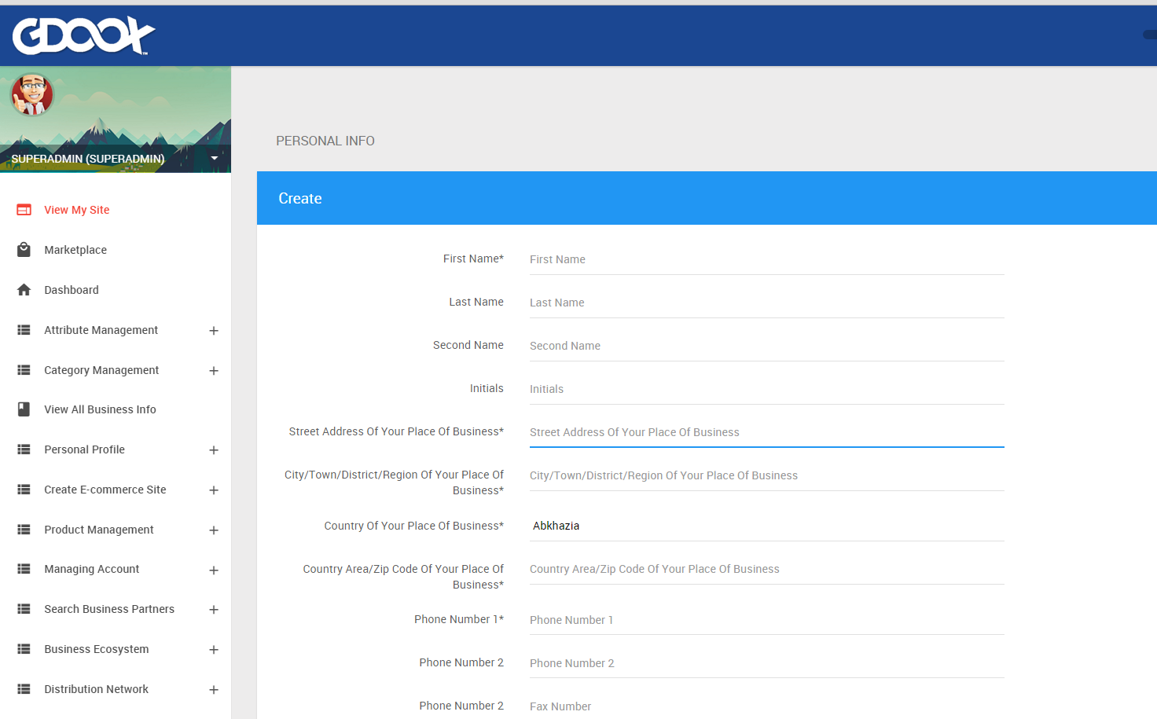

Same thing for **Social Info**, **Relation with Gdoox** and **Interests**.

**Create e-Commerce Site – Business Info – Verify Your Business Info**

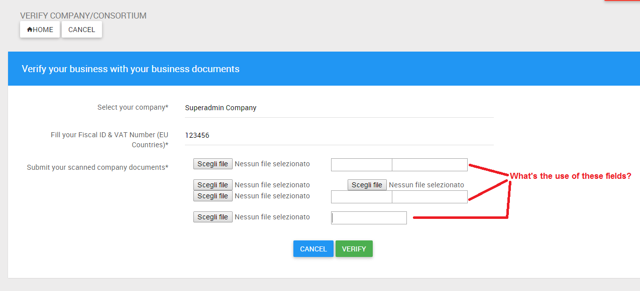

Why when you are in the process of modifying some section (i.e. clicking Action button, creating a new “*something*” or editing “*something*”, etc.) the system doesn’t show the position tracking?

Regarding the case we talked about (Multi-Item Products) where “view all” and “create new” should be put together, here is a list of the pages in which we should apply this principle:

|  |  |  |  |
| --- | --- | --- | --- |
| **Menu** | **Sub-Menu** | **Sub-Sub-Menu** | **New Name** |
| Create E-commerce Site | Manage E-commerce Site | Add Page/Show Pages | **ADD SITE PAGES** |
| CRM | Tasks | Create Task/View Tasks | **TASKS** |
| CRM | Users | Add User/View Users | **CRM USERS** |
| CRM | Accounts | Create Account/View Accounts | **CRM ACCOUNTS** |
| CRM | Opportunities | Build an Opprtunity/View Opportunities | **Build an Opprtunity** |
| CRM | Groups | Create Group/View Groups | **GROUPS** |
| CRM | Conatcts | Create Contact/View Conatct | **CRM CONTACTS** |
| CRM | Contacts | Create Contact Group/View Conatct Groups | **CREATE CONTACT GROUPS** |
| CRM | Templates | Create Template/View Templates | **CREATE TEMPLATES** |

In CRM – Contacts the submenus Export Excel Structure and Import Contacts should be moved upward (becoming the first 2 submenus of this section).