Questions:

On PERSONAL PROFILE:

1. Submenu: SOCIAL INFO

Which is the use of this Procedure? At present it is deactivated.

1. On Submenu: PERSONAL INFO and YOUR ACCOUNT appear in both: Email Address field . What ‘s happen if the user modify it in one of the option?

On BUSINESS SECTORS

Please modify this description to: **CONNECT YOUR BUSINESS**

Business Sectors I'am Interested In to **SELECT BUSINESS SECTORS I’M INTERESTED IN**

**In Select Business Sector I’m Interested in:**

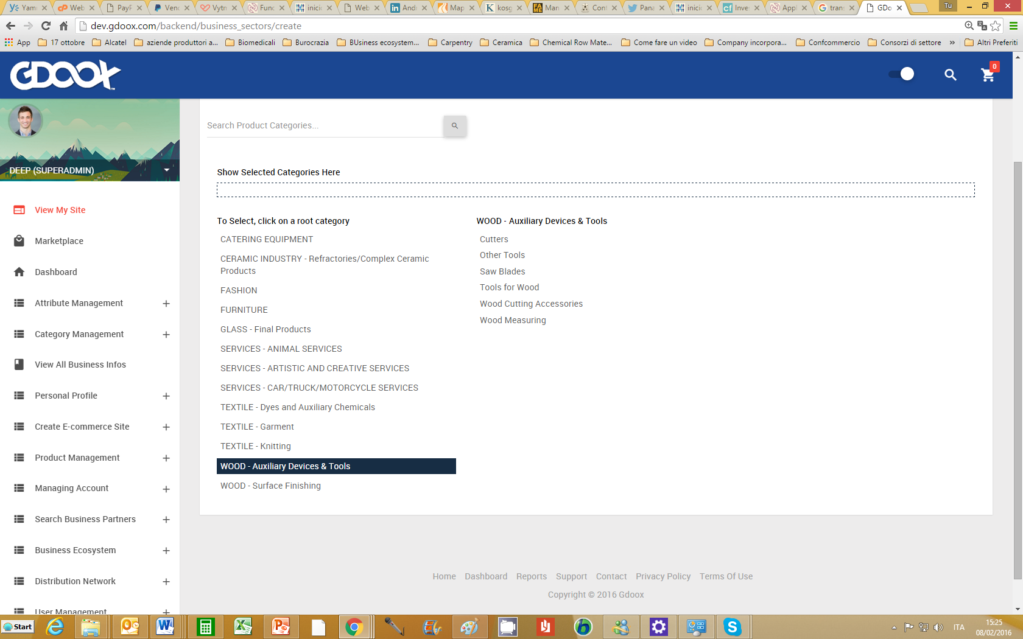

1. **This procedure is too slow for the first selection, Why?**
2. **The Category after the root category should appear as thye other subcategories (Alligned to the related category)**
3. **Search icon should be highlighted for example as a BUTTON or with a darker square**

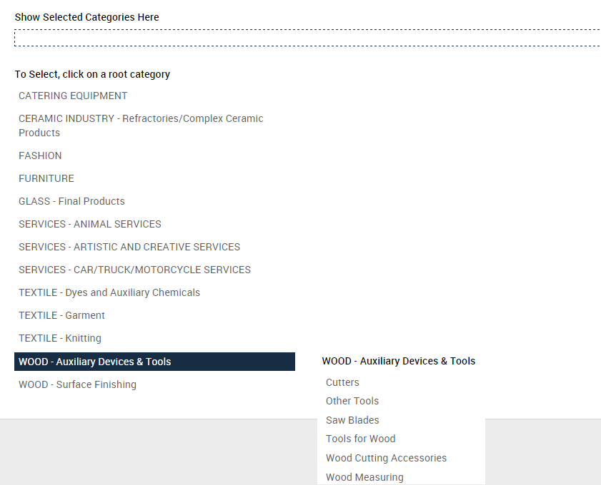

**VAT Verification:**

**Regarding European countries – European Union countries) It is possible to use the VAT procedure available . Please let me know if we can use it.**

**This procedure probably exist also for USA companies . Instead VAT probably we can use other fiscal number**

**Fiscal number and VAT number should be separated:**

* **VAT Number (EU countries)**
* **Fiscal number for USA**
* **Fiscal number for other countries**
* **VAT number for other countries**

**For the other countries the VAT should be controlled by Gdoox Team (Manually).**

**Under each page title:**

**As Sara tell you, we should insert the text are containing some explanation. Of what the user can do in the specific page. (Please create the text area in each page.**

**Attention: The message in this area should be translate in other language. The text area messages are a part of the management area by Gdoox team.**

**Lateral Menu:**

**Please verify why the menus close when you modify o edit e section.**

**Testing the procedure**

**Site Nonouser:**

**On the site there are 28 products.**

**WE have create a business ecosystem named: Multisite with monouser**

**Monouser accepted Multisite invitation to join his business ecosystem**

**Monouser share his site with Muntisite and then he shared the products in his site but in SHARE PRODUCT SECTION there is a list of only 5 products instead of the 28 shown in the site, Why?**

**Multisite created a new business ecosystem site .**

**Multisite imported his products choosing from his sites. At the moment all the product in the site chosen are imported in the new business ecosystem site.**

**It shouldn’t be like this because Multisite user should be able to decide which products to import.**

**Moreover Multisite imported monouser product too.**

**Checking the new business ecosystem site we see 28 products .**

**Since both Monouser and Multisite have 28 products on their sites and Monouser decided to share only two products from his site, the new business ecosystem site should show 30 products or at least 56 products (if Monouser product selection isn’t working).**

**Why only 28 products are shown on the new business ecosystem site??**

**Other notes about invitation, acceptation and site /product sharing will follow later.**