About how a company share product and sites

The platform should help to understand :

1. Which is the name of the site that the company want to share
2. Regarding how the companies share product, it is very important to understand from which site the company are sharing product and with whom they are sharing them.

Regarding the message from the companies inside the platform, is necessary to allow the user to access to the request regarding share site o share products in a very simple mode. At present this process should be implemented . Please let me know your suggestion , we need something that advise the user about when he has some news or request from the potential or already existing partners

The process regarding shared site or share product should appear on the same page .

Company A want to involve a partner already existing in Gdoox (Inviter)

Company B receive the request and it can be accepted or deny and it should appear in the same page instead of forcing the user to navigate.

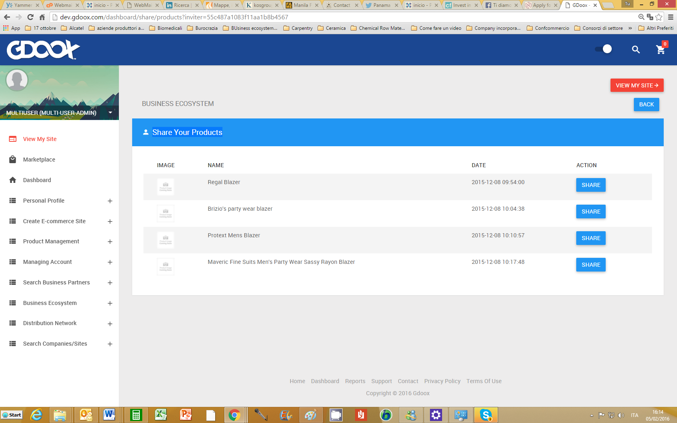

From which site? Are the user sharing product? And which is the product destination site. User doesn’t want to navigate, they want to see the process immediately

There are many pages that can be united in one page.

On Monday morning Italian time we can arrange a conference call by skype.

Question:

Commercial plan are 4

1. Mono account
2. Multi account
3. Multi-site (company can not create cluster)
4. Business ecosystem (companies can create cluster

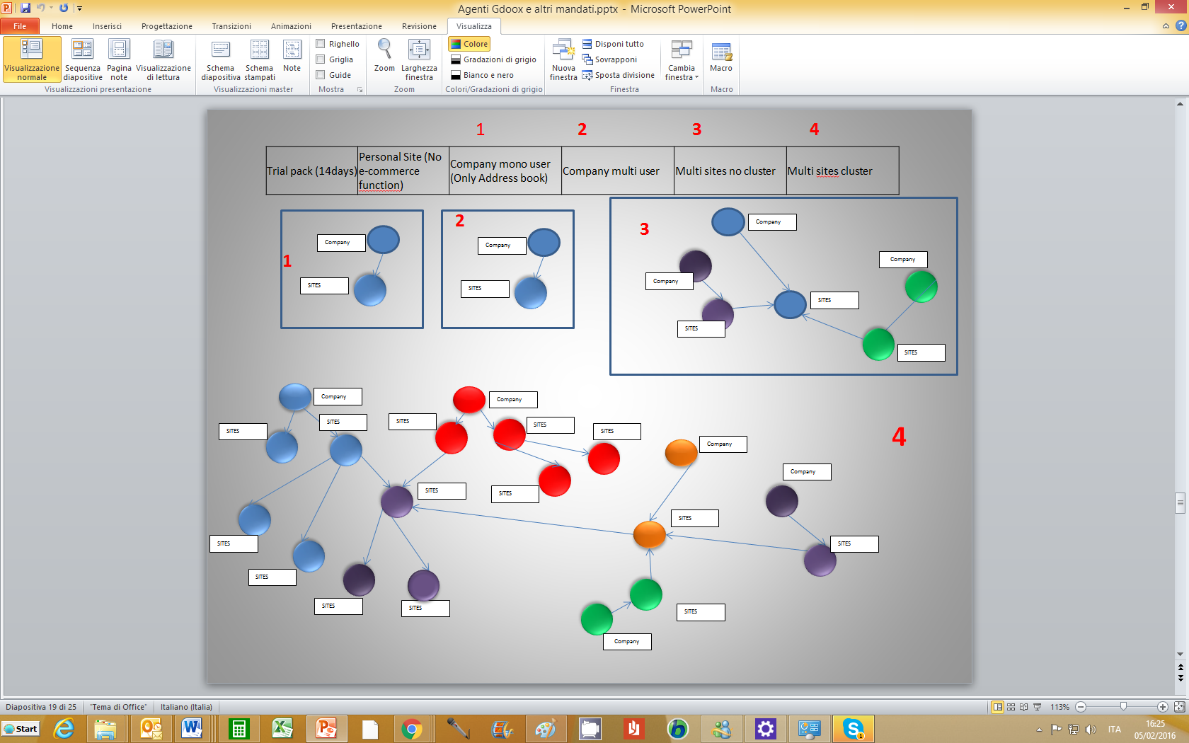

This description should appear also on the platform.

Business ecosystem include the both solution and the user can choose between the two of them.

About IMPORT PRODUCT MENU

Please explain me how it work.

Import product from a site to other site?

Import product list using an external file.

User have not idea about platform configuration.

To import a product list is a product category how can he does it?

This process should be explain more and the process should be clear for the user

Question: How the user can create the list without to know how the platform is working?

Case A: The user has already loaded a product belonging to a particular category existing on the procedure.

First step should be:

1. Go to the product already existing on the platform
2. Download the product attribute belonging to that specific category
3. The downloaded file structure CAN NOT BE MODIFY (firt row)
4. User create an external excel file including the attributes downloaded from Gdoox
5. Import the file.

Question1: How the user can import the product images?

Question2: what happen when the attributes include a multiple choices option?

Please , explain me how this procedure work

Case B: The user has never load product in Gdoox.

Steps

User have to load a sample product according to the selected category product

Before to execute the process that load the product in Gdoox, the platform ask :

Do you want to save this product structure ? If YES the system save the structure in an excel file and it can be use by the user at a later time

This list will be save on the Product attribute File list, or alternative solution. Please let me know