**Docker**

Docker is an open-source platform designed to automate the deployment, scaling, and management of applications using containerization. Containers are lightweight, standalone, and executable software packages that include everything needed to run a piece of software, including the code, runtime, libraries, and system tools.

**Features of Docker :**

**Containerization:** Encapsulates applications and their dependencies into containers, ensuring consistency across different environments.

**Portability:** Containers can run on any system that supports Docker, providing a consistent environment from development to production.

**Isolation:** Each container runs in its isolated environment, ensuring that applications do not interfere with each other.

**Efficiency:** Containers share the host system's OS kernel and resources, making them more lightweight and efficient compared to virtual machines.

**Scalability:** Docker supports easy scaling of applications through orchestration tools like Docker Swarm and Kubernetes.

**Components of Docker :**

**Docker Engine:** The core component that enables container creation and management.

**Docker Daemon:** Runs on the host machine and manages Docker containers.

**Docker Client:** Command-line tool that communicates with the Docker daemon.

**Docker Images:** Read-only templates used to create containers. They contain the application and its dependencies.

**Docker Containers:** Running instances of Docker images that hold the application.

**Docker Hub:** A cloud-based repository where Docker users can store and share Docker images.

**How Docker is Useful for Applications ?**

**Simplifying Development and Deployment:** Developers can package applications and their dependencies into a container, ensuring consistency across development, testing, and production environments.

**Microservices Architecture:** Docker enables the development and deployment of microservices, where each service runs in its container, making it easier to develop, test, deploy, and scale independently.

**Continuous Integration and Continuous Deployment (CI/CD):** Docker integrates well with CI/CD tools, allowing for automated testing and deployment of applications.

**Multi-Cloud and Hybrid Cloud Deployments:** Docker containers provide portability across different cloud providers and on-premises environments, making it easier to manage multi-cloud and hybrid cloud strategies.

**Legacy Application Modernization**: Encapsulate legacy applications in containers to improve manageability, scalability, and integration with modern cloud services.

**Environment Consistency:** Ensures that the application runs the same way regardless of where it is deployed, reducing the "it works on my machine" problem.

**Resource Efficiency:** Containers are lightweight and use fewer resources compared to virtual machines, allowing for higher density and better utilization of server resources.

**Development Environment Setup:** Quickly set up development environments by using pre-configured Docker images, reducing the time needed to configure individual developer workstations.

**Automated Testing:** Create isolated environments for automated testing, ensuring that tests run in a consistent and repeatable manner.

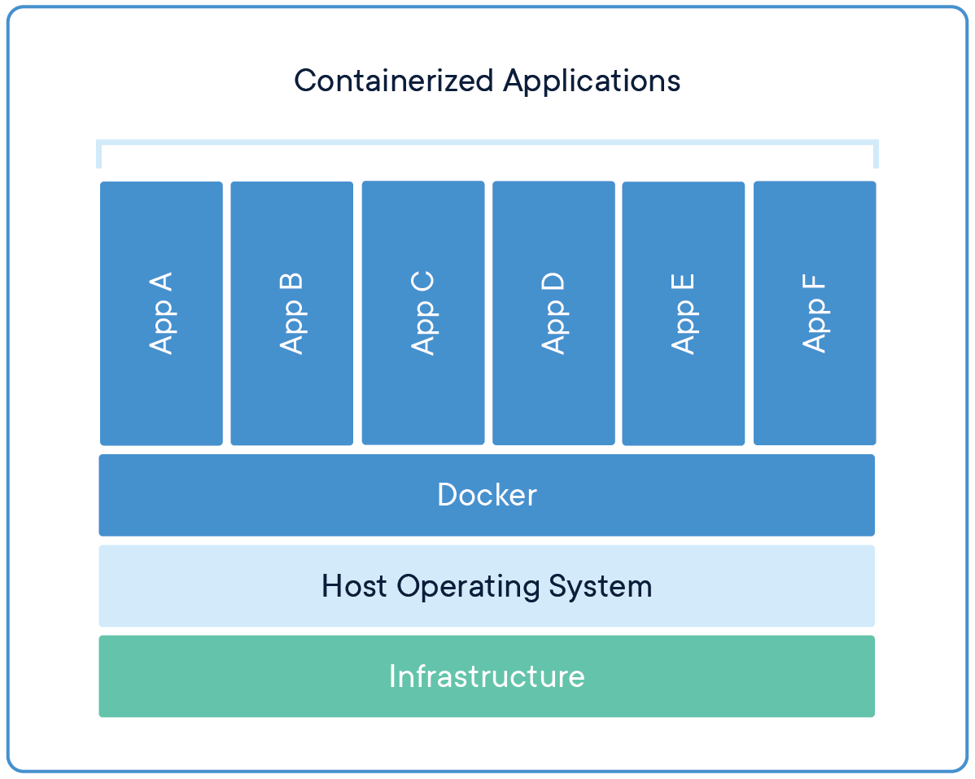

**By leveraging Docker, organizations can streamline their development and deployment processes, improve resource utilization, and achieve greater consistency and reliability in their software delivery pipelines.**

**Nginx is a high-performance web server and reverse proxy used to serve static content, handle load balancing, and improve application scalability. It is useful for converting an HTML site into a container by serving the site as a lightweight Docker container, allowing for easy deployment and management. By creating a Docker image with Nginx and your HTML files, you can efficiently deploy your website across different environments.**