**Ansible**

Ansible is an open-source automation tool used for IT tasks such as configuration management, application deployment, orchestration, and provisioning. It is designed to simplify complex IT workflows and makes it easier to manage a large number of systems by using simple, human-readable YAML templates.

**Features of Ansible :**

**Agentless:** Ansible does not require any agents to be installed on the managed nodes. It uses SSH for communication, which simplifies management.

**Human-Readable Automation:** Ansible playbooks are written in YAML, making them easy to read and write.

**Idempotency:** Ansible ensures that repeated runs of the same playbook will always produce the same result, preventing unintended changes.

**Extensible:** Ansible has a large collection of modules that can be used to manage various aspects of IT environments, and users can write their own modules as needed.

**Integrations:** Ansible integrates well with other tools and platforms, such as Docker, Kubernetes, AWS, Azure, and more.

**Master-Slave Concept in Ansible (Controller-Managed Nodes) :**

In Ansible, the traditional terms "master" and "slave" are typically replaced with "controller" and "managed nodes" respectively.

**Here’s how it works:**

**Controller Node:** This is where Ansible is installed and from where the automation tasks are initiated. It contains the playbooks, inventory files, and other configuration files.

**Managed Nodes:** These are the target machines that are being managed by Ansible. These nodes do not need Ansible installed; they just need to be accessible over SSH (or WinRM for Windows systems).

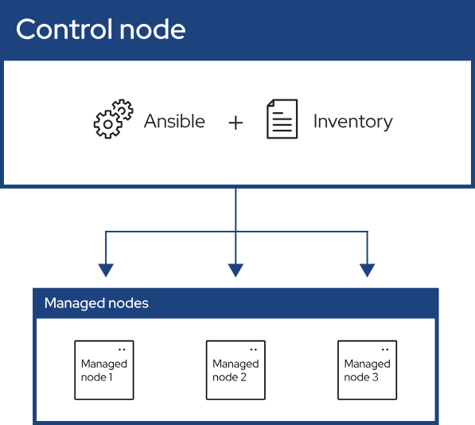

**How It Works**

**Inventory:** The controller node maintains an inventory file that lists all the managed nodes and groups them as needed.

**Playbooks:** These are YAML files that define the automation tasks. A playbook can contain multiple plays, each targeting a specific group of managed nodes.

**Modules:** Ansible uses modules to perform tasks on managed nodes. These modules are called from within the playbooks.

**Execution:** When a playbook is run, the controller node connects to the managed nodes over SSH, executes the defined tasks using the specified modules, and then closes the connection.

**How Ansible is Useful for Applications ?**

**Configuration Management:** Automate the configuration of systems and ensure consistency across the environment.

**Application Deployment:** Streamline the deployment of applications, reducing downtime and errors associated with manual deployment.

**Provisioning:** Automate the setup of new systems, whether on-premises or in the cloud, ensuring they are configured according to predefined specifications.

**Orchestration:** Manage complex workflows that require coordination between multiple systems and services.

**Continuous Delivery and Continuous Integration (CI/CD**): Integrate with CI/CD pipelines to automate the deployment of software updates.

**Security and Compliance:** Enforce security policies and compliance requirements across systems, ensuring they adhere to organizational standards.

**Cloud Management:** Manage cloud infrastructure by automating tasks such as provisioning new instances, configuring networks, and managing storage.

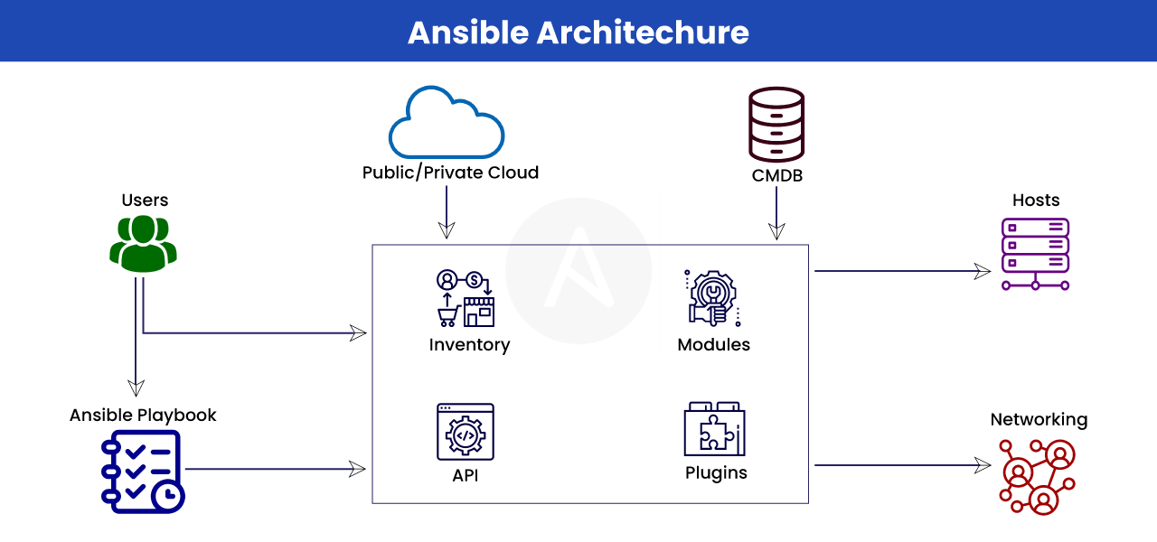

**By using Ansible, organizations can significantly improve efficiency, reduce errors, and ensure consistency across their IT environments, making it an invaluable tool for modern IT operations.**