**Git**

Git is a **distributed version control system** commonly used for tracking changes in source code during software development. It allows multiple developers to work on the same project simultaneously without interfering with each other's work.



**Features :**

**Distributed Version Control:** Unlike centralized version control systems, Git allows every developer to have a complete copy of the codebase history on their local machine. This enables offline work and provides redundancy.

**Branches and Merging:** Git enables the creation of branches, which are separate lines of development. This allows developers to work on features, bug fixes, or experiments in isolation. Branches can later be merged back into the main codebase.

**Commit History:** Git keeps a history of changes made to the codebase in the form of commits. Each commit is a snapshot of the project at a specific point in time, with a unique identifier (SHA-1 hash), a message describing the change, and metadata such as the author and timestamp.

**Staging Area:** Before committing changes, Git uses a staging area (or index) to gather changes that will be included in the next commit. This allows for fine-grained control over what changes are committed.

**Collaboration:** Git supports collaboration through remote repositories, such as those hosted on platforms like GitHub, GitLab, or Bitbucket. Developers can push their changes to remote repositories and pull changes from others.

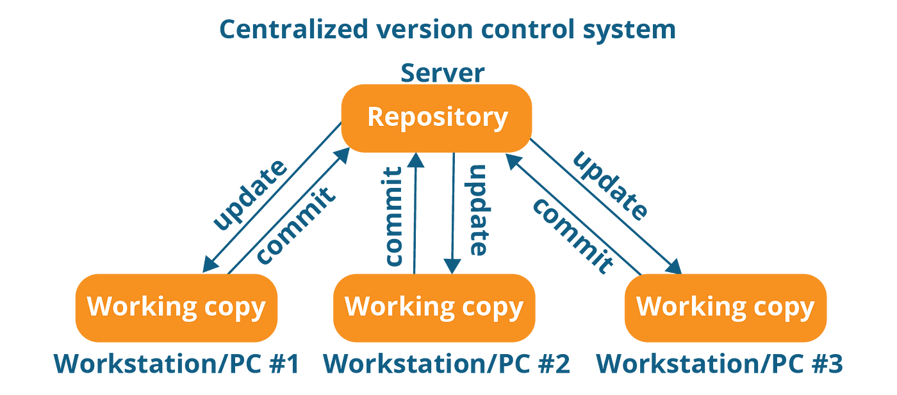

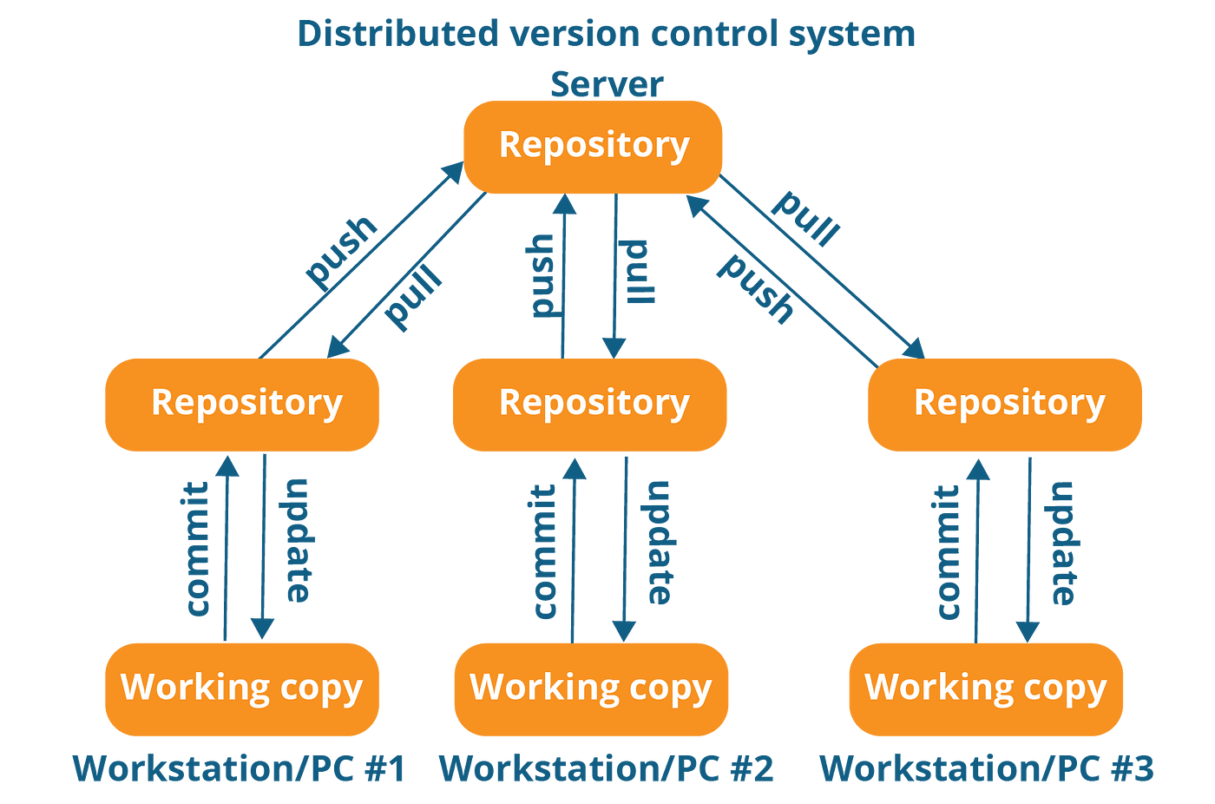

**Git Stages :**

