**Multicloud**

Multicloud refers to the use of multiple cloud computing and storage services from different providers in a single **heterogeneous architecture.** This approach allows organizations to avoid dependency on any single cloud provider, enhance redundancy and resilience, optimize costs, and take advantage of the unique capabilities of various providers.

**Heterogeneous Wireless Architecture :**

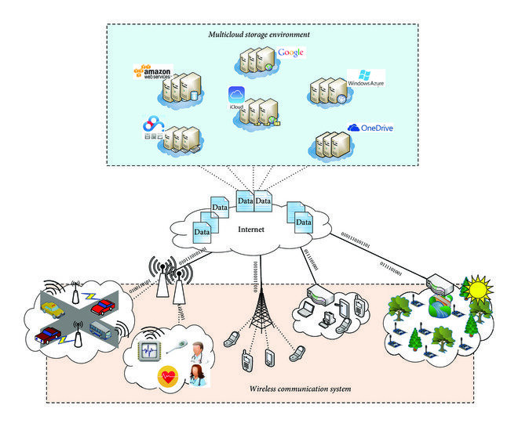

A heterogeneous architecture in the context of computing and IT infrastructure refers to a system composed of different types of technologies, platforms, or environments that work together to achieve a common goal. This contrasts with a **homogeneous** architecture, where a single type of technology or platform is used throughout the system.

**Multicloud Global market :**

**By 2025 multicloud concept will reach 1.9% of global market :**

**Assumptions for Projection:**

Initial value in 2020: $4.59 billion

Expected value in 2026: $16.69 billion

CAGR: 24.6%

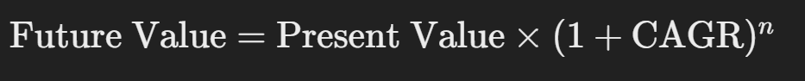

2020: $4.59 billion

2026: $16.69 billion

2030: Projected value based on CAGR

**How to achieve MultiCloud :**

1) Identify the business goals and specific requirements that drive the need for a multicloud strategy.

2) Evaluate different cloud providers (e.g., AWS, Azure, Google Cloud) based on their services, pricing, performance, and compliance offerings.

3) Create an **architecture** that supports integration and interoperability between different cloud environments.

4) Use cloud management platforms (CMPs) to manage resources, monitor performance, and ensure compliance across multiple clouds.

5) Implement robust security measures, such as identity and access management (IAM), encryption, and network security, across all cloud environments.

6) Set up secure and efficient networking between cloud environments, such as using virtual private networks (VPNs), direct connections, or cloud interconnect services.

7) Use data management tools to ensure consistent data storage, backup, and recovery across multiple clouds.

8) Use a **DevOps** approach to develop, test, and deploy applications in a multicloud environment.

**Using DevOps is indeed one of the best approaches to achieve a multicloud strategy effectively.**

DevOps practices and tools help automate, manage, and optimize workflows across multiple cloud environments, ensuring consistency, reliability, and efficiency. Here’s how DevOps can facilitate a successful multicloud strategy:

**1) Continuous Integration and Continuous Deployment (CI/CD)**

**2) Infrastructure as Code (IaC)**

**3) Containerization(Docker)**

**4) Orchestration(Kubernetes)==>It is a tool to manage and deploy containerized applications across multiple clouds seamlessly.**

**5) Monitoring and Logging**

**6) Security and Compliance**

**7) Configuration Management**

**8) Code Repository**