**Jenkins**

Jenkins is an open-source automation server that is widely used for continuous integration (CI) and continuous delivery (CD). It helps automate the parts of software development related to building, testing, and deploying, facilitating continuous delivery and integration of software projects.

**Features of Jenkins :**

**Extensibility:** Jenkins has a rich ecosystem of plugins that allow it to integrate with many other tools and platforms, making it highly customizable.

**Distributed Builds:** Jenkins can distribute builds and tests across multiple machines to speed up the CI/CD process.

**Pipeline as Code:** Jenkins supports defining build pipelines using code (Jenkinsfile), which can be version-controlled and treated as part of the project.

**Easy Configuration:** Jenkins has a web-based GUI for easy configuration and monitoring of builds.

**Community Support:** As one of the most popular CI/CD tools, Jenkins has a large and active community, providing plenty of resources, tutorials, and plugins.

**How Jenkins is Useful for Applications ?**

**Continuous Integration:** Jenkins automates the process of integrating code changes from multiple developers into a shared repository several times a day. This helps to detect errors quickly and ensures that the software is always in a release-ready state.

**Continuous Delivery and Deployment:** Jenkins automates the deployment process, allowing code to be deployed to various environments (development, staging, production) automatically after passing the necessary tests.

**Automated Testing:** Integrate Jenkins with testing frameworks to run automated tests on code changes, ensuring that new commits don’t break existing functionality.

**Feedback and Reporting:** Jenkins provides immediate feedback on the state of the build and test processes, allowing developers to address issues quickly. It also generates reports and dashboards for monitoring builds and tests.

**Environment Management:** Use Jenkins to manage and deploy environments consistently, ensuring that all environments (dev, staging, prod) are as similar as possible, reducing environment-specific issues.

**Scalability:** Jenkins can scale to handle large projects with complex build processes. It can manage distributed builds across **multiple nodes**, making it efficient for large teams and projects.

**Integration with Other Tools:** Jenkins integrates seamlessly with a wide range of tools such as **Git, Docker, Kubernetes, Maven**, and more, creating a cohesive DevOps toolchain.

**Improved Collaboration:** By automating the CI/CD process, Jenkins allows developers to focus more on coding and less on the build and deployment processes, improving collaboration and productivity within teams.

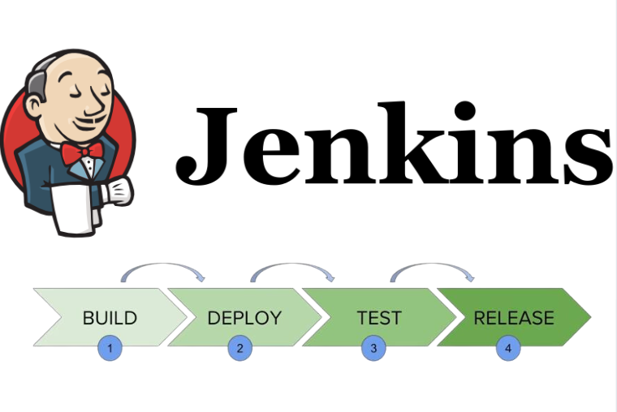

**By incorporating Jenkins into the development workflow, organizations can improve the speed, quality, and reliability of their software delivery process, enabling more frequent releases and quicker feedback loops.**