**Devops**

**Devops ===> Development and operations**

**DevOps** is a set of practices, cultural philosophies, and tools that aims to integrate and automate the processes between **software development (Dev) and IT operations (Ops) teams**. The primary goal is to shorten the systems development life cycle and deliver high-quality software continuously.

DevOps promotes collaboration, communication, and integration between developers and operations teams, fostering a culture of shared responsibility for the performance and stability of the software in production.

**Components of Devops :**

1) Continuous Integration

2) Continuous Delivery

3) Continuous Deployment

4) Infrastructure as Code (IaC)

5) Monitoring and Logging

6) Collaboration and Communication

Why DevOps is Popular: **Open source**

(Faster Delivery of Software,Improved Collaboration,Increased Efficiency,Higher Quality Software,Scalability and Flexibility,Enhanced Security,Cost Savings,Better Customer Satisfaction)

Popular DevOps Tools:

**Version Control:** Git, GitHub, GitLab

**CI/CD:** Jenkins, GitLab CI, CircleCI, Travis CI

**Containerization:** Docker

**Orchestration:** Kubernetes

**IaC:** Terraform, Ansible, Puppet, Chef

**Monitoring and Logging:** Prometheus, Grafana, ELK Stack

**Collaboration:** Slack, Microsoft Teams, Jira

**Assumptions for Projection:**

2030: Projected value based on CAGR



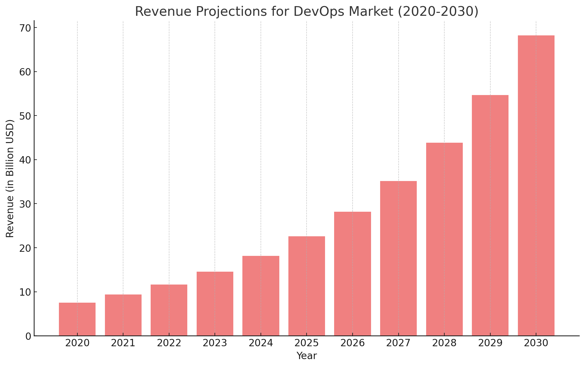

2020: $7.5 billion

2030: Projected value based on a CAGR of 24.7%

**CICD in Devops :**

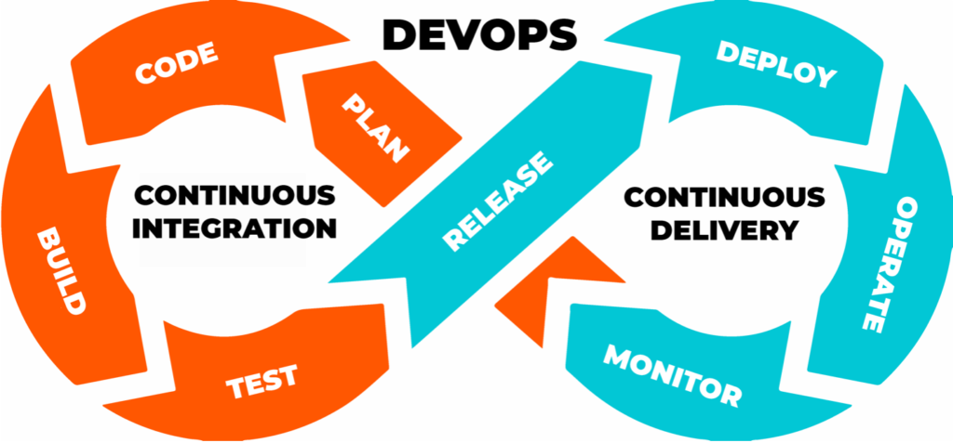

**Periodic table of Devops Tools :**

