**CLOUDFRONT**

**CDN 🡺** Content Delivery Network (Global service)

Improves read performance, content is cached at the edge(Cache server).

<https://aws.amazon.com/cloudfront/features/?nc=sn&loc=2>

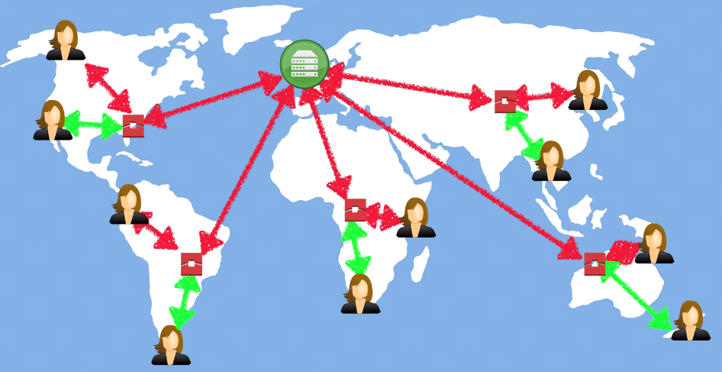

CloudFront seamlessly integrates with other AWS services, such as S3, EC2, Elastic Load Balancing, and AWS WAF (Web Application Firewall), allowing you to build scalable, high-performance applications.

It is commonly used to accelerate the delivery of static and dynamic web content, stream videos, and distribute software updates.