**EC2 ADVANCED**

**1) Volume:** Amazon Elastic Block Store (EBS) is a scalable block storage service provided by Amazon Web Services (AWS) for use with Amazon EC2 (Elastic Compute Cloud) instances.

It allows you to create storage volumes and attach them to EC2 instances.

Standard EBS volumes are typically designed to be attached to a single EC2 instance at a time. Each EBS volume is associated with a specific EC2 instance, and the attachment is exclusive to that instance.

**2)** **Snapshots :** Snapshots in Amazon EC2 allow you to create point-in-time backups of your EBS volumes, capturing their data and enabling you to easily restore or create new volumes based on those snapshots for backup and recovery purposes.

Make a backup (snapshot) of your EBS volume at a point in time. Can copy snapshots across AZ or Region.

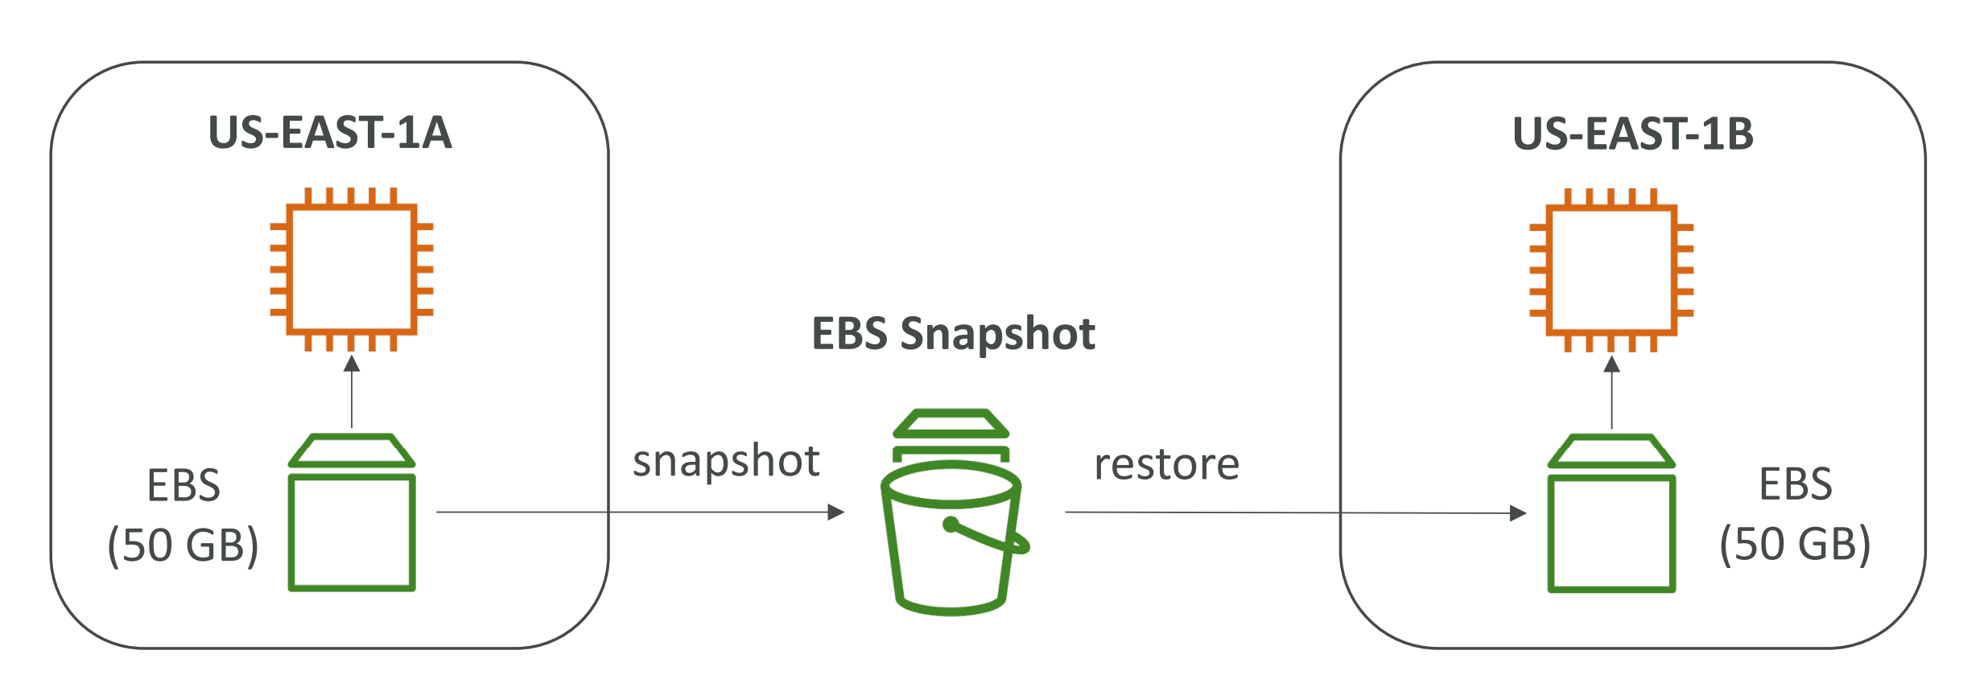

**3)** **AMI : Amazon Machine Image** in AWS is a pre-configured template that contains the information needed to launch an EC2 instance, including the operating system, application server, and application code.

AMIs facilitate easy and consistent replication of EC2 instances for scalability and rapid deployment.

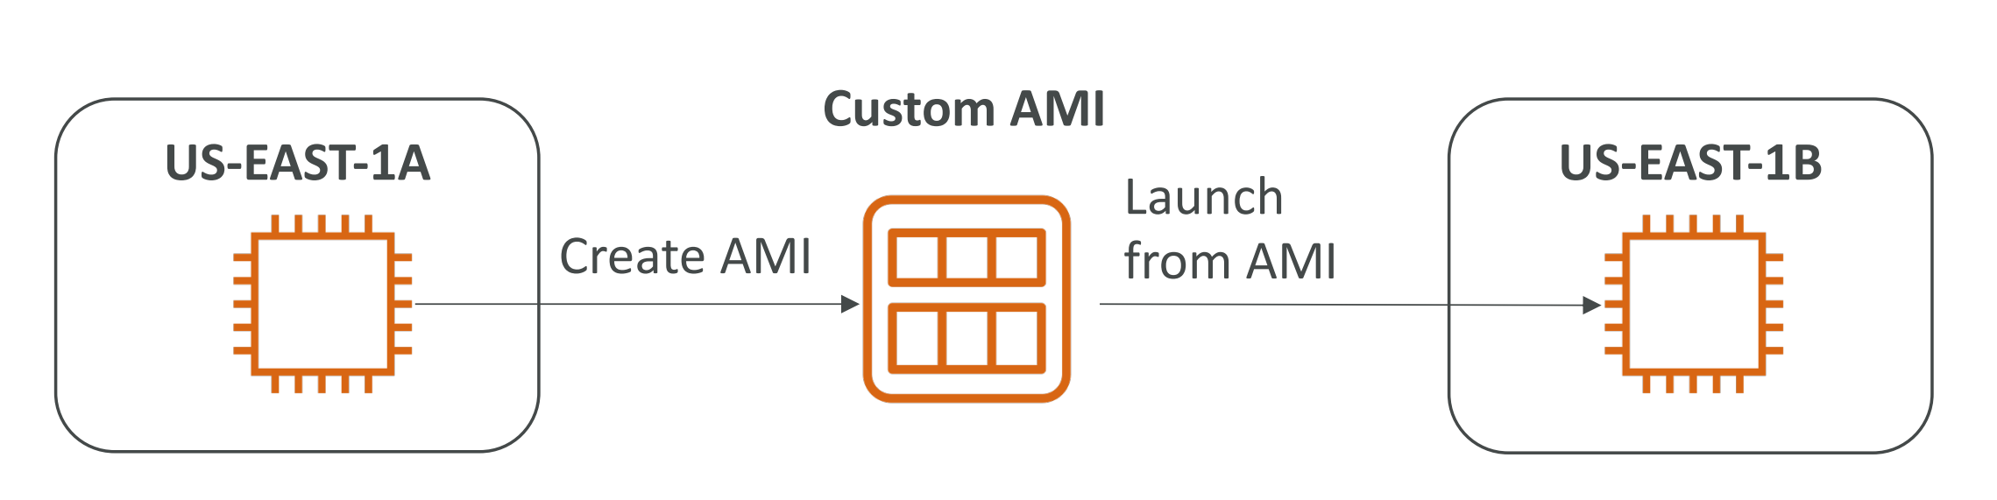

**4) Elastic ip :** An Elastic IP (EIP) in AWS is a static IPv4 address designed for dynamic cloud computing, allowing you to allocate and associate a persistent public IP to an EC2 instance. EIPs help in maintaining a consistent public IP for instances, even during instance stop-start cycles.