**ROUTE 53**

Domain Name System which translates the human friendly hostnames into the machine IP addresses.

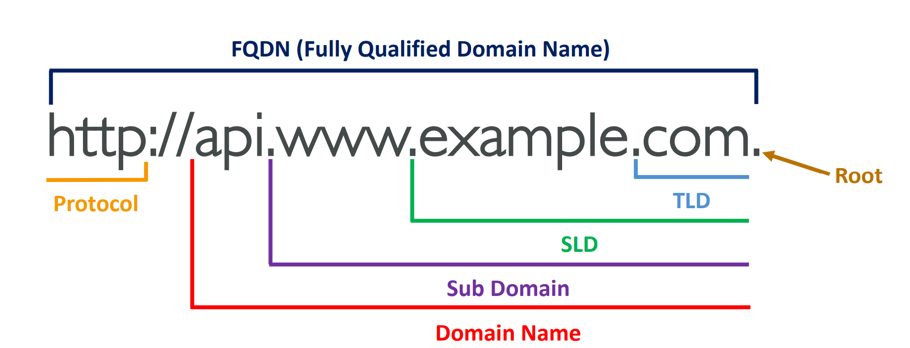

DNS is the backbone of the Internet.

Why Route 53? (Global service).

53 is a reference to the traditional DNS port.

**TYPES OF ROUTE 53 ROUTING POLICY:**

1. **SIMPLE ROUTING POLICY** 🡺 Route traffic to a single resource.

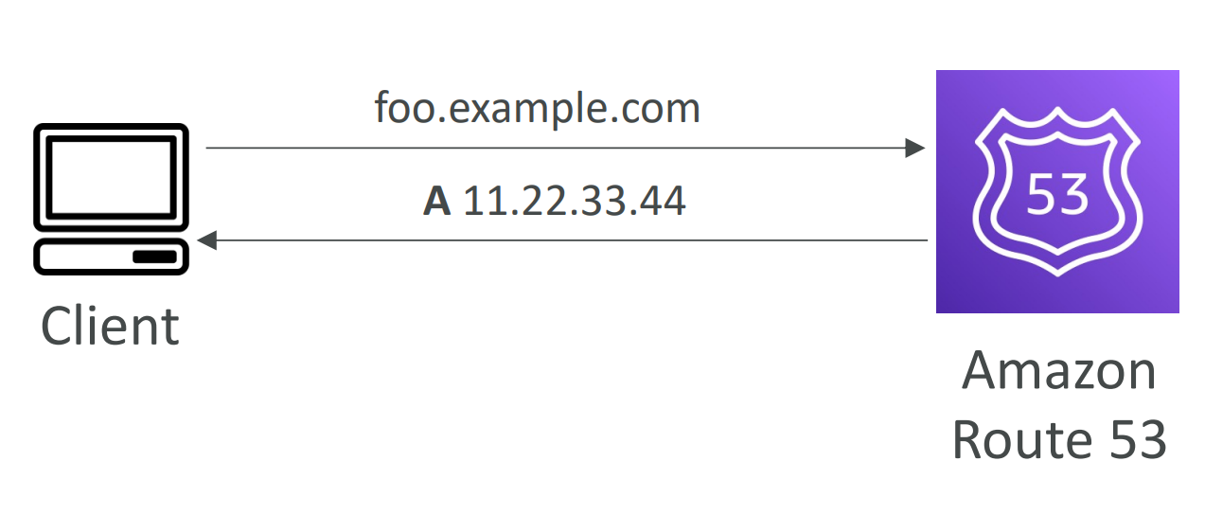

2. **FAILOVER ROUTING POLICY** 🡺 Active and Passive(Prod and DR).

3. **GEOLOCATION ROUTING POLICY** 🡺 This routing is based on user location.

4. **GEOPROXIMATY ROUTING POLICY** 🡺 Route traffic to your resources based on the geographic location of users and resources. Ability to shift more traffic to resources based on the defined bias.

5. **LATENCY ROUTING POLICY** 🡺 Redirect to the resource that has the least latency close to us.

6. **MULTIVALUE ROUTING POLICY** 🡺 Use when routing traffic to multiple resources.

7. **WEIGHTED ROUTING POLICY** 🡺 Control the % of the requests that go to each specific resource.

