**SNS**

SNS **🡺 Simple Notification Service**

The “event producer” only sends message to one SNS topic. As many “event receivers” (subscriptions).

Each subscriber to the topic will get all the messages.

Up to 12,500,000 subscriptions per topic.

100,000 topics limit.

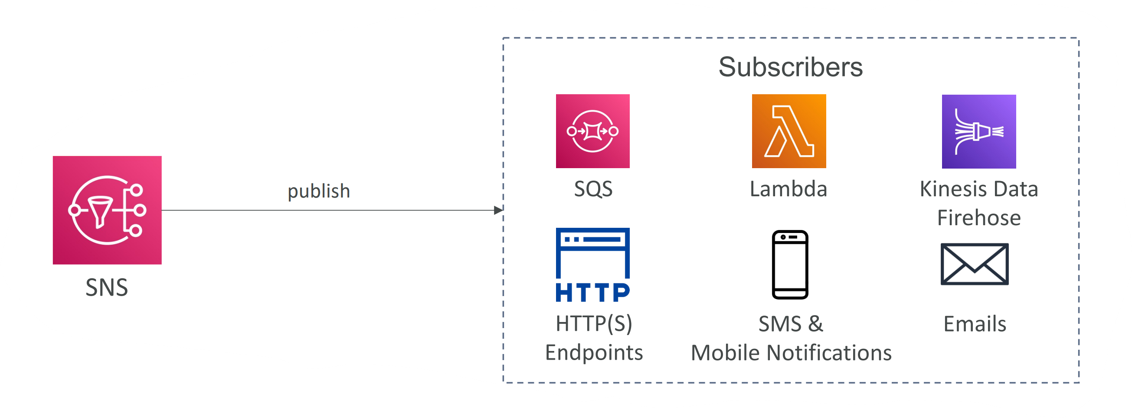

**SNS – Message Filtering :**

JSON policy used to filter messages sent to SNS topic’s subscriptions.

If a subscription doesn’t have a filter policy, it receives every message.

