**SQS**

SQS **🡺 Simple Queue Service**

Oldest offering (over 10 years old)

Fully managed service, used to decouple applications

Unlimited throughput, unlimited number of messages in queue

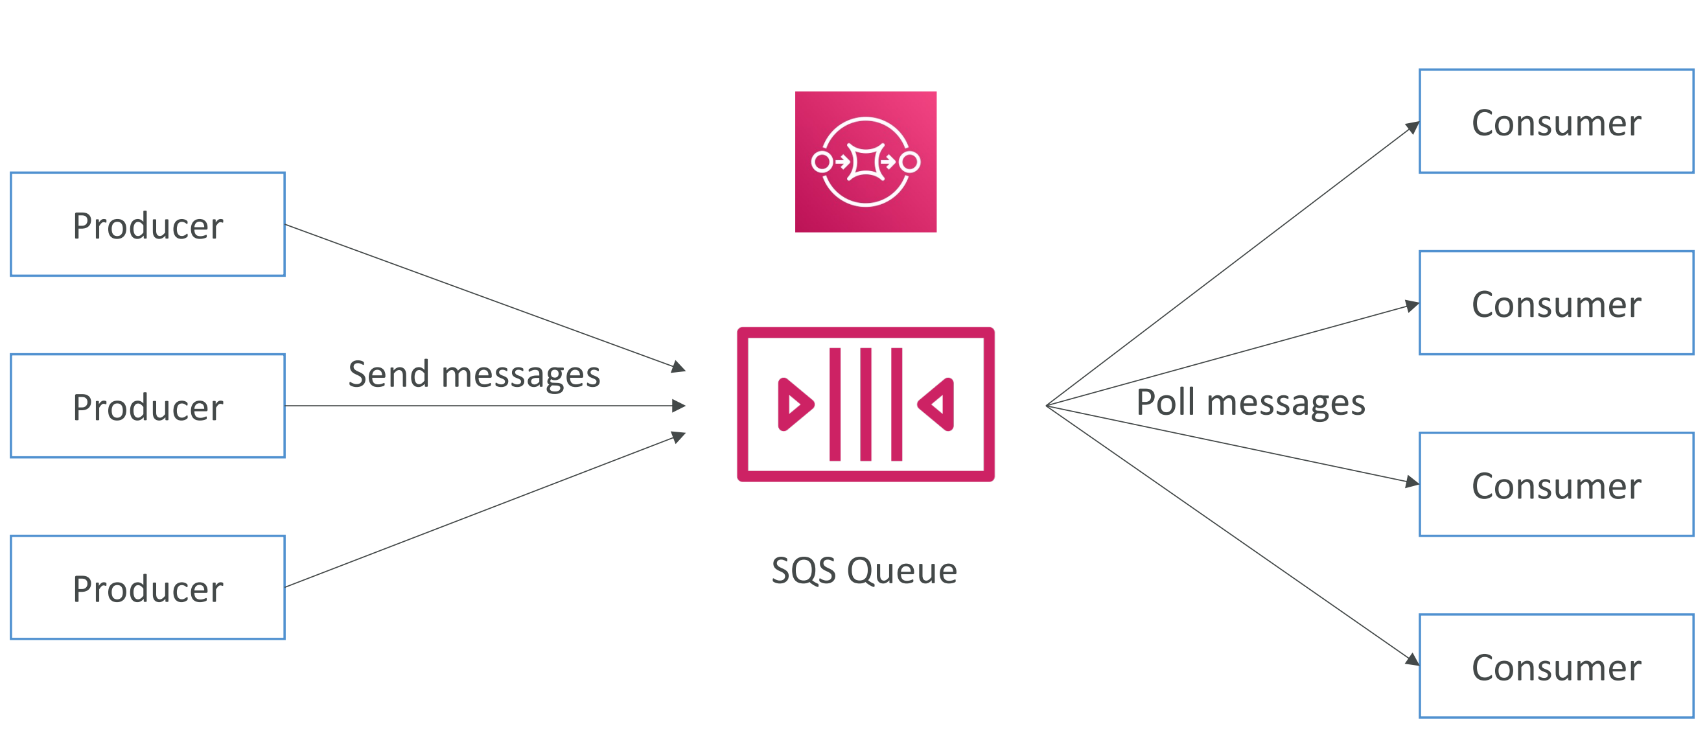

**Producer :**

Produced to SQS using the SDK (SendMessage API).

The message is persisted in SQS until a consumer deletes it.

Message retention: default 4 days, up to 14 days.

**Consumer :**

Consumers (running on EC2 instances, servers, or AWS Lambda).

Poll SQS for messages (receive up to 10 messages at a time).

Process the messages (example: insert the message into an RDS database).

Delete the messages using the DeleteMessage API.