**VPC(Numerical)**

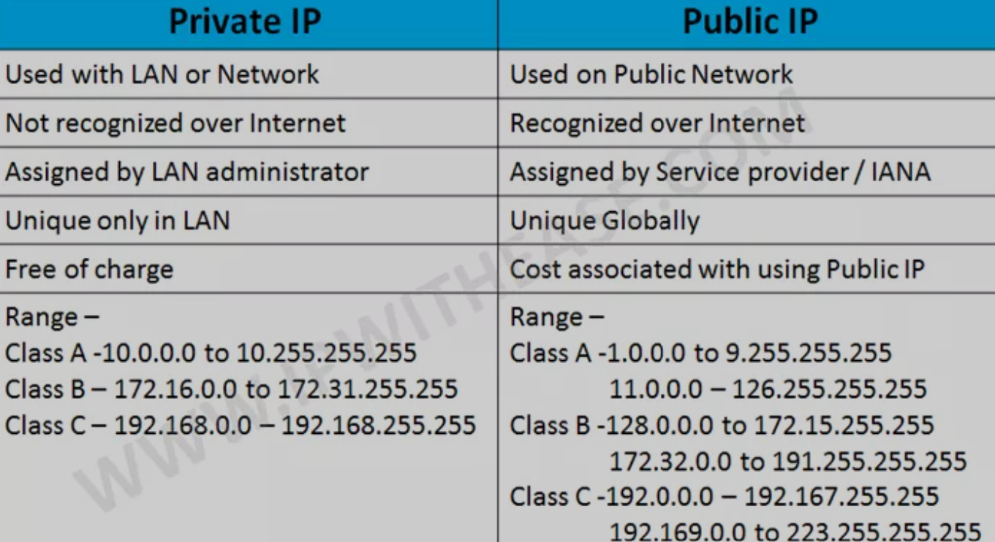

**CIDR (Classless Inter-Domain Routing)🡺** Itis a method of IP address allocation and routing that allows for more efficient use of IP addresses by using variable length subnet masking. It replaced the traditional class-based addressing system, enabling better address space management on the Internet.

Ex : **192.168.1.0/24**

192.168.1.0 **🡺 network address**

/24 **🡺 first 24 bits are used for the network portion leaving 8 bits for host addresses within that network.**

**IPv4 :**

**0-255.0-255.0-255.0-255 (“256=>2^8)🡺8 bits.**

**8b.8b.8b.8b 🡺 32 bits.**

**We are using IPV4 only so no worries**

**IPv6 :**

**Expressed as eight groups of hexadecimal numbers separated by colons.**

**2001:0db8:85a3:0000:0000:8a2e:0370:7334 🡺8 *16 🡺 128 bits.**

**Our Objective is to find the no of hosts in an subnetwork defined in an network address.**

**1) 15.0.0.0/32 🡺 no of hosts = 1 🡺 2^0.**

**2) 15.0.0.0/31 🡺 no of hosts = 2 🡺 2^1.**

**3) 15.0.0.0/30 🡺 no of hosts = 4 🡺 2^2.**

**4) 15.0.0.0/29 🡺 no of hosts = 8 🡺 2^3.**

**5) 15.0.0.0/28 🡺 no of hosts = 16 🡺 2^4.**

From the above problems we can tell that :

**n = 32 – subnet.**

**No of hosts = 2^n.**

**If you have doubt in this verify with** [**www.ipaddressguide.com**](http://www.ipaddressguide.com)

What is the answer for this question **15.0.0.0/1** ?

Don’t see in the website you calculate and mention in comments.