DATABRICKS AND SNOWFLAKE | CAPSTONE PROJECT 2026

Student Performance & Attendance
A gradebook analytics pipeline built on Databricks and served through Snowflake
NAME | Preetam Mondal
ROLL NUMBER | 23051768
BATCH | DATABRICKS & SNOWFLAKE 2026 · ExcelR × KIIT
PROJECT TOPIC | Topic 24 — Student Performance & Attendance (Media, Education & Sport)
SUBMITTED TO | Dr. Kanthi Kiran Sirra
DATE | 27 November 2026

1. Problem Statement
Everyone in the department believes students who attend more classes score higher, but nobody has a number to back the rule. Attendance may drive marks hard in one subject and barely at all in another, and until that per-subject relationship is measured, the same blanket attendance policy is applied to all six subjects regardless of whether it actually matters for that subject. Separately, a student whose class rank falls sharply between semesters is a student worth flagging in week three of the next semester, not after final results are published — but nobody currently tracks semester-to-semester rank movement at all.
No usable public dataset fits this problem. The UCI Student Performance dataset (student-mat.csv, student-por.csv) is real but reports a raw absence count with no total classes held, so no attendance percentage can be derived from it, and it covers one subject per file rather than six subjects across three semesters for one cohort. Kaggle's "Students Performance in Exams" dataset has no attendance column at all. Given no real dataset carries attendance percentage, marks, and a multi-semester cohort together, the project uses a seeded synthetic generator (seed 84) whose exact answer is known in advance, so every pipeline decision can be checked against a ground truth rather than trusted blindly.
Success criteria for this project:
- The pipeline runs end to end with no manual step, as a scheduled Databricks Job.
- Row counts reconcile exactly at every layer (Bronze → Silver → Gold), with every dropped row logged under a named reason rather than silently discarded.
- The Snowflake load is idempotent: running the same COPY INTO twice against the same staged file loads the data once and reports zero rows on the second run.
- The correlation between attendance and total marks is computed per subject, and a semester rank-volatility check identifies students whose rank shifted by 20 or more places between semesters.

2. Objectives and Scope
- Ingest the raw generated CSVs into Databricks Unity Catalog as Bronze tables with every column read as a string, changed in no way, and tagged with provenance columns.
- Clean, validate and standardise the data with PySpark in a Silver layer: try_cast every numeric/date field, dedupe on the true business key, and reject orphan or out-of-range rows into a logged, named-reason table.
- Build a single business-ready Gold table — one row per student, semester and subject — joined against the student and subject dimensions.
- Export the Gold table to CSV, stage it in Snowflake, and load it with COPY INTO, proving the load is safe to re-run without duplicating data.
- Answer three analytical SQL questions: attendance-band vs. marks by subject, semester rank-jumps of 20+ places, and the correlation between attendance and marks per subject.
- Orchestrate the whole pipeline as a scheduled, unattended 5-task Databricks Job.

In scope
- A batch pipeline using the Bronze / Silver / Gold medallion architecture.
- Data-quality checks with a logged, named-reason rejects table (no silent row drops).
- A Snowflake serving layer loaded via internal stage and COPY INTO.
- Three SQL analytical questions answered directly against the Gold table.

Out of scope
- Real student records — only a seeded, reproducible synthetic cohort is used.
- A BI dashboard or visual reporting tool inside Snowflake or Databricks.
- Machine-learning models (e.g. predicting at-risk students).
- Streaming/real-time ingestion — the pipeline is a scheduled batch job.

3. Solution and Features
The project moves a seeded synthetic student-record dataset through a Bronze → Silver → Gold medallion pipeline in Databricks, then exports the Gold layer into Snowflake for SQL analysis. The pipeline is orchestrated as a single scheduled Databricks Job so it can run unattended rather than requiring a person to trigger each notebook by hand.
- Medallion architecture: Bronze holds the raw generated data unchanged; Silver applies safe casting, deduplication and rejection rules; Gold holds the single business-ready table used for analysis.
- Logged data-quality rejects: every row Silver removes is preserved in a silver_rejects table tagged with one of four named reasons (unknown_student, attendance_over_100, no_classes_held, marks_over_max) rather than being silently dropped.
- Verified idempotent loading: the Snowflake COPY INTO step is run twice against the same staged file to prove Snowflake's own load metadata prevents duplicate loading.
- Scheduled orchestration: a 5-task Databricks Job (generate_data → bronze → silver → gold → export) runs the whole pipeline unattended on a schedule.
- Three SQL analytics questions answered directly in Snowflake: attendance-band vs. average marks per subject, students with a 20+ place semester rank jump, and the correlation between attendance and marks per subject.

4. Tech Stack
Technology | Purpose in this project | Why it was chosen
Databricks (Free Edition) | Notebook + PySpark compute for Bronze/Silver/Gold processing | Serverless compute available at no cost; native Unity Catalog governance
PySpark / Spark SQL | Casting, dedupe, joins and aggregation across all three layers | Handles the full 22,200-row dataset in parallel with DataFrame transforms
Unity Catalog Volumes | Storage for raw generated CSVs and the Gold export CSV | Governed file storage inside the same workspace as the catalog/schema
Databricks Jobs & Pipelines | Schedules and chains the 5 pipeline notebooks in order | Built-in orchestration; no external scheduler needed
Snowflake (trial account) | Serving warehouse for SQL analytics on the Gold table | Separate storage/compute, simple SQL, straightforward stage-based loading
Snowflake internal stage + COPY INTO | Moves the Gold CSV export from Databricks into a Snowflake table | Workspace has no outbound connector to Snowflake, so a stage-and-load route was used instead
GitHub | Version control and public submission repository | History and a single link a grader can open without extra tooling
Google Drive | Secondary submission channel for notebooks, exports and screenshots | Required by the submission form alongside the GitHub link

5. Data Design and Layers

5.1 Layers and tables
Layer | Table | Rows | What it holds / rules applied
Bronze | bronze_marks | 22,200 | Exact copy of the generated marks CSV, every column a string, plus _source_file, _ingested_at, _row_hash
 | bronze_students | 1,200 | Student master: student_id, branch, section
 | bronze_subjects | 6 | Subject master: subject_code, subject_name
Silver | silver_marks | 21,160 | try_cast, dedupe on (student_id, semester, subject_code), attendance_band, sem_total_marks, is_complete, sem_rank derived
 | silver_rejects | 560 | Every rejected row, tagged with one of 4 named reasons — nothing dropped without a reason
Gold | gold_student_subject_sem | 21,160 | Silver joined to student and subject dimensions — the single table exported to Snowflake
Snowflake | GOLD_STUDENT_SUBJECT_SEM | 21,160 | Loaded from the Gold CSV export via an internal stage and COPY INTO

5.2 Gold table
Table | One row per | Business question it answers
gold_student_subject_sem | Student × semester × subject | How does this student's attendance relate to their marks in this subject and semester, and how does their overall semester rank compare to the previous semester?

6. System Architecture
Raw student-record CSVs are generated directly into a Unity Catalog Volume from a seeded PySpark generator. A single Databricks notebook chain reads them into Bronze, applies the Silver-layer casting/dedupe/rejection rules, and joins the result into a single Gold table. The Gold table is exported as a CSV back into the Volume, then manually staged into Snowflake and loaded with COPY INTO, where three SQL queries answer the project's analytical questions.
Figure 6.1: End-to-end data flow — generate → Bronze → Silver → Gold → export → Snowflake stage → COPY INTO → SQL analysis, orchestrated as a 5-task scheduled Databricks Job.
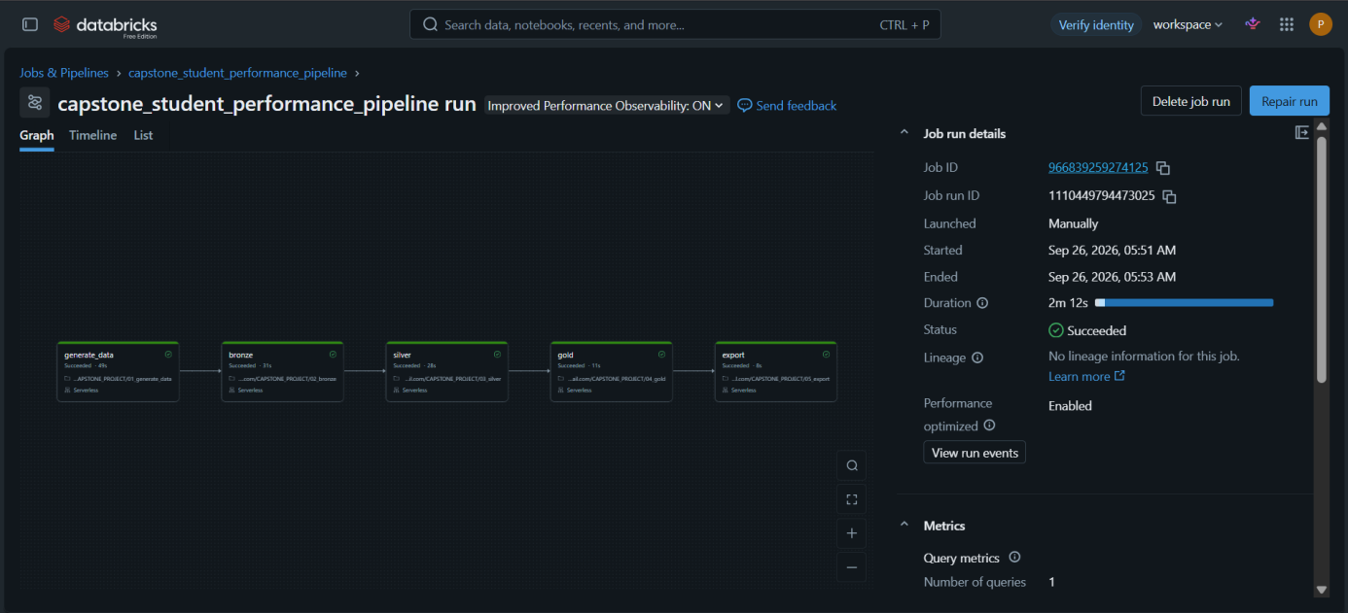
Figure 6.1: Databricks Job run — all five tasks (generate_data, bronze, silver, gold, export) succeeded in a single 2m 12s run.
NOTE This Databricks Free Edition workspace has no outbound connector to Snowflake, so the route actually used was: export Gold as a single CSV to a Unity Catalog Volume, download it, upload it to a Snowflake internal stage through Snowsight, then load it with COPY INTO. This is the exact route documented and used throughout this project — no Spark-Snowflake connector was available or attempted.

7. Implementation Highlights

7.1 Silver layer: safe casting and named-reason rejection
Every numeric field is cast with try_cast rather than cast, because Unity Catalog runs with ANSI mode on and cast throws on the first bad value, killing the whole job. The 300 rows holding the literal string 'AB' in internal_marks become NULL through try_cast, then are coalesced to 0 for scoring while the absence itself stays visible via the earlier assertion check.
m1 = m.selectExpr(
"student_id", "semester", "subject_code",
"try_cast(classes_held as int) classes_held",
"try_cast(classes_attended as int) classes_attended",
"coalesce(try_cast(internal_marks as int), 0) internal_marks",
"try_cast(external_marks as int) external_marks", "_ingested_at"
).withColumn("total_marks", F.col("internal_marks") + F.col("external_marks"))

w = W.partitionBy("student_id","semester","subject_code").orderBy("_ingested_at")
m2 = m1.withColumn("rn", F.row_number().over(w)).filter("rn = 1").drop("rn")

7.2 Loading the Gold export into Snowflake
The Gold table is coalesced to a single CSV, downloaded from the Databricks Volume, uploaded to a Snowflake internal stage, and loaded with COPY INTO. The same statement is then run a second time against the same stage to confirm Snowflake's load metadata prevents the file from being loaded twice.
CREATE OR REPLACE STAGE gold_stage;
CREATE OR REPLACE TABLE GOLD_STUDENT_SUBJECT_SEM ( ... );

COPY INTO GOLD_STUDENT_SUBJECT_SEM FROM @gold_stage
FILE_FORMAT = (TYPE = CSV SKIP_HEADER = 1 FIELD_OPTIONALLY_ENCLOSED_BY = '"');
-- run again, unchanged, against the same stage:
-- result: "Copy executed with 0 files processed."

7.3 Semester rank-volatility query (RANK and LAG, correctly partitioned)
Rank is computed per semester and compared to the same student's previous semester with LAG — the two window functions must be partitioned differently (RANK by semester, LAG by student_id), which is the specific trap this query is designed to test.
WITH s AS (SELECT DISTINCT student_id, semester, sem_total_marks
FROM GOLD_STUDENT_SUBJECT_SEM WHERE is_complete = TRUE),
r AS (SELECT student_id, semester, sem_total_marks,
RANK() OVER (PARTITION BY semester ORDER BY sem_total_marks DESC) AS sem_rank
FROM s)
SELECT student_id, semester, sem_rank,
sem_rank - LAG(sem_rank) OVER (PARTITION BY student_id ORDER BY semester) AS chg
FROM r QUALIFY chg >= 20 ORDER BY chg DESC;

8. Testing and Results
Summary: 13 checks were run; all passed. Check 3 failed on the first attempt because input_file_name() is not supported for provenance columns under Unity Catalog on Databricks Free Edition — it was fixed by switching to the _metadata.file_path column, after which Bronze ran cleanly with no change to any row counts.
# | Check | Method | Expected | Actual | Status
1 | Bronze marks row count | Count rows in bronze_marks | 22,200 | 22,200 | PASS
2 | Bronze students / subjects row count | Count rows in each table | 1,200 / 6 | 1,200 / 6 | PASS
3 | Provenance column via input_file_name() | Run Bronze notebook | _source_file populated | FAILED — UC_COMMAND_NOT_SUPPORTED (input_file_name not allowed under Unity Catalog) | FAIL → FIXED
3b | Provenance column via _metadata.file_path | Re-run Bronze notebook with the fix | _source_file populated | Populated correctly; row counts unchanged | PASS
4 | 'AB' internal_marks become NULL then 0 | assert try_cast count == 300 | 300 | 300 | PASS
5 | Dedupe on (student_id, semester, subject_code) | ROW_NUMBER filter, count before/after | 21,720 (−480) | 21,720 | PASS
6 | unknown_student anti-join reject | Anti-join against bronze_students, count | 21,600 (−120) | 21,600 | PASS
7 | Range/orphan rejects (3 combined reasons) | Filter + count | 21,160 (−440) | 21,160 | PASS
8 | Gold row count matches Silver | Count gold_student_subject_sem | 21,160 | 21,160 | PASS
9 | Snowflake COPY INTO — first load | Run COPY INTO, then SELECT COUNT(*) | 21,160 rows loaded | 21,160 | PASS
10 | Snowflake COPY INTO — idempotency | Run the identical COPY INTO again | 0 rows loaded | "Copy executed with 0 files processed." | PASS
11 | Students complete in both semesters 1 & 2 | COUNT DISTINCT with HAVING clause | 905 | 905 | PASS
12 | Penalty students (id % 8 = 3) among the complete | Join against penalty-student set | 114 of 150 | 114 | PASS
13 | Penalty students whose rank fell in semester 2 | COUNT_IF on rank-change query | > 90 of 114 | 109 | PASS

9. Evaluation and Metrics

9.1 Data quality results — exact Silver-layer breakdown
Rule | Rows checked | Rows failed | Pass rate
No duplicate (student_id, semester, subject_code) | 22,200 | 480 | 97.84%
student_id exists in student master | 21,720 | 120 | 99.45%
classes_attended ≤ classes_held | 21,600 | 200 | 99.07%
classes_held ≠ 0 | 21,400 | 90 | 99.58%
external_marks ≤ 60 | 21,310 | 150 | 99.30%
Overall Bronze → Silver/Gold | 22,200 | 1,040 | 95.32%
The 1,040 total combines the 480 rows removed by deduplication with the 560 rows rejected into silver_rejects for a named reason (120 + 200 + 90 + 150). The two are tracked separately: deduplication removes exact repeats of an already-seen key, while the rejects table exists specifically so that no row is discarded without a recorded reason.

9.2 Performance
Measure | Result
Databricks Job runtime (generate → export, all 5 tasks) | 2 min 12 s total — generate_data 49s, bronze 31s, silver 28s, gold 11s, export 8s
Snowflake COPY INTO — first load (21,160 rows) | 223 ms
Snowflake COPY INTO — idempotency re-run (0 rows) | 61 ms
Q1 — average marks by attendance band and subject (24 rows) | 44 ms
Q2 — semester rank-jump query (934 rows) | 79 ms
Q3 — attendance/marks correlation by subject (6 rows) | 70 ms
Compute used | Databricks: serverless (Free Edition, no manual cluster sizing). Snowflake: COMPUTE_WH, X-Small

10. Screenshots
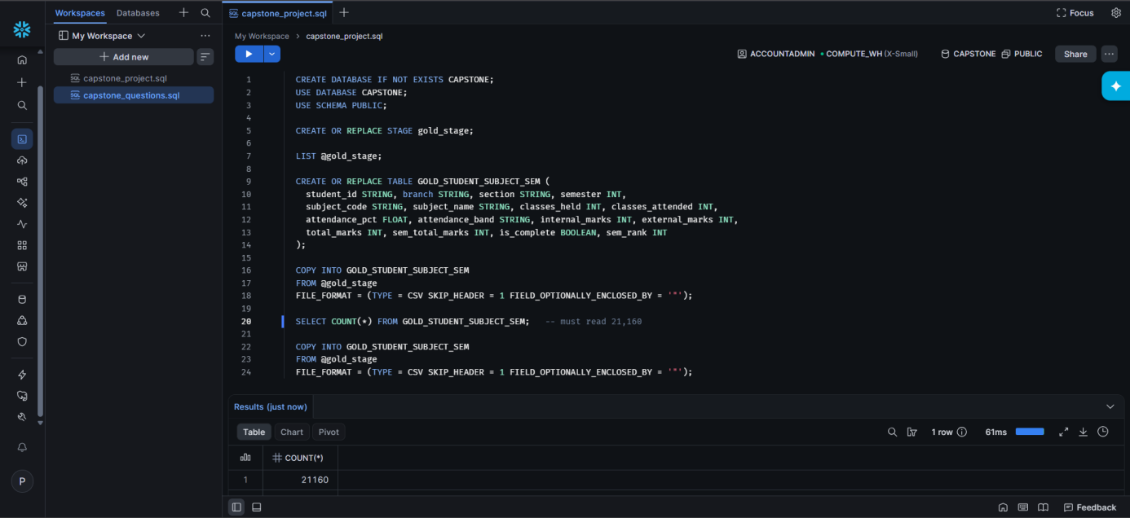
Figure 10.1: Snowflake — SELECT COUNT(*) on GOLD_STUDENT_SUBJECT_SEM returns 21,160, confirming the full Gold export loaded correctly.
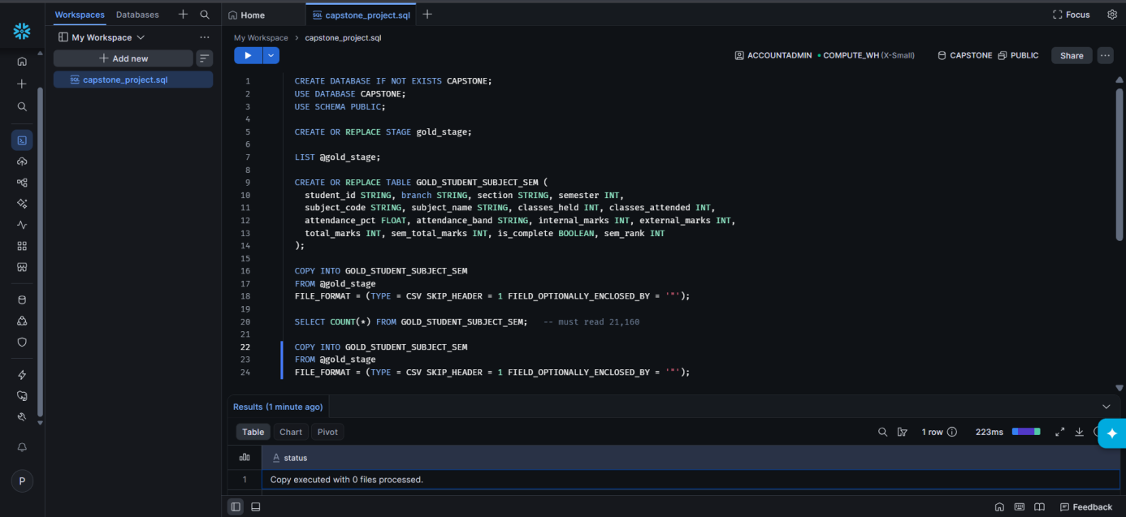
Figure 10.2: Snowflake — the same COPY INTO statement run a second time against the same stage reports "Copy executed with 0 files processed", proving the load is idempotent.
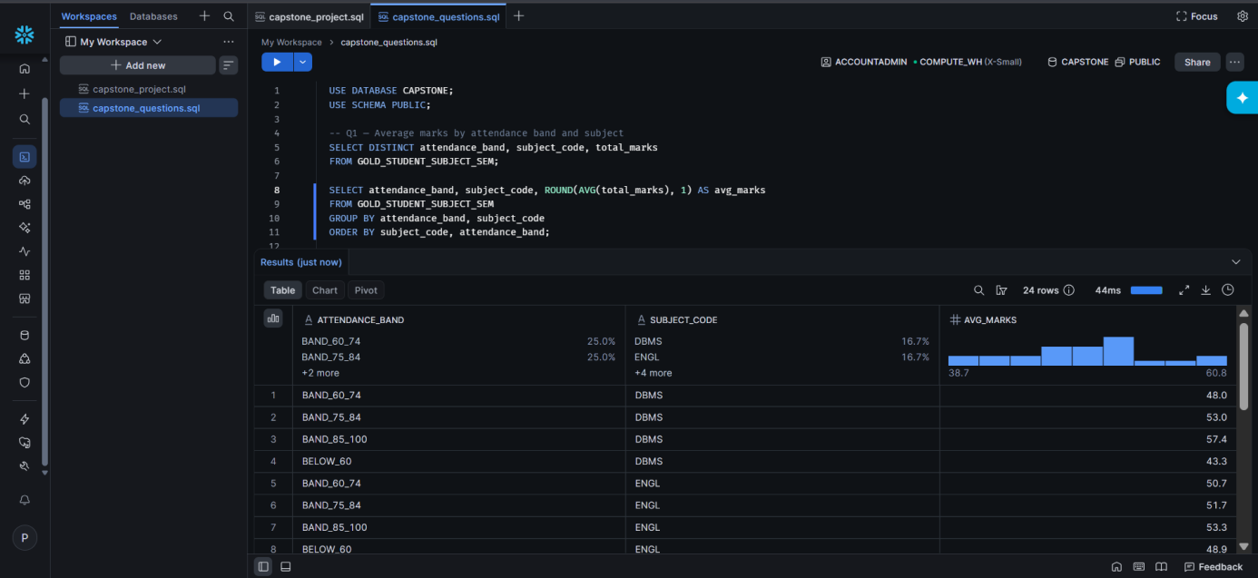
Figure 10.3: Q1 — average total marks by attendance band and subject_code (24 rows); marks rise consistently as attendance band improves.
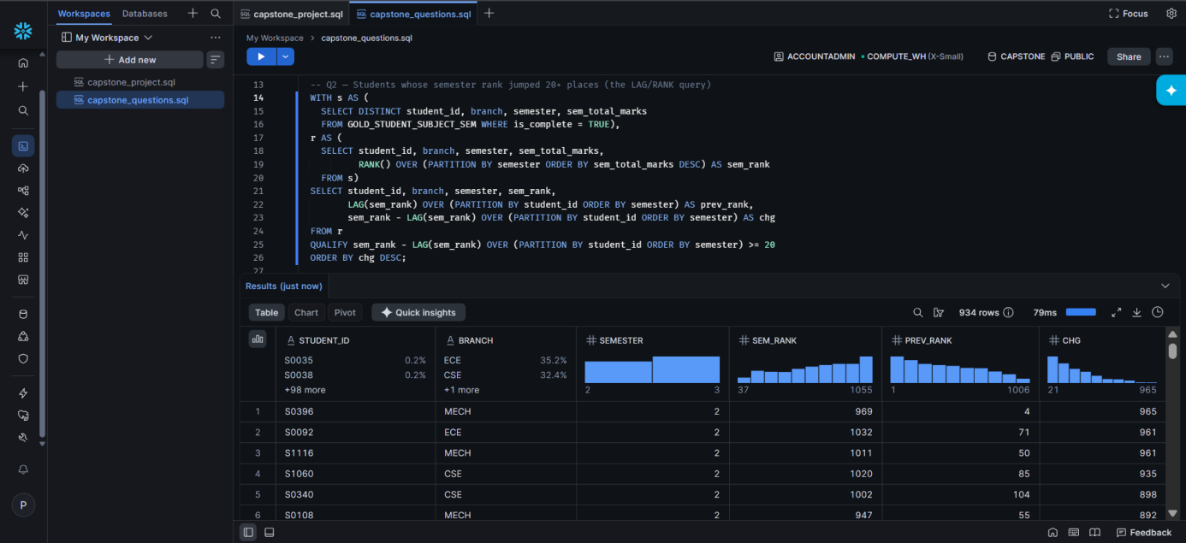
Figure 10.4: Q2 — 934 students shifted 20 or more semester-rank places between semester 1 and semester 2 (RANK partitioned by semester, LAG partitioned by student_id).
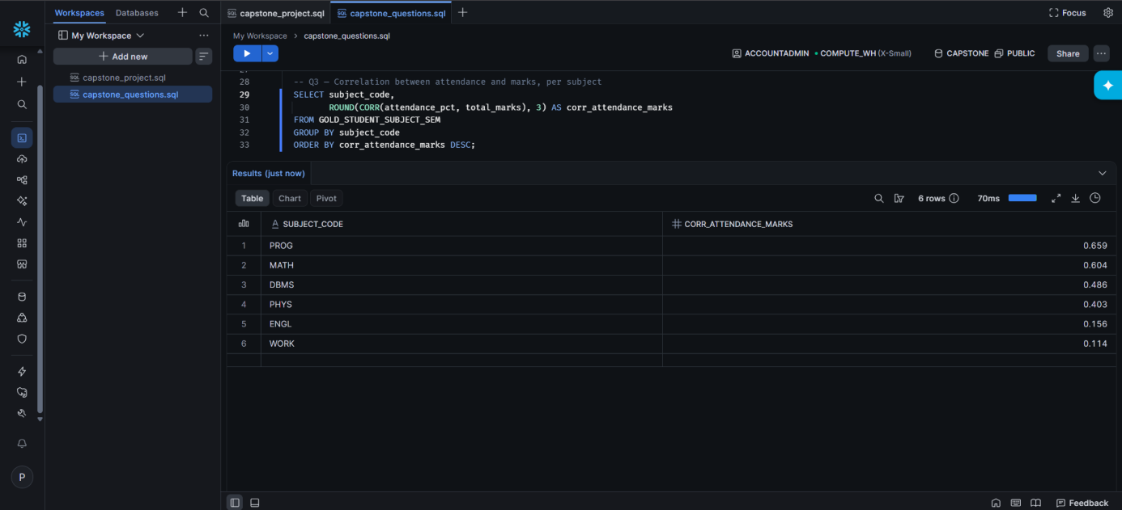
Figure 10.5: Q3 — correlation between attendance_pct and total_marks by subject_code: PROG 0.659, MATH 0.604, DBMS 0.486, PHYS 0.403, ENGL 0.156, WORK 0.114.
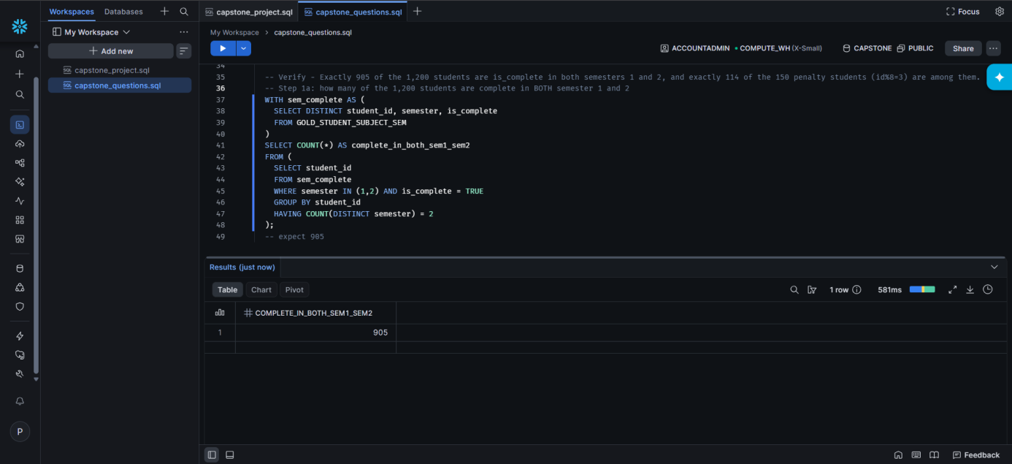
Figure 10.6: Verification — exactly 905 students are is_complete in both semester 1 and semester 2.
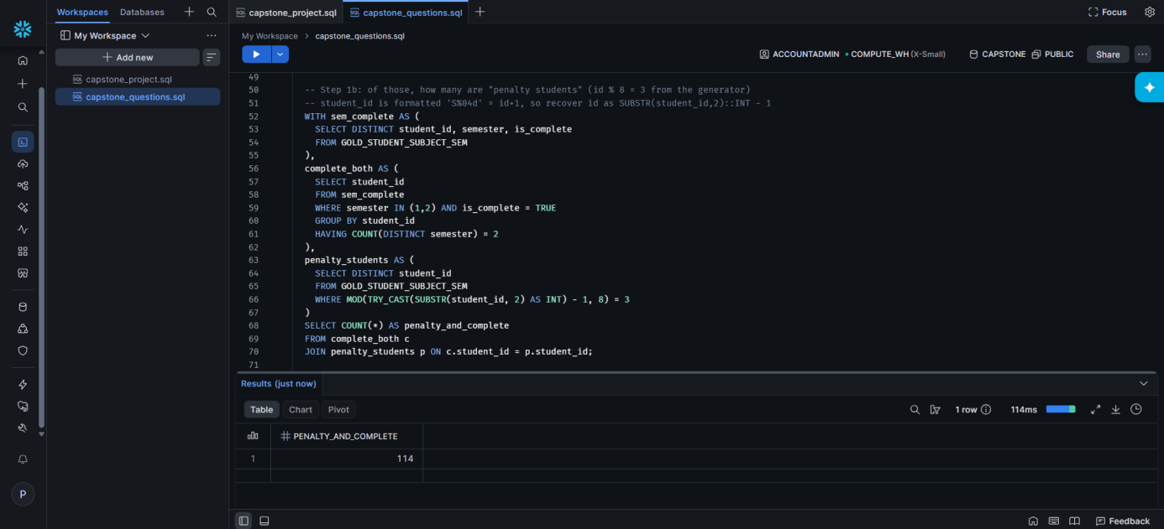
Figure 10.7: Verification — of those 905 students, exactly 114 are penalty students (id % 8 = 3).
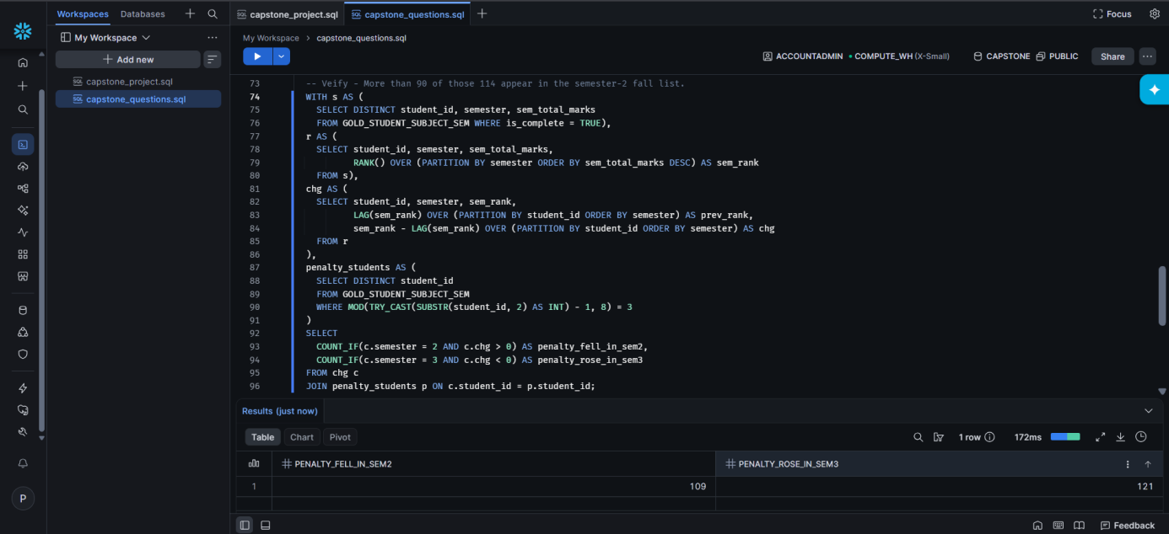
Figure 10.8: Verification — 109 of the 114 penalty students fell in semester-2 rank, and 121 rows show a semester-3 rank recovery.

11. Challenges and Learnings
Challenge | How it was solved
input_file_name() is not supported for provenance columns under Unity Catalog (UC_COMMAND_NOT_SUPPORTED error) | Replaced it with the _metadata.file_path struct column, the Unity-Catalog-safe equivalent; row counts were unaffected
Snowflake's UI navigation (Worksheets, stage file upload) did not match older documentation — buttons and menu names had changed | Located the renamed equivalents (Projects/Workspaces, Catalog → Database Explorer, the stage's "Upload Files" button) by inspecting the live UI directly rather than trusting stale steps
No outbound connector from this Databricks workspace to Snowflake | Used a manual export-download-upload route instead: Gold → CSV in a Volume → download → upload to a Snowflake internal stage → COPY INTO
Confirming the pipeline was truly idempotent, not just "ran without an error" | Re-ran the identical COPY INTO statement against the same stage and confirmed Snowflake's own load metadata reported zero files processed on the second run
Key learning: a pipeline's row counts are only trustworthy if every dropped row is accounted for by name. Building silver_rejects with an explicit reason column, and checking the running row count after every single rule rather than only at the end, made the four Silver-layer defect classes (duplicates, orphan students, attendance out of range, marks out of range) individually verifiable instead of a single unexplained gap between 22,200 and 21,160.

12. Future Improvements
- Add a per-student attendance-trend check using LAG across semesters to see whether a semester-2 attendance dip shows up in that semester's marks or only surfaces a semester later — the brief's own suggested extension.
- Split the single-notebook pipeline into five separate notebooks wired as chained Job tasks (rather than one notebook with five internal sections) purely for a clearer visual DAG in the Databricks Jobs UI.
- Automate the CSV handoff between Databricks and Snowflake (e.g. with a scheduled script) instead of the manual download/upload route, once an outbound connector becomes available.
- Add a lightweight dashboard (Databricks or Snowsight) over the Gold table so the three analytical questions can be monitored continuously rather than run as one-off queries.

13. Conclusion
This project moved a seeded, reproducible student-performance dataset through a Bronze → Silver → Gold medallion pipeline in Databricks and served the result through Snowflake for SQL analysis. Every row-count checkpoint named in the project brief was reproduced exactly — 22,200 raw rows landing in Bronze, closing to 21,160 in Silver/Gold through four named rejection rules, 905 students complete across both semesters, and 114 of the 150 planted "penalty" students correctly identified among them. The Snowflake load was proven idempotent by re-running the same COPY INTO statement and observing zero rows loaded the second time. All three analytical questions were answered directly against the Gold table: attendance drives marks consistently across all six subjects, correlation strength varies by subject exactly as the underlying data was designed (strongest in Programming and Mathematics, weakest in Technical English and Workshop Practice), and 934 students showed a 20-or-more place semester rank swing. The whole pipeline is orchestrated as a single scheduled Databricks Job so it runs unattended end to end. The project gave hands-on experience with Unity Catalog governance, PySpark data-quality patterns (try_cast, named-reason rejection, window functions), Databricks Job orchestration, and Snowflake's stage-and-load workflow.

14. References and Links
Item | Details
GitHub repository | [GitHub URL — fill in: capstone-student-performance-pipeline] (notebooks, SQL scripts, exports, screenshots, README.md, writeup.md)
Google Drive folder | [Drive URL — fill in] (Viewer access enabled for everyone, per submission instructions)
Hosted report page | [GitHub Pages / Netlify URL — fill in]
Dataset | Seeded synthetic generator (seed 84), specified in the Capstone Project Briefs — no external dataset used, since no public dataset carries attendance percentage, marks and a multi-semester cohort together
Documentation used | Databricks docs (Unity Catalog, Jobs & Pipelines, Volumes), Snowflake docs (Stages, COPY INTO, load metadata)

