Adaptive Belt Speed Modulation Across Stance Phase Evokes Spontaneous Plantarflexor and Stepping Adaptations in Healthy Adults.

|  |  |  |
| --- | --- | --- |
| **Date** | **Co-Author** | **Comments** |
| 1-24-2025 | Mac | Intro and Methods ready for review. I note below that there are some analyses undone that I hope to button up in the next few days. I have included step length, pelvis position, and step length in a body frame reference as I think they are reasonable things to wonder about in the context of the positive PF impulse results. I need to motivate step length in a body frame of reference better…. |

# Introduction

Slower walking speeds in older adults are a significant concern, associated with an increased risk of falls 1 and mortality 2. Age-related decreases in walking speed are partly attributed to the increased metabolic cost of walking3. A key contributor to this increased cost is a shift from ankle plantarflexion (PF) towards hip joint torques during the gait cycle4, a phenomenon known as the "proximal shift" which is characteristic of aging gait 5–7. Interventions that can reverse this shift by increasing PF torque could potentially improve gait efficiency and disrupt the trajectory towards reduced walking economy and speed.

While increasing walking speed can increase ankle PF demands in older adults7, this approach does not directly address inefficient gait patterns at a person's preferred speed. Furthermore, older adults often adopt faster cadences and shorter step lengths at a given speed compared to younger adults8, a strategy that reduces ankle demands at the expense of increased hip demands9.

Split-belt treadmill (SBT) walking, where belts move at different speeds, has been shown to induce spontaneous adaptations that manifest transiently as increases in PF torque on the slow side and decreases in PF torque on the fast side after belts return to matched speeds10. These changes in PF torque are correlated with the alterations in step length10 typically observed following SBT adaptation11,12 and are thought to be driven by cerebellar feedforward control mechanisms13. With repeated conventional SBT (cSBT) training, individuals with hemiparesis following stroke can improve their overground step length symmetry.

If the perturbations that evoke spontaneous changes in PF torque and step length in cSBT traing could be applied symmetrically, it may provide a means to improve the gait pattern of individuals who begin to exhibit the proximal shift of aging. The intention of this study is to verify the feasibilty of our approach to induce transient changes in PF torque in a young and healthy population prior to examining the effects in an elderly population.

We hypothesize that bilateral adaptions in PF torque can be evoked when either of the two altered weight transfers that occur in a cSBT are applied bilaterally: stepping onto a faster belt and stepping off a faster belt.

To isolate these irregular weight transfers, we use Phase-Dependent Speed Variation (PDSV), where the speed of a belt under a given limb changes as it transitions from the braking to the propulsive phase of stance. By modulating belt speed from either fast-to-slow or slow-to-fast, these two conditions can be achieved bilaterally:

1. *FastBrake*, where the leading limb belt is faster and the feet move toward each other during double support
2. *FastProp*, where the trailing limb belt is faster and the feet move away from each other during double support

We hypothesize that, similar to a cSBT, adaptation to these conditions will evoke distinct changes in step length and PF recruitment when belts return to matched speed. As the FastBrake condition will cause the trailing limb to pre-emptively advance relative to the leading limb before swing, we anticipate this “assistance” will evoke post adaptation reductions in step length with associated reductions in PF torque. In contrast, the FastProp condition will regress the trailing limb relative to the leading limb, demanding adaptations that result in increased PF torque and step length in Post Adaptation.

# Methods

## Participants

Twenty healthy adults (age range 18-45 years) were recruited from central Texas. Participants were included if they were able to walk unassisted for 20 minutes and excluded if they reported pregnancy or any lower extremity orthopedic, neurological, vascular, or metabolic conditions affecting gait. All participants received $50 for their participation. The study was approved by the Internal Review Board of the University of Texas at Austin, and all participants provided informed consent prior to participation.

## Data Collection

Kinematic and kinetic data were collected using a 10-camera Vicon Nexus motion capture system (Vicon Motion Systems, Oxford, UK) operating at 100 Hz and an instrumented split-belt treadmill with integrated force plates (Motek Medical, Amsterdam, Netherlands) sampling at 1000 Hz. Participants wore a safety harness throughout the experiment.

A 7-segment lower body marker set was used to track motion. Static and dynamic calibration trials were performed, including functional calibration of hip and knee joint centers using "hula hoop" and "quarter squat" movements.

### Protocol

Participants completed two randomly ordered trials: Bilateral FastBrake and Bilateral FastProp. Each trial consisted of three phases: a 3-minute baseline walking period at 1 m/s, a 6-minute perturbed walking (adaptation) period, and a 3-minute post-adaptation period. The speed ratio during the adaptation period was 2:1 (1 m/s and 2 m/s). The time structure and speeds were chosen to align with a previous study that identified transient changes in PF torque in healthy individuals following adaptation to a cSBT protocol 10.

These two trials were randomly presented alongside 3 additional trial conditions from a separate study that applied perturbations unilaterally. Participants were given a chance to take rest breaks at each trial's end as desired.

Participants received verbal countdowns before speed changes and were instructed to avoid using the handrails unless necessary to maintain balance. Rating of Perceived Exertion (RPE) was collected using a Borg RPE 10-point scale 14 during the final minute of the Baseline and Adaptation periods.

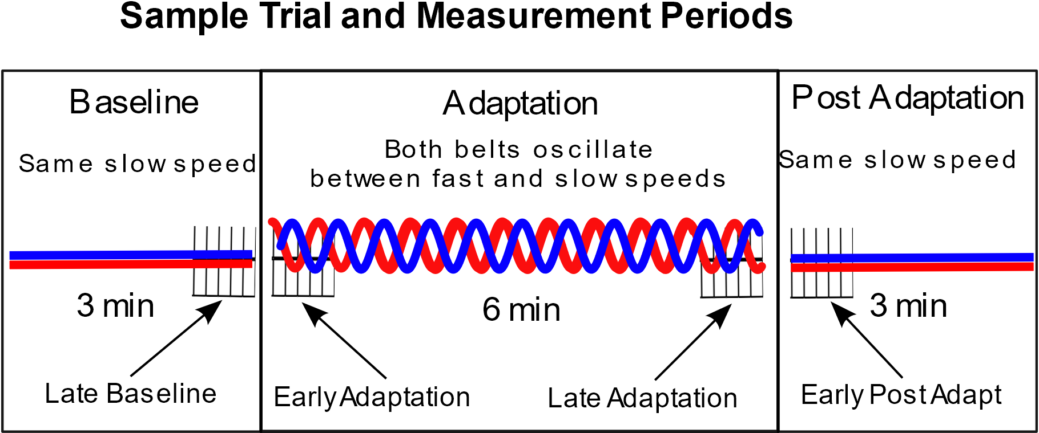Sixty-second recordings captured the transitions between periods: Late Baseline and Early Adaptation, and Late Adaptation and Early Post-Adaptation (Figure 1).

Figure 1:Variables were characterized by averaging data across 5 consecutive steps from each period shown above: Late Baseline; Early Adaptation; Late Adaptation; Early Post-Adaptation

### Split Belt Control Mechanism

D-Flow software (v3.20.0, Motek Medical) controlled belt speeds based on real-time vertical GRF data and a custom Lua script. The baseline speed was 1 m/s and the fast speed was 2 m/s. Swing initiation was detected when GRF under a limb went to zero at which point there was a change in the target belt speed (FastBrake: 2 m/s; FastProp 1 m/s). Following initial contact, when the vertical GRF under one limb exceeded the vertical GRF under the contralateral limb, the target belt speed was changed again (FastBrake: 1 m/s; FastProp: 2 m/s). Belt speed transitions were limited by the treadmill's maximum acceleration of 3 m/s².

## Data Processing

Marker trajectory and GRF data were filtered using a second-order Butterworth low-pass filter with a 6 Hz cutoff frequency in Visual3D (HAS Motion, Kingston, Ontario, Canada). Center of Pressure (COP) data were filtered using a second-order Butterworth low-pass filter with a 4 Hz cutoff frequency to remove oscillatory artifacts. Gait cycles were determined by automatic gait event detection, then visually confirmed and corrected. Joint centers were defined by malleoli markers for the ankles and functional calibration methods for the hips and knees 15.

Joint torques were calculated using inverse dynamics, normalized to body weight (BW) and then time normalized across stance phase. As participants may immediately walk faster or slower than 1 m/s upon entering post adaption, participant position on the treadmill was tracked by the pelvis CoM position. Step lengths were determined at initial contact by the position of the calcaneus markers relative to each other, and these were further subdivided into a body frame of reference16 by assessing their position relative to the pelvis CoM.

Actual belt velocity was calculated using reflective markers affixed to the belts and custom Python scripts within Vicon. Differences in belt velocity were used to identify onset and completion of the Adaptation period.

Step-by-step kinectic and kinematic values were calculated within Visual 3D and then imported into R for assignment to periods and subsequent analysis. Both sides were averaged to reduce noise from random variation. Variables were characterized for each period by averaging five complete steps in each Period as shown in Figure 1.

Plantarflexor impulse was calculated by summing the mean time-normalized joint torque profile when there was a net PF moment and then multiplying by the mean stance time to remove the effect of time normalization, thus expressing the impulse in N⋅m⋅s/BW.

### Statistical Analysis

The effect of the split-belt treadmill protocols on each variable was assessed using a linear mixed-effects model. Variables were analyzed with Period and Condition (Bilateral FastBrake, Bilateral FastProp) as fixed effects and their interaction. A random intercept for Participant was included to account for within-subject variability. Pairwise comparisons across relevant periods within each condition were conducted using the emmeans package in R, with Holm's correction applied for multiple comparisons.

To identify potential spontaneous changes in walking speed, the pelvis CoM position was compared across Late Adaptation and Early Post Adaptation. All other potential changes were assessed from Late Baseline to Early Post Adaptation.

Potential order and carryover effects on all variables were assessed by including condition order and previous condition as additional fixed effects.

All statistical analyses were performed in R17, and statistical significance was set at α = 0.05.

# Bibliograpy

1. Bergen, G., Stevens, M. R. & Burns, E. R. Falls and Fall Injuries Among Adults Aged ≥65 Years — United States, 2014. *MMWR Morb. Mortal. Wkly. Rep.* **65**, 993–998 (2016).

2. Hardy, S. E., Perera, S., Roumani, Y. F., Chandler, J. M. & Studenski, S. A. Improvement in usual gait speed predicts better survival in older adults. *J Am Geriatr Soc* **55**, 1727–1734 (2007).

3. Schrack, J. A., Simonsick, E. M., Chaves, P. H. M. & Ferrucci, L. The Role of Energetic Cost in the Age-Related Slowing of Gait Speed. *J Am Geriatr Soc* **60**, 1811–1816 (2012).

4. Delabastita, T. *et al.* Distal-to-proximal joint mechanics redistribution is a main contributor to reduced walking economy in older adults. *Scandinavian Journal of Medicine & Science in Sports* **31**, 1036–1047 (2021).

5. DeVita, P. & Hortobagyi, T. Age causes a redistribution of joint torques and powers during gait. *Journal of Applied Physiology* **88**, 1804–1811 (2000).

6. Kerrigan, D. C., Todd, M. K., Della Croce, U., Lipsitz, L. A. & Collins, J. J. Biomechanical gait alterations independent of speed in the healthy elderly: evidence for specific limiting impairments. *Arch Phys Med Rehabil* **79**, 317–322 (1998).

7. Silder, A., Heiderscheit, B. & Thelen, D. G. Active and passive contributions to joint kinetics during walking in older adults. *Journal of Biomechanics* **41**, 1520–1527 (2008).

8. Nagasaki, H. *et al.* Walking patterns and finger rhythm of older adults. *Percept Mot Skills* **82**, 435–447 (1996).

9. Umberger, B. R. & Martin, P. E. Mechanical power and efficiency of level walking with different stride rates. *Journal of Experimental Biology* **210**, 3255–3265 (2007).

10. Lauziare, S. *et al.* Plantarflexion moment is a contributor to step length after-effect following walking on a split-belt treadmill in individuals with stroke and healthy individuals. *J Rehabil Med* **46**, 849–857 (2014).

11. Reisman, D. S., Block, H. J. & Bastian, A. J. Interlimb Coordination During Locomotion: What Can be Adapted and Stored? *Journal of Neurophysiology* **94**, 2403–2415 (2005).

12. Reisman, D. S., Wityk, R., Silver, K. & Bastian, A. J. Locomotor adaptation on a split-belt treadmill can improve walking symmetry post-stroke. *Brain* **130**, 1861–1872 (2007).

13. Morton, S. M. & Bastian, A. J. Cerebellar Contributions to Locomotor Adaptations during Splitbelt Treadmill Walking. *J Neurosci* **26**, 9107–9116 (2006).

14. Borg, E. On Perceived Exertion and its Measurement. (Psykologiska Institutionen, Stockholm, 2007).

15. Schwartz, M. H. & Rozumalski, A. A new method for estimating joint parameters from motion data. *Journal of Biomechanics* **38**, 107–116 (2005).

16. Balasubramanian, C. K., Neptune, R. R. & Kautz, S. A. Foot placement in a body reference frame during walking and its relationship to hemiparetic walking performance. *Clinical Biomechanics* **25**, 483–90 (2010).

17. R Core Team. R: A Language and Environment for Statistical Computing. R Foundation for Statistical Computing (2023).