# Isolation - Heuristic analysis

## Purpose

The purpose of this document is to analyze heuristics for Isolation game and its performance as it was measured and evaluated using tournament.py script.

## Process of heuristic ‘design’ and implementation

First I considered the suggestions that were mentioned during the course videos e.g. try to keep to the center of board, try to follow opponent, try to apply differ evaluation in different phases of the game.

I started with a simple heuristic like trying to stay close to diagonals all the time, trying to follow opponent. But the performance evaluation showed much lower win rate than the other agents. As it is known what heuristic the other agents use I tried to address the situations when my agent was significantly losing with some type of agent e.g. AB_Open, AB_Center, AB_Improved.

During the selection, finetuning and improving my heuristic I ran more than 50 tournaments on my laptop.

## custom_score

This is the heuristic I ultimately selected to use in my agent simply because it could beat the AB_Improved agent in 56 % cases in average.

This heuristic is trying to stay in the center for the first 4 plies and considering the advantage in number of moves and distance between the players – moves further from opponent. This may lead to boarder split or partitioning as shown and described in Fig 3.

## custom_score_2

This was evaluated as the second best performing heuristic. Sometimes it could beat AB_improved as well as custom_core.

This one is considering the advantage in number of moves the most and then continuously (i.e. there is now limit/number of plies as for custom_scrore ) finetuning it with distance from center and distance between the players. As the game proceeds the distance between players is weighted more than distance from center. The weight is percentage of the board space left and used.

## custom_score_3

This was evaluated as my third best performing heuristic. It is definitely better than my first approaches using simple evaluation all the time. Occasionally it could beat custom_score and custom_score2 and very rarely AB_Improved.

This one is continuously evaluating distance from center, distance between players and advantage in number of moves. The weight (percentage of the board space left and used) is moving from distance from center to moves advantage and players distance as the game proceeds.

## Conclusion

I chose the heuristic custom_score because it showed bets performance in the tournaments. The reason is that, as shown on Fig 3 the approach to get far from opponent may cause board partitioning i.e. it may be difficult for opponent trying e.g. to stay at center to get inside the area and the space that he can use is getting smaller much faster.

Definitely it would help to have more time to run more tournaments to better evaluate and measure the heuristics used. I run about 50 tournaments on my laptop, one took about 15 minutes.

### Fig 1

visualization/simulation of the game where both players were using the same

heuristic – stay at the center as much as possible and follow the opponent.

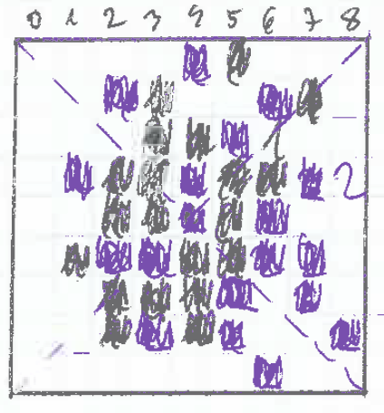

During this game, the players were “running in circles” around the center and the game ended very quickly when one of them, actually both, get close to the border.

### Fig 2

visualization/simulation of the game where both players were using the same

heuristic – stay at the center during begging of the game (first 3 plies each player) and then get as far as possible from the opponent.

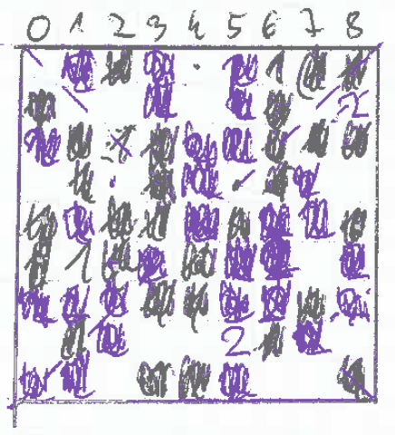

During this game, after initial moves around the center the payers got very quickly close to the opposite side of the board and stayed there as long as possible i.e. “running in circles” close to the border. We can see that, compared to Fig 1 bigger portion of the board was used because in the end there were still a couple of options to move “inside” the board.

### Fig 3

visualization/simulation of the game where player 1 (blue) was using the center tactic i.e. stay at the center as much as possible. Player 2 (black) was staying at the center for first 4 plies and then moving as far as possible from the opponent.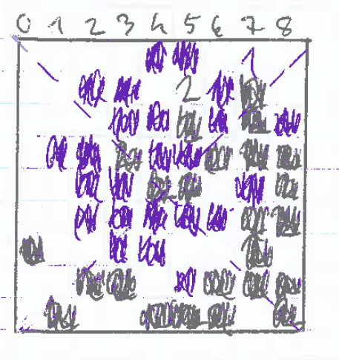

During this game, this game the blue player was running circles around the center until he was limited by black player who got quickly to the boarder and basically reserved/portioned a bigger space for him for later stage of the game.