For Standalone application

Frontend:

Software Requirements:;

Install below versions on your machine

Node : 10.16.3 version used for development



Angulalr/cli : 7.3.9 version used for development

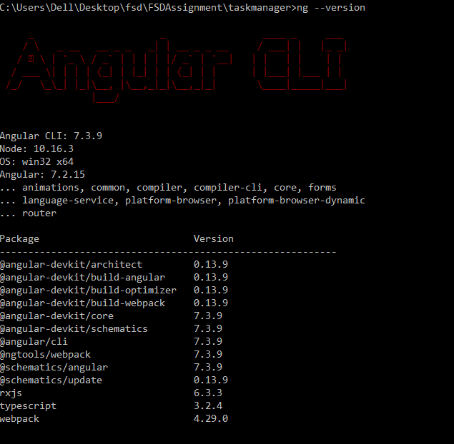

node-sass : node-sass version needs to be sometimes installed



npm: 6.9.0 version



Docker



Test coverage: Without swagger plugin added newly to show the api.

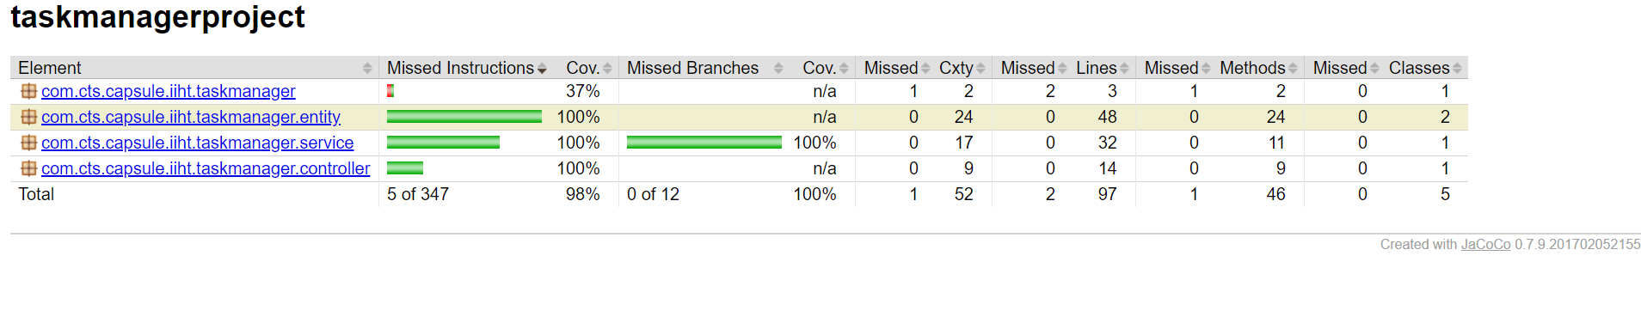

**ViewTask Screen:**

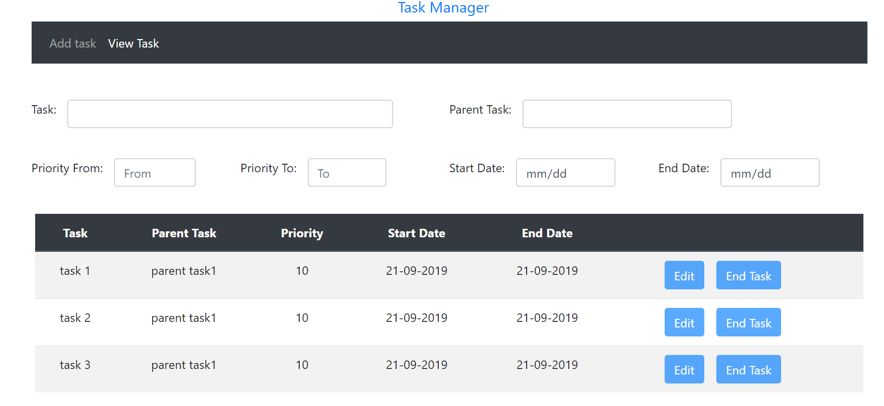

**Add Task Screen:**

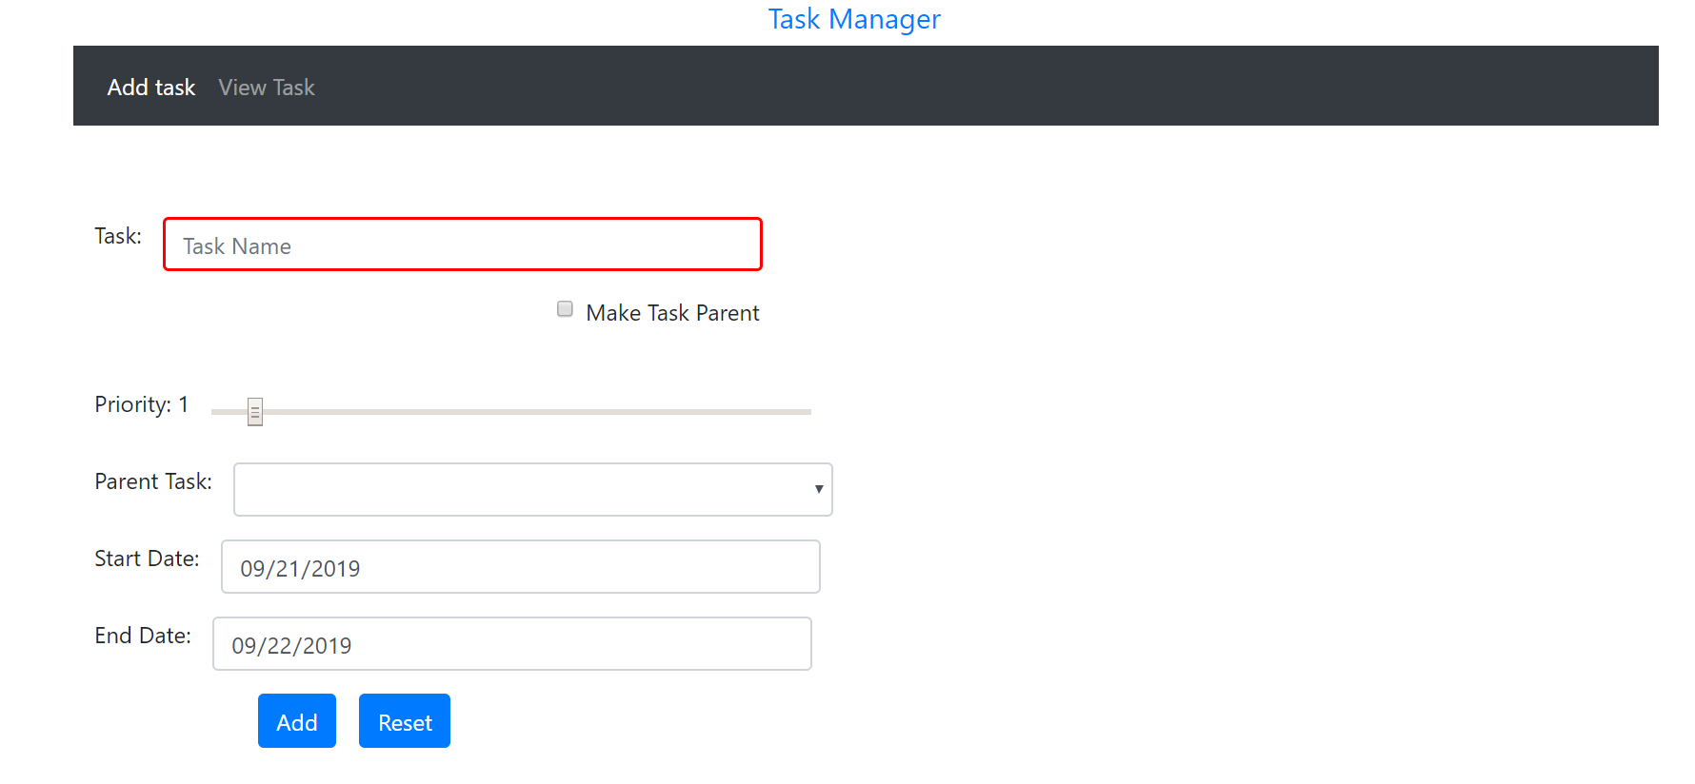

**Add Task Screen: With vaidations**

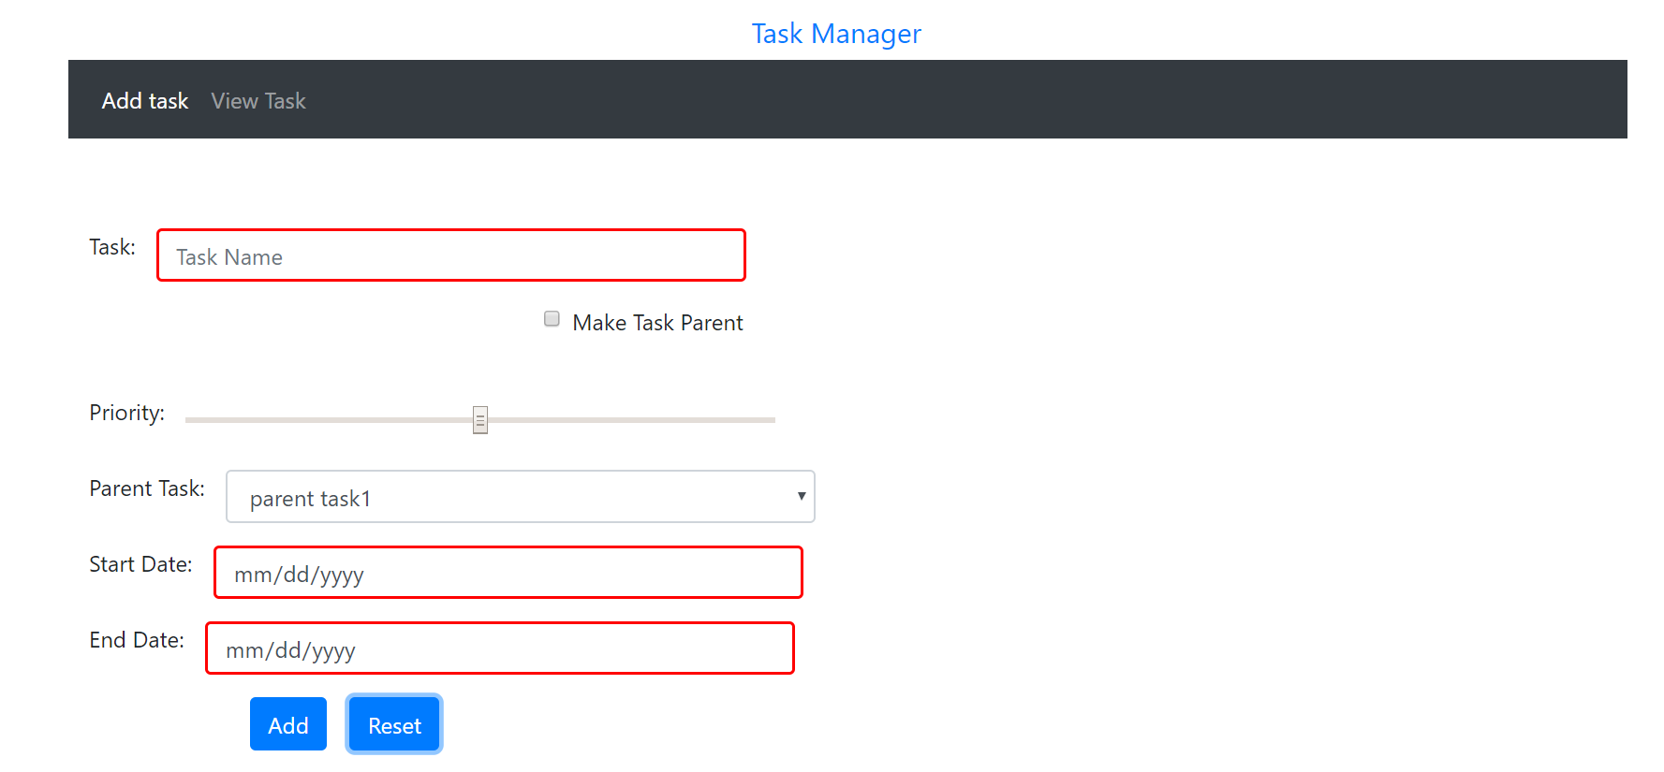

**Added task with new Entry**

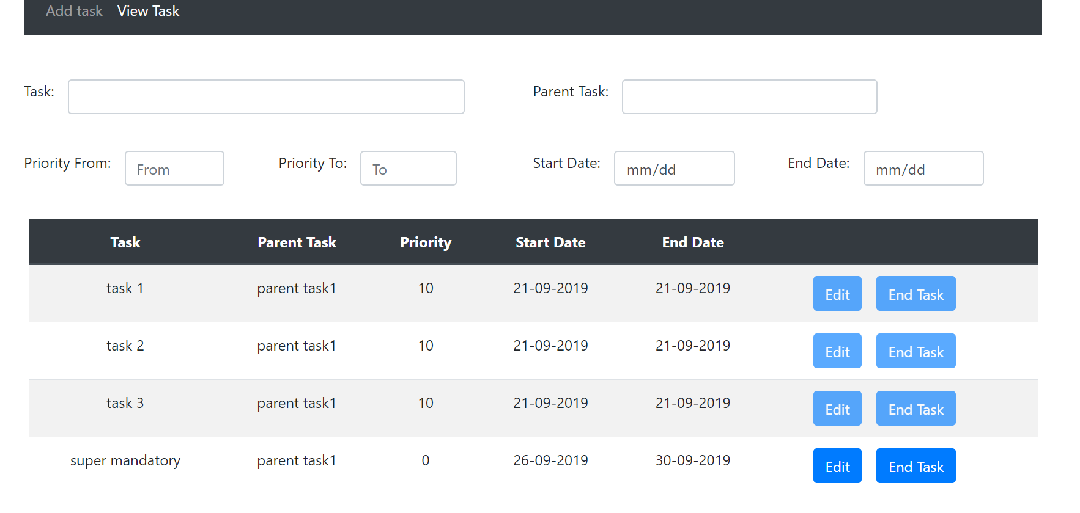

Edit Task :

