Synthesis of Lake TMDL Approaches in EPA Regions 4 and 6
Michael Schramm ¹, Lucas Gregory ²
¹ Research Specialist, Texas Water Resources Institute, Texas A&M AgriLife Research
² Associate Director, Texas Water Resources Institute, Texas A&M AgriLife Research
August 2025
Texas Water Resources Institute
Texas A&M AgriLife
College Station, TX
for the Texas Commission on Environmental Quality.

Table of Contents
Table of Contents 2
Figures 2
Tables 2
Introduction 4
Methods 7
Results 8
Empirical models 9
Mechanistic models 12
Watershed models 17
Receiving body models 18
Discussion 20
Logistical Constraints in Model Selection 21
References 22
Appendix A 25

Figures
Figure 1. Classification status for “general use” (A) and “aquatic life use” (B) in Texas reservoirs by percent of acres (EPA 2025). 4
Figure 2. Cause of impairment for “general use” (A) and “aquatic life use” (B) impaired Texas reservoirs by percent of impaired acres (EPA 2025). 4
Figure 3. (A) Number of Lake TMDL documents per state in EPA regions 4 and 6 (January 2020 through December 2024; (B) Distinct lake assessment units covered by TMDLs per state in EPA regions 4 and 6 (January 2020 through December 2024. 6
Figure 4. (A) Histogram of lake surface area (acres) and (B) histogram of lake watershed area (acres). 8
Figure 5. (A) TMDL Allocation parameter frequency and (B) target parameter frequency. 8
Figure 6. Counts of (A) empirical models, (B) watershed models, and (C) receiving body models by assessment unit. The assessment unit count of receiving body and watershed model combinations (D), NA indicates no model. 11
Figure 7. The count of distinct models used for each endpoint parameter. 12

Tables
Table 1. Texas reservoirs with existing TMDLs or WPPs. 6
Table 2. Short descriptions and documentation sources for model approaches identified during the TMDL review. 15

Introduction
States are required to identify water bodies that do not meet designated water uses under Section 303(d) of the Clean Water Act. Total Maximum Daily Loads (TMDLs) must be developed for pollutants causing the impairment. TMDLs designate an allowable daily allowable pollutant load that can be discharged to the waterbody and continue to meet criteria for designated uses. Corresponding TMDL Implementation Plans (I-Plans) are developed to identify pollutant load reductions required to meet TMDLs and a schedule for the implementation of management measures (voluntary actions) and control actions (regulated or permitted requirements) that will achieve the required load reductions.
Since the mid-2000’s addressing recreational impairments caused by excessive fecal indicator bacteria, primarily occurring in streams and rivers, has been the priority for the State of Texas’s water quality planning efforts. Under this priority, the state convened a Bacteria TMDL Task force to provide guidance and consensus among major stakeholders in the planning process for water quality planning approaches (Jones et al. 2009). The outcomes of this process included unified approaches for prioritizing impaired waterbodies, determining sources of impairments, and developing load reductions in an efficient and scientifically robust manner. These outcomes facilitated the rapid expansion of TMDL planning efforts in the state (Schramm et al. 2022).
Additional progress towards water quality planning and meeting Clean Water Act requirements will require an expanded focus beyond recreational impairments in streams and rivers. As of the 2024 version of the Texas Integrated Report on Water Quality, 301,419 acres (19.8% of total acres) of reservoirs are categorized as impaired for “General Use”; 14,768 acres (1.2% of total reservoir acres) are categorized impaired for “Aquatic Life Use” (EPA 2025, Figure 1). Of the reservoir area impaired for “General Use”, 192,005 acres (63%) list excessive algae as the reason for impairment (Figure 2A). Low dissolved oxygen is listed as the reason for 13,354 (90%) of the reservoir acres impaired for “Aquatic Life Use” (Figure 2B). Currently, 11 lakes in Texas have TMDLs and corresponding Implementation Plans and an additional four lakes have Watershed Protection Plans (TCEQ 2024, Table 1).
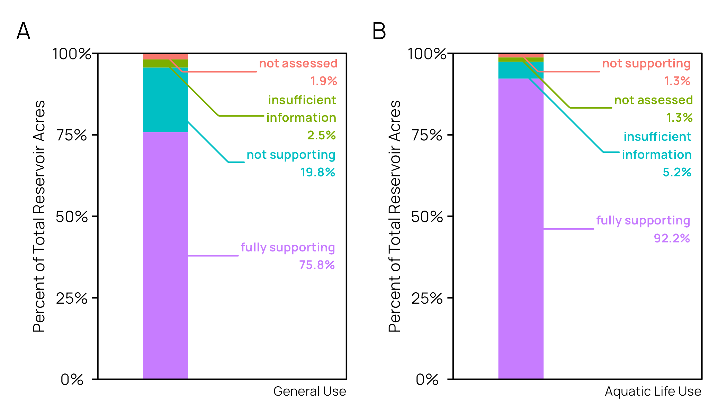
Figure 1. Classification status for “general use” (A) and “aquatic life use” (B) in Texas reservoirs by percent of acres (EPA 2025).
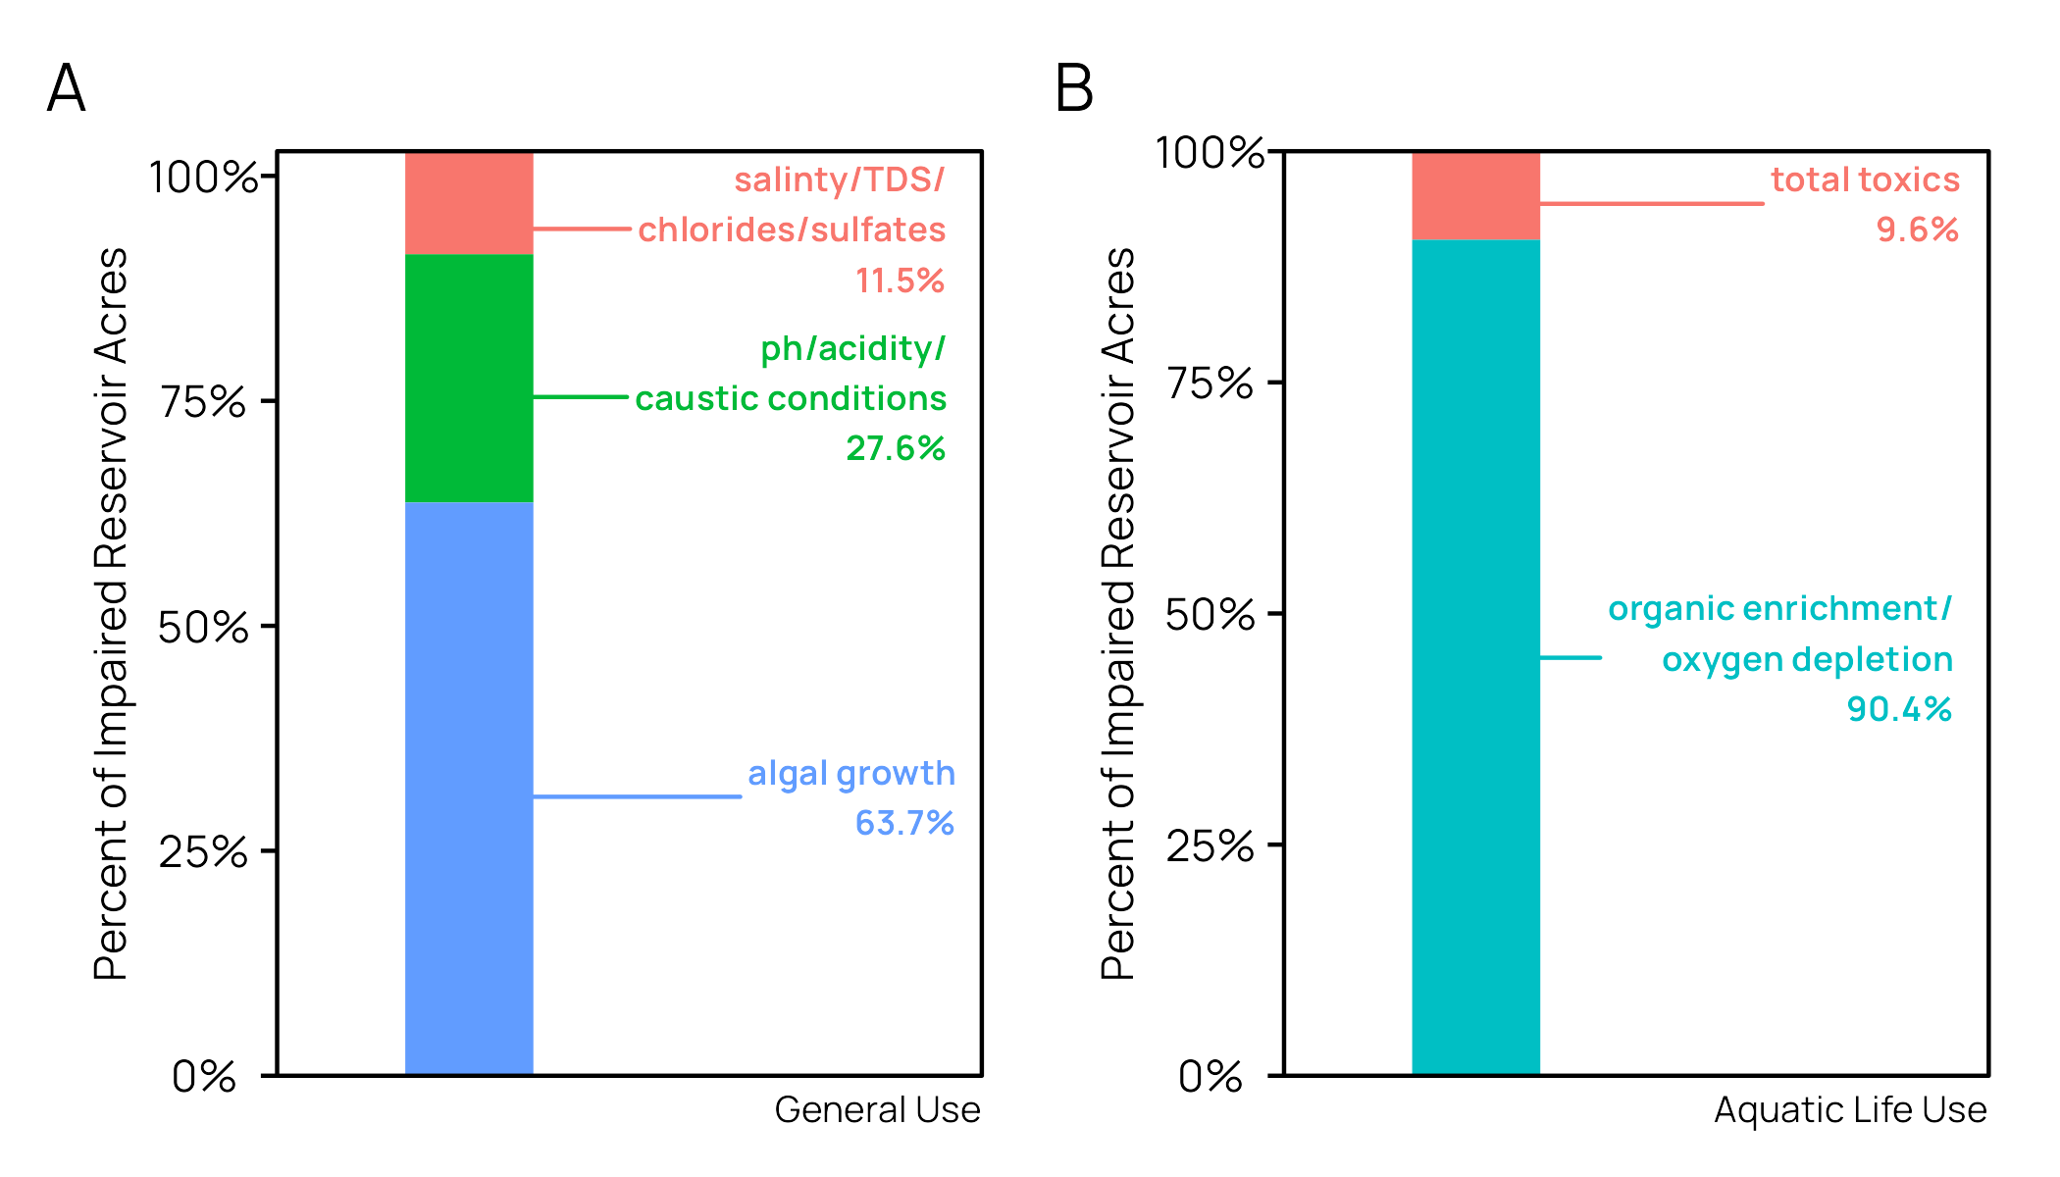
Figure 2. Cause of impairment for “general use” (A) and “aquatic life use” (B) impaired Texas reservoirs by percent of impaired acres (EPA 2025).
Table 1. Texas reservoirs with existing TMDLs or WPPs.
Name | Action | Impairment | Target Parameter(s)
Lake O’ the Pines | TMDL, I-Plan | Dissolved Oxygen | Total Phosphorus
E.V. Spence Reservoir | TMDL, I-Plan | TDS and Sulfate | Chloride, Sulfate, TDS
Lake Austin | TMDL, I-Plan | Dissolved Oxygen | Dissolved Oxygen
Lake Worth | TMDL, I-Plan | Fish Consumption Advisory | PCBs
Lake Houston | TMDL, I-Plan | Indicator Bacteria | E. coli
Aquilla Reservoir | TMDL, I-Plan | Atrazine | Atrazine
Mountain Creek Lake | TMDL, I-Plan | Fish Consumption Advisory | Chlordane, DDT, DDD, DDE, Dieldrin, Heptachlor epoxide, and PCBs
Lake Como | TMDL, I-Plan | Fish Consumption Advisory | Chlordane, DDT, Dieldrin, and PCBs
Fosdic Lake | TMDL, I-Plan | Fish Consumption Advisory | Chlordane, DDT, Dieldrin, and PCBs
Echo Lake | TMDL, I-Plan | Fish Consumption Advisory | PCBs
Donna Reservoir | TMDL, I-Plan | Fish Consumption Advisory | PCBs
Lake Arlington | WPP | Chlorophyll-a, Nitrate | Nutrients
Lake Granbury | WPP | Indicator Bacteria | E. coli
Lake Lavon | WPP | Indicator Bacteria | E. coli
Joe Pool Lake | WPP | Nitrate | TKN and NOx
Bois d’Arc Lake/Lake Bonham | WPP | Indicator Bacteria, Nitrate, Total Phosphorus, Chlorophyll-a | E. coli, Nitrate, Total Phosphorus
Unlike the tiered approach identified by the Bacteria TMDL Task Force, a unified approach for addressing impairments specifically in lakes has not been developed. Given the diversity of potential parameter impairments, impairment sources, and expected lake trophic status, a variety of TMDL development approaches are possible. This report intends to identify and summarize EPA-approved approaches used across EPA Regions 4 and 6 in the development of TMDLs in lakes and reservoirs.

Methods
The purpose of this report is to review and summarize methodologies in EPA accepted lake or reservoir TMDLs relevant to Texas. We queried the EPA Assessment TMDL Tracking and Implementation System (ATTAINS) database using the R software package, rATTAINS (Schramm 2023; EPA 2025). rATTAINS facilitates data queries and downloads from the ATTAINS online database directly into R statistical analysis software (R Core Team 2023). In March 2025 we made queries to ATTAINS for all approved TMDLs in the 13 states covered under EPA regions 5 and 6 since January 1, 2020. The data returned from the ATTAINS query includes a list of hydrologic assessment units (AUs) covered by each TMDL. Each TMDL can cover one or more hydrologic assessment units (AUs). A subsequent query to ATTAINS was made to identify the waterbody type each state assigned to the AUs covered by TMDLs. Using the data returned by this query, the list of TMDLs was reduced to those TMDLs that included AUs identified in ATTAINS as one of, “Lake, Freshwater; Lake; Reservoir; Lake/Reservoir/Pond.” ATTAINS also identifies the endpoint parameter that is the cause of the impairment (low DO, high chlorophyll-a, etc.) in each AU and the target load allocation parameter(s) (TN, TP, TSS, etc.) in the TMDL that the waterbody can assimilate without being considered impaired. The remaining list of TMDLs was further reduced by removing AUs that were impaired due to aluminum or temperature. In total 27 TMDL documents were identified in the ATTAINS query covering 44 distinct assessment units (Figure 3). ATTAINS was queried again with the remaining 27 TMDLs to download pdf copies of each EPA accepted TMDL. Appendix A includes a table of the TMDLs identified in the query, assessment units covered by each TMDL and provides a link to the TMDL document.
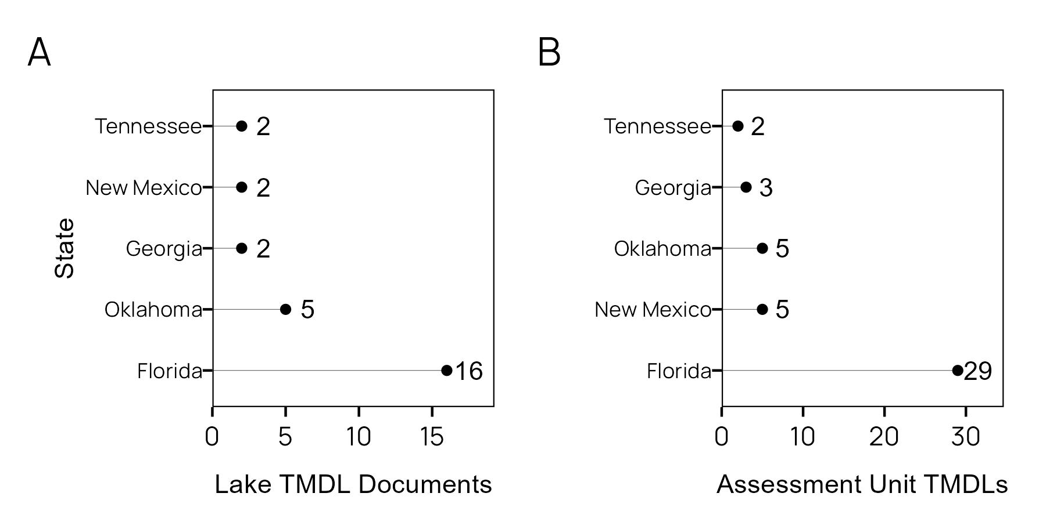
Figure 3. (A) Number of Lake TMDL documents per state in EPA regions 4 and 6 (January 2020 through December 2024; (B) Distinct lake assessment units covered by TMDLs per state in EPA regions 4 and 6 (January 2020 through December 2024.
To determine relevance to TMDLs developed in Texas, we manually reviewed each TMDL to extract info on lake morphology (lake area, lake volume, shoreline length) and watershed size (not all TMDLs had complete information about the waterbody). We then recorded information about the approach used to develop the TMDL. We used a simplified typology classifying the approaches as empirical or mechanistic, although we understand some approaches do not cleanly fit in either category. We describe empirical approaches as those using observed hydrologic and water quality data to establish loading allocations. Mechanistic models on the other hand utilize some process or physically based modelling approaches to simulate the landscape and/or hydrologic environment to establish responses to various pollutant inputs. The specific modeling approaches used in each TMDL and assessment unit were also documented (some TMDLs include multiple assessment units and may include different approaches for each assessment unit).

Results
The 27 TMDLs covered lakes and reservoirs with a surface area ranging from 9 to 29,460 acres with a median of 632 acres (Figure 4A). Watershed sizes ranged from 26 to 8,282,880 acres with a median of 4,665 acres (Figure 4B). Chlorophyll-a was the most common TMDL endpoint parameter (26 of 44 assessment units, Figure 5A), followed by total nitrogen (11 of 44) and total phosphorus (10 of 44). The high relative prevalence of chlorophyll-a, total nitrogen, and total phosphorus targets indicate nutrient enrichment and algal growth have been the primary drivers of TMDL development in the southeast regions in recent years. Conversely, turbidity (2 of 44 assessment units) and dissolved oxygen (3 of 44) were relatively infrequent in the region. This pattern is similar to the impairment patterns for reservoirs in Texas where most of the impaired acres (192,005 acres) are listed due to excessive algae while a relatively small area is listed due to low dissolved oxygen (13,354 acres). To achieve these endpoints, total phosphorus (32) and total nitrogen (38) are by far the most frequently addressed loading parameters (Figure 5B).
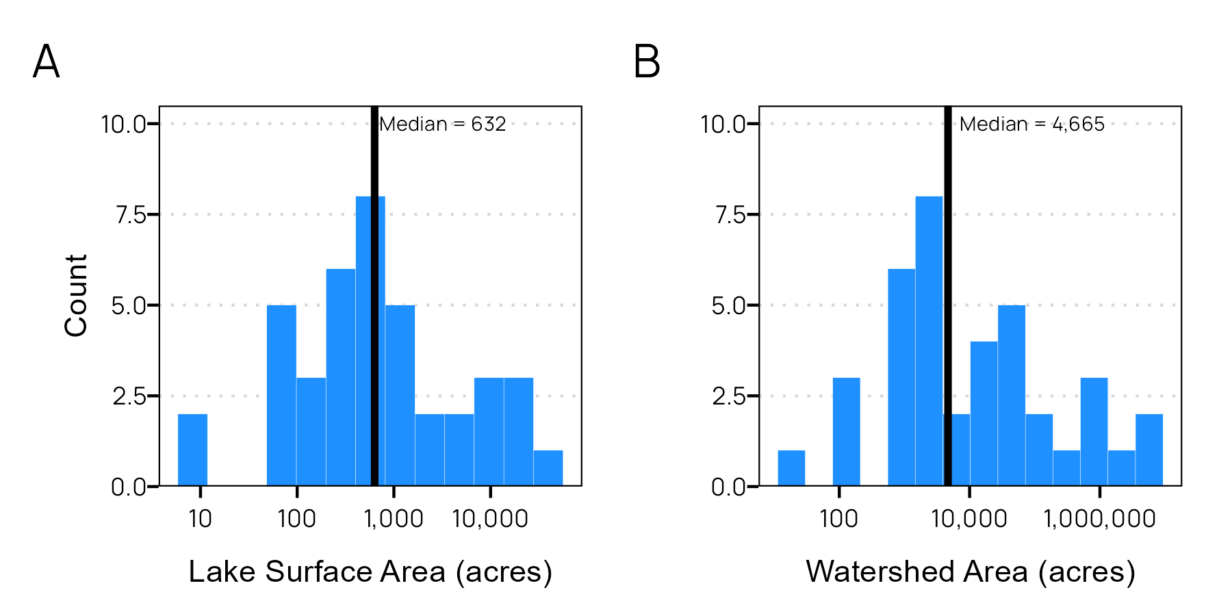
Figure 4. (A) Histogram of lake surface area (acres) and (B) histogram of lake watershed area (acres).
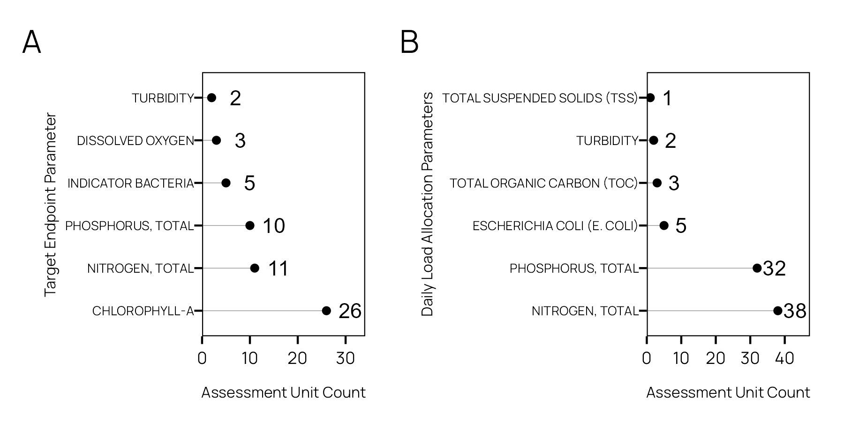
Figure 5. (A) TMDL Allocation parameter frequency and (B) target parameter frequency.

Empirical models
Empirical TMDL approaches utilize the statistical properties of measured data to establish relationships between sources and impairment as well as establish the load reductions required for attainment. Twenty assessment units had TMDLs developed with empirical methods (Figure 2). Here, we classify load duration curves (LDCs) and multiple regression as empirical models. In short, LDCs utilize a frequency distribution approach to determine flow exceedance frequency, develop broad linkages between sources and impairments, and calculation of allowable loads and load reductions. LDCs are described extensively in EPA (2007). Regression models statistically describe the relationship between one or more independent variables and dependent variables. Regression model approaches are very flexible and can be applied in many approaches to support TMDL development. Load Estimator (LOADEST), Weighted Regression on Time Discharge and Season (WRTDS) and Generalized Additive Models (GAMs) are examples of regression models that use grab samples to quantify annualized stream and river nutrient loadings which can then serve as inputs to models that forecast responses in the receiving water body (Runkel et al. 2004; Hirsch et al. 2010; Robson and Dourdet 2015; Beck et al. 2018; Bergbusch et al. 2021). Furthermore, single lake or regional regressions can be established between normalized nutrient loads or in lake nutrient concentration and chlorophyll-a (Phillips et al. 2008; Rolle Longley et al. 2019).
Regression models were observed in 15 assessment units and load duration curves (LDCs) were observed in five assessment units (Figure 2). Note that LDCs are most appropriate for lotic waters where load allocations can be estimated based on the cumulative frequency of daily streamflows and in-stream pollutant concentrations. The observed LDCs occurred in assessment units that were more geomorphologically similar to rivers than to traditional lentic systems and were applied to bacteria impairments presumed to be hydrologically driven (Figure 7), similar to the Lake Houston TMDL in Texas (TCEQ 2016).
Regression models were used exclusively in small lakes in Florida and applied to achieve the state’s site-specific narrative nutrient criteria using annual chlorophyll-a geometric means as a target (Figure 7). Simple linear regressions models were applied to establish relationships between the lake’s annual geometric mean concentrations and chlorophyll-a concentrations. Multiple regression models using log-transformed annual geometric mean in-lake nutrient concentrations as independent variables and log-transformed in-lake chlorophyll-a concentrations were used to assess the predicted concentration required to achieve the chlorophyll-a endpoint. In some cases, paleolimnological records were used to establish pre-disturbance baseline records. The TMDL loadings were then allocated as daily percent load reductions based on the percent difference in current annual geometric mean nutrient concentrations and the regression predicted concentration needed to achieve the chlorophyll-a endpoint. While this percent reduction approach is consistent with EPA guidance on TMDL development, it is probably most applicable to watersheds dominated by non-point sources of nutrients where quantifying and measuring loads and load reductions is impractical. This approach also requires an assumption that the lake is well mixed and sampling points are representative of the entire lake or assessment unit. In Texas, many of the assessment units are presumed to be large reservoirs where this assumption may not be held.

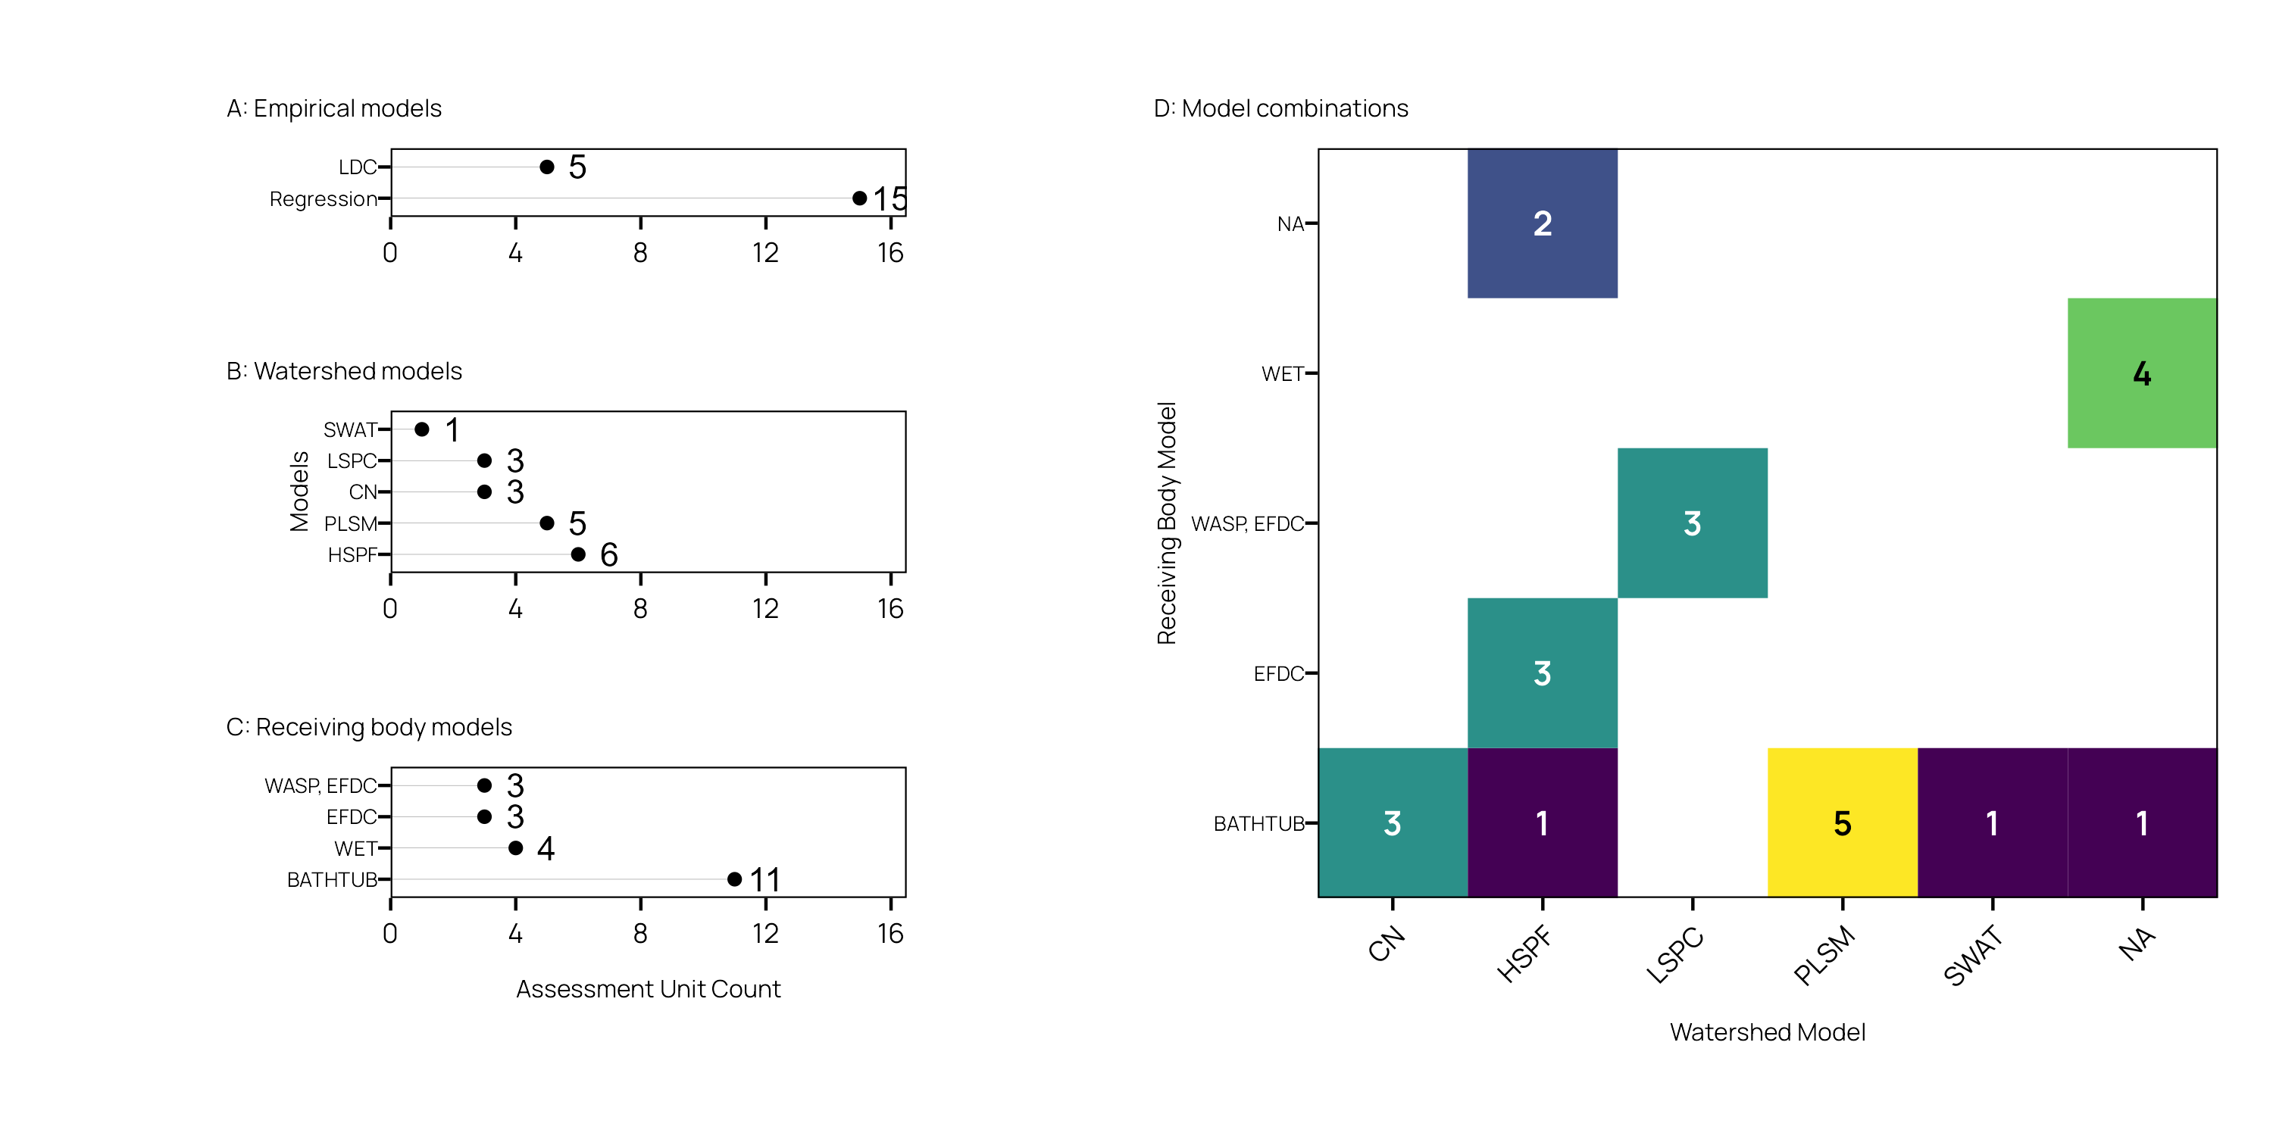
Figure 6. Counts of (A) empirical models, (B) watershed models, and (C) receiving body models by assessment unit. The assessment unit count of receiving body and watershed model combinations (D), NA indicates no model.

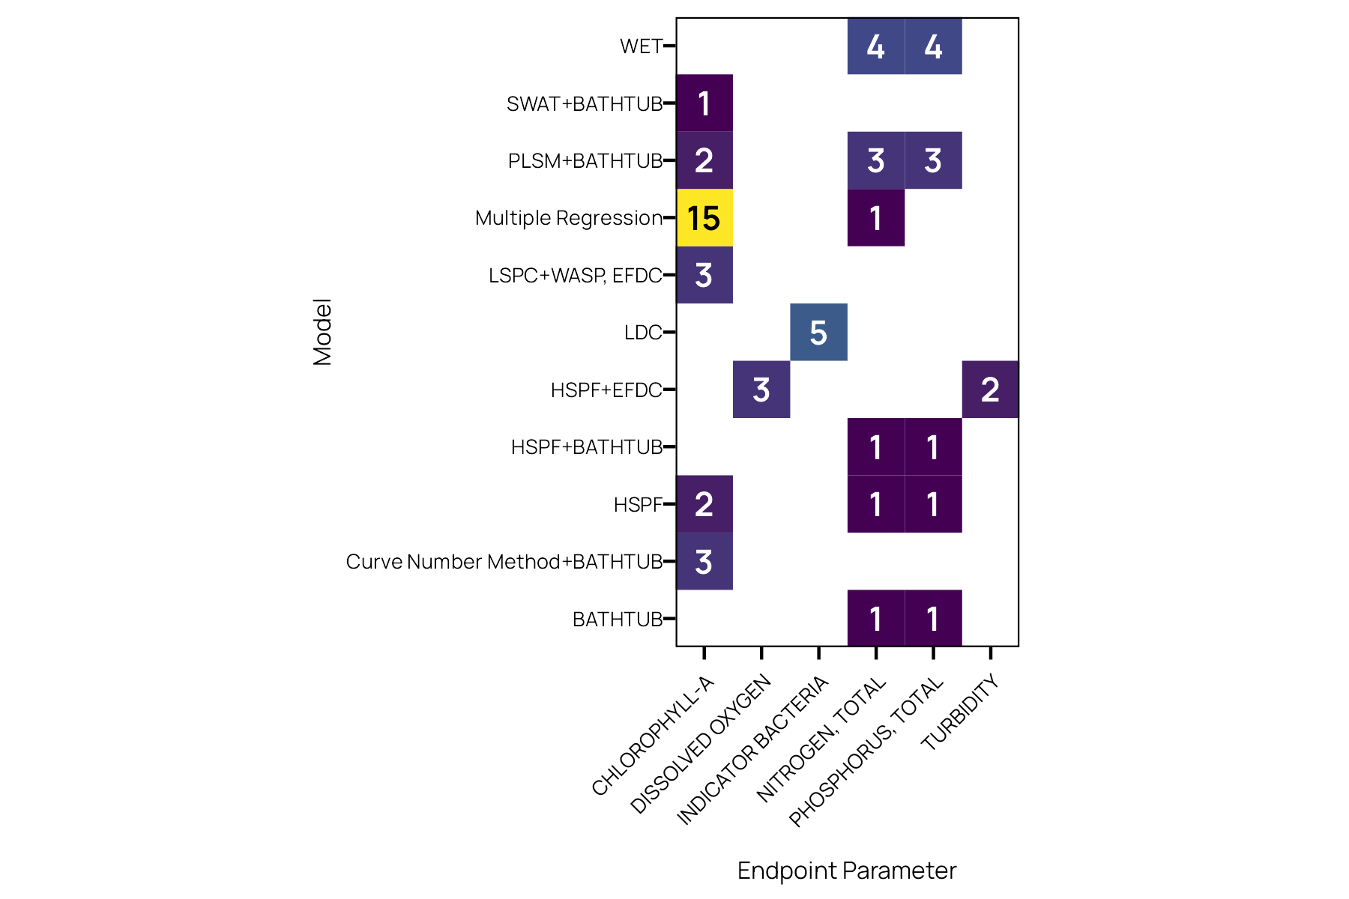
Figure 7. The count of distinct models used for each endpoint parameter.

Mechanistic models
Mechanistic models utilize process or physically based models to simulate pollutant transport, uptake, and degradation processes in the environment. Model parameters are calibrated and validated using measured data. While we simplified models into a binary mechanistic or empirical classification, many modelling approaches combine aspects of both, utilizing data driven statistical methods and relying on process-based approaches to simulate different parts of the system.
For TMDL applications, landscape or watershed loading models that simulate pollutant deposition and transport processes are often combined with a receiving body model that simulates the in-lake pollutant transport and uptake processes. Borah et al. (2019) and Camacho et al. (2019) provide thorough overviews of watershed and water quality models that are useful for TMDL development. Our review found HSPF, PLSM, LSPC, and SWAT watershed models used by TMDLs in the two regions (Figure 2). Receiving body, or lake models, simulate hydrodynamic and biological, and chemical responses to changes in freshwater inflow and pollutant loadings. Different models include capabilities to simulate the responses at different time and spatial scales. Simple models will provide an annually averaged, steady-state condition for a water body. This can be suitable for well-mixed lakes and reservoirs where diel fluctuations and/or seasonal changes do not need to be considered. As model complexity increases, model parameterization also increases, which places a larger demand on the model technician to understand both the underpinnings of the modelling system, but the lake system as well. In turn, models can simulate seasonal, daily, or sub-daily responses to changes in pollutant loading. Furthermore, models can simulate two- and three-dimensional responses in lakes based on lake morphology and in-lake hydrodynamic processes. Temporal and spatial considerations become increasingly important in systems where inflow and pollutant loadings fluctuate seasonally, or in systems where stratification/turnover, seasonal drawdowns, and related processes have significant impact on nutrient cycling and export.

Table 2. Short descriptions and documentation sources for model approaches identified during the TMDL review.
Model | Short Description | Reference
Load Duration Curve (LDC) | Empirical approach relating loads to percent flow exceedances. Requires daily or instantaneous streamflow conditions and grab or composite sampled pollutant concentration. This approach is only appropriate in riverine-like sections of a lake. | EPA (2007)
Curve Number (CN) | Semi-empirical approach for estimating small watershed runoff in response to rainfall. CN approaches underly many of the spatially distributed watershed models. In context of TMDLs, CN is often combined with empirically derived event-mean concentrations of pollutant runoff to determine watershed loading. | USDA NRCS (2021)
Regression | Empirical approach relating response variables (pollutant or indicator) to one or multiple independent variables. Typically used to establish linkages between impairment and loadings or chlorophyll-a response to in-lake nutrient concentrations. Can be used to establish annual or daily percent load reductions. | NA
Hydrological Simulation Program - FORTRAN (HSPF) | Semi-distributed process-based watershed model used to simulate hydrology and water quality in urban and rural environments. Can be used as a steady-state or temporally dynamic model. Includes the ability to simulate loading responses to various BMPs. | Bicknell et al. (1997)
Loading Simulation Program C++ (LSPC) | Underlying algorithms based on HSPF but built on C++. Integrates with Microsoft Access database structures, allows larger spatial and temporal resolutions than HSPF. | Tetra Tech (2009)
Pollutant Load Screening Model (PLSM) | Semi-empirical, spatially explicit approach for estimating watershed level annualized loads based on event-mean concentrations and runoff coefficients. Restricted to estimations of mean annualized loads. | Adamus and Bergman (1995)
Soil and Water Assessment Tool (SWAT) | Semi-distributed, daily time step process-based watershed model. Simulates hydrologic and water quality responses to changes in weather, land use, plant growth, agricultural production, and best management practices. | Bieger et al. (2017)
BATHTUB | Semi-empirical model used to predict steady-state conditions in response to changes in inflow and nutrient loads. Suitable for well-mixed lakes and reservoirs without strong temporal or spatial dynamics. | Walker (2006)
Environmental Fluid Dynamics Code (EFDC) | A fully dynamic three-dimensional hydrodynamic model that includes capability to simulate physical, chemical, and biological water quality processes. Able to simulate daily, seasonal and spatial variability. Hydrodynamic outputs are often used as inputs to the WASP model. | Tetra Tech, Inc. (2007)
Water Quality Analysis Simulation Program (WASP) | A mass-balance based mathematical model that predicts dissolved oxygen, nutrient, and phytoplankton responses to time variable loadings and system hydrodynamics. Able to simulate sub-daily, daily, and longer time steps and multiple spatial resolutions and dimensions. Well suited for complex systems, typically linked to watershed loading and hydrodynamic models. | Wool et al. (2020)
Water Ecosystems Tool (WET) | A fully dynamic and distributed mechanistic water quality model. Simulates geochemical and ecological responses to hydrologic and nutrient inputs. Able to simulate daily, seasonal and spatial variability. | Nielsen et al. (2021)

Watershed models
The NRCS Curve Number (CN) method was used in a handful of TMDLs. The CN method might be better classified as an empirical approach but was included under this section since the CN method and its various extensions can be calibrated using similar procedures to traditional process-based models. In the TMDLs applying the CN method, the CN method was used to estimate watershed runoff volume. Regionally developed runoff event-mean concentrations for nitrogen and phosphorus were multiplied to the runoff volumes to develop estimates of total watershed loading. This approach is like the Spreadsheet Tool for the Estimation of Pollutant Load (STEPL) or Pollutant Load Estimation Tool (PLET) used by the US EPA to estimate watershed pollutant loads and reductions from BMPs for grant applicants (Tetra Tech, Inc. 2024).
The Pollutant Load Screening Model (PLSM) uses a similar approach but packaged within an ArcGIS based tool that was developed specifically for the St. Johns River Water Management District (Adamus and Bergman 1995). The model incorporates multiple spatial data layers (soil, land use, and precipitation) to model runoff using specified runoff coefficients. Spatially explicit nonpoint source runoff loads are estimated using published event-mean concentration values for the region. The literature on PLSM did not make clear how the model is calibrated or validated against field data. Loading from these simplistic runoff-models served as inputs to a lake eutrophication model. These approaches are simple but rely on the availability of regionally appropriate nutrient runoff event-mean concentrations. Due to its simplicity, there are many /assumptions involved in using the CN method for estimating storm-total runoff that restricts the appropriate usage of this approach. For example, the watershed should be less than 2,000 acres and contain generally uniform land use, soil and cover (USDA NRCS 2021). Spatial resolutions of these models are limited to lumped subwatershed boundaries. The strength of these approaches are simplicity and ease of integration into existing GIS tools and databases. The Spatially Explicit Load Enrichment Calculation Tool (SELECT), commonly used in Texas for watershed planning purposes, utilizes a similar simple GIS-based approach for allocating loads across watersheds and sources (Teague et al. 2009). These approaches do assume loadings based on empirically derived event-mean concentrations at temporal resolution that are only appropriate for steady-state modeling or waterbodies where seasonal or diel fluctuations are not expected. PLSM was often an input to the BATHTUB water quality model that also predicts steady-state water quality conditions in the receiving water body.
HSPF was the most utilized watershed model (6 assessment units, Figure 2). HSPF is a semi-distributed, process-based model that simulates both hydrology and water quality in urban and rural watersheds. Some of the advantages of HSPF include its flexibility to be run as a static or dynamic model, ability to assess impacts of BMPs, and ease of integration with other models. HSPF is included in EPA’s BASINS modeling system compiled to assist states with TMDL development. LSPC is largely based on algorithms used in HSPF but changes the underlying programming architecture from FORTRAN to C++, which has the advantage of utilizing a Microsoft Access database structure and larger spatial and temporal resolutions for modelling larger watersheds. LSPC was used with an additional 3 TMDL assessment units.
SWAT was used in a single assessment unit TMDL (Figure 2). SWAT is a semi-distributed, process-based model that operates on daily time steps (Bieger et al. 2017). It simulates runoff hydrology and pollutant loading based on weather, erosion, plant growth, nutrient cycling, and agricultural yields. SWAT was developed by researchers at USDA and Texas A&M AgriLife specifically to simulate pollutant loadings and their responses to changes in land use and best management practices. SWAT integrates with other models such as the MODFLO groundwater model and outputs can be routed to various receiving water body models. SWAT is included in EPA’s BASINS modelling system. A web-based modelling system called HAWQS, which is based on SWAT has also been developed to facilitate rapid model development for HUC watersheds, storing and sharing project files, and building modelling scenarios (HAWQS 2.0 2023).

Receiving body models
BATHTUB was the most frequently used receiving body model (Figure 2). It was primarily used in Florida to simulate steady-state mean annual nutrient and chlorophyll-a conditions in small natural lakes (Figure 7. BATHTUB is a steady-state state, semi-empirical water quality model developed by U.S. Army Corp of Engineers (Walker 2006). For TMDLs, it can be used to predict eutrophication responses to changes in inflow and nutrient loads. The BATHTUB model is best suited for relatively well-mixed, long-residence-time lakes and reservoirs where water quality conditions can be reasonably approximated by steady-state, spatially averaged conditions. It performs well in systems that can be divided into discrete segments with varying nutrient loads and inflows; such as dendritic reservoirs, embayments, multi-basin lakes and where stratification is minimal or can be simplified. BATHTUB is not ideal for short-residence-time systems, strongly stratified lakes, or those requiring detailed temporal dynamics, as it assumes average annual or seasonal conditions rather than simulating daily or short-term changes. In the observed TMDLs, BATHTUB was used to simulate responses to watershed loadings derived from nearly each of the watershed modelling approaches.
WET was used exclusively in New Mexico in four different assessment units to model total nitrogen and total phosphorus endpoints (Figure 2; 7). WET is a fully dynamic process-based water quality model that simulates ecological and biogeochemical processes in aquatic systems (Nielsen et al. 2021). It is applicable to estuaries, coastal waters and reservoirs. WET integrates hydrodynamics with nutrient cycling, primary production, sediment interactions, and oxygen dynamics to assess how environmental drivers and management actions influence water quality and ecosystem health over time. Unlike simpler steady-state models, WET operates on a fine temporal scale, allowing it to capture short-term variability and seasonal dynamics. This capability makes WET suitable for application to stratified systems or reservoirs where temporal and spatial variability are particularly important. It is particularly effective in systems with seasonal or episodic events like algal blooms, hypoxia, or inflow-driven nutrient pulses and where interactions between hydrodynamics, nutrients, sediments, and biota significantly influence water quality. WET is ideal for lakes and reservoirs requiring detailed, time-varying analysis of management strategies, climate effects, or ecological restoration, especially where process-based simulation of nutrient cycling, dissolved oxygen, and biological responses is needed. Although WET includes native integration with SWAT to provide nutrient loading data, the observed TMDLs utilized a simplistic approach to estimate continuous nutrient loadings utilizing averages of grab nutrient samples and continuous inflow data.
The Environmental Fluid Dynamics Code (EFDC) is a versatile, three-dimensional, hydrodynamic and water quality model developed by the U.S. Environmental Protection Agency to simulate physical, chemical, and biological processes in surface waters (Tetra Tech, Inc. 2007). EFDC can model a wide range of aquatic systems, including rivers, lakes, reservoirs, estuaries, and coastal zones, by representing complex hydrodynamics (such as stratification, mixing, tides, and currents) along with water quality processes like nutrient cycling, sediment transport, algal growth, and dissolved oxygen dynamics. Its modular design allows integration of multiple components, including toxics, pathogens, and habitat conditions. EFDC’s ability to handle three-dimensional, time-varying conditions makes it particularly valuable for systems with significant spatial and temporal heterogeneity. EFDC was used alone in three different assessment units to directly model dissolved oxygen endpoints ((Figure 2; 7). However, EFDC was also utilized in coordination with the WASP model in three additional assessment units to model chlorophyl-a endpoints. In this fashion the EFDC model is typically used to simulate hydrodynamics across space and time in either one, two or three dimensions. Hydrodynamic information serves as an input to WASP which simulates nutrient cycling, algal dynamics, dissolved oxygen fluctuations, and contaminant transport (Wool et al. 2020). EPA’s BASINS modeling system includes plugins to support WASP and more recently EFDCPlus.

Discussion
There are numerous options for quantifying watershed runoff loads. Data availability, watershed characteristics, receiving water body characteristics, and planning needs can help guide modelling approaches. For example, regression approaches (such as WRTDS, GAMs) can be utilized to estimate daily nutrient loads in watersheds when there are strategically located stream gages near the watershed outlet and co-located pollutant samples. These approaches perform best with a long data record and most importantly flow-dependent and/or storm-biased samples that capture the flow-related variability for in-stream pollutant concentrations. Additionally, regression approaches are useful for establishing statistically defined linkages between pollutant loadings and in-lake water quality conditions or responses. However, in absence of strong evidence, one should be cautious about extrapolating typical regression model results outside of observed values. Tredennick et al. (2021) provide further discussion on different approaches for utilizing and designing regression models for inference or prediction. Therefore, using the models to predict responses in loading to best management practices, major changes in hydrology, or other unobserved scenarios can be a challenge.
Mechanistic watershed models such as HSPF, LSPC, and SWAT rely on simulating the physical processes in runoff, infiltration, geochemistry, and other environmental and anthropogenic influences. The relative advantages of these models include being able to simulate scenarios that have not been observed in the watershed, predicting responses to BMP scenarios, and being able to fit reasonable models without a long data record. However, these models do require more data in regard to soil types, land cover, agricultural uses, weather, and other variables that are used to drive the simulation. The models also have numerous parameters that can be leveraged to calibrate the models, which necessitate technicians that have strong understanding of the underlying model processes. Technical and computing improvements have simplified gathering and formatting of the input data for these models. Furthermore, new approaches that leverage machine learning and other algorithms for calibrating models have increased capacity to rapidly calibrate and validate these complex models. However, with these approaches there is a danger of achieving a good model fit with the incorrect model parameters, leading to incorrect predictions during unobserved scenarios. For reservoirs where steady-state conditions are of interest, simple semi-empirical models such as CN or PLSM might be sufficient, but modelling watershed response to management changes will remain challenging with semi-empirical approaches.
Similar predictive needs drive the decisions for appropriate receiving body models. BATHTUB is a relatively simplistic semi-empirical model well suited to simulate steady-state conditions where temporal or spatial dynamics are not of primary interest. EFDC and WASP are employed as system complexity increases or impairments are seasonally and temporally variable due to complex hydrodynamics, reservoir stratification, or other periodic drivers of nutrient input and cycling.

Logistical Constraints in Model Selection
There is rarely a single best model to use for TMDL development. Model selection is often a compromise based on budget and time, data availability, site-specific domain expertise, and model defensibility (Sridharan et al. 2021). Successful TMDL development hinges on stakeholder trust in the processes, data, and products used to develop the load allocations and scenarios for load reductions. Simplified modelling approaches are attractive due to ease of both deployment and communicating results to stakeholders, reduced data collection needs, reduced budgets, and less time spent developing models (Zhang and Quinn 2019). However, the tradeoffs for simplicity can include inaccurate load estimates, ineffective management strategies, or unrealistic expectations for water quality improvement. A single modelling approach for all water bodies should not be expected, instead the TMDL process can integrate phased approaches that move to more complex model frameworks as more data and information about the system is gathered (Chapra 2003; Zhang and Quinn 2019).
EPA introduced the Better Assessment Science Integrating Point and Nonpoint Sources (BASINS) analysis system to support watershed studies and TMDL development by the states. BASINS includes routinely used data layers, formatting tools, and several watershed and receiving body models (Kinerson et al. 2009). Models and data included in BASINS are well supported by EPA and routinely used in TMDLs. Models that are not currently included in BASINS (such as WET) may require additional review and effort to provide a defensible use case over well-accepted models.
Finally, when choosing models, data, and assumptions some consideration of model approaches currently used for water quality permitting also needs to be made. Allowable permitted point-source loads that have been determined based on different modelling approaches may end up drastically different under different TMDL models, model assumptions, or calibration/validation data. Disagreement between model results can reduce stakeholder confidence and could increase the chance for legal challenges or litigation about the validity of loading allocations. Close coordination between modelers in both groups will be needed to validate model assumptions and potentially verify and explain differences in model results should the need arise.

References
Adamus CL, Bergman MJ. 1995. Estimating nonpoint source pollution loads with a GIS screening model. Journal of the American Water Resources Association. 31(4):647–655. doi:10.1111/j.1752-1688.1995.tb03391.x.
Beck MW, Jabusch TW, Trowbridge PR, Senn DB. 2018. Four decades of water quality change in the upper San Francisco Estuary. Estuarine, Coastal and Shelf Science. 212:11–22. doi:10.1016/j.ecss.2018.06.021.
Bergbusch NT, Hayes NM, Simpson GL, Leavitt PR. 2021. Unexpected shift from phytoplankton to periphyton in eutrophic streams due to wastewater influx. Limnology and Oceanography. 66(7):2745–2761. doi:10.1002/lno.11786.
Bicknell BR, Imhoff JC, Kittle Jr. JL, Donigan Jr. AS, Johanson RC. 1997. Hydrological Simulation Program–Fortran, User’s manual for version 11. Athens, GA: U.S. Environmental Protection Agency, National Exposure Research Laboratory Report No.: EPA/600/R-97/080.
Bieger K, Arnold JG, Rathjens H, White MJ, Bosch DD, Allen PM, Volk M, Srinivasan R. 2017. Introduction toSWAT+, A Completely Restructured Version of the Soil and Water Assessment Tool. JAWRA Journal of the American Water Resources Association. 53(1):115–130. doi:10.1111/1752-1688.12482.
Borah DK, Ahmadisharaf E, Padmanabhan G, Imen S, Mohamoud YM. 2019. Watershed models for development and implementation of Total Maximum Daily Loads. Journal of Hydrologic Engineering. 24(1):03118001. doi:10.1061/(ASCE)HE.1943-5584.0001724.
Camacho RA, Zhang Z, Chao X. 2019. Receiving water quality models for TMDL development and implementation. Journal of Hydrologic Engineering. 24(2):04018063. doi:10.1061/(ASCE)HE.1943-5584.0001723.
Chapra SC. 2003. Engineering Water Quality Models and TMDLs. Journal of Water Resources Planning and Management. 129(4):247–256. doi:10.1061/(ASCE)0733-9496(2003)129:4(247).
EPA. 2007. An Approach for Using Load Duration Curves in the Development of TMDLs. U.S. Environmental Protection Agency Report No.: EPA 841-B-07-006. https://nepis.epa.gov/Exe/ZyPURL.cgi?Dockey=P1008ZQA.txt.
EPA. 2025. Assessment Total Maximum Daily Load (TMDL) Tracking and Implementation System (ATTAINS). https://www.epa.gov/waterdata/expert-query.
HAWQS 2.0. 2023. HAWQS System 2.0 and Data to model the lower 48 conterminous U.S using the SWAT model. https://doi.org/10.18738/T8/GDOPBA.
Hirsch RM, Moyer DL, Archfield SA. 2010. Weighted Regressions on Time, Discharge, and Season (WRTDS), with an application to Chesapeake Bay River inputs. JAWRA Journal of the American Water Resources Association. 46(5):857–880. doi:10.1111/j.1752-1688.2010.00482.x.
Jones A, Wagner K, Di Giovanni G, Hauck L, Mott J, Rifai HS, Ward G, Wythe K. 2009. Bacteria Total Maximum Daily Load Task Force Final Report. College Station, TX: Texas Water Resources Institute Report No.: TR-341. http://hdl.handle.net/1969.1/86092.
Kinerson RS, Kittle JL, Duda PB. 2009. BASINS: Better Assessment Science Integrating Point and Nonpoint Sources. In: Marcomini A, Suter Ii GW, Critto A, editors. Decision Support Systems for Risk-Based Management of Contaminated Sites. Boston, MA: Springer US. p. 375–398.
Nielsen A, Schmidt Hu FR, Schnedler-Meyer NA, Bolding K, Andersen TK, Trolle D. 2021. Introducing QWET – A QGIS-plugin for application, evaluation and experimentation with the WET model. Environmental Modelling & Software. 135:104886. doi:10.1016/j.envsoft.2020.104886.
Phillips G, Pietiläinen O-P, Carvalho L, Solimini A, Lyche Solheim A, Cardoso AC. 2008. Chlorophyll–nutrient relationships of different lake types using a large European dataset. Aquatic Ecology. 42(2):213–226. doi:10.1007/s10452-008-9180-0.
R Core Team. 2023. R: A Language and Environment for Statistical Computing. Vienna, Austria: R Foundation for Statistical Computing. https://www.R-project.org/.
Robson BJ, Dourdet V. 2015. Prediction of sediment, particulate nutrient and dissolved nutrient concentrations in a dry tropical river to provide input to a mechanistic coastal water quality model. Environmental Modelling & Software. 63:97–108. doi:10.1016/j.envsoft.2014.08.009.
Rolle Longley K, Huang W, Clark C, Johnson E. 2019. Effects of nutrient load from St. Jones River on water quality and eutrophication in Lake George, Florida. Limnologica. 77:125687. doi:10.1016/j.limno.2019.125687.
Runkel RL, Crawford CG, Cohn TA. 2004. Load estimator (LOADEST): A FORTRAN program for estimating constituent loads in streams and rivers. Reston, VA: USGS Techniques and Methods Report No.: 4-A5. https://doi.org/10.3133/tm4A5.
Schramm M, Gitter A, Gregory L. 2022. Total Maximum Daily Loads and Escherichia coli trends in Texas freshwater streams. Journal of Contemporary Water Research & Education. 176(1):36–49. doi:10.1111/j.1936-704X.2022.3374.x.
Schramm MP. 2023. rATTAINS: Access EPA ’ATTAINS’ data. https://CRAN.R-project.org/package=rATTAINS.
Sridharan VK, Quinn NWT, Kumar S, McCutcheon SC, Ahmadisharaf E, Fang X, Zhang HX, Parker A. 2021. Selecting reliable models for Total Maximum Daily Load development: Holistic protocol. Journal of Hydrologic Engineering. 26(10):04021031. doi:10.1061/(ASCE)HE.1943-5584.0002102.
TCEQ. 2016. Seven Total Maximum Daily Loads for Indicator Bacteria in Lake Houston, East Fork San Jacinto River, West Fork San Jacinto River, and Crystal Creek Watersheds. Austin, TX: Texas Commission on Environmental Quality Water Quality Planning Division. https://www.tceq.texas.gov/downloads/water-quality/tmdl/houston-galveston-recreational-42/82b-ewfsjr-tmdl-adopted.pdf.
TCEQ. 2024. Trophic Classification of Texas Reservoirs. Austin, TX: Texas Commission on Environmental Quality Water Quality Planning Division Report No.: AS-229. https://www.tceq.texas.gov/downloads/water-quality/assessment/integrated-report-2024/2024-trophic.
Teague A, Karthikeyan R, Babbar-Sebens M, Srinivasan R, Persyn RA. 2009. Spatially Explicit Load Enrichment Calculation Tool to Identify Potential E. Coli Sources in Watersheds. Transactions of the ASABE. 52(4):1109–1120. doi:10.13031/2013.27788.
Tetra Tech. 2009. Loading Simulation Program in C++ (LSPC) Version 3.1 User’s Manual. Fairfax, VA: Tetra Tech.
Tetra Tech, Inc. 2007. The Environmental Fluid Dynamics Code User Manual US EPA Version 1.01. https://www.epa.gov/sites/default/files/2016-01/documents/efdc_user_manual_epa_ver-101.pdf.
Tetra Tech, Inc. 2024. Pollutant Load Estimation Tool (PLET). https://www.epa.gov/system/files/documents/2024-10/user-guide-oct-24-update_final_508-full.pdf.
Tredennick AT, Hooker G, Ellner SP, Adler PB. 2021. A practical guide to selecting models for exploration, inference, and prediction in ecology. Ecology. 102(6):e03336. doi:10.1002/ecy.3336.
USDA NRCS. 2021. Estimating Runoff Volume and Peak Discharge. In: Part 650 Engineering Field Handbook National Engineering Handbook. 2nd ed. https://directives.nrcs.usda.gov/sites/default/files2/1712930818/31754.pdf.
Walker W. 2006. BATHTUB - Version 6.1 Simplified Techniques for Eutrophication Assessment & Prediction. https://www.wwwalker.net/bathtub/help/Title.htm.
Wool T, Ambrose RB, Martin JL, Comer A. 2020. WASP 8: The next generation in the 50-year evolution of USEPA’s water quality model. Water. 12(5):1398. doi:10.3390/w12051398.
Zhang HX, Quinn NWT. 2019. Simple models and analytical procedures for Total Maximum Daily Load assessment. Journal of Hydrologic Engineering. 24(2):02518002. doi:10.1061/(ASCE)HE.1943-5584.0001736.

Appendix A
Table of TMDLs retrieved in ATTAINS.

Action ID | TMDL Title | Acceptance Date | Assessment Units | URL
OK121600010200_00_TMDL_DO | Fort Gibson Lake, Upper TMDL for Dissolved Oxygen | 7/10/2023 | OK121600010200_00 | https://attains.epa.gov/attains-public/api/documents/actions/OKDEQ/OK121600010200_00_TMDL_DO/212592
OK121510010020_00_TMDL_DO_Turbidity | Oologah Lake TMDL for DO and Turbidity | 1/24/2024 | OK121510010020_00 | https://attains.epa.gov/attains-public/api/documents/actions/OKDEQ/OK121510010020_00_TMDL_DO_Turbidity/217310
OK121600010200_00_TMDL_Turbidity | Upper Fort Gibson Lake TMDL for Turbidity | 7/10/2023 | OK121600010200_00 | https://attains.epa.gov/attains-public/api/documents/actions/OKDEQ/OK121600010200_00_TMDL_Turbidity/212613
OK121600010050_00_TMDL_DO | Fort Gibson Lake TMDL for Dissolved Oxygen | 7/10/2023 | OK121600010050_00 | https://attains.epa.gov/attains-public/api/documents/actions/OKDEQ/OK121600010050_00_TMDL_DO/212570
OK310830060130_00_TMDL_Chl-a | Crowder Lake TMDL for Chlorophyll-a | 10/30/2023 | OK310830060130_00 | https://attains.epa.gov/attains-public/api/documents/actions/OKDEQ/OK310830060130_00_TMDL_Chl-a/214451
FL68604 | Nutrient TMDL for Lake Haines, Lake Rochelle, and Lake Conine | 1/27/2020 | FL1488B, FL1488C, FL1488U | https://attains.epa.gov/attains-public/api/documents/actions/21FL303D/FL68604/196513
FL68605 | Nutrient TMDL for Lake Alfred, Lake Blue, and Lake Marianna | 3/20/2020 | FL1521L, FL1521Q, FL1488D | https://attains.epa.gov/attains-public/api/documents/actions/21FL303D/FL68605/196515
FL68606 | Nutrient TMDL for Lake Ariana and Eagle Lake | 2/20/2020 | FL1623M, FL1501B | https://attains.epa.gov/attains-public/api/documents/actions/21FL303D/FL68606/196517
FL68607 | Nutrient TMDL for Lake Persimmon | 2/18/2020 | FL1938E | https://attains.epa.gov/attains-public/api/documents/actions/21FL303D/FL68607/196503
FL67540 | Lake Talquin Nutrient Total Maximum Daily Load | 8/26/2022 | FL1297Z, FL1297X, FL1297Y | https://attains.epa.gov/attains-public/api/documents/actions/21FL303D/FL67540/208176
FL68611 | Nutrient TMDL for Lake Juliana | 3/20/2020 | FL1484B | https://attains.epa.gov/attains-public/api/documents/actions/21FL303D/FL68611/196520
FL68618 | Nutrient TMDL for Pine Lake | 2/16/2023 | FL3245C4 | https://attains.epa.gov/attains-public/api/documents/actions/21FL303D/FL68618/210630
FL68619 | Nutrient TMDL for Bethel Lake | 11/6/2020 | FL2953 | https://attains.epa.gov/attains-public/api/documents/actions/21FL303D/FL68619/197996
FL68621 | Nutrient TMDL for Lake Gem | 11/4/2020 | FL2997V | https://attains.epa.gov/attains-public/api/documents/actions/21FL303D/FL68621/197997
FL68622 | Nutrient TMDL for Lake Agnes and Lake McLeod | 11/6/2020 | FL1588A, FL1466 | https://attains.epa.gov/attains-public/api/documents/actions/21FL303D/FL68622/197999
FL68623 | Nutrient TMDL for Kissimmee River Basin (Reedy Lake, Lake Ida, Hickory Lake, Lake Clinch, and Lake Adelaide) | 10/27/2020 | FL1706, FL1730D, FL1685E, FL1685D, FL1730 | https://attains.epa.gov/attains-public/api/documents/actions/21FL303D/FL68623/198000
FL68626 | Nutrient TMDL for Louise Lake | 2/9/2022 | FL2902 | https://attains.epa.gov/attains-public/api/documents/actions/21FL303D/FL68626/204621
FL68627 | Nutrient TMDL for Lake Wales | 2/23/2022 | FL1619A | https://attains.epa.gov/attains-public/api/documents/actions/21FL303D/FL68627/198005
FL68628 | Nutrient TMDL for Lake Marion & Lake Pierce | 2/16/2022 | FL1480, FL1532A | https://attains.epa.gov/attains-public/api/documents/actions/21FL303D/FL68628/204620
FL68665 | Nutrient TMDL for Lake Valrico | 3/11/2024 | FL1547A | https://attains.epa.gov/attains-public/api/documents/actions/21FL303D/FL68665/218792
FL68660 | Nutrient TMDLs for Lake Istokpoga (WBID 1856B) | 4/21/2023 | FL1856B | https://attains.epa.gov/attains-public/api/documents/actions/21FL303D/FL68660/210992
69015 | Canadian and Upper Rio Grande Basin Lakes TMDL | 8/20/2024 | NM-2305.B_20, NM-2118.B_00, NM-2306.B_30, NM-2306.B_00 | https://attains.epa.gov/attains-public/api/documents/actions/21NMEX/69015/221674
69009 | Bluewater Lake TMDL | 11/24/2021 | NM-2107.B_00 | https://attains.epa.gov/attains-public/api/documents/actions/21NMEX/69009/202756
GAR4_22_45_06 | Ocmulgee River Basin Bacteria | 5/12/2023 | GAR030701030904 | https://attains.epa.gov/attains-public/api/documents/actions/21GAEPD/GAR4_22_45_06/216351
GAR4_22_14_15 | Bacteria Indicator Supplement Coosa River Basin 2004 Fecal Coliform TMDL | 5/11/2023 | GAR031501040910, GAR031501040809 | https://attains.epa.gov/attains-public/api/documents/actions/21GAEPD/GAR4_22_14_15/219935
TN05130202_2022_ecoli | TMDL for E. coli in the Cheatham Lake Watershed (HUC 05130202) | 5/31/2022 | TN05130202001_3000 | https://attains.epa.gov/attains-public/api/documents/actions/TDECWR/TN05130202_2022_ecoli/207360
TN06020002_2023_ecoli | TMDL for E. coli in the Hiwassee River Watershed (HUC 06020002) | 4/4/2023 | TN06020002008_1000 | https://attains.epa.gov/attains-public/api/documents/actions/TDECWR/TN06020002_2023_ecoli/211712

