Report Title

Your Name 1, Coauthor Name 2

1 Position, Texas Water Resources Institute, Texas A&M AgriLife Research

2 Position, Texas Water Resources Institute, Texas A&M AgriLife Extension Service

April 1, 2021

Texas Water Resources Institute

Texas A&M Agrilife

College Station, TX

TR-ABCD

This project was funded through a grant from a generous agency.

Insert other funding or partnership acknowledgments here.

Table of Contents

1 Headings 3

1.1 Second Level Heading 3

1.1.1 Third Level Heading 3

Unumbered heading 3

2 Tables 3

3 Figures 4

4 Landscape Section 7

5 Math 8

6 References 8

Bibliography 8

Table of Figures

Figure . pressure dataset 5

Figure . sin function 7

Table of Tables

Table : this is the builtin mtcars data. 3

Table : Flextable formatted mtcars dataset. 4

Abbreviations

# 1 Headings

## 1.1 Second Level Heading

### 1.1.1 Third Level Heading

First, second, and third level headings are defined by #, ##, and ### respectively.

# Unumbered heading

Headings are automatically numbered. If you want a section heading to remain unnumbered use {-} after the heading. If you don’t want any heading numbers, edit the yaml code block at the top of the rmarkdwon document as follows:

output:   
 twriRmdTemplate::twri_rmd:  
 number_sections : false  
 plots:  
 style: Normal  
 align: center  
 caption:  
 style: Image Caption  
 pre: 'Figure '  
 sep: '. '

# 2 Tables

This is an example of an unformatted table and how we cross-reference that table (Table 1).

Table 1: this is the builtin mtcars data.

| mpg | cyl | disp | hp | drat | wt | qsec | vs | am | gear | carb |
| --- | --- | --- | --- | --- | --- | --- | --- | --- | --- | --- |
| 21.0 | 6 | 160.0 | 110 | 3.90 | 2.620 | 16.46 | 0 | 1 | 4 | 4 |
| 21.0 | 6 | 160.0 | 110 | 3.90 | 2.875 | 17.02 | 0 | 1 | 4 | 4 |
| 22.8 | 4 | 108.0 | 93 | 3.85 | 2.320 | 18.61 | 1 | 1 | 4 | 1 |
| 21.4 | 6 | 258.0 | 110 | 3.08 | 3.215 | 19.44 | 1 | 0 | 3 | 1 |
| 18.7 | 8 | 360.0 | 175 | 3.15 | 3.440 | 17.02 | 0 | 0 | 3 | 2 |
| 18.1 | 6 | 225.0 | 105 | 2.76 | 3.460 | 20.22 | 1 | 0 | 3 | 1 |
| 14.3 | 8 | 360.0 | 245 | 3.21 | 3.570 | 15.84 | 0 | 0 | 3 | 4 |
| 24.4 | 4 | 146.7 | 62 | 3.69 | 3.190 | 20.00 | 1 | 0 | 4 | 2 |
| 22.8 | 4 | 140.8 | 95 | 3.92 | 3.150 | 22.90 | 1 | 0 | 4 | 2 |
| 19.2 | 6 | 167.6 | 123 | 3.92 | 3.440 | 18.30 | 1 | 0 | 4 | 4 |

The **Error! Hyperlink reference not valid.** package provides additional formatting flexibility when exporting to Word.

Table 2: Flextable formatted mtcars dataset.

| mpg | cyl | disp | hp | drat | wt | qsec | vs | am | gear | carb |
| --- | --- | --- | --- | --- | --- | --- | --- | --- | --- | --- |
| 21 | 6 | 160 | 110 | 3.9 | 2.6 | 16 | 0 | 1 | 4 | 4 |
| 21 | 6 | 160 | 110 | 3.9 | 2.9 | 17 | 0 | 1 | 4 | 4 |
| 23 | 4 | 108 | 93 | 3.8 | 2.3 | 19 | 1 | 1 | 4 | 1 |
| 21 | 6 | 258 | 110 | 3.1 | 3.2 | 19 | 1 | 0 | 3 | 1 |
| 19 | 8 | 360 | 175 | 3.1 | 3.4 | 17 | 0 | 0 | 3 | 2 |
| 18 | 6 | 225 | 105 | 2.8 | 3.5 | 20 | 1 | 0 | 3 | 1 |
| 14 | 8 | 360 | 245 | 3.2 | 3.6 | 16 | 0 | 0 | 3 | 4 |
| 24 | 4 | 147 | 62 | 3.7 | 3.2 | 20 | 1 | 0 | 4 | 2 |
| 23 | 4 | 141 | 95 | 3.9 | 3.1 | 23 | 1 | 0 | 4 | 2 |
| 19 | 6 | 168 | 123 | 3.9 | 3.4 | 18 | 1 | 0 | 4 | 4 |

# 3 Figures

We can embed and cross-reference plots (Figure 1).

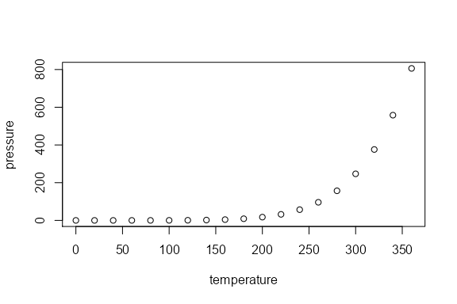

Figure 1. pressure dataset

# 4 Landscape Section

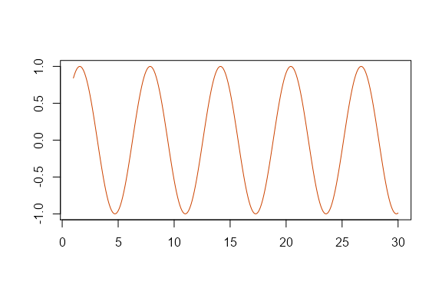

Figure 2. sin function

# 5 Math

Wrap variables or math in a single $ to show math inline. For example, $ε∼N(0,1)$. Standalone equations are wrapped with $$.

$${\left(\prod_{i=1}^{n}{y_{i}}\right)}^{\frac{1}{n}}=\text{exp}\left[\frac{1}{n}\sum_{i=1}^{n}{\text{log}}y_{i}\right], \text{when} y_{1},y_{2},...,y_{n}>0$$

If the equations need to be numbered and cross-referenced the format as:

\begin{equation}  
\left(\prod_{i=1}^{n}y_i\right)^{\frac{1}{n}} = \exp\left[\frac{1}{n}\sum_{i=1}^n\log{y_i}\right], \quad \textrm{when} \quad y_1, y_2, ..., y_n > 0  
(\#eq:gmean)  
\end{equation}

Which renders as (Equation (5.1):

$${\left(\prod_{i=1}^{n}{y_{i}}\right)}^{\frac{1}{n}}=\text{exp}\left[\frac{1}{n}\sum_{i=1}^{n}{\text{log}}y_{i}\right], \text{when} y_{1},y_{2},...,y_{n}>0 (5.1)$$

# 6 References

In-text references and bibliography generation are handled automatically. It relies on creating a bibtex .bib file with your references. Software such as Zotero, Mendely, and even Google Scholar can generate the bibtex entries for you. The entries are stored in the bibliography.bib file inside the same directory as this .Rmd file. To make a in text citation, use the following syntax, [@helsel_statistical_2002] to generate the reference at the end of this sentence (Helsel and Hirsch 2002). Use a semicolon to include multiple references [@helsel_statistical_2002; hirsch2010weighted]. Or we might indicate the Helsel & Hirsch Helsel and Hirsch (2002) provide a fundamental overview of water quality statistics. The bibliography will populate automatically.

# Bibliography

Helsel D, Hirsch R. 2002. Statistical methods in water resources. U.S. Geological Survey (Techniques of water-resources investigations of the United States Geologic Survey). **Error! Hyperlink reference not valid.**.