Synthesis of Lake TMDL Approaches in EPA Regions 4 and 6

Michael Schramm 1, Lucas Gregory 2

1 Research Specialist, Texas Water Resources Institute, Texas A&M AgriLife Research

2 Associate Director, Texas Water Resources Institute, Texas A&M AgriLife Research

April 1, 2021

Texas Water Resources Institute

Texas A&M AgriLife

College Station, TX

TR-ABCD

This project was funded by the Texas Commission on Environmental Quality.

Table of Contents

Table of Figures

Table of Tables

Abbreviations

# Headings

## Second Level Heading

### Third Level Heading

First, second, and third level headings are defined by #, ##, and ### respectively.

<https://www.tceq.texas.gov/downloads/water-quality/assessment/integrated-report-2024/2024-trophic>

# Introduction

States are required to identify water bodies that do not meet designated water uses under Section 303(d) of the Clean Water Act. Total Maximum Daily Loads (TMDLs) must be developed for pollutants causing the impairment. TMDLs designate an allowable daily allowable pollutant load that can be discharged to the waterbody and continue to meet criteria for designated uses. Corresponding TMDL Implementation Plans (I-Plans) are developed to identify pollutant load reductions required to meet TMDLs and a schedule of implementation of management measures and control actions that will achieve the required load reductions.

Since the mid-2000’s addressing recreational impairments caused by excessive fecal indicator bacteria, primarily occuring in streams and rivers, has been the priority for the State of Texas’s water quality planning efforts. Under this priority the state convened a Bacteria TMDL Task force to provide guidance and consensus among major stakeholders in the planning process for water quality planning approaches (Jones et al. 2009). The outcomes of this process included a unified approach for prioritizing impaired waterbodies, determining sources of impairments, and developing load reductions in an efficient and scientifically robust manner. These outcomes facilitated the rapid expansion TMDL planning efforts in the state (Schramm et al. 2022).

Additional progress in water quality planning will likely require an expanded focus beyond recreational impairments in streams and rivers.

Currently, 11 lakes in Texas have TMDLs and corresponding Implementation Plans (TCEQ 2024).

… something about the number of impaired lakes in texas and causes of impairments …

301,419 acres impaired for “General Use”, 192,005 acres or 63% of impaired acres list excessive algae as the impairment reason.

14,768 acres are impaired for “aquatic Life Use” with 13,354 or 90% of those acres listing low dissolved oxygen as the impairment reason.

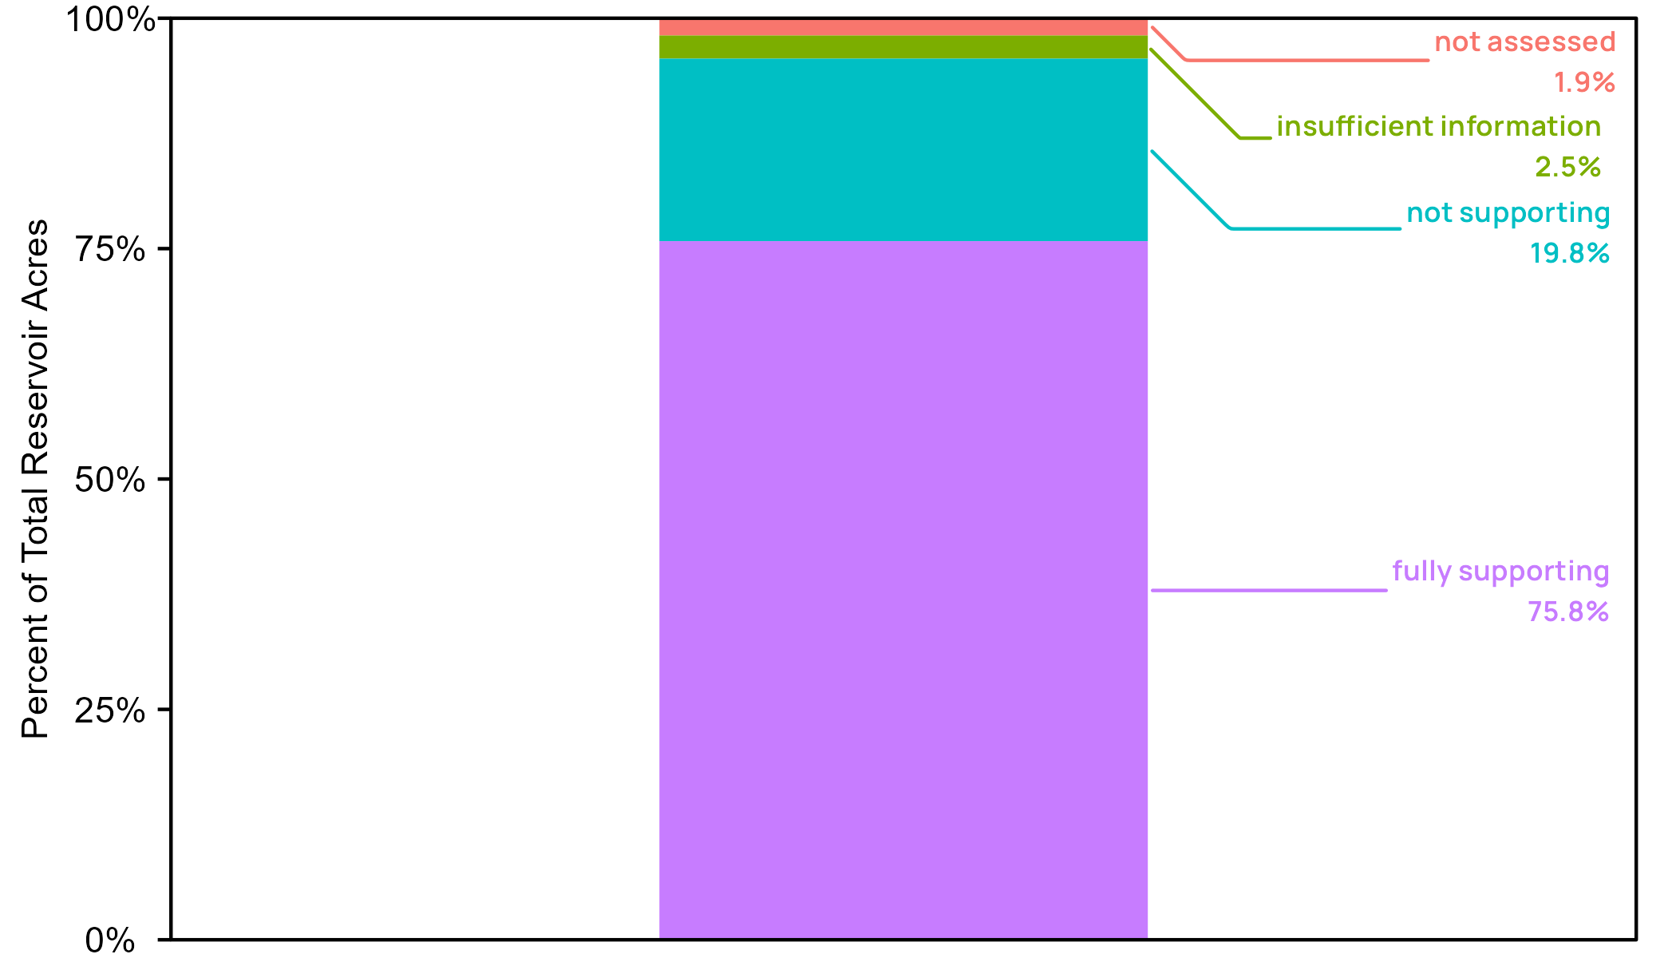

Figure . General Use impariment classification for reservoirs in Texas.

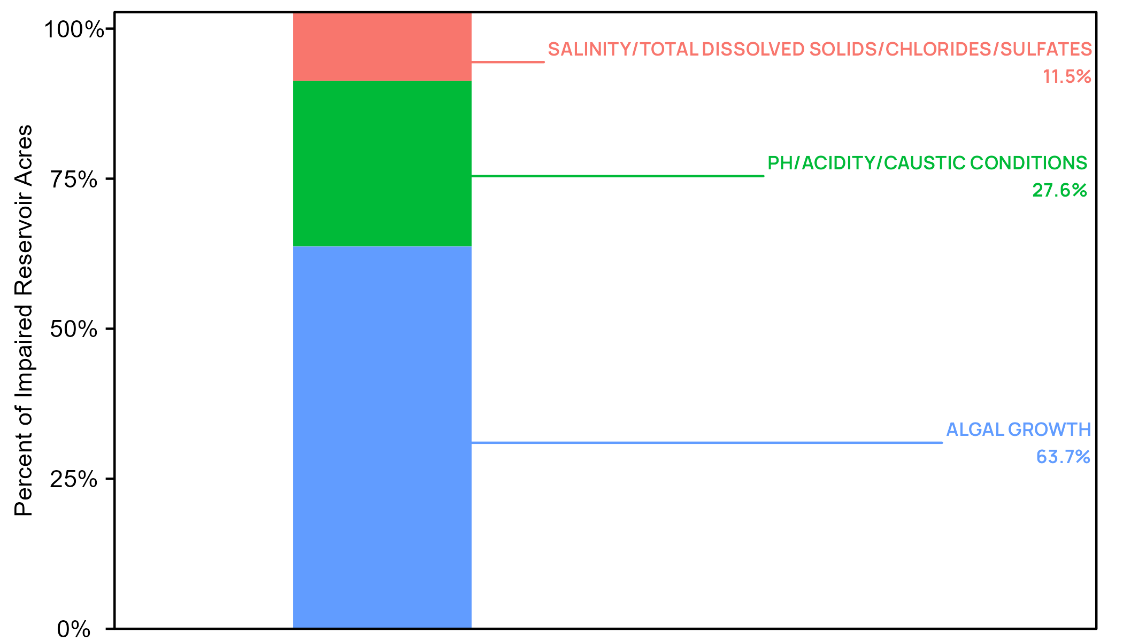

Figure . Impairment cause for reservoirs as impaired for general use.

Unlike the tiered approach identified by the Bacteria TMDL Task Force, a unified approach for addressing impairments specifically in lakes has not been developed. Given the diversity of potential parameter impairments, impairment sources, and expected lake trophic status, a variety of TMDL development approaches are possible. This report intends to identify and summarize EPA-approved approaches used across EPA Regions 4 and 6 in the development of TMDLs in lakes and reservoirs.

# Methods

The purpose of this report is to review and summarize methodologies in EPA accepted lake or reservoir TMDLs relevant to Texas. We queried the EPA Assessment TMDL Tracking and Implementation System (ATTAINS) database using the R software package, rATTAINS (Schramm 2023). rATTAINS facilitates data queries and downloads from the ATTAINS online database directly into R. In March 2025 we made queries to ATTAINS for all approved TMDLs in the 13 states covered under EPA regions 5 and 6 since January 1, 2020. The data returned from the ATTAINS query includes a list of hydrologic assessment units (AUs) covered by each TMDL. Each TMDL can cover one or more hydrologic assessment units (AUs). A subsequent query to ATTAINS was made to identify the waterbody type each state assigned to the AUs covered by TMDLs. Using the data returned by this query, the list of TMDLs was reduced to those TMDLs that included AUs identified in ATTAINS as one of, “Lake, Freshwater; Lake; Reservoir; Lake/Reservoir/Pond.” ATTAINS also identifies the endpoint parameter that is the cause of the impairment (low DO, high chlorophyll-a, etc.) in each AU and the target load allocation parameter(s) (TN, TP, TSS, etc.) in the TMDL that the waterbody can assimilate without being considered impaired. The remaining list of TMDLs was further reduced by removing AUs that were impaired due to aluminum or temperature. *Describe number of TMDLs and states. Add table in Appendix of TMDLs.*

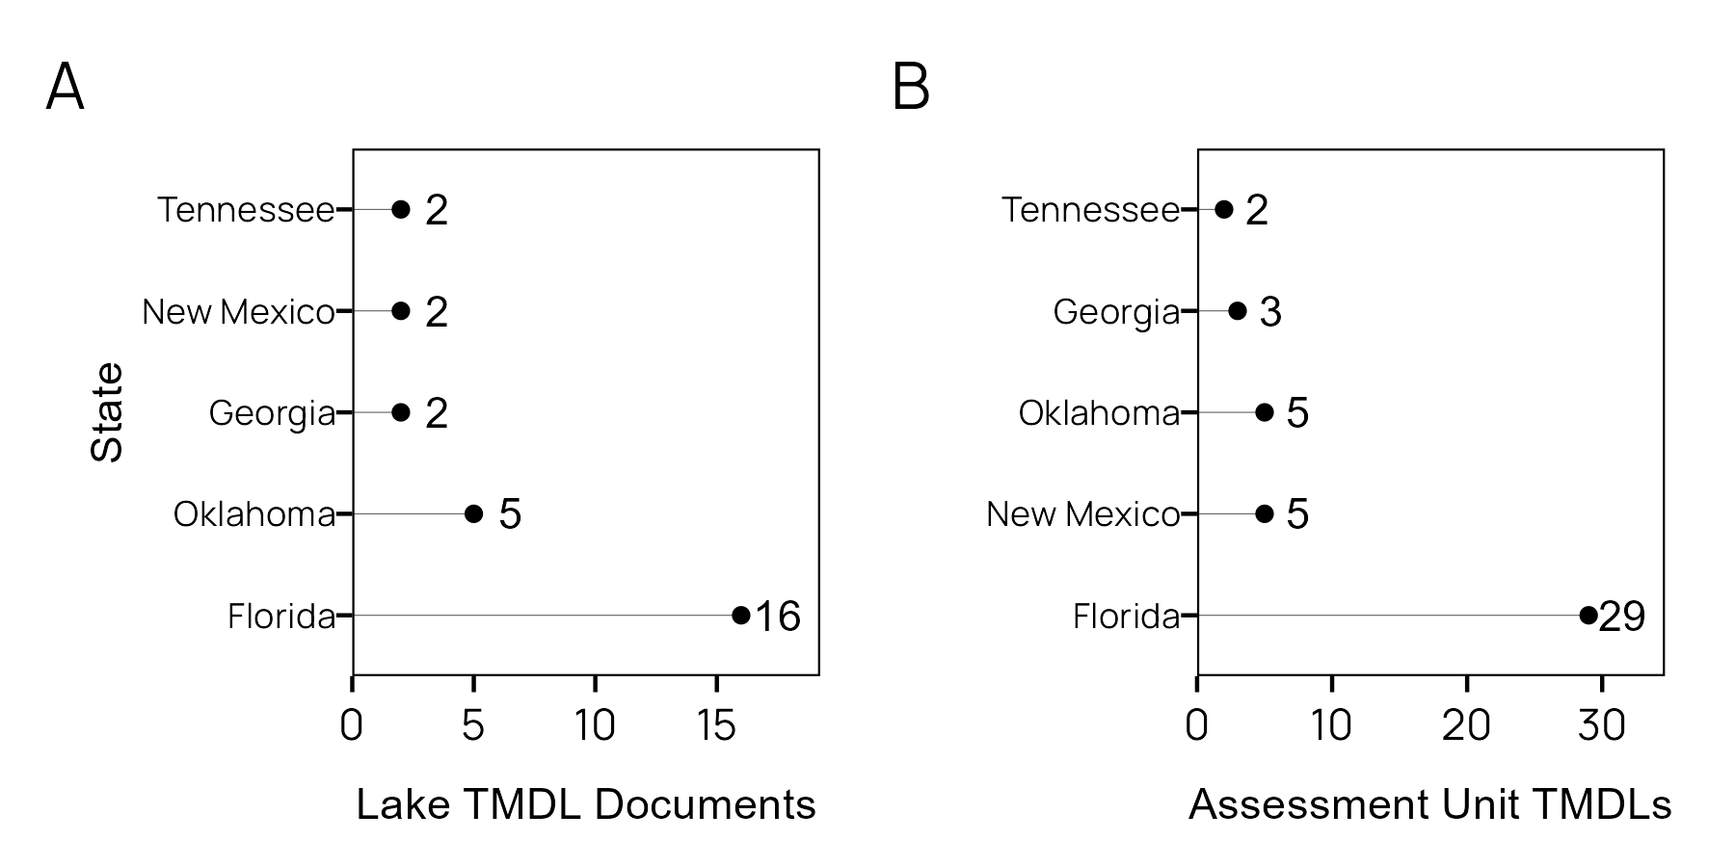

Figure . (A) Number of Lake TMDL documents per state in EPA regions 4 and 6 (January 2020 through December 2024; (B) Distinct lake assessment units covered by TMDLs per state in EPA regions 4 and 6 (January 2020 through December 2024.

ATTAINS was queried again with the remaining n TMDLs to download pdf copies of each EPA accepted TMDL. These TMDLs were manually reviewed to identify and extract relevant information.

* watershed size
* lake area
* shoreline length
* lake volume
* model typology (empirical, mechanistic)
* specific modeling approaches

# Results

# Tables

## New names:  
## Rows: 116 Columns: 47  
## ── Column specification  
## ──────────────────────────────────────────────────────── Delimiter: "," chr  
## (39): organization_identifier.x, organization_name.x, organization_type_... dbl  
## (5): load_allocation_numeric, TMDL_end_point_text, watershed_area, volu... num  
## (1): surface_area lgl (2): explicit_margin_of_safety_text, ...40  
## ℹ Use `spec()` to retrieve the full column specification for this data. ℹ  
## Specify the column types or set `show_col_types = FALSE` to quiet this message.  
## • `` -> `...40`

This is an example of an unformatted table and how we cross-reference that table (Table ).

Table . this is the builtin mtcars data.

| mpg | cyl | disp | hp | drat | wt | qsec | vs | am | gear | carb |
| --- | --- | --- | --- | --- | --- | --- | --- | --- | --- | --- |
| 21.0 | 6 | 160.0 | 110 | 3.90 | 2.620 | 16.46 | 0 | 1 | 4 | 4 |
| 21.0 | 6 | 160.0 | 110 | 3.90 | 2.875 | 17.02 | 0 | 1 | 4 | 4 |
| 22.8 | 4 | 108.0 | 93 | 3.85 | 2.320 | 18.61 | 1 | 1 | 4 | 1 |
| 21.4 | 6 | 258.0 | 110 | 3.08 | 3.215 | 19.44 | 1 | 0 | 3 | 1 |
| 18.7 | 8 | 360.0 | 175 | 3.15 | 3.440 | 17.02 | 0 | 0 | 3 | 2 |
| 18.1 | 6 | 225.0 | 105 | 2.76 | 3.460 | 20.22 | 1 | 0 | 3 | 1 |
| 14.3 | 8 | 360.0 | 245 | 3.21 | 3.570 | 15.84 | 0 | 0 | 3 | 4 |
| 24.4 | 4 | 146.7 | 62 | 3.69 | 3.190 | 20.00 | 1 | 0 | 4 | 2 |
| 22.8 | 4 | 140.8 | 95 | 3.92 | 3.150 | 22.90 | 1 | 0 | 4 | 2 |
| 19.2 | 6 | 167.6 | 123 | 3.92 | 3.440 | 18.30 | 1 | 0 | 4 | 4 |

The [flextable](https://davidgohel.github.io/flextable/) package provides additional formatting flexibility when exporting to Word (Table ).

Table . flextable formatted table.

| mpg | cyl | disp | hp | drat | wt | qsec | vs | am | gear | carb |
| --- | --- | --- | --- | --- | --- | --- | --- | --- | --- | --- |
| 21.0 | 6 | 160.0 | 110 | 3.90 | 2.620 | 16.46 | 0 | 1 | 4 | 4 |
| 21.0 | 6 | 160.0 | 110 | 3.90 | 2.875 | 17.02 | 0 | 1 | 4 | 4 |
| 22.8 | 4 | 108.0 | 93 | 3.85 | 2.320 | 18.61 | 1 | 1 | 4 | 1 |
| 21.4 | 6 | 258.0 | 110 | 3.08 | 3.215 | 19.44 | 1 | 0 | 3 | 1 |
| 18.7 | 8 | 360.0 | 175 | 3.15 | 3.440 | 17.02 | 0 | 0 | 3 | 2 |
| 18.1 | 6 | 225.0 | 105 | 2.76 | 3.460 | 20.22 | 1 | 0 | 3 | 1 |
| 14.3 | 8 | 360.0 | 245 | 3.21 | 3.570 | 15.84 | 0 | 0 | 3 | 4 |
| 24.4 | 4 | 146.7 | 62 | 3.69 | 3.190 | 20.00 | 1 | 0 | 4 | 2 |
| 22.8 | 4 | 140.8 | 95 | 3.92 | 3.150 | 22.90 | 1 | 0 | 4 | 2 |
| 19.2 | 6 | 167.6 | 123 | 3.92 | 3.440 | 18.30 | 1 | 0 | 4 | 4 |

# Figures

We can embed and cross-reference plots (Figure ).

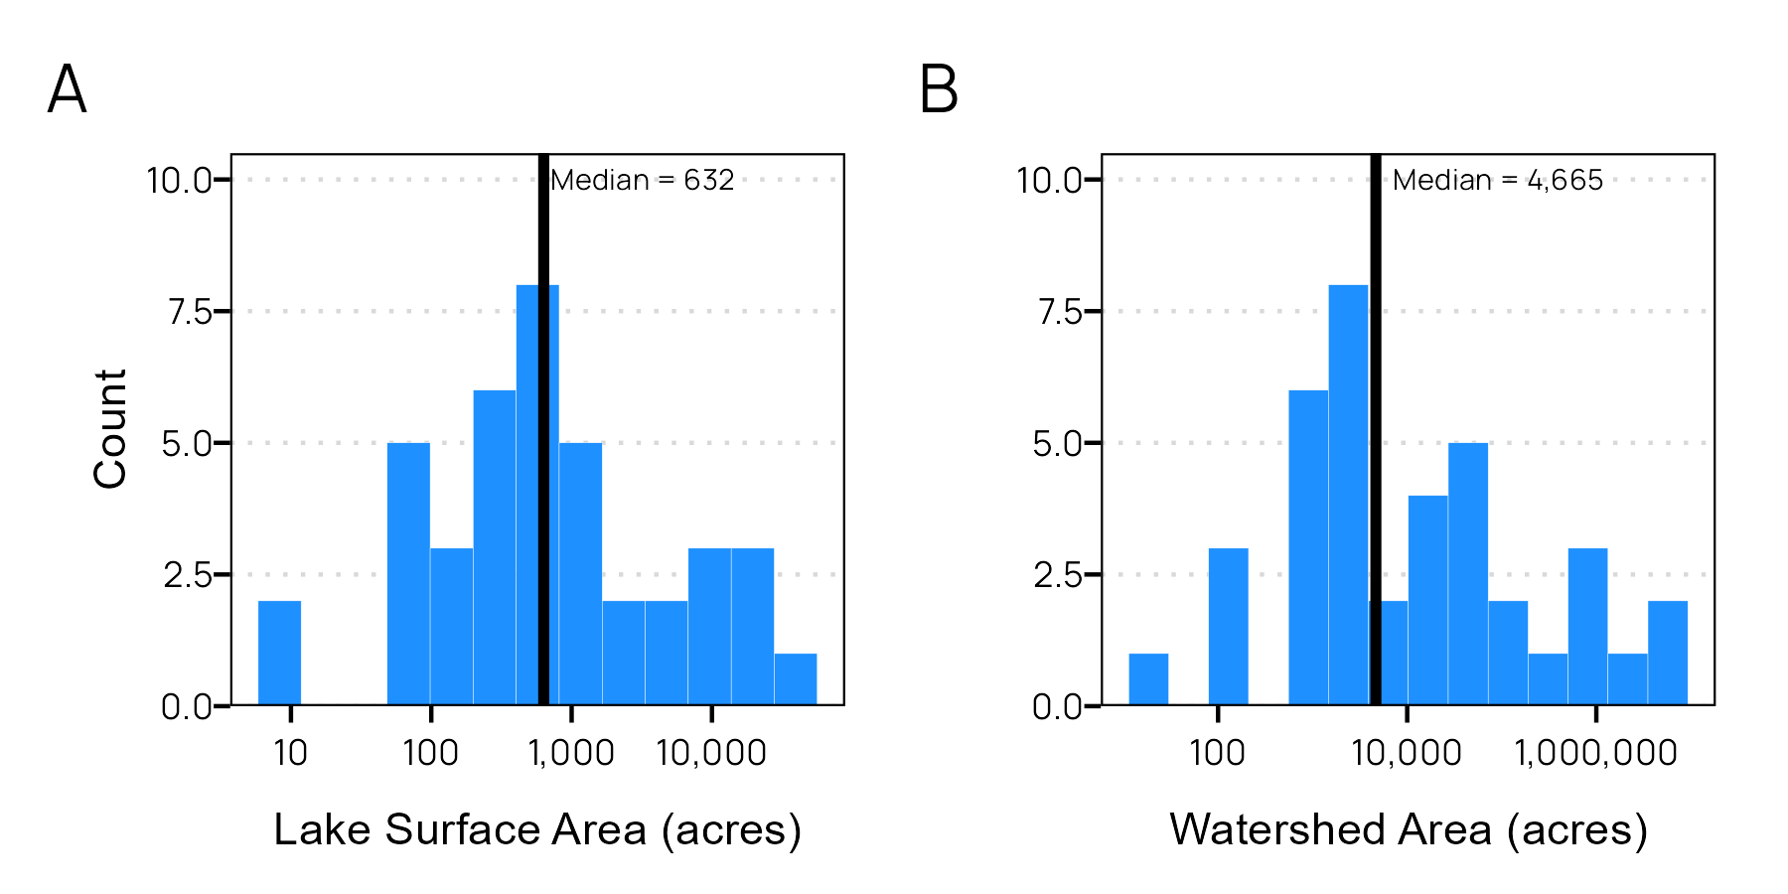

Figure . (A) Histogram of lake surface area (acres) and (B) histogram of lake watershed area (acres).

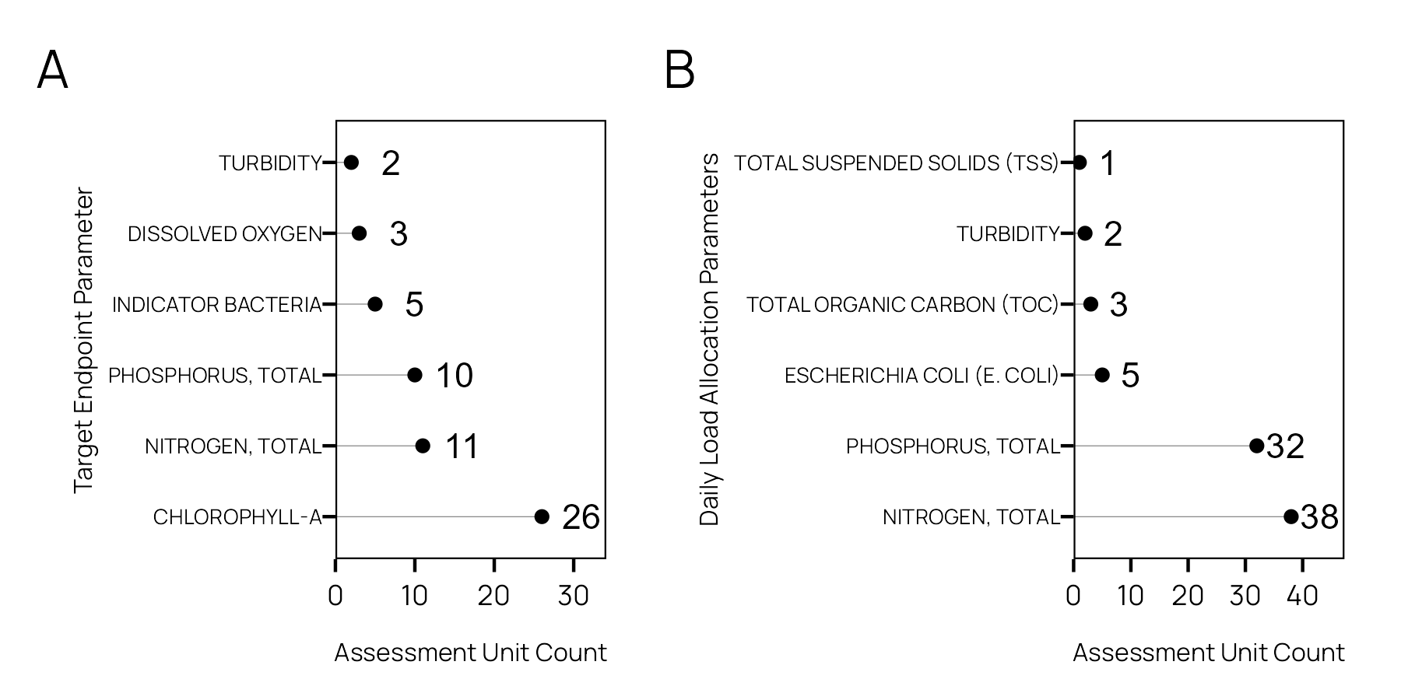

Figure . (A) TMDL Allocation parameter frequency and (B) target parameter frequency.

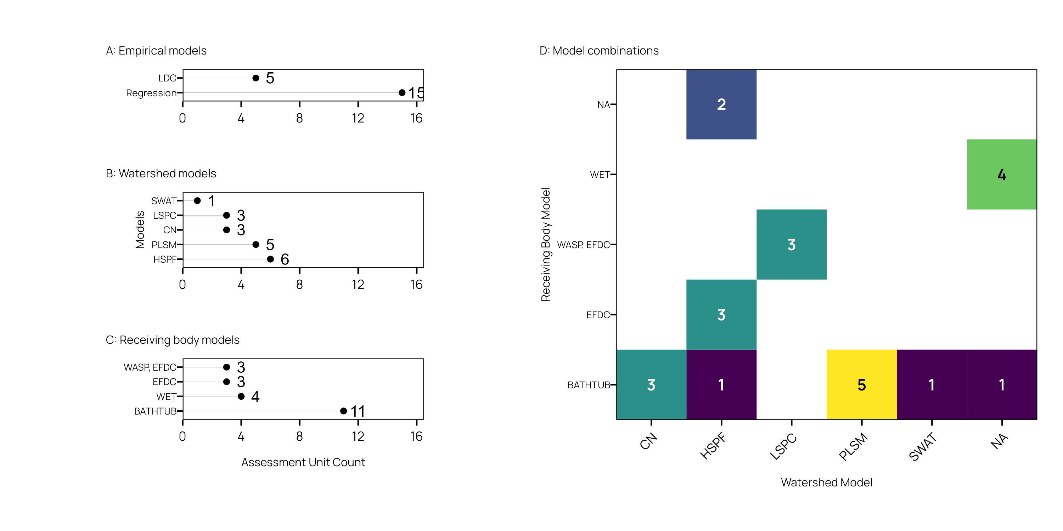

Figure . Models…

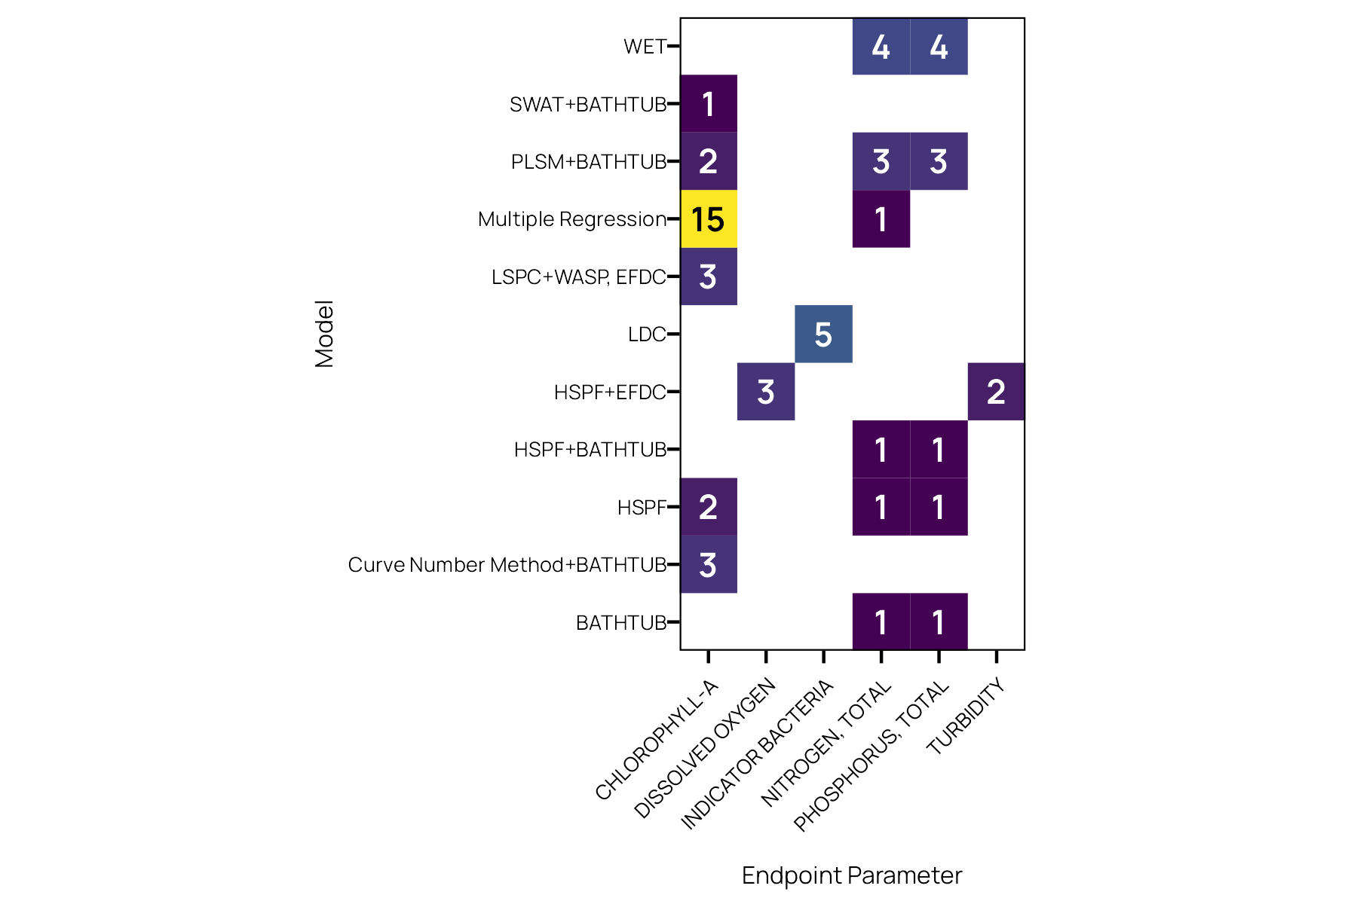

Figure . Models…

# References

# Bibliography

Jones A, Wagner K, Di Giovanni G, Hauck L, Mott J, Rifai HS, Ward G, Wythe K. 2009. Bacteria Total Maximum Daily Load Task Force Final Report. College Station, TX: Texas Water Resources Institute Report No.: TR-341. <http://hdl.handle.net/1969.1/86092>.

Schramm M, Gitter A, Gregory L. 2022. Total Maximum Daily Loads and *Escherichia* *Coli* trends in Texas freshwater streams. Journal of Contemporary Water Research & Education. 176(1):36–49. doi:[10.1111/j.1936-704X.2022.3374.x](https://doi.org/10.1111/j.1936-704X.2022.3374.x).

Schramm MP. 2023. rATTAINS: Access EPA ’ATTAINS’ data. <https://CRAN.R-project.org/package=rATTAINS>.

TCEQ. 2024. Trophic Classification of Texas Reservoirs. Austin, TX: Texas Commission on Environmental Quality Water Quality Planning Division Report No.: AS-229. <https://www.tceq.texas.gov/downloads/water-quality/assessment/integrated-report-2024/2024-trophic>.

# Appendix A

You can add more info, tables, and figures here.