Title

Michael Schramm[1]

Anna Gitter[2]

Lucas Gregory[3]

2020-10-23

This is the abstract. It consists of two paragraphs.

# Introduction

Lorem ipsum dolor sit amet consectetur adipiscing elit urna, augue nascetur magnis natoque mollis euismod libero, vitae hac parturient est quisque class quis. Bibendum eget ornare cursus ac cubilia nam dis per urna ante, integer hac nascetur luctus in eu faucibus porta mus, torquent mattis pharetra interdum curabitur nostra sociis vitae etiam. A rutrum tortor eleifend suscipit tempus viverra dapibus commodo pharetra, proin cras ligula nec ornare himenaeos at ultrices magnis iaculis, sociosqu pulvinar sagittis velit scelerisque fermentum eros posuere.

Lorem ipsum dolor sit amet consectetur adipiscing elit, conubia molestie nulla quam per dictumst varius, ad accumsan venenatis suscipit sodales blandit. Sed tristique volutpat ultrices venenatis feugiat taciti inceptos pellentesque porta, praesent lacus lectus sapien turpis facilisi proin interdum. Pretium vehicula aenean sociis duis lectus ridiculus, eros neque luctus malesuada quam tincidunt rutrum, justo eget tempor himenaeos ante.

Quisque auctor donec volutpat varius senectus euismod gravida ridiculus per metus, magna pharetra at arcu a id tellus nascetur. Neque nam morbi mi netus vulputate tincidunt sem, semper ultrices etiam non nascetur vestibulum, suscipit augue tempor hac nunc facilisis. Condimentum tincidunt porta ut integer ridiculus odio euismod taciti quis purus orci, mattis sem class curae montes facilisi eleifend fermentum at. Eget condimentum risus elementum ultrices curae penatibus feugiat libero euismod aenean, potenti justo vitae accumsan leo velit vel magnis ligula, vivamus molestie rutrum a porta dictum volutpat nostra lacus.

# Methods

## Data

Lorem ipsum dolor sit amet consectetur adipiscing elit, conubia molestie nulla quam per dictumst varius, ad accumsan venenatis suscipit sodales blandit. Sed tristique volutpat ultrices venenatis feugiat taciti inceptos pellentesque porta, praesent lacus lectus sapien turpis facilisi proin interdum. Pretium vehicula aenean sociis duis lectus ridiculus, eros neque luctus malesuada quam tincidunt rutrum, justo eget tempor himenaeos ante.

Quisque auctor donec volutpat varius senectus euismod gravida ridiculus per metus, magna pharetra at arcu a id tellus nascetur. Neque nam morbi mi netus vulputate tincidunt sem, semper ultrices etiam non nascetur vestibulum, suscipit augue tempor hac nunc facilisis. Condimentum tincidunt porta ut integer ridiculus odio euismod taciti quis purus orci, mattis sem class curae montes facilisi eleifend fermentum at. Eget condimentum risus elementum ultrices curae penatibus feugiat libero euismod aenean, potenti justo vitae accumsan leo velit vel magnis ligula, vivamus molestie rutrum a porta dictum volutpat nostra lacus.

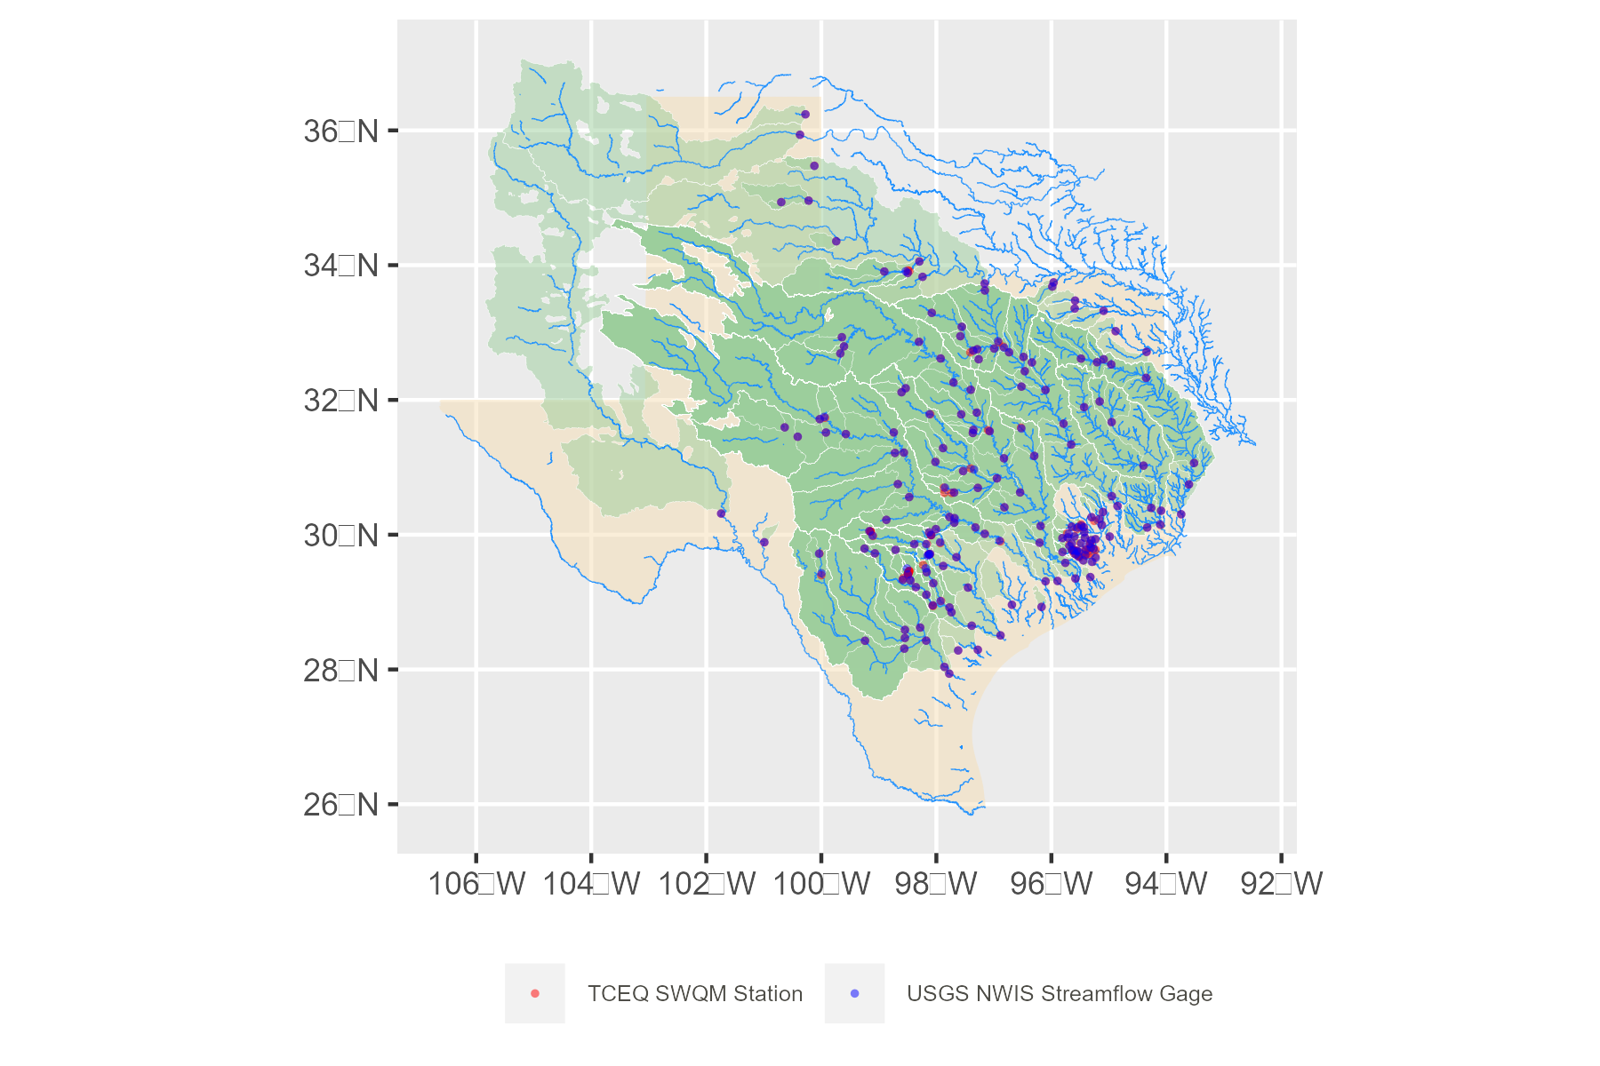

Figure 1: NHD Plus flowlines, USGS Stations

## Trend Analysis

We also assessed the presence of trends adjusted for streamflow by applying the modified Mann-Kendall test on the residuals from a Generalized Additive Model (GAM) of *E. coli* on smoothed streamflows:

$$log(y)=β_{0}+tp_{1}(log(x))+ϵ$$

where $y$ is *E. coli* concentration, $β_{0}$ is the intercept, $x$ is streamflow, and $ϵ$ is the error term assumed to be normally distributed arounnd mean zero. $tp_{1}$ is a smoothing function that utilizes reduced rank versions of thin plate splines (Wood, 2003). GAMs were fit using the “mgcv” package in R which utilizes generalized cross validation to estimate the optimal number of knots in the smoothing function (Wood, 2011).

# Results

Table 1: Summary statistics

| Variable | n | Mean | median | range | V2 |
| --- | --- | --- | --- | --- | --- |
| x | x | x | x | x | x |
| x | x | x | x | x | x |
| 1E. coli mean and SD are reported as geometric mean and geometric SD | | | | | |

# References

Barry, J., Maxwell, D., Jennings, S., Walker, D., Murray, J., 2017. *Emon* : An r‐package to support the design of marine ecological and environmental studies, surveys and monitoring programmes. Methods in Ecology and Evolution 8, 1342–1346. <https://doi.org/10.1111/2041-210X.12748>

1. Corresponding Author, Texas Water Resources Institute, [michael.schramm@ag.tamu.edu](mailto:michael.schramm@ag.tamu.edu)
2. Texas Water Resources Institute, [anna.gitter@ag.tamu.edu](mailto:anna.gitter@ag.tamu.edu)
3. Texas Water Resources Institute, [lfgregory@ag.tamu.edu](mailto:lfgregory@ag.tamu.edu)