Estimating statistical power for detecting long term trends in surface water *Escherichia coli* concentrations

Michael Schramm 1,a

1 Research Specialist, Texas Water Resources Institute, Texas AM AgriLife Research

a Corresponding author, [michael.schramm@ag.tamu.edu](mailto:michael.schramm@ag.tamu.edu)

Water quality monitoring programs commonly use the Mann-Kendall test or linear regression to identify statistically significant monotonic trends in fecal indicator bacteria concentrations (typically *Escherichia coli*). Statistical power of these tests to detect trends is rarely communicated to stakeholders and it is unlikely they are considered when designing monitoring schedules. The statistical power for detecting trends in surface water *Escherichia coli* bacteria concentrations at water quality monitoring sites across Texas was estimated using Monte Carlo simulation. The probability that a monitoring site had adequate statistical power was estimated using logistic regression.  
  
Both trend tests show similar statistical power. At effect sizes under 20%, attainment of adequate statistical power is unlikely. At 30% to 40% effect sizes, monthly sampling is needed. Many sites are sampled quarterly, it is important to communicate the relative power of tests and sample sizes for identifying trends of given magnitudes. We suggest conducting pre- or post-study power analysis to improve monitoring program designs and improve communication of trend test limitations. Tooling or training for water quality analysts could facilitate communication of power and effect sizes. Alternative trend assessment methods may be more reliable for describing changes in fecal indicator bacteria concentrations.

**Keywords** trend detection; *E. coli*, statistical power

**Abbreviations**

|  |  |
| --- | --- |
| Short Name | Descriptive Name |
| CV | coefficient of variation |
| *E. coli* | *Escherichia coli* |
| GLM | generalized linear model |
| LOADEST | Load Estimator |
| mL | milliliter |
| MPN | most probable number |
| SWQM | Surface Water Quality Monitoring |
| TCEQ | Texas Commission on Environmental Quality |
| WRTDS | Weighted Regressions on Time, Discharge, and Season |

# Introduction

Fecal indicator bacteria are used to assess the sanitary quality of water for recreational and water supply purposes. Fecal indicator bacteria themselves are not dangerous but are utilized as an indicator of potential health risks associated with exposure to pathogens associated with fecal matter. *Escherichia coli* (*E. coli*) is used as a fecal indicator bacteria in Texas to assess if streams and other freshwater bodies meet numeric water quality criteria for contact recreation. *E. coli* is a non-host specific bacteria found in the gut of warm-blooded animals, the presence of *E. coli* is used to indicate the potential for recent fecal contamination.

In-stream fecal indicator bacteria concentrations typically follow a log-normal distribution (Novotny 2004). As a result, the Texas Commission on Environmental Quality (TCEQ) biennially evaluates compliance with the in-stream criterion of 126 most probable number (MPN)/ 100 milliliters (mL) using the geometric mean over a seven-year assessment period. The geometric mean is simply a measure of central tendency calculated as the exponential of the arithmetic mean of logarithms:

Simplified, the geometric mean computes the arithmetic mean of *log(y)* and exponentiation returns the mean to the original scale. An alternative approach is to take the *n*th root of the product of *yi*. The current assessment approach requires a minimum sample size of 20 over the previous 7-years with an 80% confidence interval that exceeds the 126 MPN/100 mL criterion at the lower bound in order to be determined impaired (TCEQ 2019a). Delistings require 20 samples and the geometric mean below the 126/100 mL criterion. TCEQ (2019a) does not specify how the confidence interval should be calculated. Traditional methods multiply a critical value (obtained from the standard normal distribution or Student’s t-distribution) by the standard error. Confidence intervals can also be obtained by parametric bootstrap methods (Wilcox 2013).

As of 2018, TCEQ identified 237 water bodies impaired due to elevated fecal indicator bacteria (TCEQ 2019b). Total Maximum Daily Loads and Implementation Plans or Watershed Protection Plans are developed for these impaired water bodies to address potential fecal indicator bacteria sources. As part of these plans, trend analysis is typically conducted to assess if bacterial concentrations have increased or decreased over time. Two common methods for assessing statistical significance of monotonic trends are the Mann-Kendall test and linear regression on fecal indicator bacteria concentration values (Helsel and Hirsch 2002; Yue and Wang 2002).

Yue and Wang (2002) described the calculation of the Mann-Kendall test and the modifications for correlated data. In short, when the Mann-Kendall test statistic, *S*, is negative, newer values tend to be smaller than older values and indicate a downward trend. A small absolute value of *S* indicates no trend. The *P* value of the test statistic is estimated using the normal cumulative distribution function. The null hypothesis of the Mann-Kendall test is that there is no trend.

Simple linear regression on log-transformed *E. coli* concentrations are also suitable for identifying trends. In order to assess presence of a trend, the following linear regression is used:

where *y* is *E. coli* concentration, *β0* is the intercept, *β1* is the coefficient of time variable *x*, and ε is the error term assumed normally distributed around mean zero. If linear regressions are utilized to assess *E. coli* trends, the analyst should assess model residuals to ensure the regression model meets assumptions of heterogeneity and normal distribution.

Both the Mann-Kendall test and linear regression are straight forward methods for water quality analysts to apply and assess trends in *E. coli* concentrations. They are well accepted and have routines available in most statistical software. However, general guidance is not available for the number of samples required to detect given effect sizes. Current assessment guidance for attainment of the water quality criterion (20 samples over 7-years) is adequate given the ability to estimate confidence intervals for the geometric mean calculation. As a result, many monitoring programs across the state utilize quarterly sampling regimes, which equate to approximately 4 samples per year or 28 samples over a 7-year assessment period. Reporting the results of trend detection test implies the test has the statistical power to detect trends of certain magnitudes. However, that information is rarely reported and unlikely that it is routinely calculated by water quality analysts. Therefore, there is considerable uncertainty if monitoring schedules (especially those designed around quarterly monitoring) used across the state are adequate for detecting trends in fecal indicator bacteria.

Statistical power refers to the probability that a statistical test rejects the null hypothesis when the alternative hypothesis is actually true. In the case of the discussed trend tests, power is the probability that the null hypothesis (that no trend is present) is rejected when there is in fact a trend in the data. Statistical power is a function of pre-assigned significance level (α), effect size, sample size, and variance within the time series (Yue et al. 2002). First, a meaningful effect size must be determined. The effect size might be biologically meaningful or informed by stakeholder input. Statistical power can be determined for a range of sample size, significance levels, effect sizes and sample variance. The purpose of this article is to provide some guidance and context in determining monitoring frequency for trend analysis of fecal indicator bacteria, specifically *E. coli*. First, we estimate the statistical power of Mann-Kendall and linear regression trend tests at sampling sites across the state using Monte Carlo simulation. Second, we provide statistical power plots at different effect sizes for a range of observed variance values. Finally, we model the likelihood of adequate statistical power for *E. coli* trend detection at sampling sites across Texas.

# Methods

## Data

TCEQ Surface Water Quality Monitoring (SWQM) site information and associated *E. coli* samples collected during the 7-year period from January 2012 through December 2019 were obtained from the Water Quality Portal (<https://www.waterqualitydata.us/>) using the “dataRetrieval” package in R (De Cicco et al. 2018; R Core Team 2019). Data was restricted to river or stream sampling sites, and SWQM sites with fewer than 1 sample per year were removed from analysis. In total, *E. coli* data was assessed from 984 SWQM sites.

## Statistical Power Computation

The significance level, α, is the probability of rejecting the null hypothesis when it is true (Type I error). The probability of accepting the null hypothesis when it is false is a Type II error (*β*). The statistical power of a test is the probability of rejecting the null hypothesis when the alternative hypothesis is true and is equal to 1 - *β*. A power of 0.80 is typically considered appropriate, which equates to a 20% chance of encountering a Type II error. If sampling from a population where the null hypothesis is false, power is calculated as:

where *N* is the total number of tests and *Nrejected* are the total number of times the test rejected the null hypothesis.

For each SWQM site, Monte Carlo simulation was used to observe the statistical power of the Mann-Kendall and linear regression test for detecting trends (Sigal and Chalmers 2016). The simulation generates 1,000 independent log-normal distributed time series samples per evaluated effect size for each SWQM site using the site specific log-transformed mean and standard deviation. Effect sizes were induced by reducing the annual log-transformed mean over the 7-year sampling period by 10%, 20%, 40%, and 80%. Over 3.93 million simulations were run per trend detection method. Significance level, α, was set at 0.10. The Mann-Kendall test and linear regression was applied to each simulation sample and the number of times the tests correctly reject the null hypothesis (*Nrejected*) are tabulated. Statistical power plots were also generated using Monte Carlo simulation on sample datasets generated using the quartiles (lower, median and upper) of the observed coefficient of variation (CV) of *E. coli* from SWQM sites. CV is a method of measuring the spread of a distribution relative to the size of the mean; specifically, it is ratio of the standard deviation to the mean. These power plots provide a general idea of the expected statistical power of characteristic *E. coli* datasets in the state using typical sampling intervals. They are not intended to be a replacement for conducting a statistical power test using site specific data.

## Likelihood of adequate statistical power

We modeled the likelihood that a SWQM site would have adequate statistical power (≥ 0.80) as a function of sample size, variance, and effect size using generalized linear models (GLMs). GLMs are an extension of linear regression that allows for response variable with non-normal error distributions through the use of a link function. GLMs were setup as a logistic regression model of form:

where the probability of adequate statistical power is response on the right hand side of the equation and is a function of the sum of the dependent variables with their corresponding coefficients (*β*) and random errors (*ε*). GLMs were fit using the “glm” function in R with the binomial family and logit link function.

# Results

## Monitoring Frequency

Out of the 984 evaluated SWQM sites, 329 were located in water bodies with a TMDL. SWQM sites located on water bodies without a TMDL were generally sampled 3 to 4 times per year (Figure ). SWQM sites with a TMDL skewed higher, with a peak at 9 times per year and smaller peaks at 4 and 6 times per year. This suggests that increased monitoring efforts are targeted towards sites where planning efforts have been implemented. Similarly, the *E. coli* geometric mean skewed higher at sites with a TMDL (Figure ).

## Estimated Statistical Power at SWQM Sites

At current annual sampling frequencies, all SWQM sites fell below 0.80 power for detecting effect sizes of 10% (Figure ). At 20% effect size, all non-TMDL sites had less than 0.80 power. The majority of TMDL SWQM sites fail to detect a 20% change. However, there is large observed variance in statistical power for TMDL sites at 20% effect size. At 40% and 80% effect sizes the majority of TMDL SWQM sites had power above 0.80. Non-TMDL SWQM sites exhibit high variance at 40% effect sizes and sufficient statistical power at most sites at 80% effect size. These differences coincide with the higher sampling efforts devoted to TMDL SWQM sites.

The upper, middle, and lower quartiles of the CV across all sites was 2.71, 1.96, and 1.36. The CV values indicate the relatively high variance in *E. coli* concentrations within SWQM sites. Statistical power calculated for the Mann-Kendall and linear regression tests on simulated *E. coli* datasets at the identified CV quartiles is displayed in Figure . For each test, as CV increases, statistical power decreases at each given effect size. Overall, both methods show similar statistical power.

Neither method has adequate power to detect trends at 10% effect size. At median variance, both tests have marginal power to detect trends of 30% with 12 samples per year. At 40% effect size, Mann-Kendall and linear regression require five and four samples per year respectively to achieve greater than 0.8 power. At 50% and greater effect size 3 or fewer samples per year are required to achieve adequate power. It is important to note that these figures are developed for typically expected *E. coli* distributions at SWQM sites. A site specific power analysis conducted using existing sample sets would provide a more accurate assessment of the expected sample distribution and estimated statistical power.

## Likelihood of Obtaining Statistical Power

Variance, sample size, and effect size are significant and substantial predictors of the probability that a SWQM site will have adequate power for detecting trends using linear regression or Mann-Kendall test methods (Table ). Figure displays the estimated effect of sample size and effect size on probability of adequate statistical power being obtained at a SWQM site. At mean variance values and large effect sizes, it is likely that adequate power will be obtained regardless of sample size. Probability decreases substantially as effect size and sample size decrease. Even with monthly sampling, there is only 0.5 probability that a SWQM site will obtain 0.80 power for detecting a 10% effect size.

Table : GLMs for probability of adequate statistical power.

|  | Mann-Kendall | | | Linear Regression | | |
| --- | --- | --- | --- | --- | --- | --- |
| Variable | OR1 | 95% CI1 | p-value | OR1 | 95% CI1 | p-value |
| cv | 0.39 | 0.34, 0.45 | <0.001 | 0.38 | 0.33, 0.43 | <0.001 |
| Sample Size | 1.74 | 1.66, 1.83 | <0.001 | 1.72 | 1.63, 1.80 | <0.001 |
| Effect Size | 0.90 | 0.89, 0.90 | <0.001 | 0.89 | 0.89, 0.90 | <0.001 |
| 1OR = Odds Ratio, CI = Confidence Interval | | | | | | |

The GLM models demonstrate the implications of sample design for identifying trends at SWQM sites. Non-TMDL sites often have four or fewer samples per year (Figure ). The likelihood of detecting all but the largest of changes in *E. coli* concentrations at non-TMDL sites are small. TMDL sites generally implement more sampling effort through the year and are more likely to obtain adequate power for identifying trends of smaller magnitude. In either case, the relative detectable effect size might seem high to stakeholders given the sampling effort expended.

# Discussion

The primary objective of this exploratory analysis is to communicate the importance of considering effect sizes when utilizing hypothesis tests to identify trends in fecal indicator bacteria datasets. Given the high variance observed in *E. coli* samples, we observe relatively low power for detecting trends of 20% or less in magnitude. Logistic regression demonstrates there is low likelihood that SWQM sites will have have desired power for detecting up to a 20% change in *E. coli*. At 40% and larger effect sizes, various sampling regimes can be developed with sufficient power for detecting trends. The paper focuses on statistical power and effect size because effect sizes are a more useful metric that provides environmental or decision-making relevance (Nakagawa and Cuthill 2007).

Power calculations prior to development of monitoring schedules would allow improved estimation of the number of samples required for trend detection. The basis of identifiable effect sizes requires communication with stakeholders to determine meaningful changes in water quality. Conversely, power can be calculated after the data is collected to identify the statistical power achieved. Water quality management is an inherently stakeholder driven process that requires substantial communication, trust, and knowledge-sharing (Leach and Pelkey 2001). Power analysis could be useful for communicating the anticipated or achieved statistical power of trend tests to stakeholders. By focusing discussion on effect sizes and not statistical significance, there is increased opportunity for communicating understandable results.

Although the Mann-Kendall and linear regression trend tests are relatively easy to conduct, statistical power tests are likely to be outside the expertise of a typical water quality analyst. On one hand, communication with a statistician is often recommended before sample design. However, for such routinely designed water quality monitoring projects, an accessible software package for water quality analysts would be useful. For example, the “emon” package in R provides accessible functions for estimating the statistical power of various hypothesis tests on environmental data sets (Barry et al. 2017). However, it does not include functions for evaluating typically log-normal data such as fecal indicator bacteria. Recently, simplified interfaces for running models such as the Soil and Water Assessment Tool have been provided online (Yen et al. 2016). With the increased availability of low cost cloud computing and cloud based statistical platform, similar implementation of simplified targeted statistical services should be feasible.

Alternative methods for evaluating indicator bacteria trends can also be utilized. Statistical models, such as generalized additive models, Load Estimator (LOADEST), or Weighted Regressions on Time, Discharge, and Season (WRTDS) can estimate monthly or annual average fecal indicator concentrations (Runkel et al. 2004; Hirsch et al. 2010; Wood 2011). Aggregated modeled values typically have less variance than sampled measurements, allowing for improved comparisons of year to year variations and trends. Furthermore, the marginal effect of the temporal component of these models can be assessed for periods of significant change using confidence intervals or decomposed to assess trends under different flow conditions (Zhang et al. 2020). However, it is likely that monthly sampling for at least several years is required to build accurate statistical model. For example, WRTDS recommends 10 to 20 years of data and at least 100 samples to identify temporal trends with confidence. Even this recommendation might be low for log-normal data with such high variance. A second drawback is the difficulty fitting these models. Generalized additive models and WRTDS both rely on the R statistical software and an analyst that is proficient in statistical modeling and programming in R. LOADEST is available as a stand-alone executable; however, still requires some specified training.

It is also worth noting, that despite the numerous TMDLs and watershed based plans developed in Texas based on fecal indicator bacteria based assessments, effort is being made toward developing risk based assessments using Quantitative Microbial Risk Assessment and Microbial Source Tracking (Goodwin et al. 2017). It is well established that pathogen sources (wildlife, raw sewage, or treated effluent for example) influence the infectivity of fecal pathogens which directly influence the risk of infection due to exposure to fecal indicator bacteria(Schoen and Ashbolt 2010; Soller et al. 2010; Gitter et al. 2020). Management based only on fecal indicator bacteria concentrations and not the makeup of the contributing sources results in overestimates in human health risk. As methods to assess water body compliance with potential future risk based pathogen exposure criteria develop, the methods to estimate and communicate trends and effect sizes with stakeholders will also need to evolve.

# Bibliography

Barry J, Maxwell D, Jennings S, Walker D, Murray J. 2017. *Emon* : An R‐package to support the design of marine ecological and environmental studies, surveys and monitoring programmes. Methods in Ecology and Evolution. 8(10):1342–1346. doi:[10.1111/2041-210X.12748](https://doi.org/10.1111/2041-210X.12748).

De Cicco LA, Lorenz D, Hirsch RM, Watkins W. 2018. DataRetrieval: R packages for discovering and retrieving water data available from U.S. federal hydrologic web services. Reston, VA: U.S. Geological Survey; U.S. Geological Survey. <https://code.usgs.gov/water/dataRetrieval>.

Gitter A, Mena K, Wagner K, Boellstorff D, Borel K, Gregory L, Gentry T, Karthikeyan R. 2020. Human health risks associated with recreational waters: Preliminary approach of integrating quantitative microbial risk assessment with microbial source tracking. Water. 12(2):327. doi:[10.3390/w12020327](https://doi.org/10.3390/w12020327).

Goodwin KD, Schriewer A, Jirik A, Curtis K, Crumpacker A. 2017. Consideration of natural sources in a bacteria TMDL—lines of evidence, including beach microbial source tracking. Environmental Science & Technology. 51(14):7775–7784. doi:[10.1021/acs.est.6b05886](https://doi.org/10.1021/acs.est.6b05886).

Helsel D, Hirsch R. 2002. Statistical methods in water resources. U.S. Geological Survey (Techniques of water-resources investigations of the United States Geologic Survey). <http://water.usgs.gov/pubs/twri/twri4a3/>.

Hirsch RM, Moyer DL, Archfield SA. 2010. Weighted regressions on time, discharge, and season (WRTDS), with an application to Chesapeake Bay river inputs. JAWRA Journal of the American Water Resources Association. 46(5):857–880. doi:[10.1111/j.1752-1688.2010.00482.x](https://doi.org/10.1111/j.1752-1688.2010.00482.x).

Leach WD, Pelkey NW. 2001. Making watershed partnerships work: A review of the empirical literature. Journal of Water Resources Planning and Management. 127(6):378–385. doi:[10.1061/(ASCE)0733-9496(2001)127:6(378)](https://doi.org/10.1061/(ASCE)0733-9496(2001)127:6(378)).

Nakagawa S, Cuthill IC. 2007. Effect size, confidence interval and statistical significance: A practical guide for biologists. Biological Reviews. 82(4):591–605. doi:[10.1111/j.1469-185X.2007.00027.x](https://doi.org/10.1111/j.1469-185X.2007.00027.x).

Novotny V. 2004. Simplified databased total maximum daily loads, or the world is log-normal. Journal of Environmental Engineering. 130(6):674–683. doi:[10.1061/(ASCE)0733-9372(2004)130:6(674)](https://doi.org/10.1061/(ASCE)0733-9372(2004)130:6(674)).

R Core Team. 2019. R: A language and environment for statistical computing. Vienna, Austria: R Foundation for Statistical Computing. <https://www.R-project.org/>.

Runkel RL, Crawford CG, Cohn TA. 2004. Load estimator (LOADEST): A FORTRAN program for estimating constituent loads in streams and rivers. U.S. Geological Survey Techniques and methods Report No.: 4-A5. <https://doi.org/10.3133/tm4A5>.

Schoen ME, Ashbolt NJ. 2010. Assessing pathogen risk to swimmers at non-sewage impacted recreational beaches. Environmental Science & Technology. 44(7):2286–2291. doi:[10.1021/es903523q](https://doi.org/10.1021/es903523q).

Sigal MJ, Chalmers RP. 2016. Play it again: Teaching statistics with Monte Carlo simulation. Journal of Statistics Education. 24(3):136–156. doi:[10.1080/10691898.2016.1246953](https://doi.org/10.1080/10691898.2016.1246953).

Soller JA, Schoen ME, Bartrand T, Ravenscroft JE, Ashbolt NJ. 2010. Estimated human health risks from exposure to recreational waters impacted by human and non-human sources of faecal contamination. Water Research. 44(16):4674–4691. doi:[10.1016/j.watres.2010.06.049](https://doi.org/10.1016/j.watres.2010.06.049).

TCEQ. 2019a. 2016 guidance for assessing and reporting surface water quality in Texas. <https://www.tceq.texas.gov/assets/public/waterquality/swqm/assess/16txir/2016_guidance.pdf>.

TCEQ. 2019b. Executive summary 2018 Texas integrated report for Clean Water Act Sections 305(b) and 303(d). Austin, TX: TCEQ. <https://www.tceq.texas.gov/assets/public/waterquality/swqm/assess/18txir/2018_exec_summ.pdf>.

Wilcox R. 2013. Introduction to robust estimation and hypothesis testing. Third. Academic Press Elsevier. <https://doi.org/10.1016/B978-0-12-386983-8.00015-9>.

Wood SN. 2011. Fast stable restricted maximum likelihood and marginal likelihood estimation of semiparametric generalized linear models: Estimation of semiparametric generalized linear models. Journal of the Royal Statistical Society: Series B (Statistical Methodology). 73(1):3–36. doi:[10.1111/j.1467-9868.2010.00749.x](https://doi.org/10.1111/j.1467-9868.2010.00749.x).

Yen H, Daggupati P, White MJ, Srinivasan R, Gossel A, Wells D, Arnold JG. 2016. Application of large-scale, multi-resolution watershed modeling framework using the hydrologic and water quality system (HAWQS). Water. 8(4):164. doi:[10.3390/w8040164](https://doi.org/10.3390/w8040164).

Yue S, Pilon P, Cavadias G. 2002. Power of the Mann–Kendall and Spearman’s rho tests for detecting monotonic trends in hydrological series. Journal of Hydrology. 259(1):254–271. doi:[10.1016/S0022-1694(01)00594-7](https://doi.org/10.1016/S0022-1694(01)00594-7).

Yue S, Wang CY. 2002. Regional streamflow trend detection with consideration of both temporal and spatial correlation. International Journal of Climatology. 22(8):933–946. doi:[10.1002/joc.781](https://doi.org/10.1002/joc.781).

Zhang Q, Webber JS, Moyer DL, Chanat JG. 2020. An approach for decomposing river water-quality trends into different flow classes. Science of The Total Environment. doi:[10.1016/j.scitotenv.2020.143562](https://doi.org/10.1016/j.scitotenv.2020.143562).

# Figures

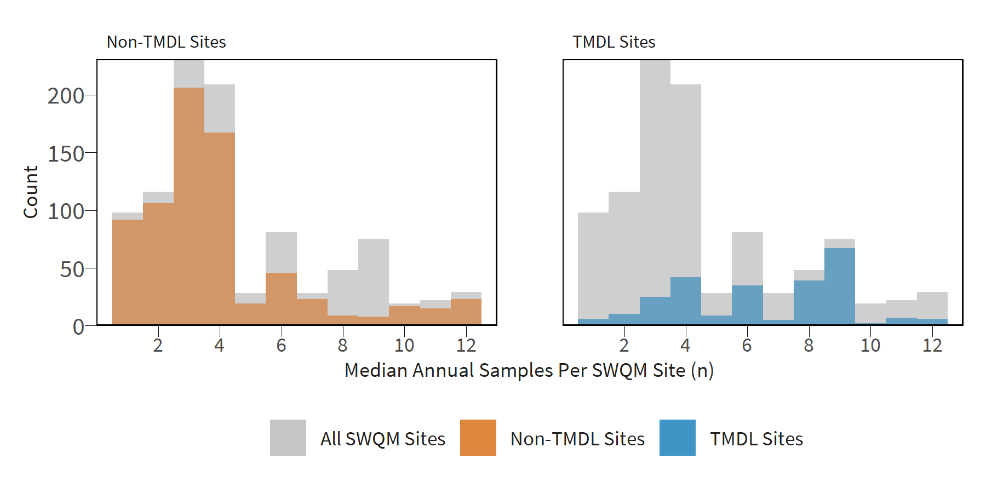

Figure : Histograms of annual *E. coli* sampling distribution for TMDL and non-TMDL SWQM sites across Texas.

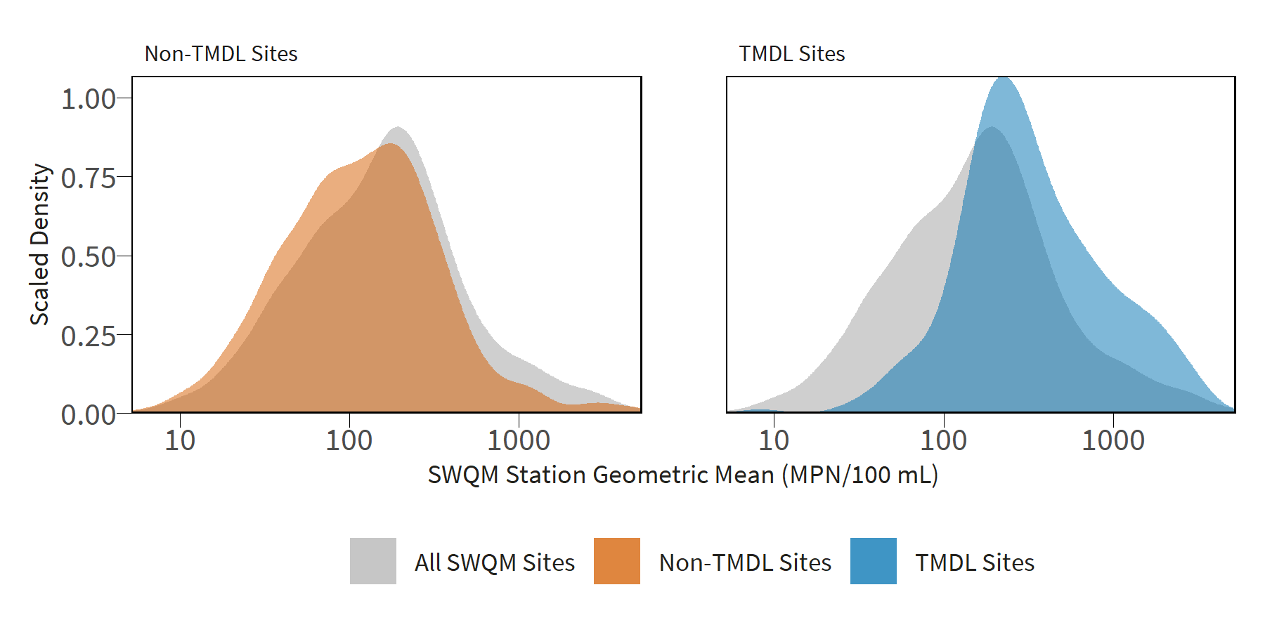

Figure : Scaled density plots of of *E. coli* geometric mean distribution for TMDL and non-TMDL SWQM sites across Texas.

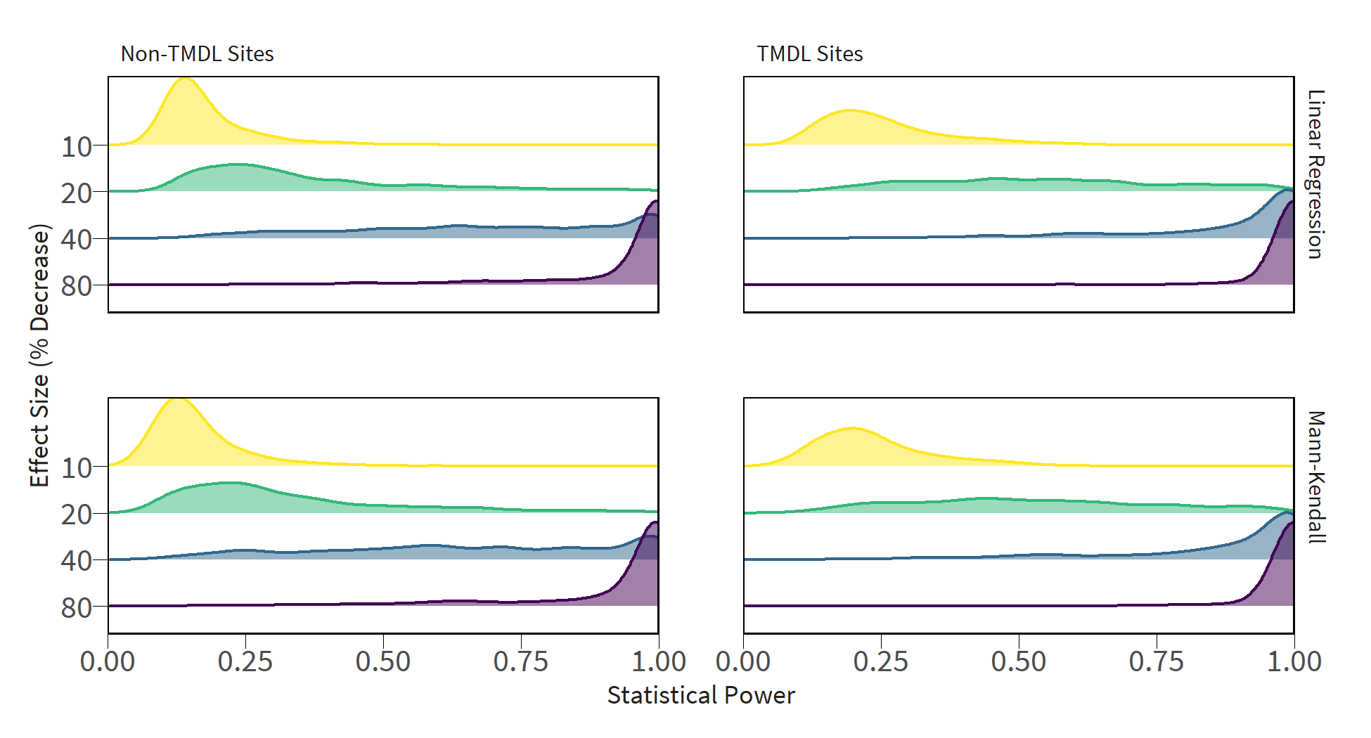

Figure : Scaled density plots of Mann-Kendall and GLM statistical power distribution for TMDL and non-TMDL SWQM sites as a function of effect size at ɑ = 0.1. Individual curves represent the scaled density estimate of statistical power values calculated for SWQM sites at a given effect size (y-axis values).

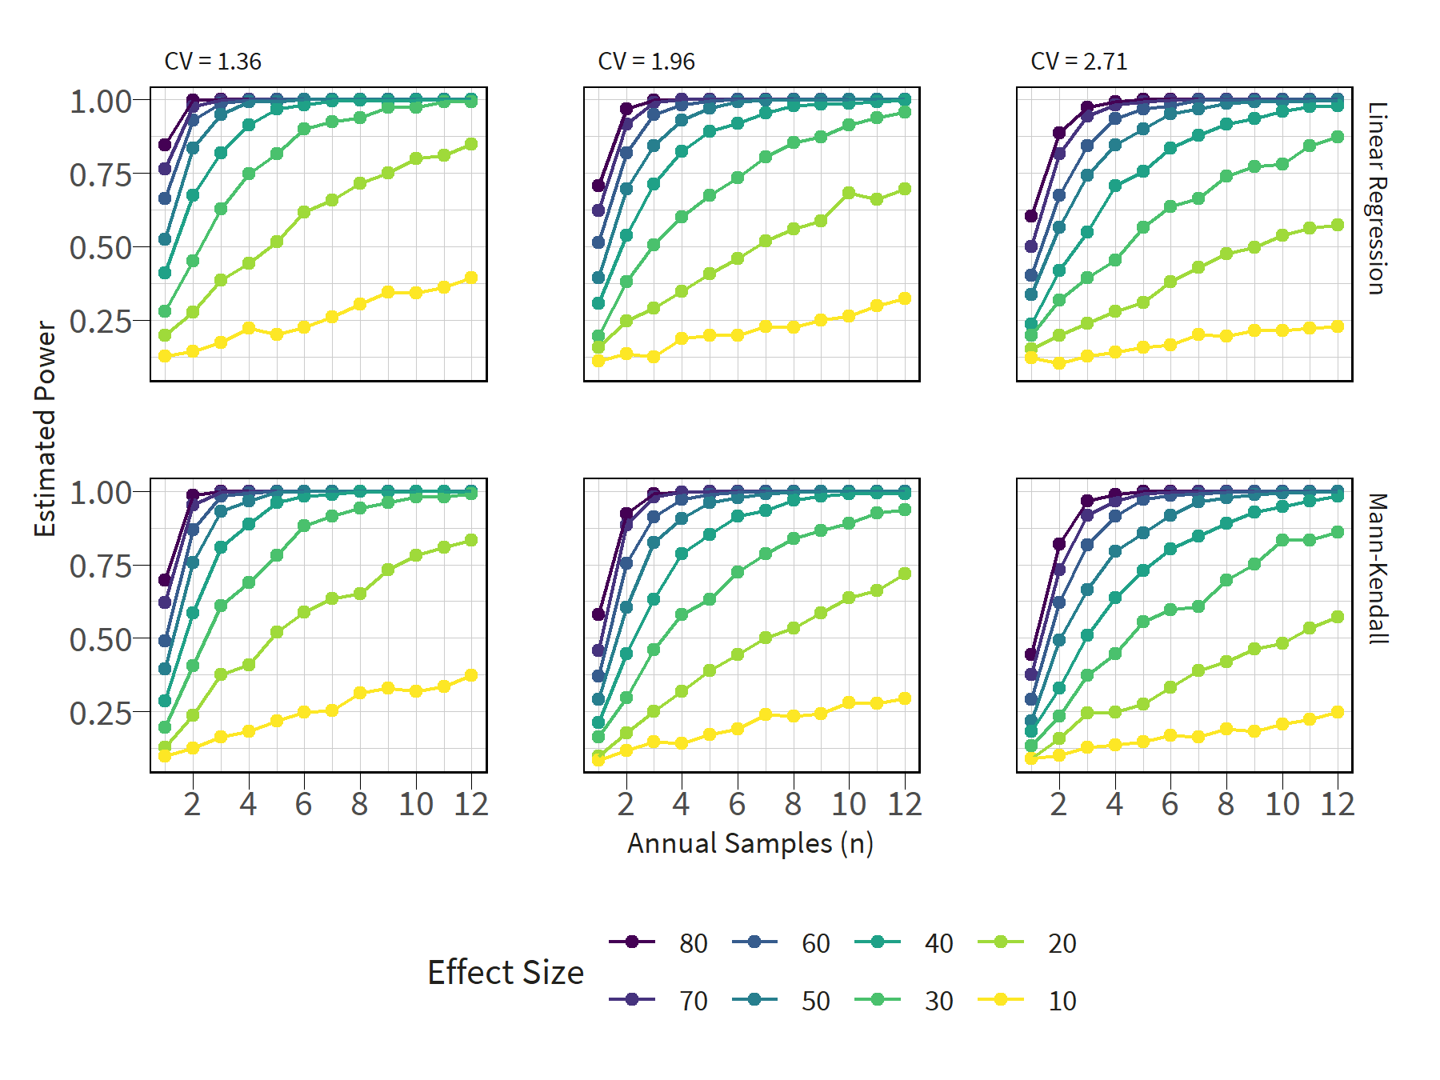

Figure : Estimated statistical power of Mann-Kendall linear regression trend tests at upper, middle, and lower quartiles of observed station *E. coli* variance.

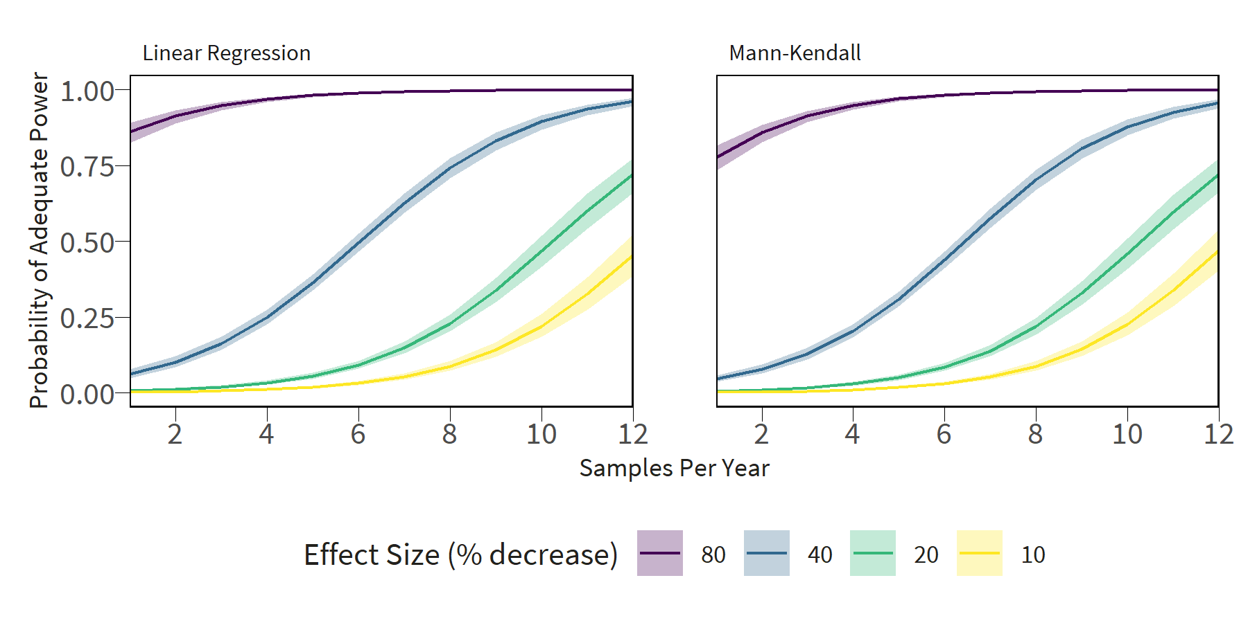

Figure : GLM marginal effects plots show the likelihood that a SWQM site has adequate statistical power for detecting trends as a function of the number of samples and desired detected effect size. CV is held constant at the mean.