**Lecture 08: DSB-SC Detection**

**COSTAS loop demodulation of DSB-SC**

**Reference – 01:** Rodger E. Ziemer, William H. Tranter-Principles of Communications, 7th Edition_ Systems, Modulation, and Noise-Wiley (2014)

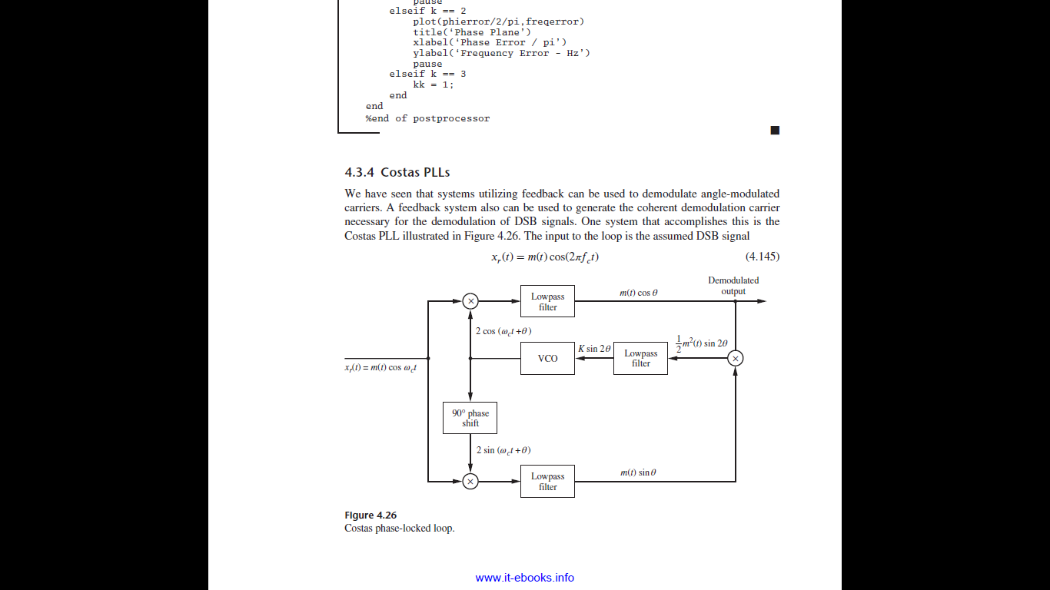

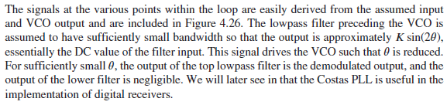

**Reference – 02: Communication System Bruce Carlson 4ed**

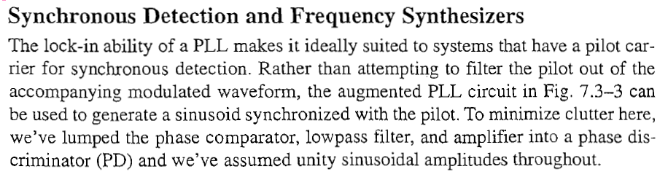

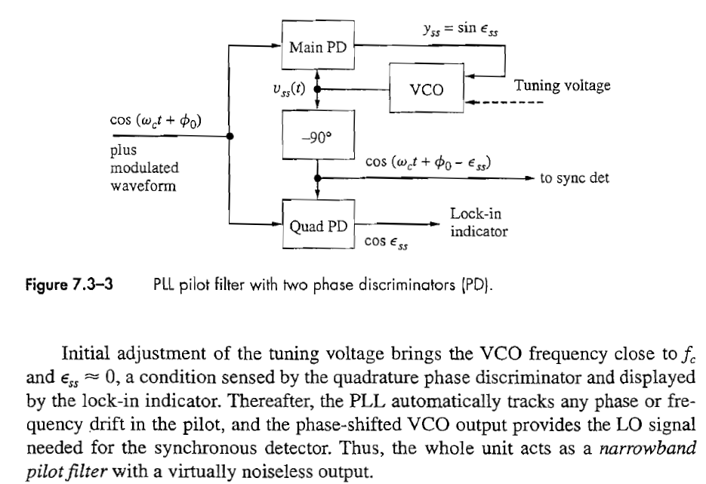

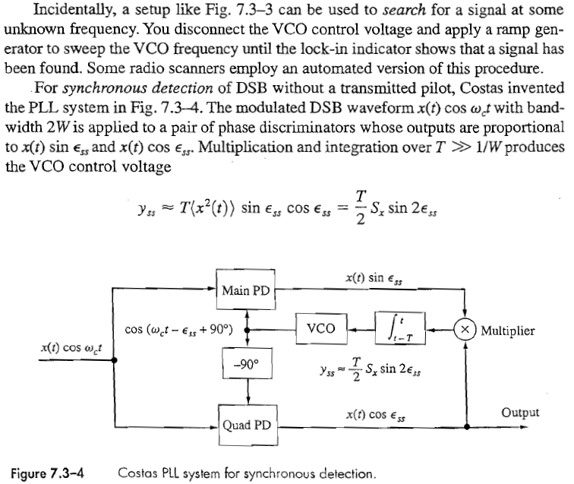

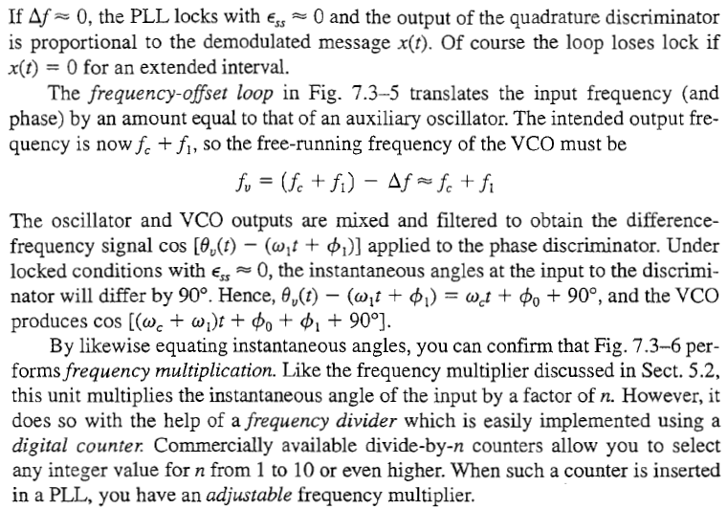

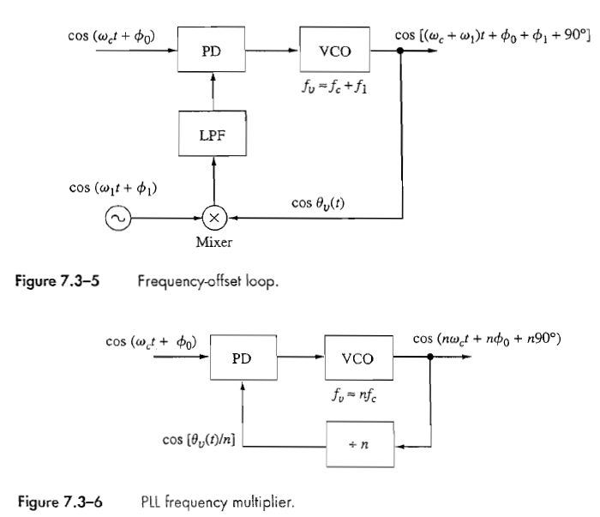

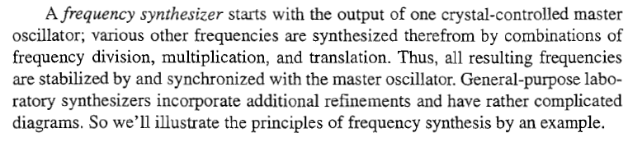

**Reference – 03: ECE 5625/4625 Communication Systems Notes by Dr Woickert**

