**Lecture 02: Modulation**

**Definition:** It is defined as the process by which some characteristic parameters of high frequency carrier signal is varied in accordance with the instantaneous value of another signal called modulating or message signal.

* High frequency signal is called carrier because it carries message signal.
* Message signal is called modulating signal because it modifies the carrier.

Modification of carrier can be possible on two ways:

* **Amplitude Modulation:** Amplitude of carrier is modulated according to the instantaneous value of message signal.
* **Angle Modulation:** Angle of carrier is modulated according to the instantaneous value of message signal.

More generally, angle θ=ωt+φ.

* **Frequency Modulation:** Modification in angle can be done with the help of modification of frequency, ω only (taking φ as constant)
* **Phase Modulation:** Modification in angle can be done with the help of modification of phase, φ only (taking as ω constant)

**Need For Modulation:**

The modulation can be needed

1. To translate the frequency spectrum
2. To multiplex the more number of signals
3. To reduce the antenna height
4. To reduce the noise & distortions
5. To narrow banding the signal.
6. **Frequency Translation**:

Consider the audio signal (20Hz to 20 KHz) transmission by radio broadcasting. All occupies the same band (as they all are audio signals), so without any proper technique all audio signals after transmission from radio station will be mixed and will not able to listen them.

But the solution is available when we transmit audio signals at different frequencies. This shifting of same frequency range signals at different frequency locations is called ***frequency translation or frequency conversion***.

It should be known that any spectrum can be easily shifted to any amount of frequency by multiplying a signal with any periodic signal of frequency $'ω_{c}'$ regardless of its waveform.

For example: v (t) = Ac t and band-limited message signal m (t) are multiplied then the resultant spectrum is translated spectrum of m (t), i.e.

F [m (t).v (t)] = $\frac{A_{c}}{2}$ [M (ω+ $ω_{c}$) + M (ω- $ω_{c}$)].

Thus audio frequency signal has been shifted at higher frequency ($ω_{c}$ > ω).

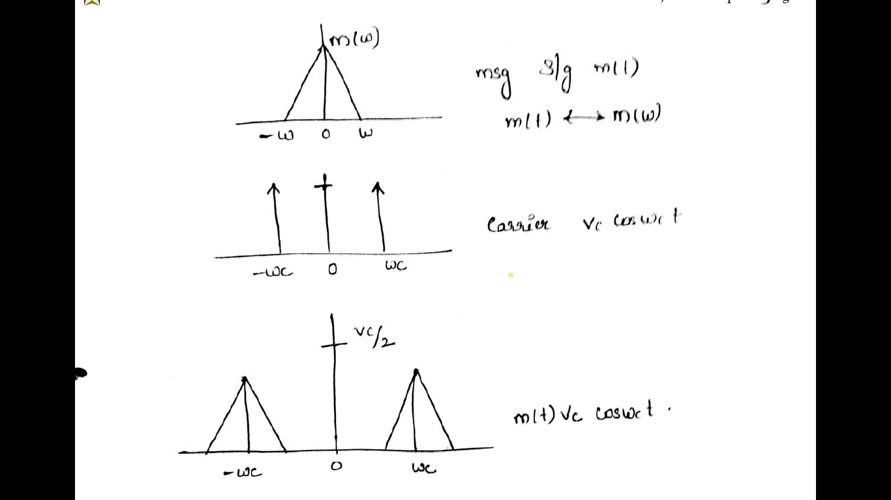

1. **Frequency Division Mulutiplexing:**

With the help of frequency translation, many audio signals of same frequencies can be shifted at different locations in spectrum. Now they can be easily sent on a single channel without overlapping and mixing with each other. This process is called ***multiplexing***.

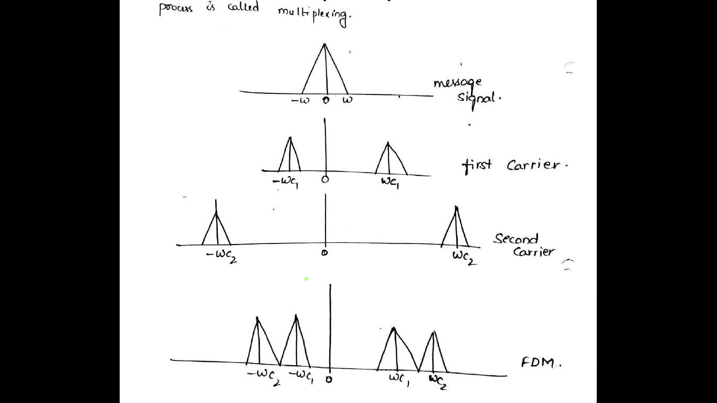

M (ω) has been transmitted by different radio broadcasting stations:

1st station using carrier = $V_{c1}cosω_{c1}t$,

2nd station using carrier = $V_{c2}cosω_{c2}t$.

So their combined spectrum taking assumption ωc2>ωc1.

1. **Practicability of antenna:** It is found practically that for proper receiving and transmitting of a signal, the antenna height should be in order of magnitude of wavelength of signal to be transmitted.

Ex: For a frequency of 1 KHz, antenna height required for effective radiation would be quarter the wavelength, i.e. antenna height = $\frac{λ}{4}$ = $\frac{C}{4f}$ = $\frac{3 X {10}^{8}}{4 X {10}^{3}}$ = 75Km.

Here, λ = wavelength of the signal to be transmitted, C = velocity of light, and

f = frequency of signal to be transmitted.

This shows that antenna height should be in the range of 75 Km which is totally impracticable.

This can be reduced by modulation in which A.F. signal is converted into R.F. This R.F. acts as carrier. Here 1 KHz message signal is translated to high frequency, for example, 1MHz.

Hence the required antenna height = $\frac{λ}{4}$ = $\frac{C}{4f}$ = $\frac{3 X {10}^{8}}{4 X {10}^{6}}$ = 75m.

This can be practically achievable.

1. **To reduce the noise and interference:** Sometimes effect of noise will be more at some frequency and effect will be less at some other frequency. If effect of noise is more at some particular frequency then by modulation the spectrum is shifted to high frequency where the effect of noise is less.
2. **Narrow Banding:** Suppose without modulation, a signal (audio) is transmitted then we have λmin = = =15 Km,

Andλmax =  = =15 Mm.

i.e. we need the antenna height variation from 1Km to 1Mm.

But if we modulate with 200MHz carrier: $f_{max}$ = $200 X {10}^{6}+20 X {10}^{3}$

And $f_{min}$ = $200 X {10}^{6}-20$.

So ${ λ}_{max}≈{ λ}_{min}≈1.5 m$.

That means with modulation to transmit audio signal (20-20KHz) we can use the same antenna. We have just changed wide band signal into narrow band signal.

**Frequency Division Multiplexing:**

An important signal processing operation is multiplexing, whereby a number of independent signals can be combined into a composite signal suitable for transmission over a common channel.

Voice frequencies transmitted over telephone systems, for example, range from 300 to 3100 Hz. To transmit a number of these signals over the same channel, the signals must be kept apart so that they do not interfere with each other, and thus they can be separated at the receiving end. This is accomplished by separating the signals either in frequency or in time.

The technique of separating the signals in frequency is referred to as ***frequency-division multiplexing*** (FDM), whereas the technique of separating the signals in time is called ***time-division multiplexing*** (TDM).

The incoming message signals are assumed to be of the low-pass type, but their spectra do not necessarily have nonzero values all the way down to zero frequency.

A block diagram of an FDM system is shown in fig. below.



Following each signal input, we have shown a low-pass filter, which is designed to remove high-frequency components that do not contribute significantly to signal representation but are capable of distributing other message signals that share the common channel. These low-pass filters may be omitted only if the input signals are sufficiently band limited initially.

The filtered signals are applied to modulators that shift the frequency ranges of the signals so as to occupy mutually exclusive frequency intervals. The necessary carrier frequencies needed to perform these frequency translations are obtained from a carrier supply. For the modulation, we may use any method of modulation. However, the most widely used method of modulation in FDM is single sideband modulation, which, in the case of voice signals, requires a bandwidth that is approximately equal to that of the original voice signal. In practice, each voice input is usually assigned a bandwidth of 4 KHz.

The band-pass filters following the modulators are used to restrict the band of each modulated wave to its prescribed range. The resulting band-pass filter outputs are next combined in parallel to form the input to the common channel.

At the receiving terminal, a bank of band-pass filters, with their inputs connected in parallel is used to separate the message signals on a frequency-occupancy basis. Finally, the original message signals are recovered by individual demodulators.

Note that the FDM system shown in fig. operates in only one direction. To provide for two-way transmission, as in telephony, for example, we have to completely duplicate the multiplexing facilities, with the components connected in reverse order and with the signal waves proceeding from right to left.

**Types of modulation:**

When the carrier wave is continuous in nature Continuous wave modulation

When the carrier wave is pulse in nature Pulse modulation