Starting point: the overall HE-Business Process Diagram

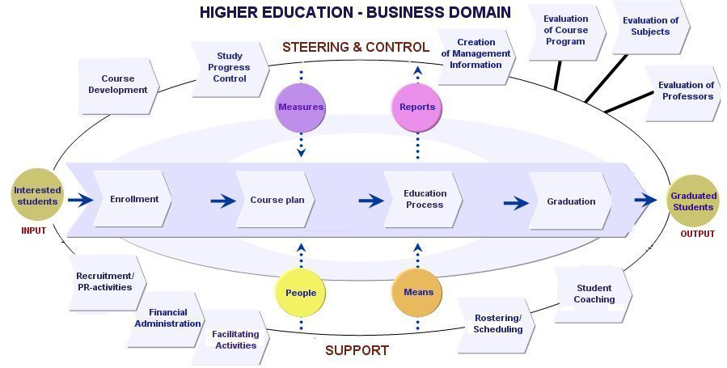

Overview of Use Cases within the various Business Processes.

BP: Enrolment (ENR)
- ENR1: Enroll in the university
- ENR2: Enroll in a study year
- ENR3: Enroll in (individual) courses

BP: Course Development (CD)
- CD1: Register a study
- CD2: Add courses to a study year
- CD3: Register a course

BP: Facilitating Activities (FA)
- FA1: Register organizational unit
- FA2: Register staff member

BP: Education Process
- EP1: Register test results
Use Case ENR1: enroll in the university (belongs to BP: Enrolment)

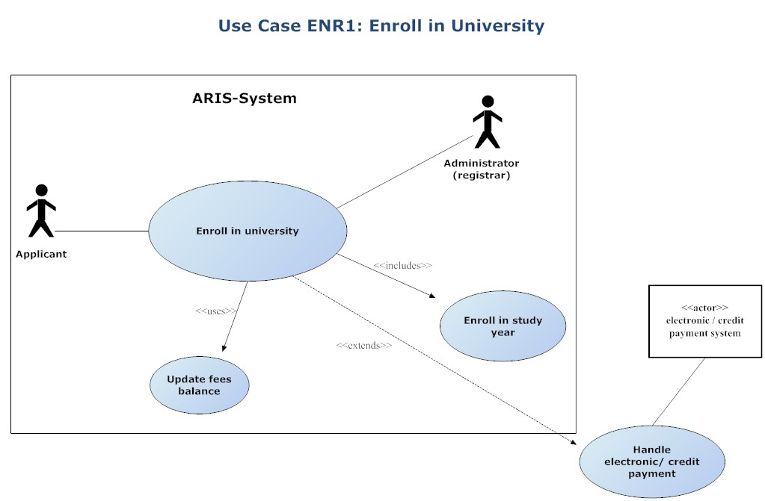

Goal: to register a new student at the university

Primary actor: applicant (to become a student)

Stakeholders and their interests:
- Student: wants to start university studies, and therefore wants to be registered properly for a given study.
- University: wants to have students registered in a uniform, structured way.
- Registrar: wants a smooth and efficient administration (registration) process, with minimal efforts and disturbances.

Pre-conditions:
- Basic data on studies already registered in the system, since a student always registers for a (at least one) study.
Post-condition: student properly registered for a study.

Happy Path (main scenario)
- Applicant present him/herself at the registrar administration desk.
- Registrar controls whether the applicant is eligible for application [BRENR1.1]
- Registrar hands over an application form to the applicant [Alt course A] [Alt course B].
- Applicant fills in the application form
- Registrar controls the application form (all required items filled in, in the correct way, according to BR’s) [Alt course C] [Alt course D].
- Registrar registers the form data in the system (“fees paid” not checked) [Alt course E] [Alt course F]
- System generates student ID
- System executes “enrollment in study year” component.
- System calculates fees.
- Applicant pays fees to registrar [BRENR1.2] [Alt course G] [Alt course H] [Alt course I] .
- Registrar makes the registration definitive, i.e. enters amount of fees paid and checks “fees paid” indication.
- System executes the “update fees balance” component.
- System produces a confirmation of registration and (including) a receipt of fees payment.
- Registrar hands over confirmation of enrolment and receipt of fees payment to the student.
Alternate course A: in case of an electronic application form
A3. Registrar indicates electronic form to applicant (PC, terminal)
A4. Applicant fills in the application form
A5. System controls the application form (all required items filled in, in the correct way, according to BR’s)
A6. System registers the form data (“fees paid” indication unchecked)
From here on (step 7) the main scenario executes.

Other alternative courses/extensions

Alternate course B: applicant not eligible to enrol in university
B3 Registrar informs student about reasons
B4 Use case ends unsuccessfully.

Alternate course C: Information not filled in or wrongly filled in and applicant has correct information available
C5a Registrar handles back the form to the student for correction
C5b Student corrects information
(below in case of electronic form)
C5a System warns student to correct information (in case of electronic form)
C5b Student corrects information
From here onthe main scenario (step 6) executes.

Alternate course D: information not filled in or wrongly filled in and applicant has information not directly available
D5a Registrar informs the applicant about the BR for supply of missing information [BRENR1.3.]

Alternate course E: Not all information available
E6a Registrar enters data with “Form complete” indication unchecked.
(below: in case of electronic form)
E6a System registers data with “Form complete” indication unchecked (in case of electronic form)
E6b System indicates deadline for providing missing information.
E6c1 Applicant provides missing data according to BR.
E6c2 Applicant does not provide missing data according to BR.
E7 Registrar deletes form
E8 use case ends unsuccessfully.

Alternate course F: preliminary exam needed
F6a Registrar enters data; “preliminary needed” indication checked
F6b. Registrar provides information (where, when, etc…) on the preliminary to student.
(below: in case of electronic form)
F6b System provides information (where, when, etc…) on the preliminary to student.
F6c Applicant (after taking the preliminary) provides preliminary result to registrar.
F7 In case of failure for preliminary: registrar deletes applicant information
F8 Use case ends unsuccessfully.
In case preliminary has been passed succesfully: main scenario (step 7) continues

Alternate course G: applicant pays fees electronically or by CC
G10a Applicant pays immediately on line or by credit card
G10b System invokes “Handle credit/electronic payment” component.
From here on the main scenario (step 10) executes.

Alternate course H: student cannot pay now and (wants to) pay(s) later
H10a. Student indicates he/she wants to pay later
H10b Registrar informs the student about modalities for payment [BRENR1.2]
H10c Student pays (at a later time)
H10d Student comes back to the registrars office with receipt of payment document.
From here on the main scenario (step 10) executes.

Alternate course I: student does not pay (enough or in time)
I10 Student does not pay
I11 Data deleted from system
I12 Use case ends unscuccessfully.

Use Case ENR2: enroll in a study year (belongs to BP: Enrolment)

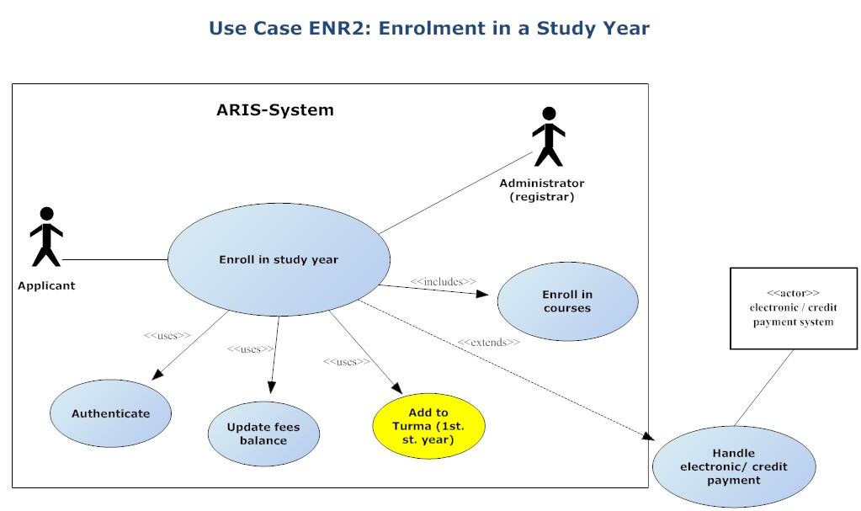
Goal: to register a student for a given study year.

Primary actor: student

Stakeholders and their interests:
- Student: wants to be registered properly for a given study year.
- Faculty/department (responsible unit for the study): wants to have students registered for each year in a uniform, structured way.
- Registrar: wants a smooth and efficient administration (registration) process, with minimal efforts and disturbances.

Pre-conditions:
- Basic data on curricula structure and individual courses for the study year in question already registered in the system.
Post-condition: student properly registered for a study.

Happy Path (main scenario)
- Student goes to an ARIS-authorized work station and starts up the ARIS.
- Student authenticates him/herself through the authentication component (log in).
- Student starts up the “enrol in study year” component.
======== here start the process steps also used in the “enrol in university” use case ==========
- Student indicates for which study and study year he/she wants to register.
- System checks whether student is eligible for the study year in question [BRENR2.1][ BRENR2.2] [Alt course A]
- System executes “enrolment in courses” component for all compulsory courses of the study year.
- System presents the “compulsory from list” courses for the given study year with their BR's to the student for choice [BRENR2.3]
- Student picks courses from the list.
- System executes “enrolment in courses” component for the picked courses.
- System registers (saves) study year data for the student in question (“fees paid” not checked).
- System executes “add to turma” component in case of 1st study year [BRENR2.4]
- System calculates fees and informs student about fees to be paid [BRENR2.5]
========= here end the process steps also used in the “enrol in university” use case ==========
- Student pays fees to the registrar [BRENR2.5] [Alt course B] [Alt course C] [Alt course D]
- Registrar makes the registration definitive, i.e. enters amount of fees paid and checks “fees paid” indication.
- System executes “update fees balance” component.
- System produces a confirmation of registration and a receipt for the payment of fees.
- Registrar hands over the confirmation and the fees receipt to the student.

Alternative courses/extensions

Alternate course A: Student is not eligible.
A5 Systems detects student is not eligible
A6 System informs student about reason.
A7 use case ends unsuccessfully.

Alternate course B: applicant pays fees electronically or by CC.
B13a Applicant pays immediately on line or by credit card.
B13b System invokes “Handle credit/electronic payment” component.
From here on the main scenario (step 14) executes.

Alternate course C: student (wants to) pay later.
C13a Student indicates he/she wants to pay later.
C13b Registrar informs the student about modalities for payment (BR: how and when it should be done).
C13c Student pays (at a later time).
C13d Student comes back to the registrars office with receipt of payment document.
From here on the main scenario (step 14) executes.

Alternate course D: student does not pay (enough or in time).
D13 Student does not pay.
D14 Data deleted from system.
D15 Use case ends unscuccessfully.

Use Case ENR3: enroll in (individual) courses (belongs to BP: Enrolment)

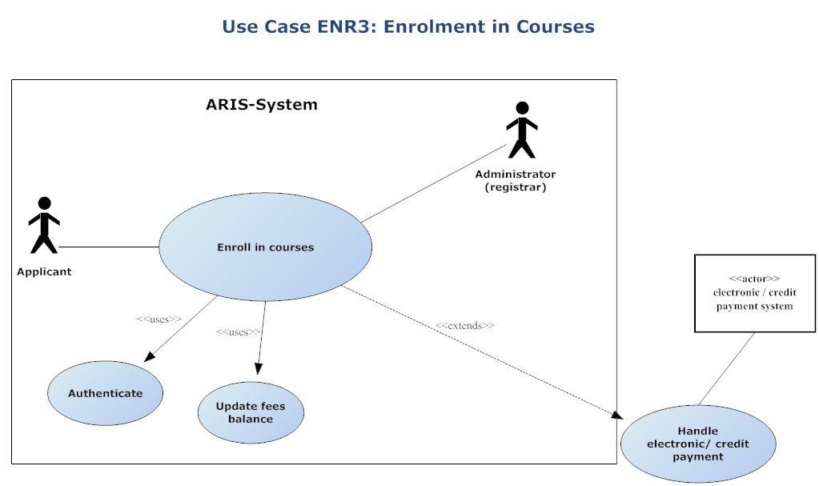
Goal: to register a student for given course(s).

Primary actor: student

Stakeholders and their interests:
- Student: wants to register for a given course (free to choose, otherwise.
- Faculty/department (responsible unit for the study): wants to have students registered for each year in a uniform, structured way.
- Registrar: wants a smooth and efficient administration (registration) process, with minimal efforts and disturbances.

Pre-conditions:
- Basic data on curricula structure and individual courses for the study year in question already registered in the system.

Post-condition: student properly registered for a study.

Happy Path (main scenario)
- Student goes to an ARIS-authorized work station and starts up the ARIS
- Student authenticates him/herself through the authentication component (log in).
- Student starts up the “enrol in a course” component.
- Student indicates study and study year he/she is currently in
- System presents a list of available courses to choose from
- Student picks the courses he/she wants to enrol in
- System checks whether student is eligible for the courses in question [BRENR3.1 – a.b.c] [Alt course B]
======== here start the process steps also used in the “enrol in study year” use case ==========
- System adds student to the courses
========= here end the process steps also used in the “enrol in study year” use case ==========

- System calculates fees [BRENR2.3] [Alt course A]
- Student pays fees to the registrar [BRENR2.3] [Alt course C] [Alt course D] [Alt course E]
- Registrar makes the registration definitive, i.e. enters amount of fees paid and checks “fees paid” indication.
- System executes “update fees balance” component.
- System produces a confirmation of registration and a receipt for the payment of fees.
- Registrar hands over the confirmation and receipt of fees payment to the student.

Alternative courses/extensions

Alternate course A: No fees required.:
This applies when the chosen courses fit within the framework of the “free to choose courses” space of a study year. In this case the fees for the chosen courses is already included in the study year fee.
9. System produces a confirmation of registration
10. Use case ends successfully.

Alternate course B: Student is not eligible.
B7 Systems detects student is not eligible
B8 System informs student about reason.
B9 use case ends unsuccessfully.

Alternate course C: applicant pays fees electronically or by CC.
C10a Applicant pays immediately on line or by credit card.
C10b System invokes “Handle credit/electronic payment” component.
From here on the main scenario (step 11) executes.

Alternate course D: student (wants to) pay later.
D10a Student indicates he/she wants to pay later.
D10b Registrar informs the student about modalities for payment (BR: how and when it should be done).
D10c Student pays (at a later time).
D10d Student comes back to the registrars office with receipt of payment document.
From here on the main scenario (step 11) executes.

Alternate course E: student does not pay (enough or in time).
E10 Student does not pay.
E11 Data deleted from system.
E12 Use case ends unscuccessfully.

Use Case CD1: register study (curricula) (belongs to BP: Course Development)

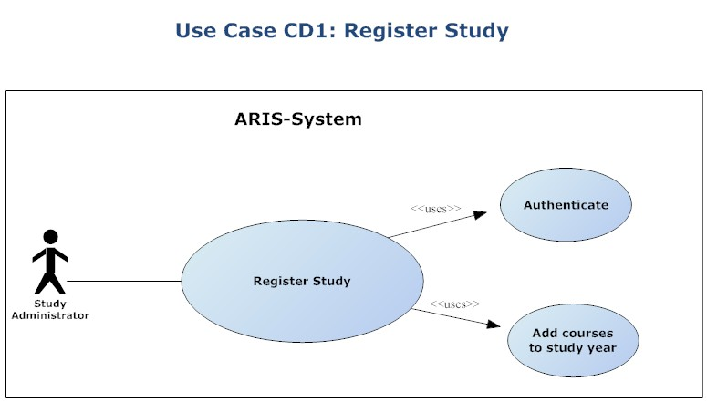

Goal: to register the structure and content (in terms of courses involved) of a study in the ARIS system.

Primary actor: study administrator

Stakeholders and their interests:
- Faculty/department (responsible unit for the study): wants to have the study properly registered.
- Study administrator: wants a smooth and efficient administration (registration) process, with minimal efforts and disturbances.
- Students: need proper information on structure and content of studies to put together their course or study plan.

Pre-conditions:
- Basic data on individual courses involved in the study already registered in the system.
- Basic data on (responsible) unit (faculty, department, etc…) already registered in ARIS.

Post-condition: study information properly registered.

Happy Path (main scenario)
- Study administrator (SA) starts up the ARIS.
- SA authenticates him/herself through the authentication component (log in).
- SA starts up the “Study administrator functions” component.
- SA indicates he/she wants to register a new study.
- System presents the “New study: basic information” form
- SA fills in the basic information on the new study.
- System registers (saves) the basic information, including the compulsory courses for all the study years.
- System starts up the “Add course blocks” component.
- System saves information.

Use Case CD2: add courses to study year (belongs to BP: Course Development)

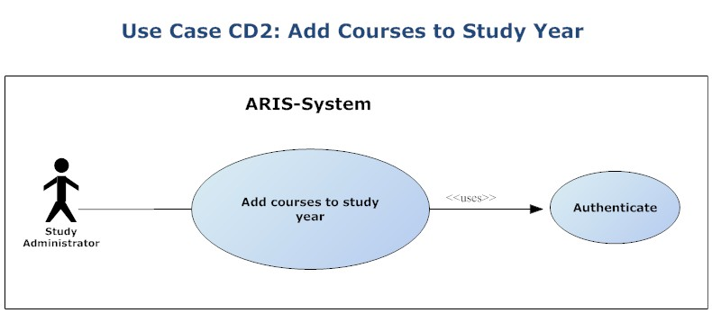

Goal: to register courses for a given study year of a given study (in other words: to link courses to a given study year)

Primary actor: study administrator

Stakeholders and their interests:
- Faculty/department (responsible unit for the study): wants to have it’s studies properly structured, meaning a correct division of the courses which constitute the study over the various study years and their semesters.
- Study administrator: wants a smooth and efficient administration (registration) process, with minimal efforts and disturbances.
- Students: need proper information on structure and content of studies to put together their course or study plan.
- Professors: need to know where their courses are situated in the study curricula.

Pre-conditions:
- Basic data on individual courses involved in the study already registered in the system.
- Basic data on (responsible) unit (faculty, department, etc…) already registered in ARIS.

Post-condition: study structure and content, in terms of study years and semesters, properly registered.

Happy Path (main scenario)
- Study administrator (SA) starts up the ARIS.
- SA authenticates him/herself through the authentication component (log in).
- SA starts up the “register/update courses to study years” component.
- SA indicates the study and study year for which he/she wants to add courses
======== here start the process steps also used in the “register study” use case ==========
- System shows “basic study year information” form
- SA fills in the form
- System presents the “block of courses for study year” form .
- SA checks the courses on the form which are compulsory for the study year in question and adds the business rule. [BRCD2.1]
- System saves the basic and the compulsory courses information
- System presents again the “block of courses for study year” form. [Alt course A] [Alt course B]
- SA checks the courses which form a “compulsory courses from list” block and adds the business rule which applies for the block. (to be repeated for each block) [BRCD2.2]
- System saves the compulsory from list information
- System presents the “Free choice space” form where the BR concerning the “free choice” criteria has to be formulated. [Alt course C]
- SA fills in the BR which applies to the “Free choice space” for that study year [BRCD2.3]
- System saves information.

Alternative courses/extensions

Alternate course A: All courses in the study year are compulsory.:
A9. System saves information, and
A10. Use case ends successfully.

Alternate course B: There are only compulsory courses and a “free choice” space, so NO “compulsory from list” blocks.:
B9. System saves information, and
Use case continues from main step 13 on.

Alternate course C: There is no “fee choice space”.
C12 System saves information, and
C13 Use case ends succesfully

Use Case CD2: add course block (to a study) (belongs to BP: Course Development)
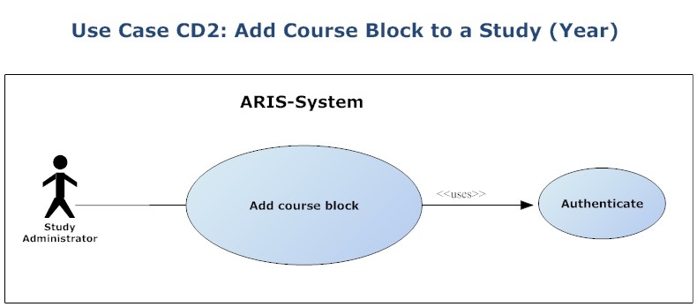

Goal: to register blocks of courses for a given study year of a given study, necessary when a structure of a study year exists in which students have to choose a number of courses out of a list (block) or when there is the opportunity for students to fill in a number (block) of “free choice” courses themselves.

Primary actor: study administrator

Stakeholders and their interests:
- Faculty/department (responsible unit for the study): wants to have it’s course blocks properly registered, since this is necessary to appropriately reflect the study structure in a given study year.
- Study administrator: wants a smooth and efficient administration (registration) process, with minimal efforts and disturbances.
- Student: need proper information on the exact structure and content of a study to put together his/her course or study plan.
- Professors: need to know where their courses are situated in the study curricula.

Pre-conditions:
- Basic data on individual courses involved in the study already registered in the system.
- Basic data on (responsible) unit (faculty, department, etc…) already registered in ARIS.
Post-condition: course blocks properly registered for the study years of a study.

Happy Path (main scenario)
- Study administrator (SA) starts up the ARIS.
- SA authenticates him/herself through the authentication component (log in).
- SA starts up the “Register Course Blocks” component.
- System shows the “Choose study and study year” form
- SA indicates the study and study year for which he/she wants to register course blocks
- ======== here start the process steps also used in the “register study” use case ==========
- System presents the “Add course block” form .
- SA fills in the form, including the business rule which applies for the block. (to be repeated for each block) [Alt course A] [BRCD2.2]
- System saves the compulsory from list block information
- System presents the “Add course block” form. [Alt course B]
- SA fills in the form, including the BR which applies to the “Free choice space” for that study year [BRCD2.3]
- System saves information.

Alternative courses/extensions

Alternate course A: There is only “free choice” block, so NO “compulsory from list” blocks.:
B8. System presents the “Free choice space” form where the BR concerning the “free choice” criteria has to be formulated. [Alt course C]
B9. SA fills in the BR which applies to the “Free choice space” for that study year [BRCD2.3]
B10 System saves information.

Alternate course B: There is no “fee choice space”.
C9 System saves information, and
C10 Use case ends succesfully
Use Case CD3: register a (individual) course (belongs to BP: Course Development)
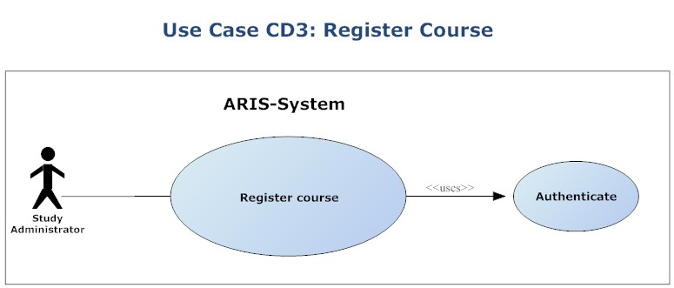

Goal: to register information about an individual course.

Primary actor: Course administrator (can be a professor, secretary, registrar, etc…)

Stakeholders and their interests:
- Faculty/department (responsible unit for the course): wants to have its courses properly registered.
- Course administrator: wants a smooth and efficient administration (registration) process, with minimal efforts and disturbances.
- Professors: need the courses they give properly registered.
- Students: need proper information on individual offered to put together their course or study plan.

Pre-conditions:
- Basic data on (responsible) unit (faculty, department, etc…) already registered in ARIS.
- Basic data on academic staff members (professors) already registered.

Post-condition: course information properly registered.

Happy Path (main scenario)
- Course Administrator (CA) starts up the ARIS.
- CA authenticates him/herself through the authentication component (log in).
- CA starts up the “register course” component.
- System presents the “New course” form
- SA fills in the information on the course. [BRCD3.1.]
- System saves information.

Use Case FA1: register organizational unit (belongs to BP: Facilitating Activities)
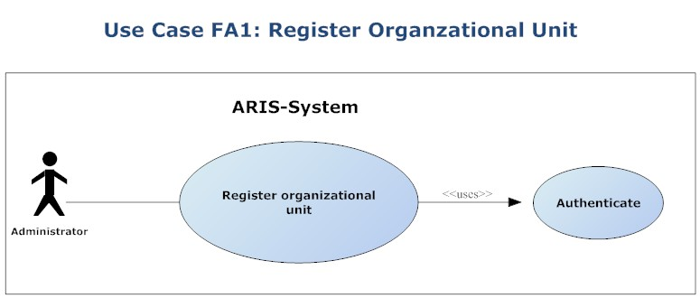

Goal: to register an organizational unit within the HE-institution

Primary actor: administrator (central or decentral)

Stakeholders and their interests:
- Institution: wants to have its organizational structure and units properly registered
- Organizational unit: wants to have its information properly registered and available for interested parties.
- Administrator: wants a smooth and efficient administration (registration) process, with minimal efforts and disturbances.

Pre-conditions: none

Post-condition: organizational unit (or_gunit) properly registered.

Happy path
- Administrator (ADM) starts up the ARIS.
- ADM authenticates him/herself through the authentication component (log in).
- System presents the “Administrator functions” form
- ADM starts up the “enter organizational unit” function.
- System presents the “New organizational unit” form.
- ADM fills in the information on the org_unit.
- System saves information
Use Case FA2: register staff member (belongs to BP: Facilitating Activities)

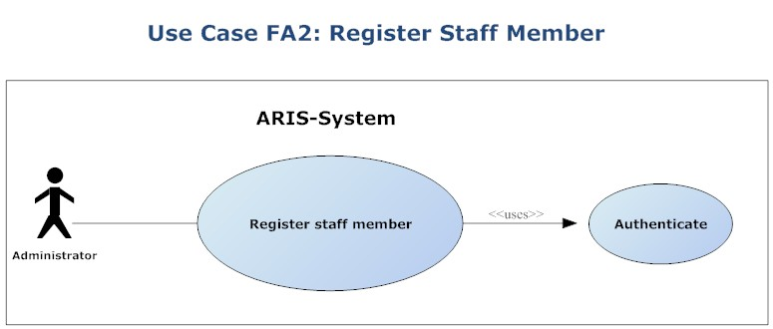

Goal: to register a staff member, appointed at an organizational unit within the HE-institution

Primary actor: administrator (central or decentral)

Stakeholders and their interests:
- Institution: wants to have the information on its personnel properly registered
- Organizational unit: idem
- Administrator: wants a smooth and efficient administration (registration) process, with minimal efforts and disturbances.

Pre-conditions: (information on) organizational units already existing in the system.

Post-condition: staff member properly registered.

Happy path
- Administrator (ADM) starts up the ARIS.
- ADM authenticates him/herself through the authentication component (log in).
- System presents the “Administrator functions” form
- ADM starts up the “enter staff member” function.
- System presents the “New staff member” form.
- ADM fills in the information on the staff member.
- System saves information,
(to be repeated for every staff member)

Use Case EP1: register test result (belongs to BP: Education Process)

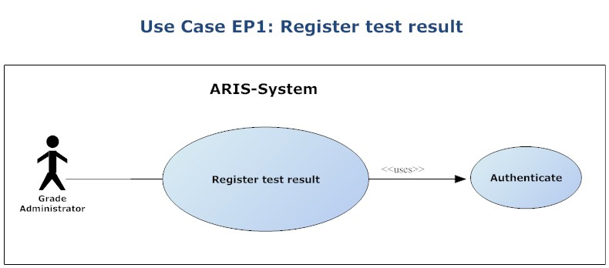

Goal: to register the result (mark) a student obtained for a given test (test = (sub)event of an exam)

Primary actor: grade administrator (professor, secretary, etc…)

Stakeholders and their interests:
- Institution: wants to have the marks of students properly registered and available for statistics and evaluations.
- Organizational unit: idem
- Student: wants his/her marks properly and securely stored and available in order to keep track of his/her personal study career and progress.
- Professor: wants the marks of all his/her students properly stored and available for overviews, statistics, evaluations etc...
- Grade Administrator: wants a smooth and efficient administration (registration) process, with minimal efforts and disturbances.

Pre-conditions:
- (information on) Courses already registered in the system.
- Information on which students follow which courses already registered (= enroll in courses process finished for all students).
- (information on) Possible types of test already registered (e.g. partial test, final test, etc…)
- Business rule concerning the decision on marks for the test in question clearly formulated and registered.

Post-condition: student mark on a test properly registered.

Happy path
- Grade administrator (GADM) starts up the ARIS.
- GADM authenticates him/herself through the authentication component (log in).
- System presents the “Grade Administrator functions” form
- GADM starts up the “enter test results” function.
- System presents the “Test Result” form.
- GADM fills in the information on the marks of the student for the test in question [BREP1.1.]
- System saves information,

