note |  |  |  | Version: | 2 2012-03-17
Subject | Functional Design Bank Interface CBU
To | CBU Bursary, CBU CICT, CBU Focal Points
CC | opus User Group, Ed Simons, Markus Pscheidt
From | Monique in het Veld | [date] | [doccodeuci]
 | move

General Description

CBU has an interface between ZANACO bank and Dimensions (financial system). From Dimensions an export is made to the current STURECO system with the relevant student information concerning invoices and student balances. All actual transactions and handling of invoices and their payments is done in Dimensions.

a. Import from Dimensions into Opus
CBU wishes to make a view on the information from Dimensions for Opus. Below a visual interpretation of the desired connections.

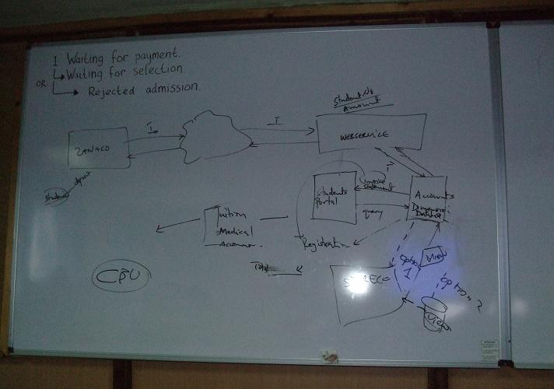

Dimensions is used by CBU to impose invoices on students based on their fees. The invoices concern all fees for a student for an academic year (no breakdown possible !). The transaction type of these invoices is INV.
A student can pay more than one invoice at once or just a part of an invoice, so it is not possible to say for which invoice a student is paying. Payments are simply done bottom-up (oldest ones first).

To establish a view on this information per student in the Opus database a number of intermediate tables is created, which will be populated by a push action from Dimensions. This includes invoices imposed on student and the him / her together with the balance of a student and the payments made.

Note that the fees themselves are not stored in Dimensions at CBU. They are only kept on paper by Academic Office. They may use the fee module to store the information, but there will be no direct connection between the financial balance of the students and the fees imposed on him/her in Opus.

Opus will store information on student balances and invoices from January 1 2012 on. If a necessity is established in the coming period for more archive information that has to be elaborated more.

b. Export from Opus for Dimensions
The second task is to create an export function from Opus that shows a summary of limited information of all new students to the university (students that apply for admission the first time). This information is stored into Dimensions once and is not updated afterwards anymore.
The format of the information is Excel, so it can be a report generated from Opus.
TODO: Pastor sends the exact information needed by Dimensions.

Import from Dimensions into Opus

a. Transaction Storage

CBU Module:

FinancialTransactionTmp: store the transaction records from dimensions
- Id unique id, generated by the Opus system
- TransactionTypeId type of transaction (see list)
- FinancialRequestId transaction reference
- TimestampProcessed moment of transaction
- StudentId CBU studentId of the student
- NationalRegistrationNumber nrc
- Amount amount
- Name student name
- RequestString description
- ProcessedToFinancialTransaction (y/n) ‘N’
- Writewho automatically generated
- Writewhen automatically generated

StudentBalanceTmp: store the student balance records from dimensions
- Id unique id, generated by the Opus system
- StudentId CBU studentId of the student
- FinancialRequestId transaction reference
- BalanceBefore balance before change (+ or -)
- BalanceAfter balance after change (+ or -)
- TimestampProcessed moment of balance
- ProcessedToStudentBalance (y/n) ‘N’
- Writewho automatically generated
- Writewhen automatically generated

The possible types of transaction are:
INV Invoice
PAY Payment
CRN Credit Note (e.g. reversed invoice)
ACR Credit adjustment
ADR Debit adjustment

College Module:

FinancialTransaction: store the FinancialTransactionTmp records
- Id unique id, generated by the Opus system
- TransactionTypeId type of transaction (see list)
- FinancialRequestId transactionId of Zanaco
- RequestId <not used>
- StatusCode <not used>
- ErrorCode <not used>
- StudentId CBU studentId of the student
- NationalRegistrationNumber nrc
- AcademicYear <not used>
- TimestampProcessed automatically generated
- Amount amount
- Name (??) student name
- Cell (??) <not used>
- RequestString description
- ProcessedToStudentbalance (y/n)
- ErrorReportedToFinancialBankrequest (y/n) ‘Y’ -> not used

StudentBalance: store the StudentBalanceTmp records
- StudentId CBU studentId of the student
- FeeId <not used>
- StudyplancardinaltimeunitId <not used>
- StudyplandetailId <not used>
- AcademicyearId <extract by Opus from payments>
- Exemption (Y/N) ‘N’
- Balance (new attribute !)

Together this forms this picture, in which the relations between the CBU module and Opus are explained:
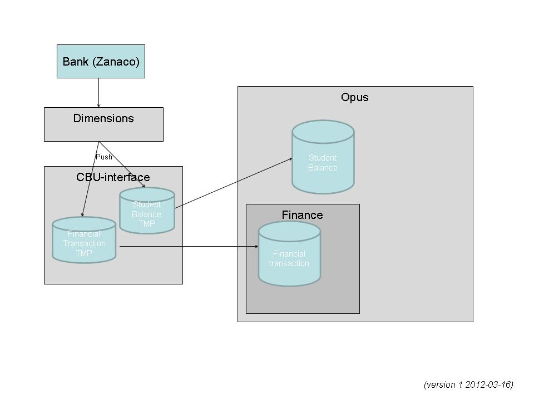

b. Progressing the intermediate transactions and studentbalances

From the financial system Dimensions there will be a push of information concerning the student finances (bank transactions and studentbalances) into intermediate tables in the Opus database.
Once stored in these tables Opus will pick ‘new’ information up on a scheduled basis (to start with: twice a day) and import it into the related opus tables.

After the information is progressed to the Opus tables an automatic check must be made on the balances of students. If they are zero, the student will be able to progress to the next status in both admission and continued registration flow: Waiting for payment -> Waiting for selection.

Changes in Opus:
- creation of new intermediate tables to store the push information from Dimensions
- programming the scheduled transition from the intermediate tables to the Opus tables (financialTransaction, studentBalance). In this transition the correct academicyear to which the invoice, payment etc. apply must be retrieved in Opus.
- programming a view on the transitioned information in Opus, this means disable the ability in financialTransaction.jsp and studentFinancialTransactions.jsp to edit this information. This is best done by adding an application configuration attribute (suggested name: financialInformationEditable Y/N) and use that attribute on this page.
- Progressing the status of a student in admission flow and continued registration flow automatically from ‘waiting for payment’ to ‘waiting for selection’ when the balance is within the business rules outlined underneath. First a check must be done whether a student is in the status ‘waiting for payment’ in admission flow. If that is not the case, then the continued registration flow must be viewed.

Business rules balance for progression:
- if a student is on 100 % GRZ sponsorship, their balance must be zero
- if a student is on 75 %, 50 % or 25 % sponsorship, they should have paid at least 75 % of their fees. Any carried forward balance above this threshold will result in not being cleared to register – the system will automatically bar them
- if a student is on self or private sponsorship, they should have paid 50 % of the current invoices. Any carried forward balance above this threshold will result in not being cleared to register – the system will automatically bar them.

c. Authorisation & Security

Dimensions has a direct access to the opus database and pushes information into the intermediate tables. Authorization and security to prohibit illegal access to the database by other users is an issue that CBU will solve themselves, this is no concern for Opus.

- Export from Opus for Dimensions

Details will come from Pastor.
From Opus a report in excel format will be generated, based on these details.

