Extension point concept overview

The extension point mechanisms as described here is based on Eclipse.

There are two elements that have to work together (see figure):
- Extension points: are defined by a module that shall be extended with unknown functionality by other modules. The core module defines several extension points.
- Extensions: these implement functionality that fits to the specification of extension points. Modules that implement extensions are often called plugins.

Note: Plugins themselves can also define extension points, for which other modules can provide extensions.

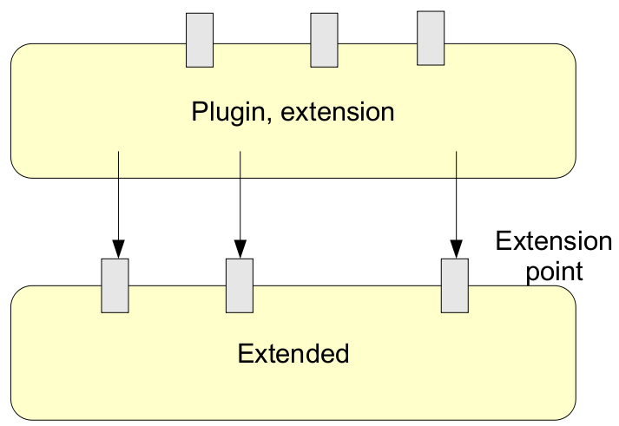Illustration 1: From Prof. Uwe Aßmann: "Eclipse and Framework Extension Languages"
Major challenges for the Opus project are to find ways to
- formulate specifications for extension points, and
- declare extesions
in a manner that fits into the Spring framework and is easily readable.

What follows is a design for extension points definition and extension implementation. Furthermore, it is shown how extensions are processed.

Explanations are given based on a specific example: putting the “Fast Input” screen in a separate module.

Defining extension points
The definition of extension points is done through interfaces in a specific package. In this case we define an extension point called “AddStudentScreen”. Its meaning is to allow to add (“plugin”) further screens to add students to Opus, besides the main, detailed, add-student screen. The fast-input screen as it has been designed for the Mozambican context, is one alternative way to add students. Other add-student screens may be useful in the future. Therefore this exension point exists.

package org.uci.opus.college.web.extpoint;

public interface AddStudentScreen {

/**
* The title, which will be used as the menu item.
* Note: this is the I18n key that is looked up in the message file.
* @return
*/
public String getTitleKey();

/**
* The description, which is a bit more informative than the title.
* It will be shown as a hint when the mouse is over the menu item.
* Note: this is the I18n key that is looked up in the message file.
* @return
*/
public String getDescriptionKey();

/**
* The web URL that will be used when the menu is selected.
* @return
*/
public String getHref();

}

Table 1: Extension point "AddStudentScreen"

Implementing extensions
To implement the fast-input screen as an extension (plugin) in any module, a bean is defined in the applicationContext:

[...]
<!-- beans that implement the extension (located in the 'remote' module) -->
<bean id="fastInputExtension" class="org.uci.opus.college.web.flow.FastInputExtension"/>
[...]
Table 2: applicationContext of module that implements the extension

The bean has to be implement the interface of the extension point (see previous chapter):

package org.uci.opus.college.web.flow;

import org.uci.opus.college.web.extpoint.AddStudentScreen;

public class FastInputExtension implements AddStudentScreen {

public String getHref() {
return "/college/fastinput.view";
}

public String getTitleKey() {
return "jsp.menu.fastinput";
}

public String getDescriptionKey() {
return "jsp.menu.title.fastinput";
}

@Override
public String toString() {
return getTitleKey() + ":" + getHref();
}

}
Table 3: The extension bean source code

Processing extensions
After defining the extension point (in the special extenstion point package) and the declaration of an extension, what is left is to integrate the extension into Opus.

First, in the CollegeWebExtensions class add a set that aggregates all extension that implement the extension point interface. The @Autowired tag will automatically inject all beans that implement this interface. This Spring feature comes in handy at this point.

package org.uci.opus.college.web.extpoint;

import java.util.Set;

public class CollegeWebExtensions {

private static Logger log = Logger.getLogger(CollegeWebExtensions.class);
private Set<AddStudentScreen> addStudentScreenExtensions;

@Autowired(required=false)
public void setAddStudentScreenExtensions(Set<AddStudentScreen> studentScreenExtensions) {
this.addStudentScreenExtensions = studentScreenExtensions;
logExtensions(studentScreenExtensions);
}

public Set<AddStudentScreen> getAddStudentScreenExtensions() {
return addStudentScreenExtensions;
}
[...]
}
Table 4: The set of all extensions that implement the addStudentScreen extension point interface

Finally, the actual integration into the Opus source code is highly dependent on the extension point. In this case, we want to add a menu entry in the student – add menu. Note the foreach loop:

[...]
<li><a href="#" class="MenuBarItemSubmenu"><fmt:message key="jsp.general.add" /></a>
<ul>
<li><a href="<c:url value='/college/student.view?tab=0&panel=0&searchValue='/>" class="MenuBarItemSubmenu" title="<fmt:message key='jsp.menu.title.detailed' />"><fmt:message key="jsp.menu.detailed" /></a></li>

<c:forEach var="addStudentScreenExtension" items="${collegeWebExtensions.addStudentScreenExtensions}">
<li><a href="<c:url value='${addStudentScreenExtension.href}'/>" class="MenuBarItemSubmenu" title="<fmt:message key='${addStudentScreenExtension.descriptionKey}' />"><fmt:message key="${addStudentScreenExtension.titleKey}" /></a></li>
</c:forEach>
</ul>
</li>
[...]
Table 5: menu.jsp: integration of the add-student-screen extensions into the menu structure

Further notes
The CollegeWebExtensions bean is defined in the applicationContext of the core module. Each module that defines extension points shall have its own extensions bean.
<!-- the container for extensions that extend this module -->
<bean id="collegeWebExtensions" class="org.uci.opus.college.web.extpoint.CollegeWebExtensions">
</bean>
Table 6: The container for extensions is also a bean (applicationContext-web-extensions.xml)

The collegeWebExtensions bean needs to be available to other beans and JSP pages. This is currently done through the StartController, which puts the collegeWebExtensions into the session.
The snippet within the StartController:
protected ModelAndView handleRequestInternal(HttpServletRequest request,
HttpServletResponse response) throws Exception {
[…]
@Autowired private CollegeWebExtensions collegeWebExtensions;
[…]
session.setAttribute("collegeWebExtensions", collegeWebExtensions);
[…]
Table 7: Putting collegeWebExtensions to the session

