note |  |  |  | Version: | 4 2012-02-22
Subject | Flow for continued registration process
To | Opus User Group
CC | Ed Simons, Markus Pscheidt
From | Monique in het Veld | [datum] | [doccodeuci]
 | move

Continued registration Flow

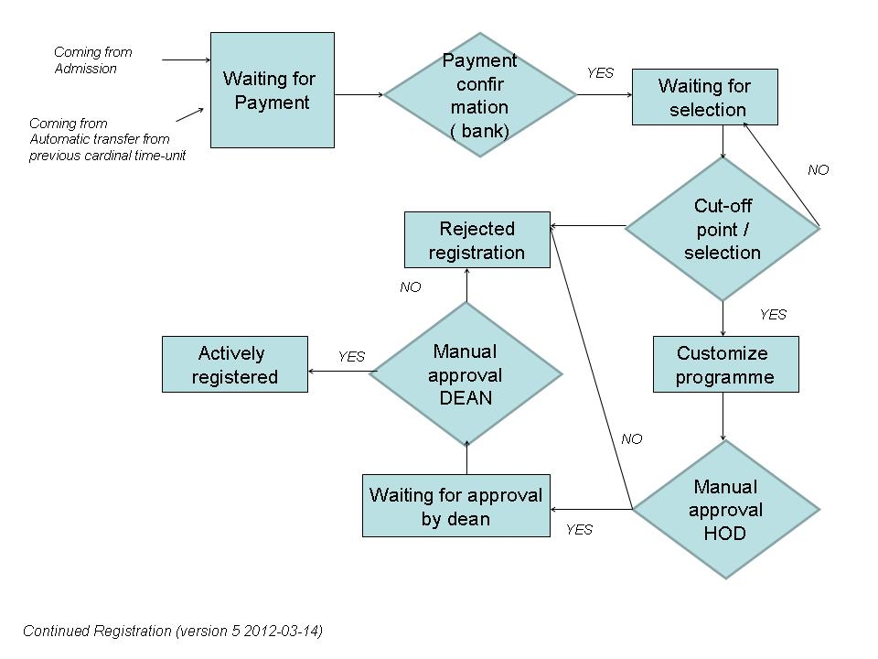

Identified steps in continued registration:
Action / phase | Input | Result - Status in flow | Who sets status
Start continued registration | Progress status / Transfer students | Waiting for payment continued registration | Automatically set by the system
Confirmation of payment | Bank (Zanaco) / Financial Office | Waiting for selection (cut-off point or elsewise) | Financial Office / Dean
Waiting for selection | HOD / Dean | Customize programme (electives, exemptions) | Dean / HOD
Customize programme | Student / HOD / Dean | Waiting for approval of registration | HOD / Dean
Manual approval HOD … Review customized student study years/semesters/trimesters | HOD / Dean | Manual Approval Dean | HOD
Manual approval Dean … Approve formally | HOD | Actively registered / Rejected registration | Dean
Request for Change (not implemented yet !) | Student / HOD / Dean | - | Dean
Rejected registration | Financial Office / Dean | - | -
Actively registered | Dean | - | -

Note: registry can perform all steps of the process.

Progress statuses in continued registration:

Status code | Status | Continuing | Increment | Graduating | Carrying
01 | CP - Clear Pass | Y | Y | N | N
03 | R - Repeat Academic Year | Y | N | N | A
04 | P - Proceed | Y | Y | N | N
14 | S - Suspended | N | N | N | N
15 | E - Expelled | N | N | N | N
19 | PT - At part-time | Y | N | N | S
22 | EU - Exclude University | N | N | N | N
23 | WP - Withdrawal with permission | Y | N | N | A
25 | G - Graduate | N | N | Y | N
27 | PR - Proceed and Repeat | Y | Y | N | S
29 | TPT - To part-time | Y | N | N | S
31 | FT - To full-time | Y | Y | N | N
34 | ES - Exclude school | N | N | N | N
35 | EP - Exclude program | N | N | N | N
37 P | WTP - Withdrawal Without Permission | N | N | N | N
53 | DE - Deferred Examinations | N | N | N | N

Continuing : yes means not expelled or withdrawn …
Increment : proceed to the next cardinal time unit
Graduating : is this step the final one in a study programme
Carrying : do you take courses from the previous step in the study programme with you to the next or repeated cardinal time unit:
N: NO
A: ALL
S: SELECTED (ONLY FAILED COURSES)

