note |  |  |  | Version: | 2 2011-08-24
Subject | Flow for admission process
To | Opus User Group
CC | Ed Simons, Markus Pscheidt
From | Monique in het Veld | [datum] | [doccodeuci]
 | move

Admission Flow

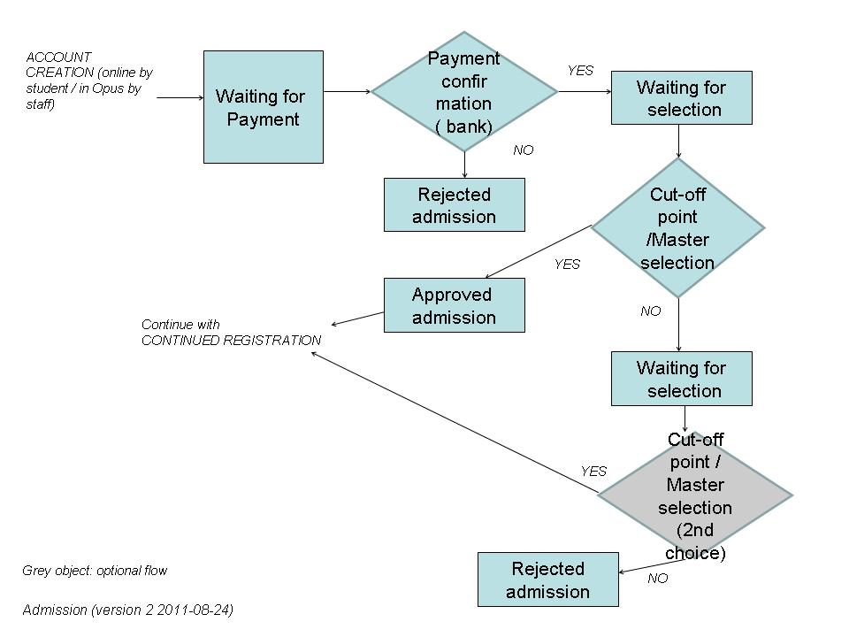

Identified steps in admission:
Action / phase | Input | Result - Status in flow | Who sets status
< Registered online / through fast input > | Student / Academic Office | Waiting for payment | Automatically set by the system
Waiting for payment | Bank (Zanaco) / Financial Office | Waiting for selection (cut-off point / selection master students) | Financial Office / Academic Office
Waiting for selection | HOD / Dean | Approved admission / Rejected Admission | HOD / Dean / Academic Office
Rejected admission | HOD / Dean / Academic Office Financial Office | - | -
Approved admission | HOD / Dean / Academic Office | - | -
Temporarily inactive | ?? | - | -
Graduated | ?? | - | -
Withdrawn | ?? | - | -

Note: registry can perform all steps of the process.

