note |  |  |  | Version: | 2 2007-09-14
Subject | SecurityModel OPUS-College
To | Ed Simons
CC | Gerbrand ten Napel, Wim van Zanten
From | Monique in het Veld | [datum] | [doccodeuci]
 | move

Role based security J2EE
For Opus-College we will use the role-based security which J2EE supplies.

When you are developing a J2EE application, you don’t need to know what categories
of users have been defined for the realm in which the application will be
run. In the J2EE platform, the security architecture provides a mechanism for
automatically mapping the roles defined in the application to the users or groups
defined in the runtime realm. After your application has been deployed, the
administrator of the Application Server will map the roles of the application to
the users or groups of the file realm, as shown below in Figure 1.
In the case of Opus-College our users and roles will be stored in the database and extracted through the context of the application (see: META-INF/context.xml).

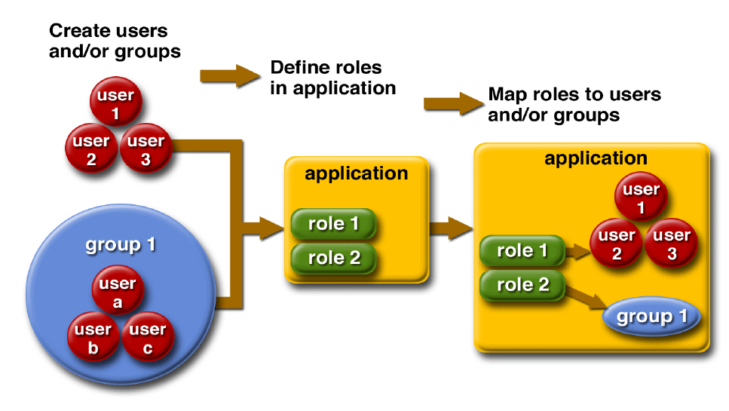
Figure 1 Role Mapping

Form-based security
There are several options for the role-based security within J2EE. We will choose the Form-based security.

With form-based authentication, the following things occur:
1. A client requests access to a protected resource.
2. If the client is unauthenticated, the server redirects the client to a login
page.
3. The client submits the login form to the server.
4. If the login succeeds, the server redirects the client to the resource. If the
login fails, the client is redirected to an error page

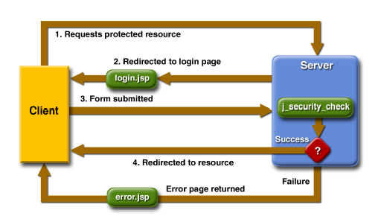
Figure 2 Form-based authentication

Security in the application
In the application the security will find it’s way in both the JSP’s as the JAVA code as follows:
- JSP’s: specific parts of JSP-pages will be visible for specifically authorized people. These authorizations are role-based.
- JAVA: all requests on methods will be checked for the right authorization (role-based). This will be done through a Service Delegate pattern. This pattern consists of a delegate object that handles all requests from the web layer and decides where to send the request.

The users and their authorisation will be saved in a special table in the database. Their credentials together with their roles will supply the right view on the application.

Roles
The known roles so far are:
- Admin
- Admin-C
- Admin-D
- guest
- staff/teacher
- student

