Flexible user roles in Opus

There are two different parts: a) the structure of privileges; b) assigning privileges to users

Defining structure of privileges with “role” profiles

Screen
Simply a list of roles, clicking on a role one can edit a role. With + a new role can be created
When editing a role, a list of all privileges is shown, and specific privileges can be selected or deselected.

Database tables
Name of table | Description | Columns | Example
OPUSPRIVILEGE | Lookup-Table of all possible privileges | (Lookup-Table) | Print result slip  Alter study plan
OPUSROLE | The name of a role profile | name; active | Student  Dean
OPUSROLE_PRIVILEGE | Define which privileges belong to which role | role-id; privilege-code; | Student is allowed to print result slip  Dean is allowed to alter study plan

List of (some) privileges (Table OPUSPRIVILEGE):

Admission

Registration

View academic results

Enter academic results

View history of academic results

View bursary information

Enter bursary information

View history of bursary information

Quota allocation

View/Print student lists

View/Print class lists

View/Print curricula

View/Print student cards

View/Print registration slips

View/Print result slips

View/Print statistics

View/Print semester comments

View/Print mark sheets (pauta)

View/Print publication list

View/Print results

View/Print results (incl. withheld)

Create/modify opususer accounts

Edit lookup tables

[...]

Assigning roles to users

Screen
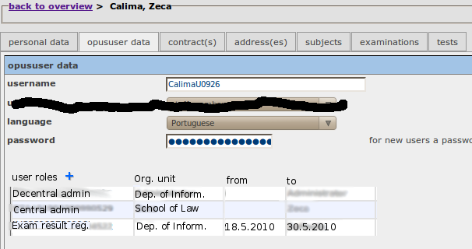

Database tables
Name of table | Description | Columns | Example
OPUSUSER | Login, Password, preferred language for staff members | person-id; username; password; preferred language
OPUSUSERROLE | Link opus-users with one or more roles. Roles can be temporary | opususer-id; role; orgunit-id; start date; end date

Notes:
- “preferred language” moves from OPUSUSERROLE to OPUSUSER

