note |  |  |  | Version: | 1 2010-05-27
Subject | Install Manual OPUS-College environment - LINUX
To | Ed Simons
CC | opus User Group
From | Monique in het Veld  Frits de Vries  Caspar Terheggen | [date] | [doccodeuci]
 | move

This document is meant for the SYSTEM ADMINISTRATOR and the DEVELOPER

0. Get install-files from the opus college website

All (or most) install-files in this document can be fetched from the opus college website:

http://www.opuscollege.net/
Go to the menu: SUPPORT

Also update-files in the future can be fetched from this website.

1. Installation of Linux

This document concerns the installed Linux distribution of RedHat, minimum version ???.

Note: this document uses the VMWare-cluster Lusaka.uci.ru.nl. Firewall of this cluster is ndola.uci.ru.nl.
Opus WA OTA: 192.168.100.22
Opus DB OTA: 192.168.100.23

Admin / v1ct0r1a
Ssh-console: ndola.uci.ru.nl
Port: 22060 (WA), 22061 (DB)

2. Installation of JDK 1.6.x

The latest version of the JDK is installed from the RedHat Distribution.
Check if this is at least version 1.6 with:
java -version
You should see something like:
version “1.6.0_21″
Java(TM) SE Runtime Environment (build 1.6.0_21-b05)
Java HotSpot(TM) Server VM (build 1.6.0_21-b05, mixed mode)

3. Installation of Tomcat 6.0.x

Tomcat 6.0. is installed from the RedHat Distribution.
(Note: You can also use the bin-file, delivered in the installation package on www.opuscollege.net.)

yum install tomcat6
Note: all the configuration that is done manually in the ubuntu-install is here done by this yum install. Including init.d for stop / start tomcat as a service.
You can manage the memory the server will use by altering the /usr/share/java/apache-tomcat-6.0.29/bin/Catalina.sh file. Alter the following line:
JAVA_OPTS=%JAVA_OPTS% -D...

Change it to:
JAVA_OPTS=%JAVA_OPTS% -Xmx512M -D...

Add tomcat manager user to configuration
Open the file <apache-tomcat-6.x.x>conf\tomcat-users.xml. Activate the roles/users part. Add a new role ‘manager’. And add a new user with any name you like with the role ‘manager’. Now you can go to the web-page and click the url Tomcat manager. You can log in with the credentials you provided in the users-file.
You can now undeploy / deploy WAR-files etc. through the web browser instead of having to go to the server.

Add security attributes to web.xml and context.xml configuration of tomcat
Open the file ..\apache-tomcat-6.0.29\conf\web.xml. Find the <session-config> tag.
Add the following attributes underneath <session-timeout>30</session-timeout>:

<session-max>1028</session-max>
<enable-url-rewriting>false</enable-url-rewriting>
<reuse-session-id>false</reuse-session-id>

Open the file ..\apache-tomcat-6.0.29\conf\context.xml. Find the <session-config> tag.
Add the following tag in the bottom of the file:

<useHttpOnly>true</useHttpOnly>

Configure the opusCollege database as JNDI data source
Open <apache-tomcat-6.0.29>/conf/server.xml. Add the following <Resource> definition under the <GlobalNamingResources> tag:

<GlobalNamingResources>
[…]
<Resource name="jdbc/opusCollege" auth="Container"
type="javax.sql.DataSource"
driverClassName="org.postgresql.Driver"
url="jdbc:postgresql://opusdb:5432/opusCollege"
username="postgres" password="123koffie"
maxActive="20" maxIdle="10" maxWait="-1"/>
[…]
</GlobalNamingResources>
NB: Change the password according to your postgres password!

4. Extend host-file with opusdb
Add ‘opusdb’ to your hostfile by doing the following:
vi /etc/hosts
Extend the line with localhost (or add a new line when there is no localhost line) with the following:
127.0.0.1 localhost opusdb
Note: if your database is not on the same server as your webserver, then do not extend the line with 127.0.0.1, but add a new line with the correct i.p.-address, for instance:
123.456.999.1 opusdb

5. Environment variables
After this you need to setup the global environment variables in /etc/profile file for all users. Therefore type the following in the shell:
vi /etc/profile
Add these lines at the bottom of the file (with INSERT)
export JAVA_HOME=/<install-dir jdk>
export JRE_HOME=/<install-dir jdk>//jre
export CATALINA_HOME=/usr/share/java/apache-tomcat-6.0.29
export PATH=$JAVA_HOME/bin:$PATH
Exit the file with:
<ESC>
:wq
Then restart the server OR type:
source /etc/profile
Test if Java environment is successfully installed by typing in this in the shell:
java -version
You should see something like:
version “1.6.0_21″
Java(TM) SE Runtime Environment (build 1. 6.0_21-b05)
Java HotSpot(TM) Server VM (build 1.6.0_21-b05, mixed mode)

Also try typing:
$JAVA_HOME
It should show the java-directory:
/usr/share/java

Check if the installation has succeeded by opening a browser and type: http://<server-name>:8080/

6. Install the postgresql jdbc driver into tomcat

Install postgresql-jdbc:
yum install postgresql-jdbc
ln –s /usr/share/java/postgresql-jdbc.jar /usr/share/tomcat5/server/lib/postgres-jdbc.jar

Give the correct privileges. Go to the following directory:
/<install-dir>/apache-tomcat-6.0.29/server/lib/

Type:
chmod 644 postgresql-jdbc-8.4-701.jdbc4.jar

7. Installation of Postgres 8.4.x

The PostgreSQL installation is part of the VMWare / Redhat server configuration. Do the following:
(Note: You can also use the bin-file, delivered in the installation package on www.opuscollege.net.)

yum install postgresql84-server
service postgresql initdb
service postgresql start
chkconfig postgresql on

After a check if the server-installation has succeeded, login as postgres user.

Then check if the file /var/lib/pgsql/data/pg_hba.conf is extended with a list of trusted hosts. These are the hosts that need to have access to the database (the webserver and the range of developers workstations that will use pg-admin to administer the database).

Host all all 131.174.66.177/32 password
Host all all 127.0.0.1/32 password

And in the file /var/lib/pgsql/data/postgresql.conf you have to check if the listen_addresses are outcommented and altered to the following:

Listen_addresses = ‘*’

After these changes restart PostgreSQL.

8. Create the database with pgAdmin

Open pgAdmin to connect to the server. If there is no server created, create one manually:
Name: PostgreSQL Databaseserver 8.4
Hostname: localhost
Maintenance db: postgres
User: <opusdb-user>
Password: <opusdb-password>

Create in the databaseserver the database in PostgreSQL manually:
CREATEDB opusCollege UTF8 owner postgres tablespace pg_default;

OR create the database through the graphical interface of pgadmin:
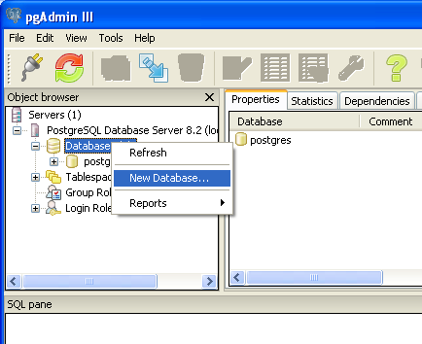
Figure 1: Right click on "Databases" and choose "New database..."

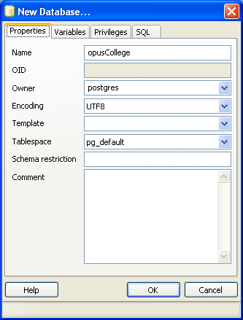
Figure 2: Enter the value as shown in the picture to create the opusCollege database

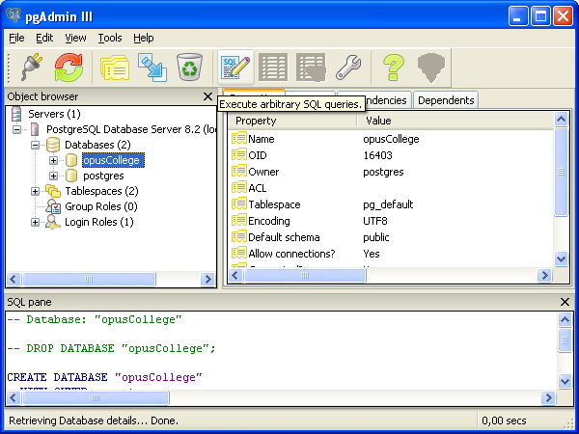
Figure 3: Choose database "opusCollege".

First you do the initial install of the opuscollege schema and the college module, in the directory: installation_files_server_admins_V3.0\database_scripts
you will find all necessary files.

Step on the database opusCollege and choose the icon SQL with the pencil.
This opens an sql-query-editor. To add the language plsql to the database you first have to open and execute the file 30_000_opuscollege_version30_plpgsql.sql
as follows:
pgAdmin -> sql editor -> file -> open -> search for file below -> run

Then step on the database opusCollege again and right-click. Choose restore and go to the following file:
30_001_opuscollege_version30_cleandump.backup

If you encounter errors on this script (asking for user pgsql82), then do the following:
Create Postgresql login role: pgsql82

To fill the database with the default values for initial institutions and some lookup tables you then have to execute:
30_005_opuscollege_version30_cleaninsert.sql
Note: for all insert-scripts you have to make sure they are in UTF-8. If they are not, you can alter them as follows:
Linux: Edit the file with vim.
Type the following:
:set
You see all configuration, including:
fileencoding=latin1
fileencodings=utf-8,latin1
To change the encoding, press ENTER and type the following:
:set fileencoding=utf-8
Then save the file, it will now be saved in the new encoding.

If you want to install some of the modules, you should also execute the sql-files which belong to that specific module:

200-299-range: fee
300-399-range: scholarship
400-499-range: report
500-599-range: alumni
???-???-range: mozambique
???-???-range: zambia

Note: always execute the files in ascending order following their numbers.

In the course of the project there will be new update-files again. You can execute them from the directory:
update_files_server_admins\

In the update files the same ranges of numbers are being maintained, so if you are not installing any of the modules, you don’t have to install update files in the range of those modules.

9. Upload the war file into tomcat's webapps dir

Upload the war file to the tomcat webserver:
cp /<install-dir>/<last-update>/war/eSURA.war /usr/share/java/apache-tomcat-6.0.29/webapps/

Check if it works, therefore browse to: http://<servername>:<port>/eSURA
(e.g. http://localhost:8080/eSURA)

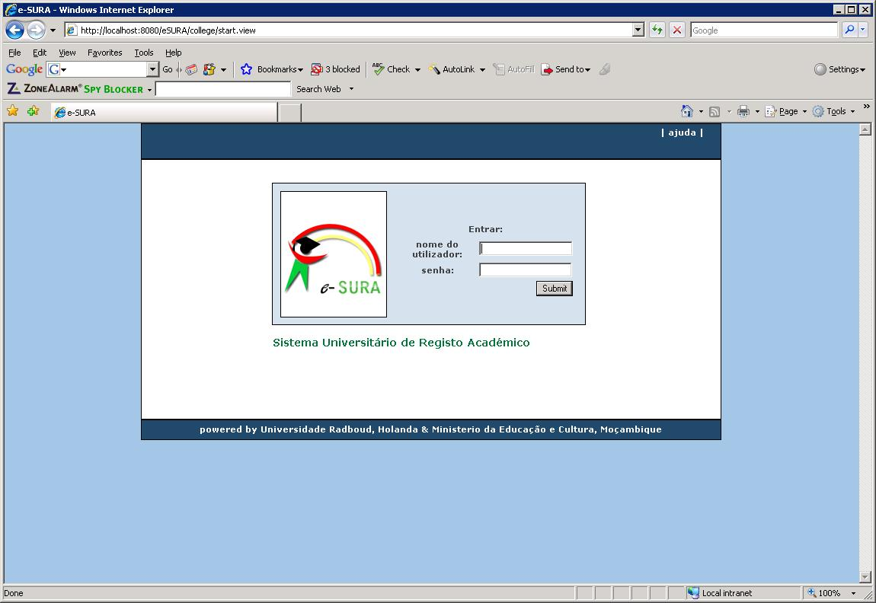
Figure 2: Open your browser and go to http://localhost:8080/eSURA to see if the deployment has been successful

Note: if you need to reinstall the war-file, the best is to do this through the Tomcat management console. But if you are deleting the files themselves, then do not forget to remove all these:

/<tomcat-dir>/webapps/eSURA/ < and all underlying directories >
/<tomcat-dir>/webapps/eSURA.war
/<tomcat-dir>/conf/Catalina/localhost/eSURA.xml (automatically generated !!)

10. Inspect the log file

Use the tail command in following mode (always use the log file of the current day):
tail -f /var/log/tomcat6.0/catalina.<current-date>.log

Note: see an example of the log-file of Karol in the document:
Logfile_installation_OPUS-College_environment_LINUX.doc

11. Create a log directory and a backup directory for the application

Create a log-file directory and a backup directory with the following path. In the application this path is used, so you have to explicitly use this path.

mkdir /usr/share/java/logs/
mkdir /usr/share /java/backups/

DATABASE MAINTENANCE

1. Create the backup file with pgAdmin
To make a backup, go to pgAdmin, select the database (opusCollege) and choose “Backup…” from the Tools menu. The option has to be ‘COMPRESS’.
Then choose a location where to save the file. Choose a filename for the backup file.
The extension will be .’backup’.

2. Restore the backup file with pgAdmin
To restore the database from your backup file, you need to drop the schema from the database: select the schema (opuscollege) and choose ‘DROP Cascaded’ from the Tools Menu.
Then select the database. Then select “Restore…” from the Tools menu. Find the backup-file and execute it,

- Making manual backups of the database

Go with a command prompt to the directory where Postgres is installed. Then go to the bin-directory of the PostgreSQL-installation or login to PostgreSQL.

Here you find commands to dump and restore the database: pg_dump.exe. And the reverse action: pg_restore.
You can run these commands from the command-line, using the following options.

The right syntax is:
pg_dump -i -h localhost -p 5432 -U postgres -F c -b -v -f "/java/backups/opuscollege.backup" opusCollege

Note: to logon to Postgres you need your database-account (the second account you created when creating the database server),

See: Postgres_Commands.doc for details about the syntax.

PG_RESTORE

Of course you can do a restore with the Postgres admin tool. You can follow the instructions above and then choose the location C:\Java\backups\ and then the file pg_dump_opuscolleg.backup.

However, if you want to choose your own options on restoring, then you can do this manually. Therefore go with a command prompt to the directory where Postgres is installed. Then go to the bin-directory or login to Postgres.

Here you find command to restore the database: pg_restore.
You can run this command from the command-line, using the following options.

First the database needs to be dropped, and restored. The syntax is:
$ dropdb -U postgres opusCollege
$ pg_restore -C -h localhost -p 5432 -U postgres -d postgres -v “java/backups/opuscollege.backup"

See: Postgres_Commands.doc for details about the syntax.

- Making automatic backups of the database

You can also make a CRONTAB job to run the backup automatically.
Because passwords cannot provided on the command line in the case of cron-jobs, a .pgpass file needs to be created:

$ vi ~/.pgpass

The content of the .pgpass file follows the format: hostname:port:database:username:password, therefore enter the following line into the .pgpass file:

localhost:5432:opusCollege:postgres:<opusdb-password>

The .pgpass file needs to have limited permissions (no group or world permissions), therefore execute:

$ chmod 0600 ~/.pgpass

Therefore you have to create or edit the crontab of your server as follows:
$ crontab -e

Prepare a backups folder where database backup files will be stored:

$ mkdir /root/backups

The format of crontab files is <minute> <hour> <day> <month> <day of the week> <command> where * can be used as a wildcard (see for further details: http://www.pantz.org/software/cron/croninfo.html).
In the crontab-editor you can now put (or add) the following line:
30 23 * * * pg_dump --no-password -h localhost -p 5432 -U postgres -F c -b -v -f "/root/backups/opuscollege-daily.backup" "opusCollege"

This will make sure the backups of the database will be run every night at 23:30h.
Make sure you control if the crontab is actually working !!!

To make a weekly backup, add the following line (executes at 23:40h at the first day of the week):
40 23 * * 0 pg_dump --no-password -h localhost -p 5432 -U postgres -F c -b -v -f "/root/backups/opuscollege-weekly.backup" "opusCollege"

To make a monthly backup, add the following line (executes at 23:50h at the first day of the month):
50 23 1 * * pg_dump --no-password -h localhost -p 5432 -U postgres -F c -b -v -f "/root/backups/opuscollege-monthly.backup" "opusCollege"

To make a yearly backup, add the following line (executes at 23:00h at the first day of the year):
00 23 1 1 * pg_dump --no-password -h localhost -p 5432 -U postgres -F c -b -v -f "/root/backups/opuscollege-yearly.backup" "opusCollege"

