note |  |  |  | Version: | 4 2012-10-18
Subject | Install Manual OPUS-College environment - WINDOWS
To | Ed Simons
CC | opus User Group
From | Janneke Nooitgedagt Markus Pscheidt | [2012-10-18] | [doccodeuci]
 | move

This document is meant for the SYSTEM ADMINISTRATOR and the DEVELOPER

0. Getting started

The war file and database backup with basic content, needed to install the application can be fetched from the opus college website:

http://www.opuscollege.net/
Go to the menu: SUPPORT

Also update-files in the future can be fetched from this website.

Default users:
Administrator:
Username: admin
Password: admin

Registrar:
Username: registry
Password: registry

Note for new adopters:
If you are not employed by of one of the participating universities, we would advise you to choose either the CBU or the UNZA version. The UNZA version contains the most modules. If this is more than you need, you might be helped better with the CBU version, which is still a complete application.

For the versions of JDK, Postgres and Tomcat, it is advisable to use the latest (stable) versions.
At the moment of writing, Opus is tested well with JDK 6 and 7, Postgres 9 and Tomcat 6 and 7.
If a version is mentioned in the following text, please replace it with the version you are actually working with.

Step 1 – Create directories C:\Java and log-directory and backup-directory
Create a directory on C:\Java. All the following installations will be done into this directory.
Also create a log-directory and a backup-directory:
C:\Java
C:\Java\logs
C:\Java\backups

N.B. If C:\Java already exists, create another directory that is unique. But please note that the manual and the application assume that you use C:\Java. So it’s best to do use this directory.

Step 2 - JDK and configuration

2.1 Install the JDK and the JRE

Windows installation:
Install the installation file into the base directory C:\Java
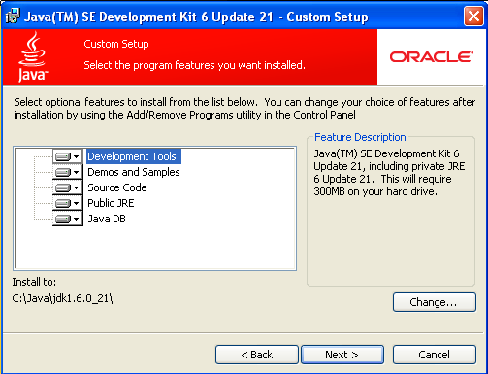
Figure 1: After accepting the licence, change the installation path as shown in the screenshot

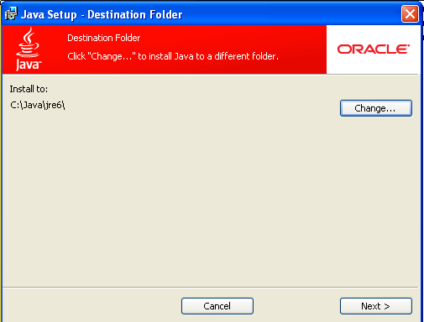
Figure 2: Installation of Java Runtime Environment: Change the installation path as well

2.2 Set Windows environment variables
Open the System properties by clicking Start Menu => Settings => Control Panel => System. Then choose the “Advanced” tab and select “Environment variables”. See 3 for screenshots.

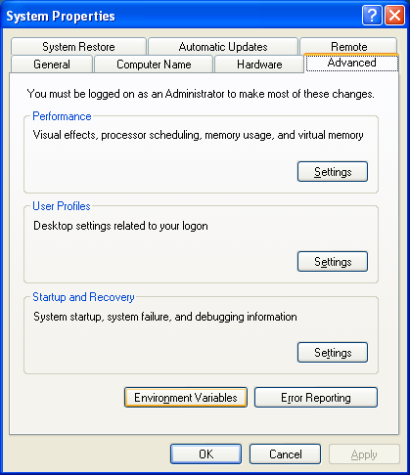
Figure 3: Open the Environment Variables (Start => Settings => Control Panel => System)

The following environment variables should be added:

Bottom part environment variables (System variables):
Add the JAVA_HOME and JRE_HOME variables:
JAVA_HOME C:\Java\jdk1.6.0_21
JRE_HOME C:\Java\jdk1.6.0_21\jre
With the PATH variable you have to be careful! ADD the following to the PATH, but DON’T REMOVE ANYTHING OF THE CURRENT PATH:
Path ;%JAVA_HOME%\jre\bin;%JAVA_HOME%\jre\bin\client

See Figure 4 for screenshots.

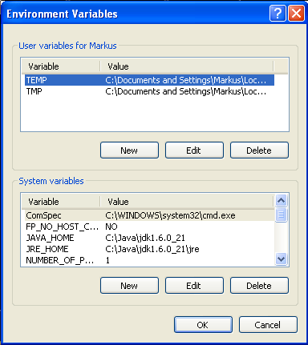
Figure 4: Define the user and system environment variables

2.3 Extend LM Host File with ‘opusdb’.
Add ‘opusdb’ to your hostfile by going to the following directory:
C:\WINDOWS\system32\drivers\etc. Open the file hosts for editing.
Extend the line with localhost (or add a new line when there is no localhost line) with the following:
127.0.0.1 localhost opusdb
Note: if your database is not on the same server as your webserver, then do not extend the line with 127.0.0.1, but add a new line with the correct i.p.-address, for instance:
123.456.999.1 opusdb

Step 3 – Install Tomcat 6.0.x Server

3.1 Install the Web Server
Apache Tomcat: version 6.0.29.

Windows installation:
Install the installation file into the directory C:\Java apache-tomcat-6.0.-x.

Add the extra lib-file: tomcat-juli.jar from the installation package

Figure 5: Install a Tomcat server by extracting the Zip file

You can start the server by double clicking C:\Java\apache-tomcat-6.0-x\bin\startup.bat
You can stop the server by double clicking C:\Java\ apache-tomcat-6.0-x\bin\shutdown.bat

You can manage the memory the server will use by altering the C:\Java\ apache-tomcat-6.0-x\bin\catalina.bat file. Alter the following line:
JAVA_OPTS=%JAVA_OPTS% -D...

Change it to:
JAVA_OPTS=%JAVA_OPTS% -Xmx512M -D...

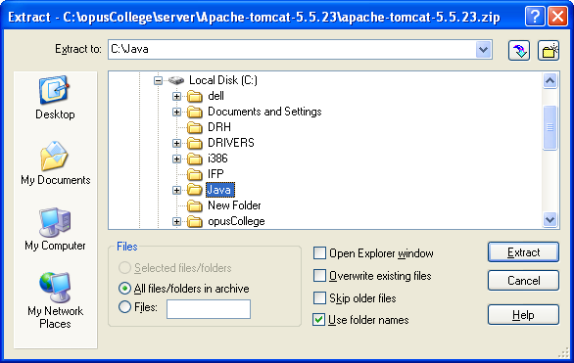
Figure 6: Choose the C:\Java directory for extraction

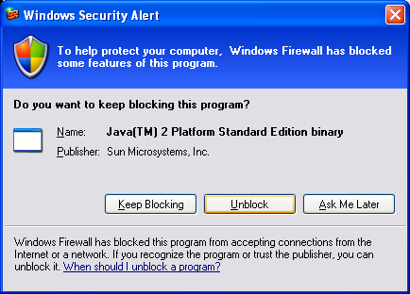
Figure 7: When starting Tomcat, choose Unblock if you get this alert

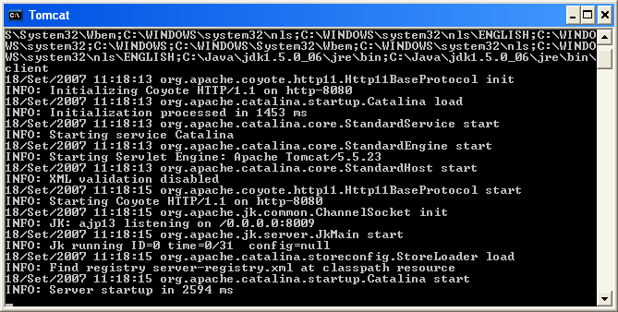
Figure 8: If the Tomcat start was OK, you should see the line "Server startup in xxx ms"

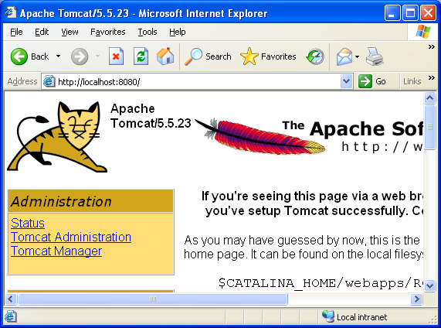
Figure 9: Open your browser and go to http://localhost:8080/ or to http://127.0.0.1:8080/ - if you see this screen then your Tomcat is running correctly

3.2.1 Add tomcat manager user to configuration
Open the file ..\apache-tomcat-6.0.29\conf\tomcat-users.xml. Outcomment the roles/users part. Add a new role ‘manager’. And add a new user with any name you like with the role ‘manager’. Now you can go to the web-page and click the url Tomcat manager. You can log in with the credentials you provided in the users-file.
You can now undeploy / deploy WAR-files etc. through the webbrowser instead of having to go to the server.

3.2.2. Add security attributes to web.xml configuration of tomcat
Open the file ..\apache-tomcat-6.0.29\conf\web.xml. Find the <session-config> tag.

Add the following attributes underneath <session-timeout>30</session-timeout>:

<session-max>1028</session-max>
<enable-url-rewriting>false</enable-url-rewriting>
<reuse-session-id>false</reuse-session-id>

3.2.2. Set fixed memory allocation for tomcat

Open the file ..\apache-tomcat-6.0.29\bin\catalina.bat and add the following line:

set JAVA_OPTS=%JAVA_OPTS% Xmx2048m

3.3 Set Windows environment variables – CATALINA HOME
Open the System properties by clicking Start Menu => Settings => Control Panel => System. Then choose the “Advanced” tab and select “Environment variables”. See Figure 3 for screenshots.

Bottom part environment variables (System variables):

CATALINA_HOME C:\Java\apache-tomcat-6.0.29

3.4 Configure the opusCollege database as JNDI data source
Open <apache-tomcat-6.0.29>/conf/server.xml. Add the following <Resource> definition under the <GlobalNamingResources> tag:

<GlobalNamingResources>
[…]
<Resource name="jdbc/opusCollege" auth="Container"
type="javax.sql.DataSource"
driverClassName="org.postgresql.Driver"
url="jdbc:postgresql://opusdb:5432/opusCollege"
username="***" password="***"
maxActive="20" maxIdle="10" maxWait="-1"/>
[…]
</GlobalNamingResources>

NB: Change the password according to your postgres password!

Step 4 – Install Tomcat 6.0.x Server as a service

In order to make Tomcat start and stop when you start and stop the server, you have to install it as a service.

First stop the server through:
<tomcat-server-dir>/bin/shutdown.bat

Go to the bin-directory of the tomcat-server and find the service.bat file. If it is there, open a command prompt.
Go with a command prompt to the bin-directory inside the command prompt. Then type:
Service.bat install

The tomcat-server is now installed as a service.

Go to the service-screen through Start Menu -> Program Files -> Administrative Tools -> Services

Find the ‘Apache Tomcat’ service. Change the status to ‘automatic’.
Then start the service.

Step 5 – Install Postgres Driver into Tomcat 6.0.x Server

Driver
PostgreSQL Driver: postgresql-9.2-1002.jdbc4.jar

The PostgreSQL-driver needs to be put in the apache-tomcat/server/ lib directory.
Copy the file into this directory. Then restart the apache tomcat server.

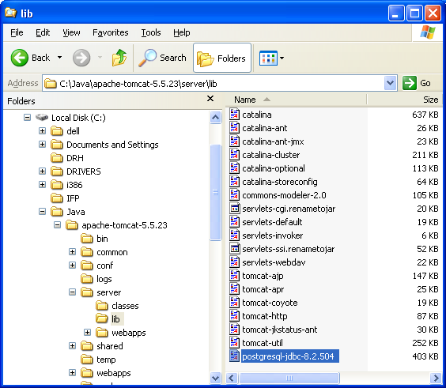
Figure 10: The postgresql .jar file has to be in the tomcat server library directory

Step 6 – Install PostgreSQL 9.2.x Database Server

Database
PostgreSQL: version 9.2.x

Windows installation:
Install the installation file by stepping through it. First you have to create an admin-user. The default is postgres. Then you have to provide a password. This can be any password. In the next step you have to make the database user. Make sure you create the following as your database user:
User: <opusdb-user>
Password: <opusdb-password>

Through iBatis the database can be approached transparantly.

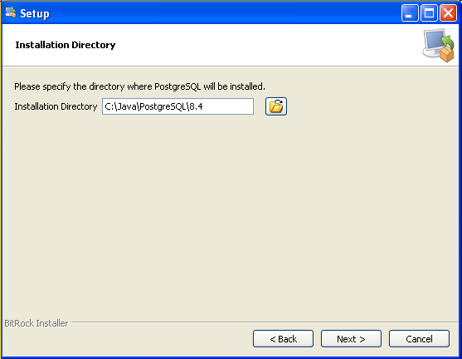
Figure 11: Start the Postgresql installation by double clicking the postgresql installer package.

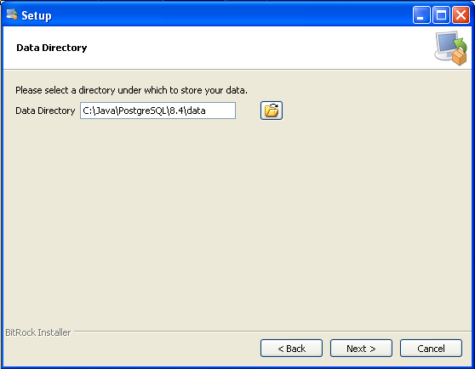
Figure 12: The data directory screen.

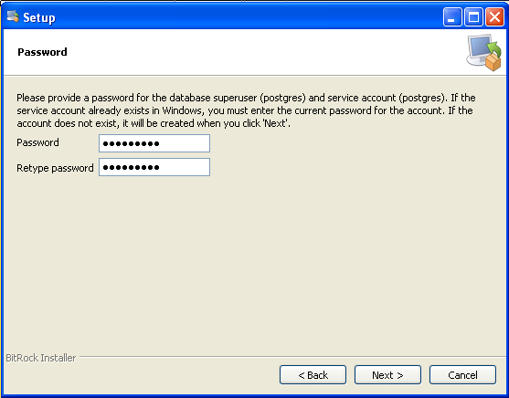
Figure 13: Set the password to <opusdb-password>.

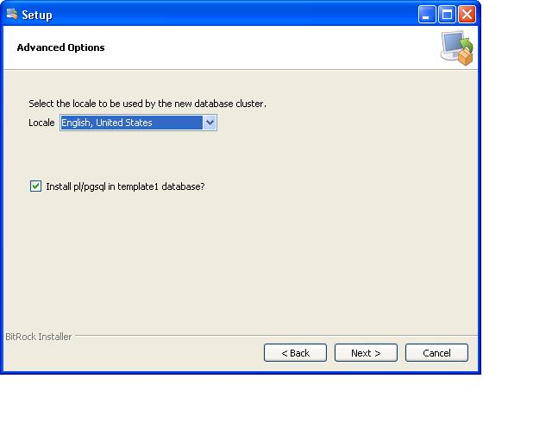
Figure 14: Choose locale ‘English, United States’ and leave pl/pgsql template 1 checked. Afterwards continue the wizard using default values.

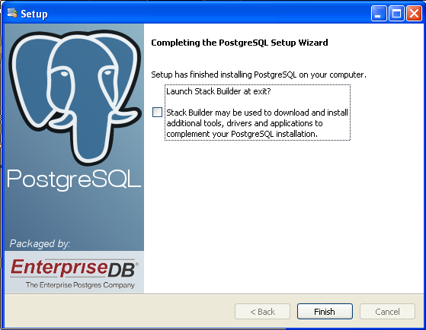Figure 14: Deselect Stackbuilder and click "Finish"

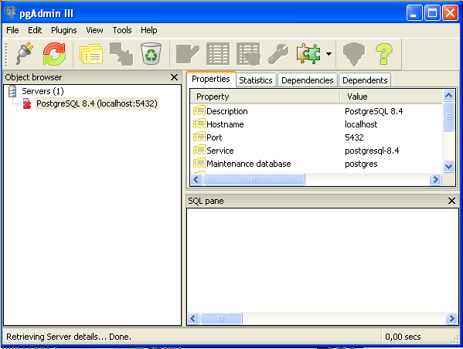
Figure 15: To test the Postgresql installation, open pgAdmin III from the Start Menu => Postgresql

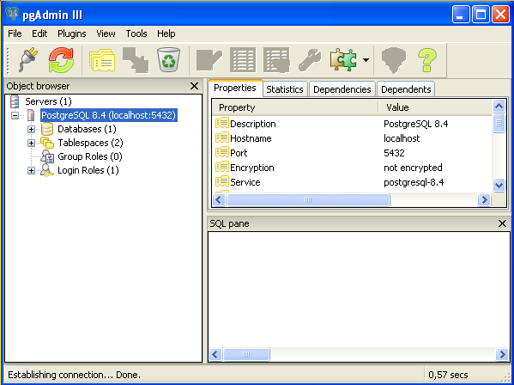
Figure 16: Double click on the "PostgreSQL Database Server (localhost:5432)" and enter the password <opusdb-password> to connect to the database server. If it works, it should look like this screen.

Step 7 - Create the database

Open pgAdmin to connect to the server. If there is no server created, create one manually:
Name: PostgreSQL Databaseserver
Hostname: localhost
Maintenance db: postgres
User: <opusdb-user>
Password: <opusdb-password>

Create in the opusCollege database in PostgreSQL as shown in the screenshots:

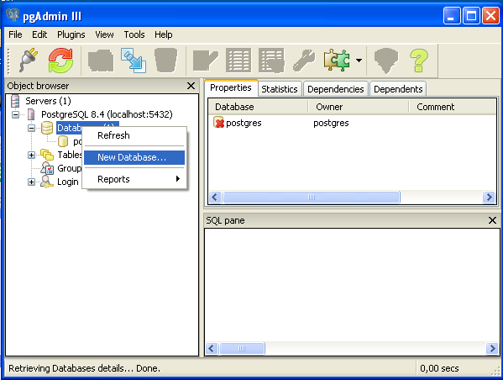
Figure 17: Right click on "Databases" and choose "New database..."

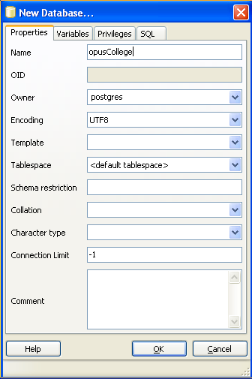
Figure 18: Enter the values as shown in the picture to create the opusCollege database

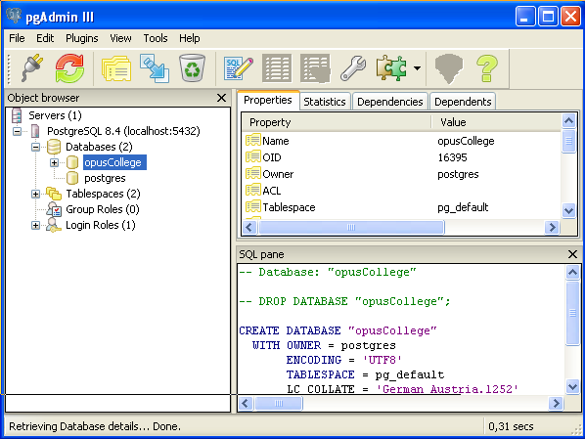
Figure 19: Choose database "opusCollege".

Go to http://www.opuscollege.net → support and click on the latest release on the page (as we write this, it is version 4.1). Then click on the “application” folder and choose one of the offered versions. Download the war file and the database backup.

In PostgreSql, step on the database opusCollege, right-click and select “restore”. Choose the backup file you just downloaded and click on “OK”. If the restore has finished correctly, the return value at the end of the comments should be 0.

NOTE for WINDOWS7:
If you ‘re working on a windows 7 machine, you have to alter the pg_hba.conf file in /<server>/data/.
The entry for localhost should be outcommented and put to trust:

host all all 127.0.0.1/32 trust

Step 7 - Deploy the application

Take the war file you downloaded and copy it into the apache-tomcat/webapps directory.
The server will start to deploy the file immediately. If this doesn’t happen, then restart the server.

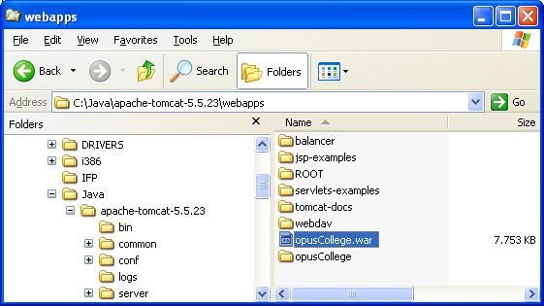
Figure 20: Copy the opus.war file into Tomcat's webapp directory to deploy the application

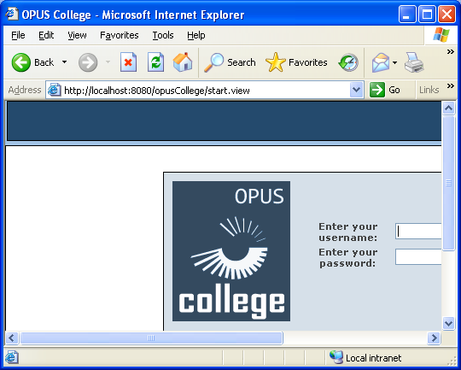
Figure 21: Open your browser and go to http://localhost:8080/opus to see if the deployment has been successful

Note: if you need to reinstall the war-file, the best is to do this through the Tomcat management console. But if you are deleting the files themselves, then do not forget to remove all of these:

/<tomcat-dir>/webapps/opus/ < and all underlying directories >
/<tomcat-dir>/webapps/opus.war
/<tomcat-dir>/conf/Catalina/localhost/opus.xml (automatically generated !!)

DATABASE MAINTENANCE

1. Create the backup file
To make a backup, go to pgAdmin, select the database (opusCollege) and choose “Backup…” from the Tools menu. The option has to be ‘COMPRESS’.
Then choose a location where to save the file. Choose a filename for the backup file.
The extension will be .’backup’.

2. Restore the backup file
To restore the database from your backup file, you need to drop the schema from the database: select the schema (opuscollege) and choose ‘DROP Cascaded’ from the Tools Menu.
Then select the database. Then select “Restore…” from the Tools menu. Find the backup-file and execute it,

- Making manual backups of the database

Go with a command prompt to the directory where Postgres is installed. Then go to the bin-directory:
<postgres-installation-dir>\bin

Here you find commands to dump and restore the database: pg_dump.exe. And the reverse action: pg_restore.exe.
You can run these commands from the command-line, using the following options.

The right syntax is:
pg_dump.exe -h localhost -p 5432 -U postgres -F c -b -v -f "C:\java\backups\opuscollege.backup" "opusCollege"

Note: to logon to Postgres you need your database-account (the second account you created when creating the database server),

See: Postgres_Commands.doc for details about the syntax.

PG_RESTORE

Of course you can do a restore with the Postgres admin tool. You can follow the instructions above and then choose the location C:\Java\backups\ and then the file pg_dump_opuscolleg.backup.

However, if you want to choose your own options on restoring, then you can do this manually. Therefore go with a command prompt to the directory where Postgres is installed. Then go to the bin-directory:
<postgres-installation-dir>\bin

Here you find command to restore the database: pg_restore.exe.
You can run this command from the command-line, using the following options.

The right default syntax is:
pg_restore.exe -h localhost -p 5432 -U postgres -d "opusCollege" -v "C:\java\backups\opuscollege.backup"

See: Postgres_Commands.doc for details about the syntax.

- Making automatic backups of the database
You can also make a batch job to run the backup automatically.

First copy the directory tasks to C:\Java. In the directory you find a file ‘pg_dump_opuscollege.bat’
Then create a directory C:\Java\backups.
You can double-click the bat-file to execute it and see if it works.

Then go to C:\WINDOWS\Tasks. Create a new task. Call it ‘Dump OpusCollege’.
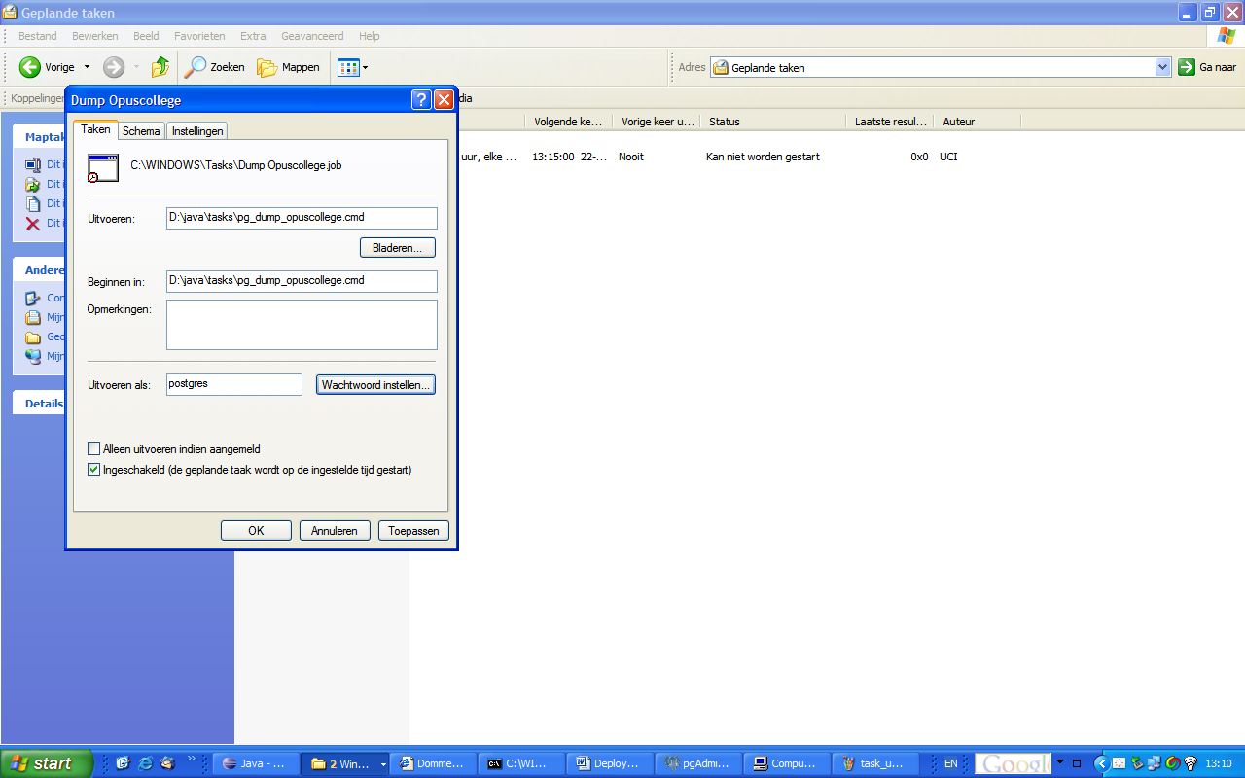

Then assign the task to the Administrator user of the machine and give in the password of this user. DO NOT assign the task to the postgres user, since it has not enough rights to execute the task. (Note: Within the batchjob the Administrator user gives the task to your postgres user.)

You can do the same for the restore job. You can also find it in ‘tasks’: file ‘pg_dump_opuscollege.bat’. Call the task ‘Restore OpusCollege’.

