note |  |  |  | Version: | 1 2008-05-27
Subject | Screen Flows for the Opus Scholarship Module
To | Ed Simons
CC | Competence Center Mozambique
From | Monique in het Veld | [datum] | [doccodeuci]
 | move

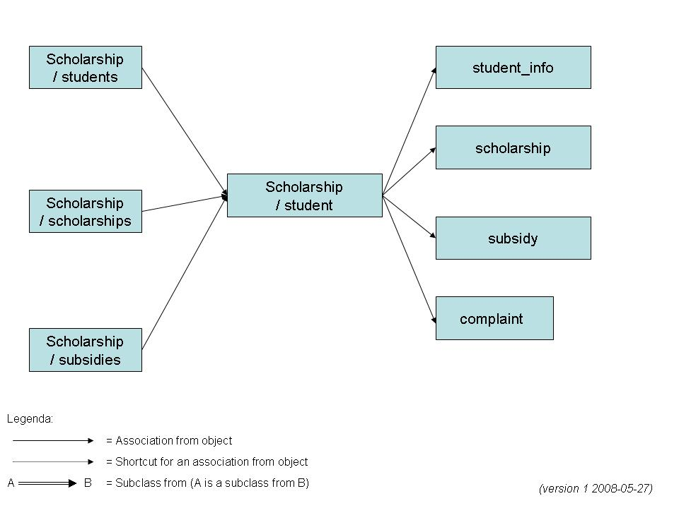

scholarship/students

We agreed on having a few that will in default show all scholarship students, but will have a select box on top of the screen with the possibility to show 'all students'. This is to be able to add a scholarship to a student that is not yet known to the main system as a scholarship student. If you add a scholarship to such a student, you will have to alter the field student.scholarship in that case from 'N' to 'Y' too !

Once you click on a student in the overview, you get a detail-view where you can edit the scholarships and subsidies of this particular student.

The overview view will look much like the College students.view, so I suggest you take that jsp as a starting point. It will save you a lot of work.

scholarship/scholarships
Under scholarships.view you would have a view on all scholarship types as a starting point and then be able to choose the students from that particular scholarship type.

scholarship/subsidies
Under subsidies.view you would have a view on all subsidy types as a starting point and then be able to choose the students from that particular subsidy type.

scholarship/student
Once you click through on one student you can see the details of this student: is a specific scholarship approved or still in progress, and so on... The same goes for a specific subsidy.
The student detail view will be different from the College student.view, but here you can also use that jsp as a starting point and strip everything you don't need. But feel free to start from scratch with this one too.

