note |  |  |  | Version: | 1.5 2012-01-17
Subject | Functional Design Bank Interface UNZA
To | UNZA CICT, UNZA Focal Points
CC | opus User Group, Ed Simons, Markus Pscheidt
From | Monique in het Veld | [date] | [doccodeuci]
 | move

General Description

UNZA has an interface with ZANACO bank for financial transactions. The ZANACO bank sends requests with single transactions by students to a specific URL at UNZA and the ORS (Online Registration System) catches these requests and processes them. The financial officers of UNZA have access to the interface of ORS to keep track of the financial transactions.
For Opus parts of the current interface will be kept, a.o. the original requests from ZANACO bank, so that there will be no big changes when the responsibility for this moves from ORS to Opus.

There is however an issue with the current request that must be solved before the Opus interface can become operational: see further in this document.

Input

The input can be one of the three following actions:
1. PostTran
2. QueryStatus
3. ReverseTransaction

- PostTran

The application is addressed using the following url:
registration.unza.zm/bank.php/api/<action>

Format PostTran request:
http://registration.unza.zm/bank.php/api/PostTran?RequestId= ECJ62ICW1&Key= NzIzMGJhYzJiZWU5MDZmZGQ0OTY0YTMwZTQ0M2FmYTdmNmVhNjRjYQ==& StudentID=10003622&NRC=199720/31/1&Date=2011-04-19 09:19:40&Amount=1140000&TranID=ECJ62ICL8&Name=0831010000000019:INNOCENT_MAKASA&Type=0&Phone=N

- QueryStatus

Zanaco performing a querystatus:

http://registration.unza.zm/bank.php/api/QueryStatus?RequestId=EEOGQGV67&Key=YzAzNzUyYzc5YTM2YzM3NmVlMDE4NTkyZWJhMDQ0NWFhNDU2MDQ2ZA==&TranID=EEMAJSNN3

- ReverseTransaction

Format ReverseTransactionrequest:

http://registration.unza.zm/bank.php/api/ReverseTransaction?RequestId=EERWIXRR6&Key=NjZkZDU4MjFjZmYwMWJiMWQxN2ZjZjY3Zjc2MjQzNzU3MjNlZDA2ZA==&StudentID=10003622&NRC=199720/31/1&Date=2011-04-19 10:20:30&Amount=1140000&TranID=EBNOUR3W9

Output

The output back to Zanaco bank belongs to one of the three following actions:
1. PostTran
2. QueryStatus
3. ReverseTransaction

- PostTran
For the action PostTran the system outputs a return XML with the appropriate status and errorcode to Zanaco Bank:
When the executePostTrans method finishes excution, it sets the contentType of the response object to application/xml, it then passes this Response object that contains the results of the processing and this view is actually the xml template that is returned to ZANACO.
Since the contentType is set to application/xml on the web response object, the system returns an xml document as opposed to the normal html document. The xml document is sent to the i.p. address that initiated the request. It’s similar to requesting a web page from an HTTP server. The ORS server extracts the parameters from the request and sends a response, only this time the response is not an html web page but an xml file. The client at the ZANACO end knows how to display xml documents. This is downloaded at the ZANACO end via HTTP and an application at ZANACO renders this xml file.

<?xml version="1.0"?>
<PostTranResponse status="SUCCESS" errorMessage="">
<Transaction id="EEOGHHUF9" status="SUCCESS" errorMessage=""></Transaction>
</PostTranResponse>

- QueryStatus

For the action QueryStatus the system outputs a return XML with the appropriate status and errorcode to Zanaco Bank:

<?xml version="1.0"?>
<QueryStatusResponse status="SUCCESS">
<Transaction id="EEMAJSNN3" status="SUCCESS" errorMessage="SUCCESS"></Transaction>
</QueryStatusResponse>

- ReverseTransaction

<?xml version="1.0"?><ReverseTransactionResponse status="SUCCESS">
<Transaction id="EBNOUR3W9" status="SUCCESS" errorMessage=""></Transaction> </ReverseTransactionResponse>

Progressing transactions

Deposit (PostTran)
Zanaco sends an HTTP request to the input-url of UNZA with action PostTran. The request parameters contain details for the student's deposit of money. Each request contains only one transaction.
The request is received, parsed, processed, and finally studentBalance in Opus is updated. The flow for this whole process is as follows:
- Receive HTTP request from Zanaco (PostTran action)
- Preprocess and validate the bank request
- Process transaction
- Preprocess and validate the transaction
- Process the actual deposit into Opus (update StudentBalance) -> note: this is for now a manual action, performed through a screen in the application by the financial officers.
- Return XML with the appropriate status of the request to Zanaco Bank

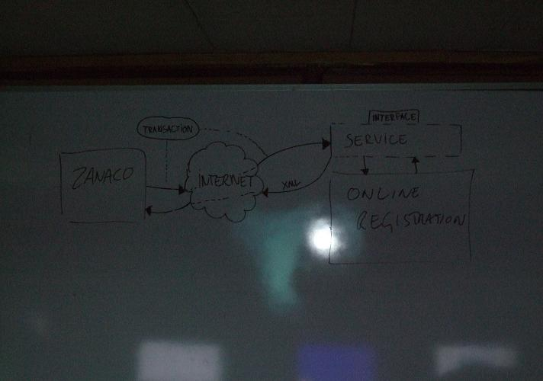

      - Request and Transaction

All requests will be read into Opus in a separate table fi_bankrequest. And processed into fi_transaction to retrieve errors in the request before updating Opus itself.
The request simply represents the raw request received from Zanaco. The fi_bankrequest table is used to store these request objects. The purpose of this table is to capture the raw data received from Zanaco. This is helpful for replaying transactions, logging, and debugging. More importantly, if there is a problem with the transaction, the raw data can be saved and used later to communicate with Zanaco the details of the problem.
In contrast, a transaction represents the processed bank request, the outcome of the processing. More importantly it represents a successfully processed transaction. This is stored in the fi_transaction database table. While the fi_bankrequest table contains raw data, the fi_transaction table contains processed data for this transaction.
After this in between storage the successful transactions can be processed into Opus: All ‘normal’ transactions can be selected in bulk and moved at once by the Financial Officer into Opus to update the StudentBalance table. The ProcessedToStudentbalance attribute of fi_transaction will be set to Y and the Status attribute in fi_transaction will be 0 (OK).

All odds and errors are shown for the Financial Officer to decide upon manually. Known errors coming from the bank are:
- Unidentified student id
- Wrong transaction amount

If a request is coming from the bank the following checks must be done:
- If the request (zanaco_request_id) is already present in fi_bankrequest:
  - If the request is already processed as a transaction:
    - If the transaction is already processed from fi_transaction to StudentBalance: create the new request and set the status to STATUS_IGNORED.
    - If the transaction is not yet processed from fi_transaction to StudentBalance: set the old request to STATUS_IGNORED and the corresponding transaction also to STATUS_IGNORED. Create the new request and replay the transaction.
  - If the request is not processed yet: set the old request to STATUS_IGNORED and create a new request
- If the request is not yet entered into fi_bankrequest: write a new record

There is however a persistent problem with the current interface: if a student deposits twice the same amount on one day then the transaction id from Zanaco is changed. But if a transaction fails and is sent through for the second time, the id from Zanaco is also changed: therefore you cannot establish whether this is a repeated or a new transaction. If there is a different amount deposited the change can be seen through the difference in amount, but not if the amount is exactly the same.
This problem must be solved before implementation of the new financial interface in Opus, otherwise it is also a problem for the new interface. Monique has addressed this problem with the DVC / Registrar of UNZA.

      - Status and Errors

Both the fi_bankrequest and fi_transaction table can contain a status. This status field is used to set the error state of the record. The 4 possibilities are:
0 = STATUS_OK
1 = STATUS_ERROR_INTERFACE
2 = STATUS_ERROR_OPUS
4 = STATUS_IGNORED

STATUS_OK
Used when the request or transaction was processed successfully.
STATUS_ERROR_INTERFACE
On the raw fi_bankrequest table, the error means that the most basically processing failed. Usually this means that the message received did not comply to the API document. This basic validation is checked during the preprocessing and validation step. If it fails for any reason this error status is used. In most cases, an error at the fi_bankrequest level is most likely the result of an error that was made by Zanaco.
STATUS_ ERROR_OPUS
This error type is used to signify a error that has occurred that is the responsibility of UNZA and not Zanaco. Usually these means the message was valid, but something on the OPUS side has failed. These errors are mainly application logic errors. The student has successfully deposited their money with Zanaco, Zanaco has successfully sent the data to OPUS, but the information in OPUS doesn’t correspond with the sent information. The STATUS_ERROR_OPUS is used to distinguish these types of errors.
STATUS_ IGNORED
This error type is used to signify a request that was resent by the bank. The current record is not used and the new record has been processed. This status is set to make sure that the same request is not executed twice.
There are a multitude of specific error messages and codes that are sent back to Zanaco in the XML response in the event of a message failure. This error code can be stored in both the errorCode of a fi_bankrequest record during the processing to a transaction or in errorCode of a fi_transaction record, if the error occurs in the next step of the process. If this is the case the error must be transported into the errorCode of fi_bankrequest of that specific request too, so that a response can be sent to the bank on all sorts of error reports.
The following error codes can be stored in fi_bankrequest and / or fi_transaction and sent back to the Zanaco bank:
STATUS_ERROR_INTERFACE
ERR_GENERAL_FAILURE = 1;
ERR_STUDENTID_INVALID = 2;
ERR_TRANS_NOT_FOUND = 3;
ERR_AMOUNT_INVALID = 5;
ERR_UNPAREABLE_CSV_DATA = 7;
ERR_MISSING_FIELDS = 8;
ERR_DUPLICATE_REQUEST_ID = 9;
ERR_MISSING_TRANID = 10;
ERR_MISSING_REQUESTID = 11;
ERR_INVALID_KEY = 12;

STATUS_ ERROR_OPUS
ERR_GENERAL_FAILURE = 1;
ERR_STUDENT_NOT_EXIST = 4;
ERR_STUDENT_NOT_REGISTERED = 6;
ERR_MISSING_STFEES = 13;

After the error is communicated with Zanaco bank the record must be set to ErrorReportedToBank = Y. And the ProcessedToFiTransaction attribute must be set to N.

      - Replaying Transactions

The interface has the ability to replay a transaction. The “replay” is simply a mechanism to re-process an existing transaction. The reason to replay is generally based on a repaired error state of a transaction within Opus. For instance if after the Opus error ERR_MISSING_STFEES the corresponding fees for the student are added to Opus, the transaction can be replayed. This can only be done when the error has not been reported to the ZANACO bank yet (fi_bankrequest – request must have status ErrorReportedToBank N). Also the processedTo triggers must be changed accordingly in both finance_bankrequest and finance_transaction:
finance_Bankrequest :
- StatusCode = STATUS_OK
- ErrorCode = <EMPTY>
- processedToFiTransaction = Y
- ErrorReportedToBank = N
finance_Transaction:
- StatusCode = STATUS_OK
- ErrorCode = <EMPTY>
- ProcessedToStudentbalance = Y
- ErrorReportedToFiBankrequest = N

Replaying will simulate re-processing the incoming transaction in it's entirety. This means that if the original transaction was recorded on a previous studyplancardinaltimeunit and / or academic year and now the student has started a new studyplancardinaltimeunit and / or academic year, the replay will cause the fees to be still processed on the old one, in the hierarchy that is defined as a business rule (see corresponding paragraph). Only by manual action the payment can be posed on the new one.
      - Reversing a Transaction

As part of the bank API documentation, there is the ability for the bank to perform a reverse transaction. When a reverse message is received from Zanaco, the corresponding transaction will be performed in the OPUS system updating the payments of a student as a negative amount.
Example:
Bankrequest XY is sent for Stud 123 for amount 1,250,000 KWA. Type: TRAN (0). This was supposed to be 125,000 KWA.
The corresponding transaction XY is performed and updated into OPUS.
UNZA sends an email to the bank stating that the transaction was incorrect and must be reversed.
The bank now sends two new requests:
Bankrequest ZY for Stud 123 for amount 1,250,000 KWA. Type: REVERSE (1).
The student’s StudentBalance will be charged with a negative payment amount of 1,250,000 KWA, starting from the newest payments backwards.
Bankrequest AB for Stud 123 for amount 125,000 KWA.The StudentBalance will be charged with a positive payment amount of 125,000 KWA.

Querying status of a request (QueryStatus)

The last method provided by the bank API is for querying a transaction status. The logic for querying status can also be viewed in the symfony bank application in the api module. This method simply allows Zanaco a way to programmatically retrieve the status of transaction records in the OPUS system by giving the zanaco_request_id. This is mainly used for correlation and validation purposes. It is a read-only process and no data is modified on the OPUS system.

Reverse Transaction (ReverseTransaction)

Transaction Storage

UNZA Module:
FinancialRequest : store the raw request from the bank (current: bank_request):
- Id
- RequestId request_id (request: requestId)
- FinancialRequestId zanaco_request_id (request: tranId)
- StatusCode status
- RequestString data
- TimestampReceived (datetime) received
- RequestVersion version
- TimestampModified (datetime) modified_at
- WriteWho modified_by
- ErrorCode
- ProcessedToFinanceTransaction (y/n)
- ErrorReportedToFinancialSystem (y/n)

Finance Module:
FinancialTransaction: store the processed fi_bankrequest records (current: bank_trans):
- Id
- TransactionTypeId type
- FinancialRequestId zanaco_id
- RequestId request_id
- StatusCode status
- ErrorCode error_code
- StudentId studid
- NationalRegistrationNumber nrc
- AcademicYear (not necessary) ayear
- TimestampProcessed timestamp
- Amount amount
- Name (??) name
- Cell (??) cell
- RequestString data
- ProcessedToStudentbalance (y/n)
- ErrorReportedToFinancialBankrequest (y/n)

College Module:
StudentBalance (see Opus specifications document - Fee module)

Together this forms this picture, in which the relations between the UNZA module and Opus are explained:
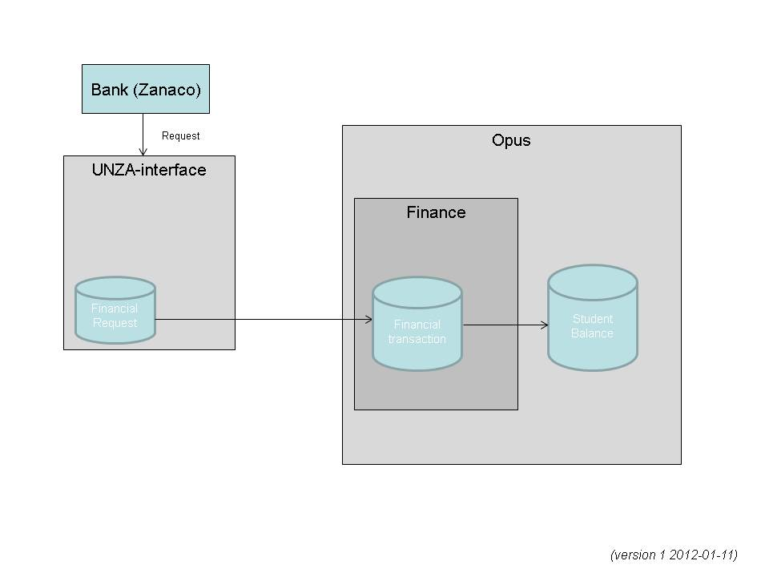

The details of the original tables and relationship can be seen below.

There is a ForeignKey on bank_tran.request_id. One will also notice that the bank_tran table contains the specific details of the request and also to which student's ayear this transaction was applied to.
NOTE: The zanaco_id defined in the API specification is meant to be a globally unique identifier for each transaction across both systems. This ID was meant to be used for correlation between both systems. It was also meant to be unique per student deposit. So if a student made a deposit for 100000ZMK, no matter how many times that transaction was sent, or resent, that zanaco_id would always be the same. This was designed to prevent reprocessing of the same transaction multiple times. Unfortunately, this was not implemented correctly by the Zanaco team and it was too late for them to make changes on their system to address this problem.

Business rules for updating payments in Student Balance
Source: Floyd Sheke, Payment logic.docx
For a student to register he MUST pay all outstanding balance in full plus 75% of Tuition fees plus all other fees i.e. (Medical, examination, registration, graduation, etc)
The standard rule is:
- First the balance must be paid: e.g. all outstanding fees for previous semesters/studyyears.
- Secondly all other fees must be paid in full.
- Third 75% of the Tuition fee must be paid.

For example if a student fees are show below: 

Scenario 1
A student makes a payment of 1,600,000.00 ZMK, his records shows a balance B/forward (feetype ‘D’) of 1,552,500.00 therefore the first thing is to pay off the balance (1,552,500.00 ZMK) FROM the first payment (1,600,000.00 ZMK) as a result the record will appear as show below.


Scenario 2
The student decides to make another payment of 5,200,000.00 ZMK therefore the system allocates this payment to other fees and remaining amount is allocated to the Tuition fee. Note that the second payment in this scenario does not affect the B/balance because it was paid off by the first payment of 1,600,000.00 ZMK. The fig below the picture in Scernario 2


Scenario 3
The student may decide to clear the balance of 1,525,000.00 but in this scenario he decides to pay more than the balance (1,525,000.00), he makes a payment of 4,875,000.00. The financial record changes to the status show below;

Note that the balance shows a negative number meaning the student made an overpayment of K3, 350,000.00 ZMK. This over payment should appear in the coming semester (next semester) as a balance B/Fwd. It must have a negative sign meaning the fees must be less the amount.

Authorisation & Security

Whitelist

To minimize foreign messages not originating from Zanaco, there is a whitelist of allowed IP address where BankAPI messages can originate from. This list of IP addresses must be maintained by UNZA. If a message is received from an IP address outside of the whitelist, it will be rejected immediately. The whitelist contains the following ip addresses at the moment:
72.229.186.130/32, 41.72.96.130/32, 192.168.99.5/32, 41.133.54.17/32

SHA-key
Unza and ZANACO have agreed on a SHA-key that is sent within the request. OPUS will check the value of this SHA-key to see if this is the correct one. If not, the request is not processed.
Base64 ( SHA -1 ( KEY + *requestId* )) is set in the Key parameter of http request.

Note: For security-reasons the SHA-code is not in this document. It can be requested for at UNZA or the central administration of Opus College.

