Enrichment
superadmin
2013/02/04 10:05

Table of Contents
Wizard steps to perform an enrichment analysis 2
Exploring the results of the analysis 9

Enrichment analysis consists in a quantitative measure to infer if the values of a biological condition (e.g. fold changes) shows statistically significant, concordant values or increased proportion for a particular set of biological annotations (module or gene set).

Wizard steps to perform an enrichment analysis
Before running an enrichment analysis you should have this data prepared in files:
- A matrix with the data resulting of your experiment (i.e. an expression matrix) or a list or lists of elements (i.e. genes or probesets) that has been found significant after other analysis (i.e. after differential expression you get lists of genes over and under expressed).
- A list of all elements (i.e. probesets or genes) that conform the background population of your analysis. For example, in the case of an affymetrix microarray the population would be all the probesets of the microarray. This is not necessary if you have a matrix with data for the whole population.
- Modules (i.e. gene sets related by Gene Ontology biological process) to analyze enrichment for.
To start the enrichment wizard go to the menu File > New > Analysis > Enrichment analysis ...
Presentation and example
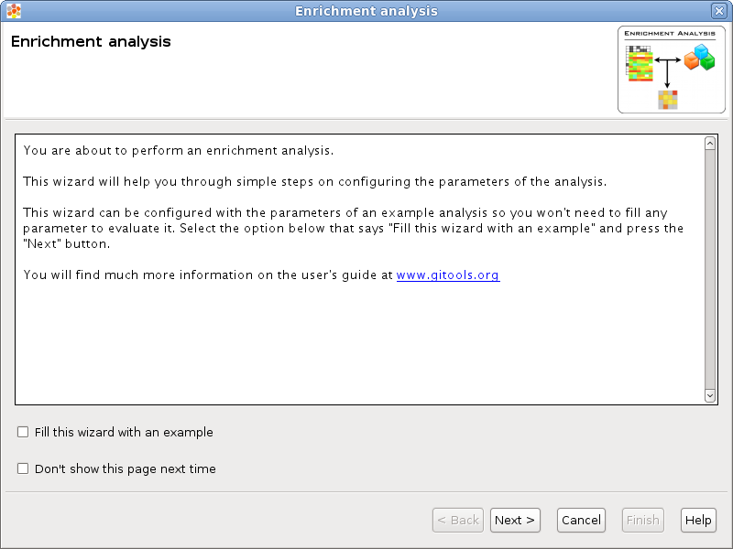
If you select the option Fill this wizard with an example all the following wizard pages will be filled with example files and parameters. In some situations the example files will be downloaded automatically before you can go to the next page. By default, when Gitools is installed from the zip file, the examples are already included. But when Gitools is executed directly from the web page the example files have to be downloaded the first time they are used. In that case the files are cached at $HOME/.gitools/examples.
You can avoid this first presentation page by selecting the option Don’t show this page next time.
Selection of the data to analyze
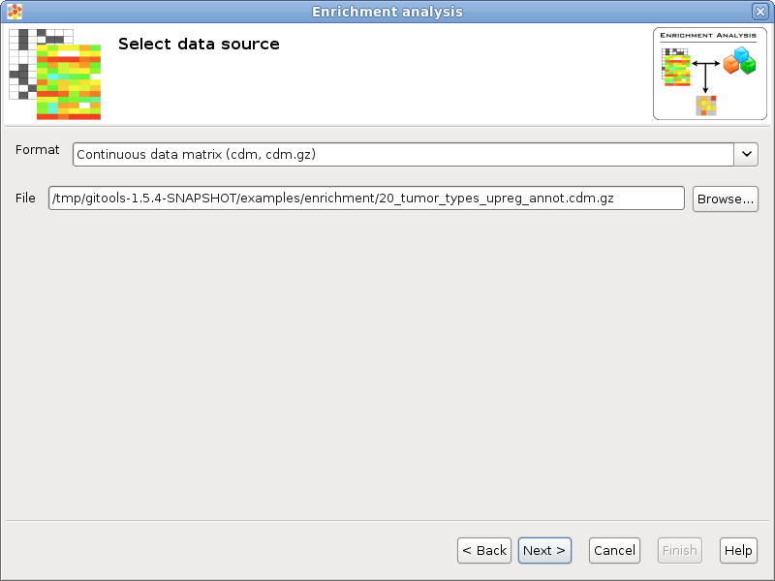
If you follow the conventions on file formats explained here then simply click on the button [Browse] and select the file containing the data to analyze. The format selector will recognize the extension of the file. If your data file doesn’t have a known file extension then you should specify which is the format of the file.
Selection of the data transformation options
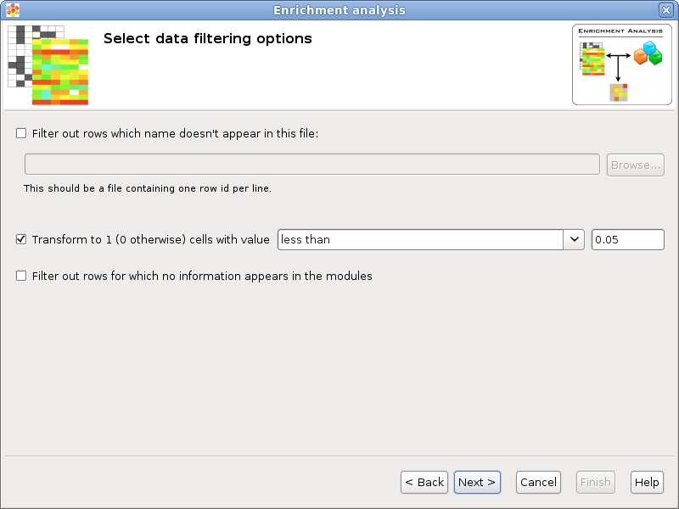
Population / Background elements: This field can be left blank if the data file contains data for all background elements, otherwise a file with the elements of the background population should be selected. The format of this file is a simple text file with one element per line. For example the list of all the protein coding genes, each one in a different row. All the rows in the data that don’t appear in the population will be removed and all the elements specified in the population that don’t appear in the data will be added to the data with the default value specified by the user.
Transform to 1 / 0: Some statistical tests are designed to work with discrete events (as Binomial or Fisher’s exact tests), this option allows to transform a matrix with real values into a binary matrix containing only 1’s and 0’s for the analysis. All the values which satisfy the condition will be transformed to 1 and the rest to 0. For example, if the data file is an expression matrix with log ₂ ratios it can be transformed to a binary matrix having a 1 for all the log ₂ ratios greater than 1.5. Other possible application is when the matrix have p-values, if a significance of 0.05 is considered, all values less than 0.05 could be transformed to 1’s.
Filter out rows for which no information appears in the modules: Sometimes is conveniento to restrict the background population to only those elements belonging to any module, for example, the data file could have information for all the genes of a microarray but only the genes in your data with GO biological process annotations should be considered for the background.
Selection of the modules
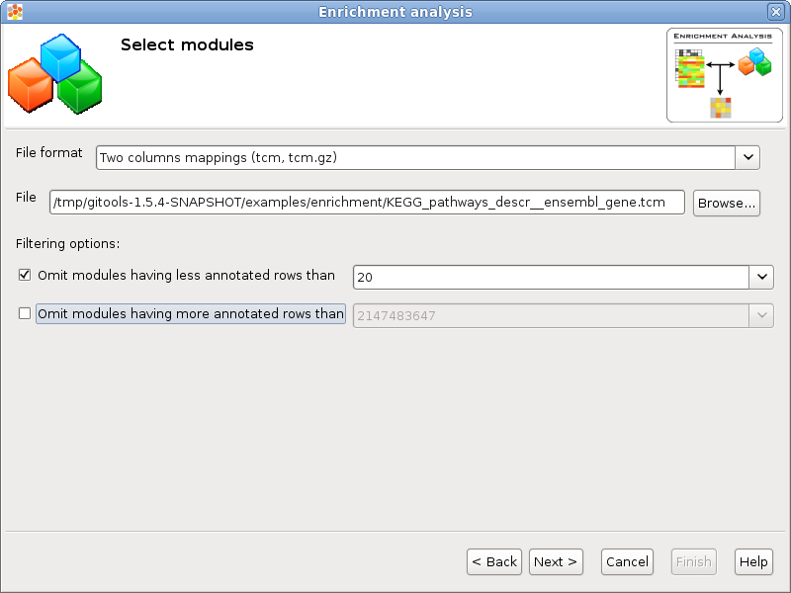
File format & File: A file containing the modules information can be selected pressing the button [Browse...] and selecting a file. The format of the file will be automatically detected if the file extension matches any of the known file formats, otherwise a warning will appear and it should be the user who selects the appropiate format.
Filtering options: If the number of elements annotated for one module is too low some tests could not generate reliable results (i.e. zscore or bionamial tests), on the other hand there are tests best suited for small modules like fisher’s exact test. It is possible to discard the modules with less or more than a certain quantity using this filters.
Selection of the statistical test
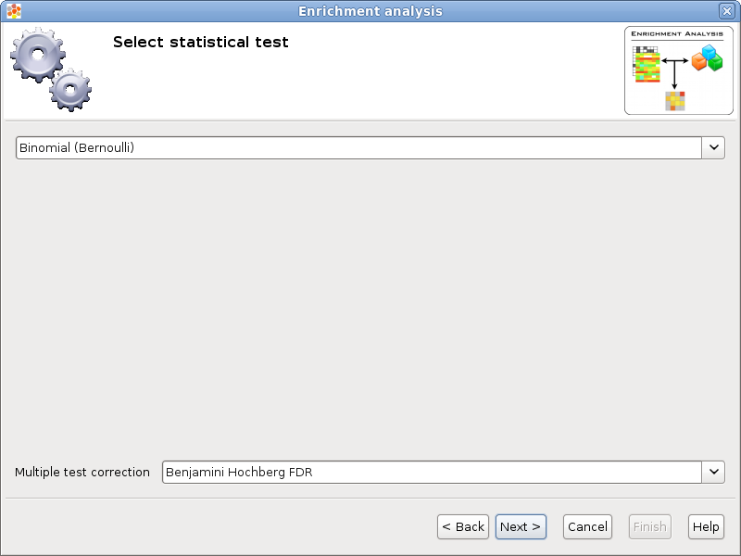
There are different types of statistical tests that can be used, in this page the user can select the one that he/she wants to use in the selector on the top.
Currently there are three different statistical tests implemented for enrichment analysis in Gitools:
- Binomial test
- Fisher’s exact test
- Z-score test with bootstrapping
As multiple tests are performed it is important to adjust the p-values. The method for adjusting the p-values can be chosen in the Multiple test correction option.
Selection of the destination file
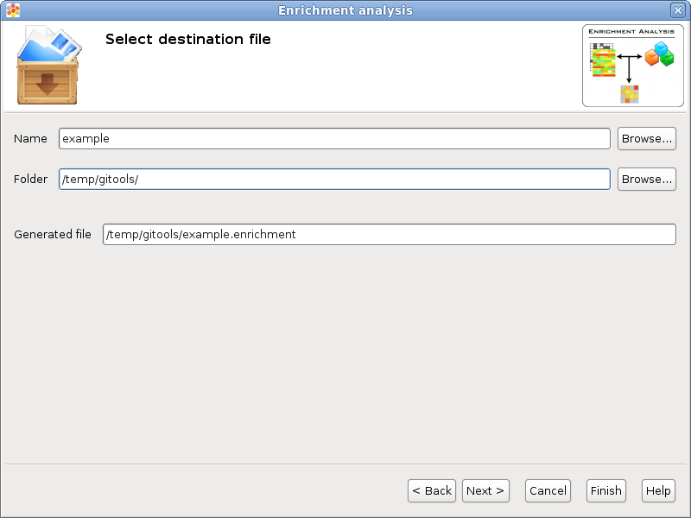
This wizard page allows to specify the prefix name for the files generated during the analysis and the folder where they will be created. The text in name and folder can be freely edited but it is also possible to navigate through the system folders in order to select an existing file by pressing the button [Browse].
Analysis details
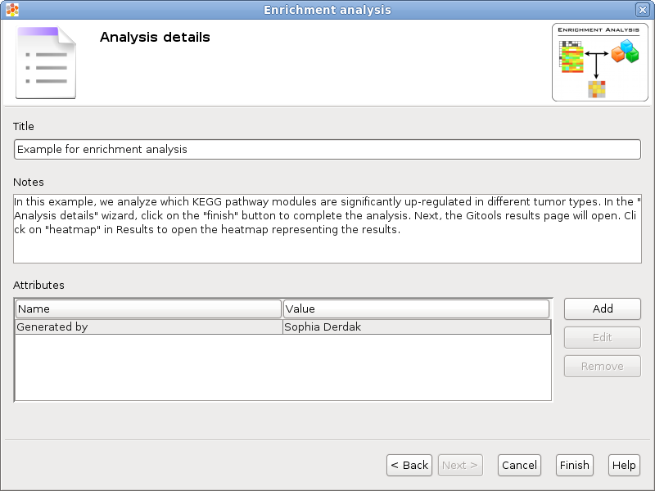
This step is optional but recommended as it allows to give some details about the analysis for better organization and annotation of the results for future reviews.
It is possible to specify free attributes for the analysis as Organization, Operator, Platform and so on.

Exploring the results of the analysis
After performing the analysis a new editor with the details of the analysis will be opened:
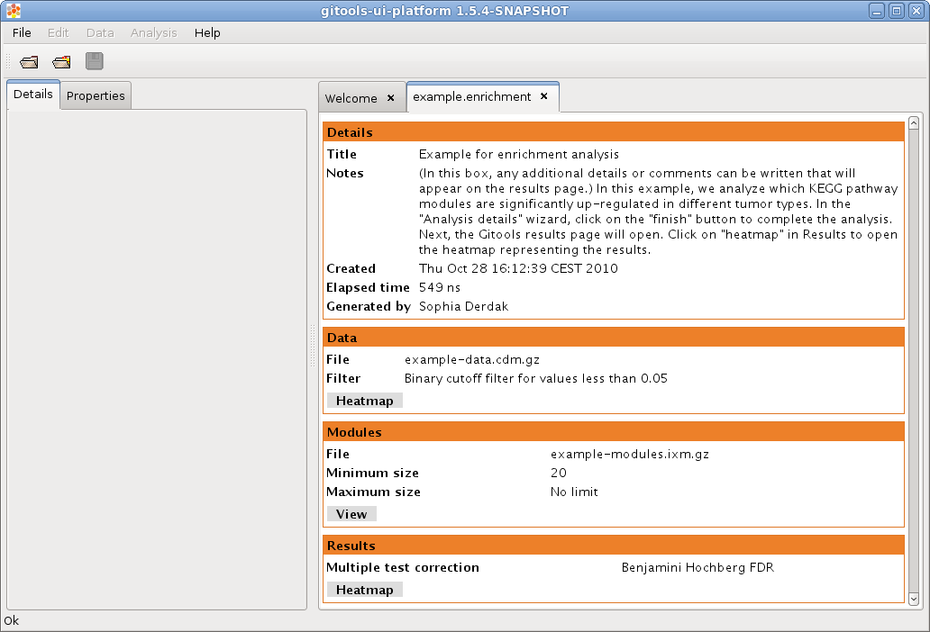
To explore the data matrix resulting from the transformations with a heatmap click on the Heatmap button in the Data section.
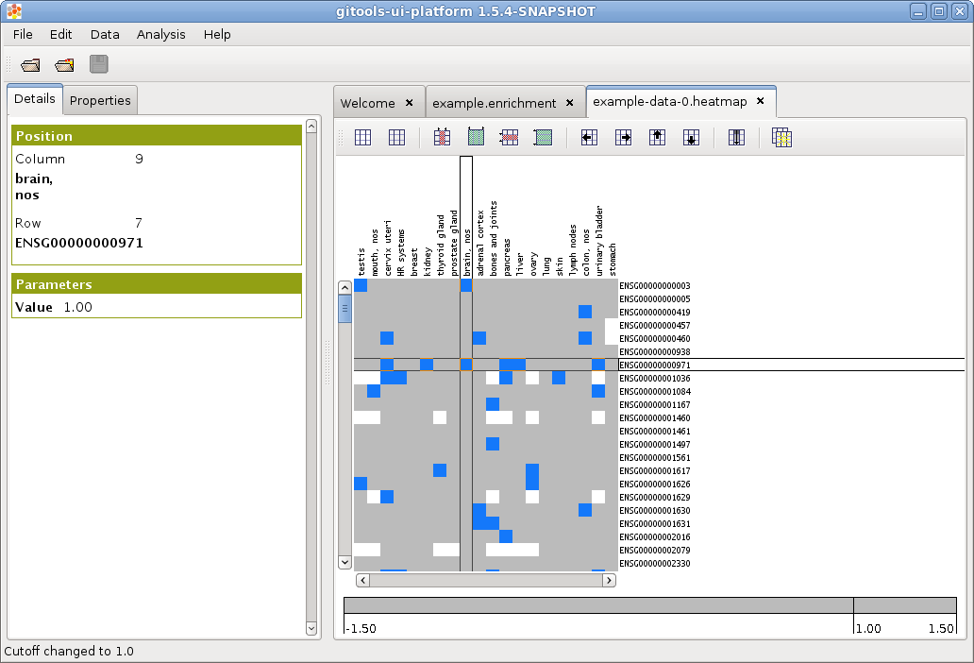
To explore the results of the analysis with a heatmap click on the Heatmap button in the Results section.
