Export heatmap data
XWikiGuest
2012/08/25 08:28

Table of Contents

Labels
When editing a heatmap the visible or hidden row or column labels can be exported as a list in a plain text file. This list can be used in the future to filter other heatmaps by label.
Go to File --> Export --> Export labels ...
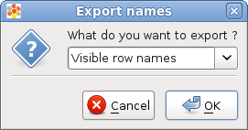
Data
When editing a heatmap the user can export the heatmap data contents in two ways:
- Matrix: The user can select one attribute of the cells and then a matrix will be exported with the values for the selected attribute. Go to File --> Export --> Export matrix ...
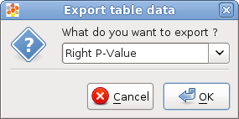
- Table: The user can select a set of attributes and then a table for all the heatmap visible cells (one row for cell) will be exported. Go to File --> Export --> Export table ...
