Export heatmap images
XWikiGuest
2011/09/15 01:44

Table of Contents

When editing a heatmap the user can export an image of the heatmap in any of the supported formats (PNG, JPG) that could be later used in a paper or in the web.
Go to File --> Export --> Export heatmap as an image ...
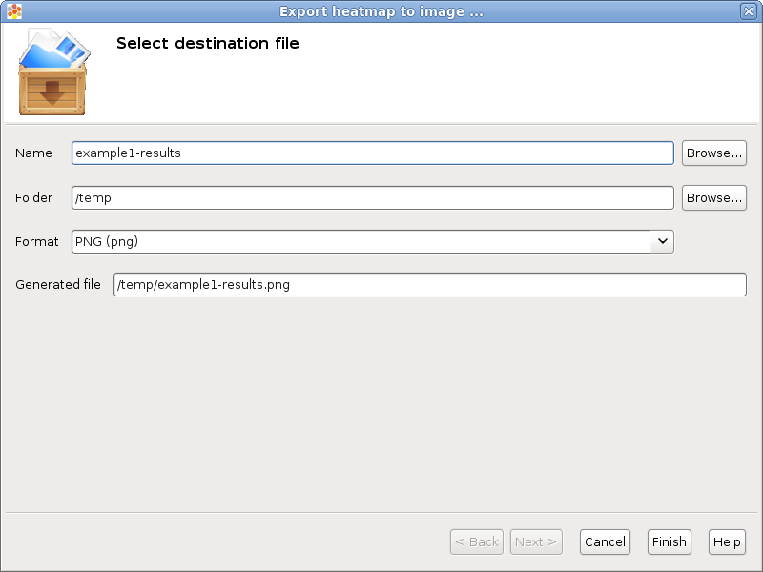
It allows also to export the selected color scale in a different image file. Go to File --> Export --> Export scale as an image ... 