HowtoMultiDimensionalData
Michael P Schroeder
2012/02/21 11:39

Table of Contents
Files/Data needed 2
Browse in Gitools 4

Gitools accepts a matrix format (.tdm) that contains various values per cell - or in other words multi-value matrices. This is especially helpful for browsing genomic data as nowadays study data is being released with expression, mutation, CNA and more data for each patient.

Files/Data needed
For whatever data you want to browse, you need to prepare a multivalue-data matrix (extension .tdm). For genomics data it may look like this:
column | row | expression | CNA | mutation
patient_01 | gene_A | 8.5 | 0 | 0
patient_01 | gene_B | 2.3 | -2 | 0
patient_02 | gene_A | 6 | 0 | 1
patient_02 | gene_B | 5 | 0 | 0
patient_03 | gene_A | 12.1 | 2 | 0
patient_03 | gene_B | 4.9 | 0 | 1
This is an example with three columns and two rows. Each cell has three data values. Download this example matrix as file.

Browse in Gitools
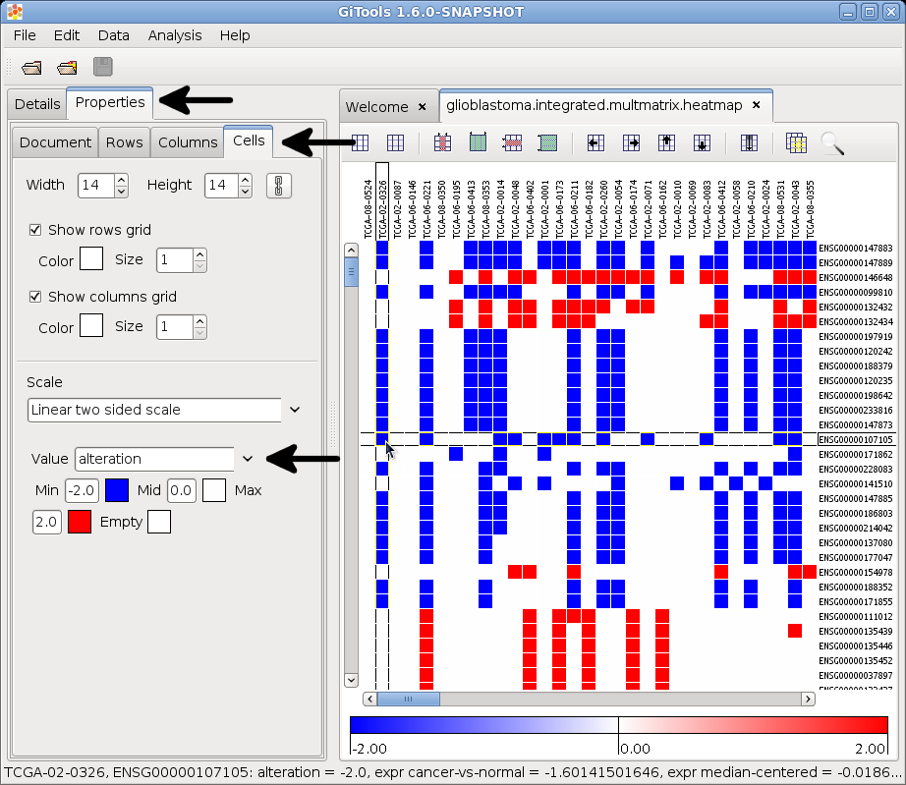
Select the option File -> Open -> Heatmap
In the dialog that pops up select as file Filter (the lowest box) one of the following two options:
- Multivalue data matrix (tdm, tdm.gz)
- Multivalue data matrix (*.*)
Once the heatmap is opened in Gitools, go to the tap Properties / Cells. Under the section Scale you will find a drop-down menu called Value that let’s you switch between the different attributes. The screenshot to the right helps you to find the option.

