Introduction
Christian Pérez-Llamas
2010/11/02 17:11

Table of Contents
What is Gitools ? 2
Authors 3
Contacting 3
Acknowledgements 4
License 4

What is Gitools ?
Gitools is a framework for analysis and visualization of genomic data. Gitools allows importation of data directly from Biomart compatible databases and IntOGen facilitating the exploration and mining of large amount of oncogenomics data and allows performing several types of analyses, such as enrichment analyses, correlations, finding driver alterations and others.
The main workflow is summarized in figure this figure:
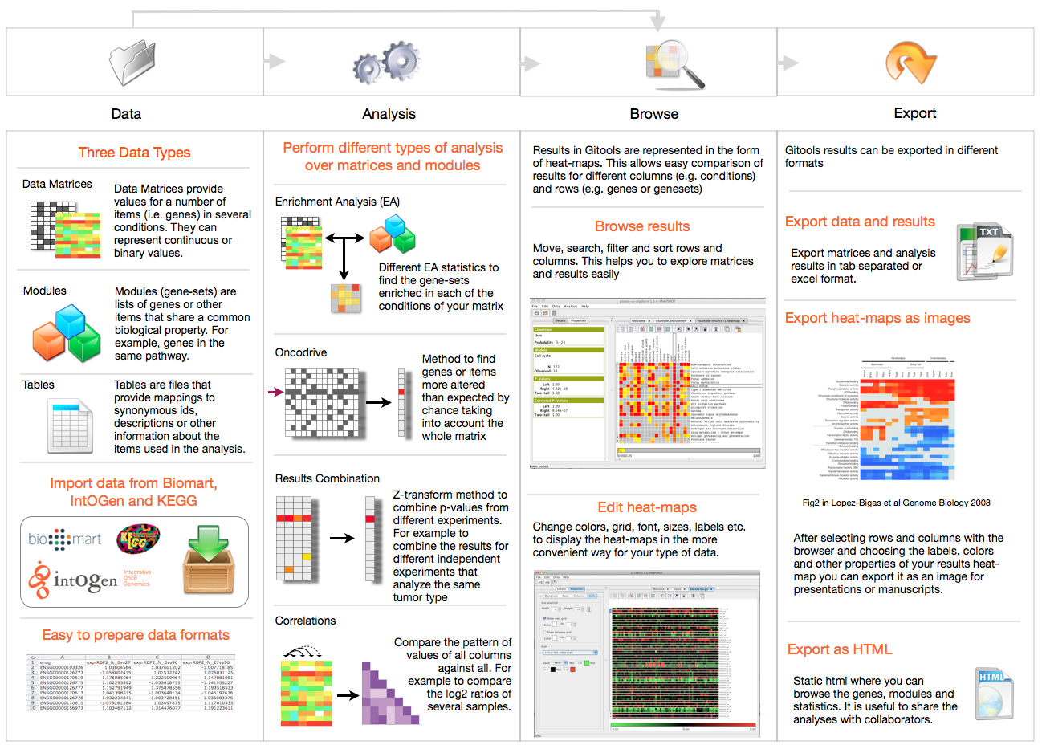
The main workflow summarized: The first step involves preparing the data to work with by editing files manually using Excel or any other well known program or alternativelly importing the data from any of the Gitools available data importers as Biomart or IntOGen. The second step consist in analyzing the data. There are different methods implemented as enrichment analysis, Z-weight combinations, correlations and oncogenomics driver alterations. The third step is to explore the data and the results using the implemented browsers where the heatmap allows to explore different results (for example for genes in rows) over different conditions (in columns). In th last step you can export the data, the results and the generated figures in different ways (as tabulated files, as images, as PDF and/or as static HTML).

Authors
Gitools has been conceived by Nuria López-Bigas and the architecture and most of the programming has been done by Christian Pérez-Llamas. Other people has contributed too, Jordi Deu-Pons with the interface to import IntOGen data and Xavier Rafael-Palou improving the interface with Biomart.

Contacting
Gitools web is at https://www.gitools.org
There you will find how to subscribe to the newsletter to be updated with the last news regarding Gitools.
For suggestions or bug reports you can email christian.perez@upf.edu. Please remember to include the error description and give instructions on how to reproduce the error when reporting bugs.

Acknowledgements
GiTools is being developed under the grants of the Ministry of Science of Spain and Human Frontiers Science Program.

It is also important the feedback received from users, specially our early bug reporters: Khademul Islam, Alba Jené-Sanz, Michael Schroeder, Sophia Derdak and Gunes Gundem.

License
The Gitools distribution is licensed according to the liberal Apache License 2.0. See the files in the top-level of the Gitools distribution called LICENSE-2.0.txt and see licenses for accompanying products in the “ lib” directory. See full explanation and FAQs regarding the Apache License at http://www.apache.org/licenses/

