Visualization
superadmin
2013/02/04 10:07

Table of Contents

The main window of Gitools is divided in two parts: the left part or the contextual panels and the right part or editors panel.
On the left there are some tabs that show contextual information and configuration of the elements selected on the current editor on the right. On the right you will have a tab for each document that is opened.
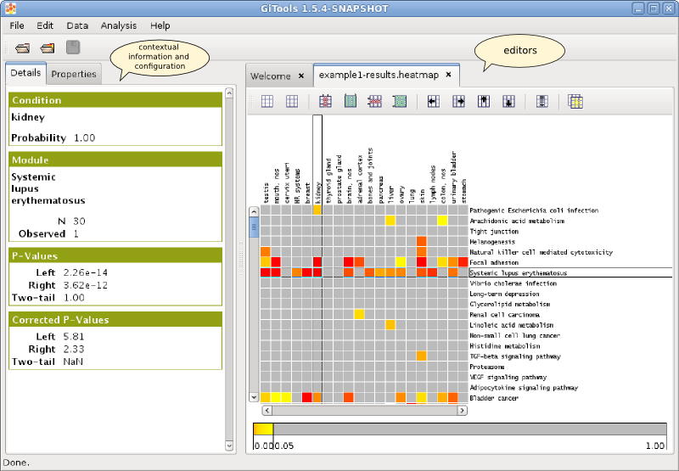
Gitools is document editor oriented, this means that you can have many documents opened at the same time, edit them and save changes. For each kind of document you would have at least one type of editor, so for example a matrix can be visualized with a heatmap.
There are also editors that simply show information and create other editors. An example of this is the analysis editor that shows all the parameters of an analysis that was performed before and allows to create heatmaps for the data and the results.
There are different kind of editors planned but for the time being the most mature one is the heatmap editor .

