Tutorials
Michael P Schroeder
2012/04/25 14:48

Table of Contents
CASE STUDY 1: Finding the Biological Processes enriched among genes significantly up-regulated in different types of cancer 2
CASE STUDY 2: Studying the expression profile of 156 lung tumors and adjacent normal lung tissue samples 18
CASE STUDY 3: Functional protein divergence in the evolution of Homo sapiens 31
CASE STUDY 4: Studying the regulatory programs governing the expression in different tissues 35
CASE STUDY 5: Experimental regulatory modules in cancer 43
CASE STUDY 6: Studying multi-dimensional cancer data with Gitools 47

- CASE STUDY 1: Finding the Biological Processes enriched among genes significantly up-regulated in different types of cancer
- CASE STUDY 2: Studying the expression profile of 156 lung tumors and adjacent normal lung tissue samples
- CASE STUDY 3: Functional protein divergence in the evolution of Homo sapiens
- CASE STUDY 4: Studying the regulatory programs governing the expression in different tissues
- CASE STUDY 5: Experimental regulatory modules in cancer
- CASE STUDY 6: Studying multi-dimensional cancer data with Gitools

CASE STUDY 1: Finding the Biological Processes enriched among genes significantly up-regulated in different types of cancer
Tutorial 1.1: Import Data Matrix From IntOGen
Import a data matrix from IntOGen that contains p-values for significantly up-regulated genes in each tumor morphology type

Tutorial 1.2: Import pathways From KEGG
Import a module file that maps all human genes to KEGG Pathways and the annotations of these terms

Tutorial 1.3: Run Enrichment Analysis
Run an enrichment analysis to test which pathways are enriched among genes significantly up-regulated in different types of cancer

Tutorial 1.4: Explore results in a heatmap
Explore the heatmap with the enrichment analysis results by sorting, filtering, hiding and moving rows and columns

Tutorial 1.5: Edit heatmaps
Edit properties of the heatmaps: change color scale, add annotations, change font size and edit grid

Tutorial 1.6: Export heatmap image and table results
Export the results of the enrichment analysis as an image and as a table containing the details of the statistic results

CASE STUDY 2: Studying the expression profile of 156 lung tumors and adjacent normal lung tissue samples
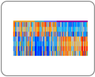 | Tutorial 2.1: Sample Level Enrichment Analysis (SLEA) with KEGG pathways  Identify pathways which genes are differentially expressed in various groups of samples
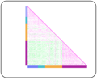 | Tutorial 2.2: Expression profiles correlations  Compare the expression profile of samples using correlations
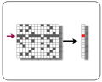 | Tutorial 2.3: Identifying significantly up-regulated genes  Run Oncodrive to identify the genes that are significantly up-regulated taking into account a set of tumour samples
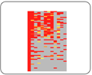 | Tutorial 2.4: Compare and combine experiments  Compare and combine the significantly up-regulated genes in our experiment and other lung experiments imported from IntOGen
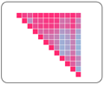 | Tutorial 2.5: Overlapping analysis  Compare the overlap of significantly up-regulated genes in our experiment and in other lung experiments imported from IntOGen

CASE STUDY 3: Functional protein divergence in the evolution of Homo sapiens
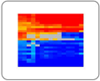 | Tutorial 3.1: Gene Ontology enrichment analysis  Analyse the conservation patterns of genes involved in different biological processes

CASE STUDY 4: Studying the regulatory programs governing the expression in different tissues
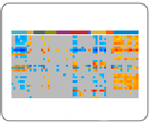 | Tutorial 4.1: TFBS enrichment analysis  Identify the transcription factors involved in the regulation of expression in different tissues
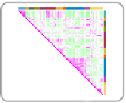 | Tutorial 4.2. Correlation of expression patterns in different tissues  Compare the expression pattern of genes expressed in different tissues

CASE STUDY 5: Experimental regulatory modules in cancer
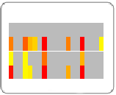 | Tutorial 5.1. Regulatory Modules enrichment analysis  Study the misregulation in different cancer types of modules derived from binding experiments such as ChIP-sequencing

CASE STUDY 6: Studying multi-dimensional cancer data with Gitools
The videos we have put online for this case study we are accessible on Youtube.
Watch the whole case study as a YouTube playlist
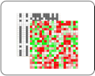 | Tutorial 6.1. Loading and annotating a multi-value matrix  Get prepared to start working
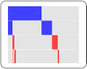 | Tutorial 6.2. Finding and visualizing mutually exclusive genes  See which genes are altered in a mutually exclusive manner
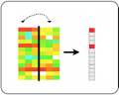 | Tutorial 6.3. Exploring the effect of genomic alterations on expression  See which genes are significantly influenced by genomic alterations in their locus
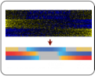 | Tutorial 6.4. Sample Level Enrichment Analysis  Asses transcription level for pathways for each sample in the study

