Tutorial 2.4: Compare and combine experiments
superadmin
2013/02/04 10:54

Table of Contents
Compare and combine the significantly up-regulated genes in our experiment and in other lung experiments imported from IntOGen 3
Files needed 3
Import p-value matrix from IntOGen for up-regulation in various independent lung cancer experiments. 3
Open heatmap and change scale and labels 3
Combine 4
Explore the results 4

Compare and combine the significantly up-regulated genes in our experiment and in other lung experiments imported from IntOGen

Files needed
- intogen_lung_upreg_plus_gse19188.cdm.gz : matrix file containing p-values for upregulation per gene for 11 experiments imported from IntOGen and the experiment from Hou et al. that we analyzed in the previous tutorial.
- intogen_lung_upreg-columns.tsv.gz : file with annotations of columns (experiments) for the matrix above
- intogen_lung_upreg-rows.tsv.gz : file with annotations of rows (genes) for the matrix above

Import p-value matrix from IntOGen for up-regulation in various independent lung cancer experiments.
- For this tutorial, we provide the matrix file containing p-values for these lung experiments plus the result of the oncodrive analysis in tutorial 2.3, after mapping probes to genes, see files above.
- See this chapter of the user guide to learn how to import data from IntOGen.

Open heatmap and change scale and labels
- File>Open>Heatmap… and select the file intogen_lung_upreg_plus_gse19188.cdm.gz.
- Change the color scale to p-value scale (in Properties/Cells/Scale).
- Change the labels of columns: In properties/columns, select the file “intogen_lung_upreg-columns.tsv.gz” and choose “authors” and “year” as label to show in the columns instead of the id of the experiment.
- Change the labels of rows: In properties/rows, select the file “intogen_lung_upreg-rows.tsv.gz” and choose “symbol” as label to show in the rows instead of the ensembl id of the gene.
- Select all the rows and sort to have the most significantly up-regulated genes in the various lung cancer experiments on top.
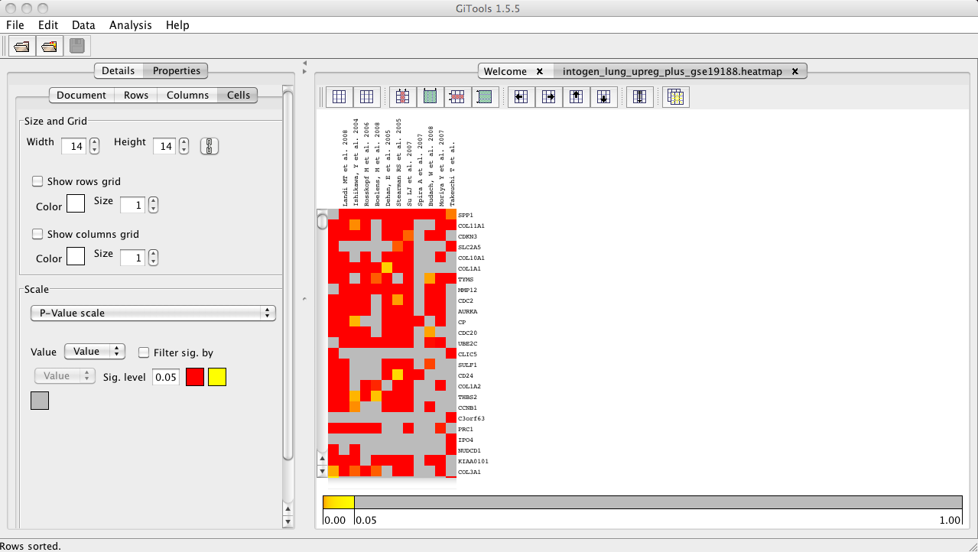

Combine
- To combine the p-values of all the lung cancer experiments, select Analysis>Combinations.
- See this chapter for further details on how to combine experiments.
- Apply to columns, with all columns with the same weight.
- Do not select any file for sets of columns or rows to combine, this way we will combine all columns of the heatmap.
- Click Next and Finish.

Explore the results
