Tutorial Times Day 1:
Introduction 17:00 - 17:30
Tutorial 1 / Hands on 1 / Break: 17:30 - 18:45
Tutorial 2 / Hands on 2 / Break: 18:45 - 20:00
Tutorial 3 / Hands on 3: 20:00 - 21:00

Main Room Zoom Link:
https://zoom.us/j/96966012450?pwd=T2VUdFBFdDlHS0l3T0x3NHdKZ0llQT09

First Breakout room: Ajay
Room 1: https://univ-amu-fr.zoom.us/j/92400392808?pwd=U3gxWGVqbmdXSDF0alBCMmNJYW9LUT09
mafaldapsantos
dasprabir
geduques
swatantra.5.dhara
kalzaabi6

Second Breakout room: Michael
Room 2: https://univ-amu-fr.zoom.us/j/96609184143?pwd=ZGYvVG1xYVZKaDZzV0VpMzdyWDcrQT09
samxrisa
muratorela
qiu.liming
vagechirkov
segebarth_d

Third Breakout room: Jan
Room 3: https://univ-amu-fr.zoom.us/j/94810517984?pwd=ZnM1Q0E3cVBoN1ZyL0JXd0FVRW9mdz09
rene.bernard
ruyb7033
subedivijaybikram
swetax9559

Technical
How to handle the attendee number?
So far, we said 30 people, and we have 60+ applications.

Zoom meeting with breakout rooms to which we assign the interactive attendees. The observers have to stay in the main room? And listen to elevator music…

How to deal with the observers? Could use listen-only links:
https://support.zoom.us/hc/en-us/articles/205172455-Hosting-a-Personal-Audio-Conference-meeting
It is possible to live stream a zoom meeting in parallel to the actual interactive meeting. We could probably use the BCOS Vimeo channel for streaming.

pre-assign participants to breakout rooms → using a csv file.
https://support.zoom.us/hc/en-us/articles/360032752671#h_f1d7287d-ade8-4b73-b0b9-37365faecf55

Email 1 template:

Dear …

we are happy to welcome you to our Nix-Neo workshop.

We are busy preparing stuff and will tell you all the details in a second email which will be sent out about a week before the course.

It would be great if you could give use a few feedback sentences regarding

- What kind of data do you deal with in your lab and what file formats do you use to store these?
- Is there a specific use-case for NIX/NEO you are interested in?
- Do you intend to join all parts of the workshop or do you have special interest in only some parts of it? Are you registered with any other workshop?
- Do you have example data from your lab that you would like to store in NIX.

Cheers and see you at the workshop,
The organizers

Email 2 template:

Title NIX-Neo workshop preparation

Dear INCF NIX-Neo workshop attendee!

We are happy to welcome you to our NIX-Neo workshop!

While we are in the last stages of preparing the workshop material, we would kindly ask active attendees to perform the following steps to ensure that the workshop runs as smoothly as possible:
- Have a running Python environment on your local computer.
- Have a look at the workshop repository containing (to be read as: will contain) all materials at https://gin.g-node.org/INCF-workshop-2021/NIX-Neo-workshop and follow the instructions in the README.md to have the required workshop environment prepared locally or have the provided Binder links running.
- Please note, the workshop material is not final yet. For the moment don’t rely on the content of the individual workshop days yet.
- The finalized material is ready for download on Monday 16:00 CEST. Download size less than 200 MB including example data.
- We encourage you to bring your own data so that we can try to store it in NIX during the workshop. To keep it feasible, the data should be 1 or 2 dimensional. If you do so, make sure they can be easily loaded or are stored e.g. as numpy arrays. Additionally for the Neo exercises you can bring data in any common electrophysiology format.

Cheers and see you at the workshop,
The organizers

Day 0 - Preparations, Background

How are the day 0 materials presented and communicated?
- background-presentation -> repo
- screencast video presentation -> repo
- email with instructions and link to repo

Mention over the course of the workshop when we describe e.g. how a dataset is saved or a tag is added and the example fits how NEO information is saved to NIX. Ask Achilleas to go over the existing notebooks and point out where it makes sense to add NEO specific mentions.

Presentation points

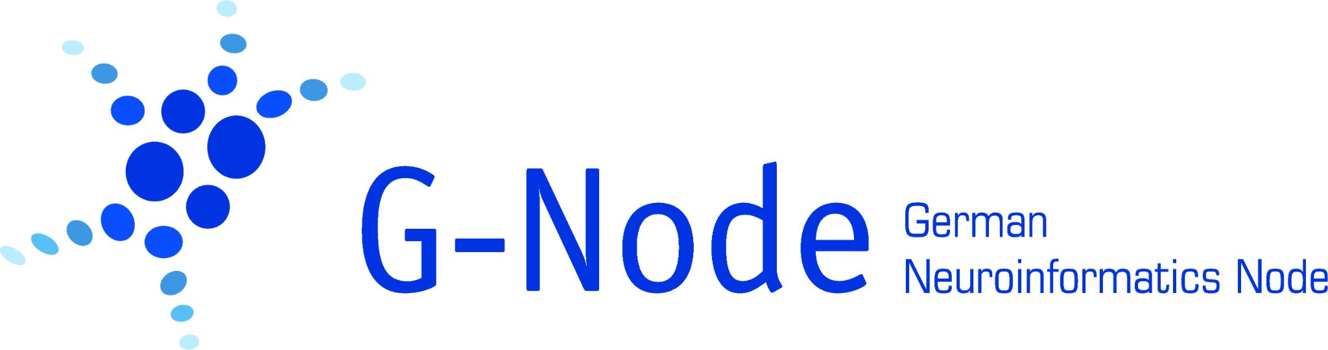

-> should we collect resources here? got a possible reusable introduction here: https://github.com/mpsonntag/prespost/blob/master/201810_RTG_Venice/Introduction_Data_Management.html

- Reproducibility crisis: important metadata are missing or not stored along with the data.
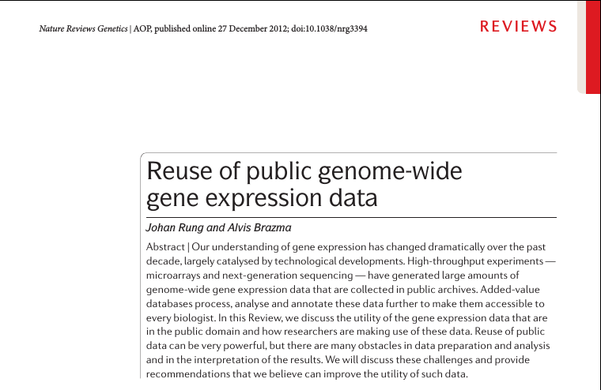

- How do we store a plethora of data types and add metadata to it that we do not know their names of.
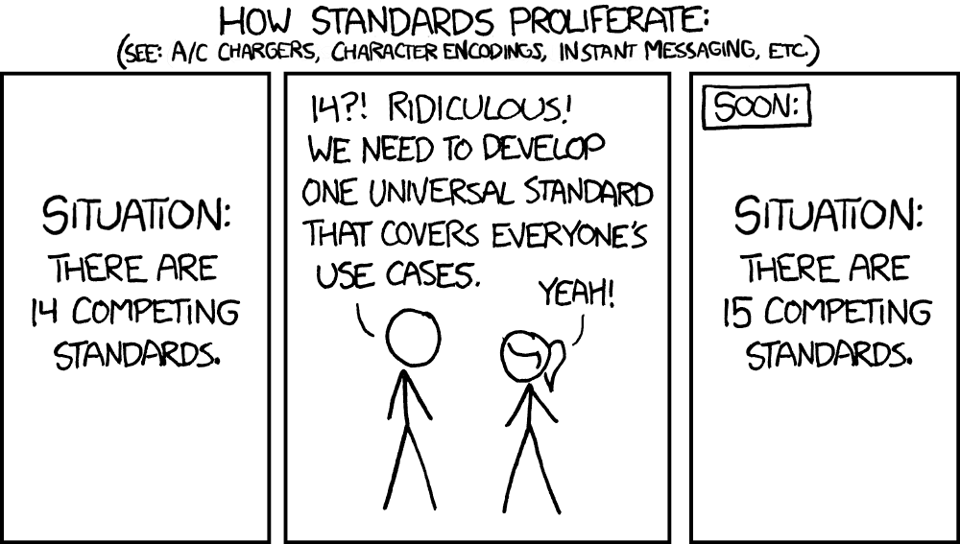
Should we also mention why NIX exists in the first place?
- multitude of unrelated open file formats
- closed vendor file formats
-> generalization of the NEO format to accommodate the multitude of different data

- Our approach (in contrast to other approaches) is to provide a generic data model that is flexible enough to store arbitrary data and metadata, link between entities and to allow for standardization.

- This leads to the data model

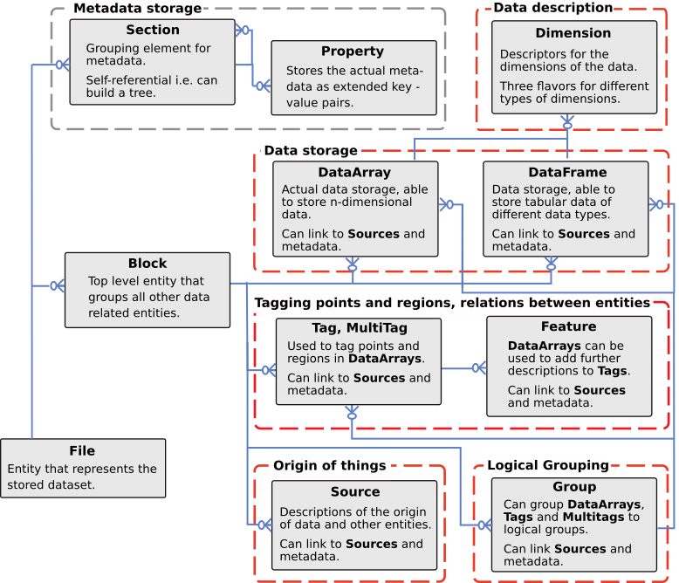

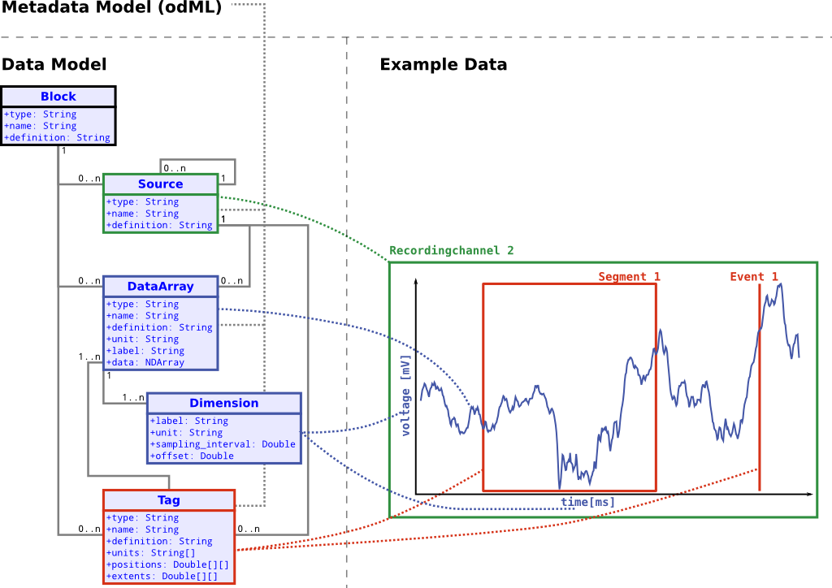
- Data -> DataArray / DataFrame; Dimensions, units and labels
- grouping -> Block, Group
- Metadata
- Multiple levels of experiments/analysis in the same file: References -> Tagging (ROI and metadata references.

- The data model is not bound to a certain file format but can be implemented using many different storage backends.
- We do provide APIs for different languages implementing the data model using the hierarchical data format (HDF5)
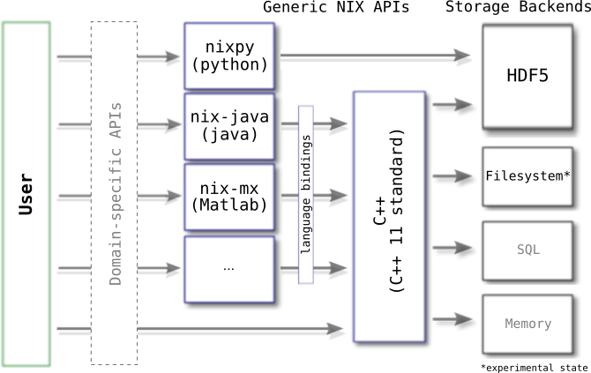
- Maybe stress the automation option: automatically record to file including metadata and script further analysis steps to the same file; from recording to figure all data is kept in the same file?
- Users can read/write nix files using our low-level APIs but the ideal solution is the definition of domain-specific APIs (such as NEO) to interact with the data/files.
What is domain specificity?

- Using nix also at recording time, relacs use case.

- Resources:
https://github.com/g-node/nix
https://github.com/g-node/nixpy
https://github.com/g-node/nix-mx
https://nixpy.readthedocs.io/
https://nixio.readthedocs.io/

NIX = NEAT information exchange - neat efficient annotated formaT
- Course Program

Day 1 - Basics
Use individual stand alone notebooks for each topic. Prepare input files if required.

Introduction (15min)
- “Life” demo of relacs data recording
- showing off a cool dataset in nixview? visualizing all the nice features - easy plotting, multitags, metadata in a single file and easy to export?
- a very brief recap of the day 0 intro as an explanation why NIX exists and we think it's a good idea to have it.
- where to find resources
https://github.com/g-node/nix
https://github.com/g-node/nixpy
https://github.com/g-node/nix-mx
https://nixpy.readthedocs.io/
https://nixio.readthedocs.io/

Basics

File handling (10 min)
  - creation of a new file,
  - opening a file for reading
  - opening for rewrite
  - What happens when I open a file in nixio.Overwrite mode?
file attached behavior, ReadWrite mode is default! Changes are immediately persisted → Notebook (2nd day)
File modes
  - File extension (we prefer nix ;)) → Notebook
  - We write HDF5 files. Which can handle very large files and datasets.`
HDF5 is a long standing file format (NASA).
  - ID concept. low collision probability unique identifier
  - Standard fields (created_at, updated_at) how to convert to real time?

Data and dimensions (20 min … 30 min)
  - Try to find multiple examples from various domains to specify which data the different dimensions represent. (search what the participants are working on)
  - Storing regularly sampled data. (say something about sampling of data using DAQ devices)
  - Irregularly sampled data. (Real life example where this happens? Irregular neuronal activity or radar trap, occurrence of behavioral events, eye saccades and the saccade amplitude)
Easy case, ticks are passed as list/array
Advanced case: ticks are stored in a separate DataArray/Frame
  - Categorical data e.g. weather data
  - Linking to DataArrays/DataFrames in RangeDimensions → Notebook (2nd day)
  - Data types: we make exact definitions of the supported data types and how they are stored. (e.g. the endianness, always little-endian → Day 2)
  - Choice of data type impacts on the file size → Notebook, Day 2
  - Reading of data and plotting with labels → Notebook (snippet for labeling the axes)

Hands on session I: user data import to NIX (45 min … 60-75 min)
  - opening and closing files,
  - FileModes.
  - Simple example: store regularly sampled data,
  - Advanced example: store two-D regularly sampled data [EEG-like (several channels) or heatmap image data (both dimensions are sampled)?]
  - ask users to bring 1 or 2 dimensional data and be able to fully describe it in units and dimensions
  - What example data do we provide?
  - load example data and store it to NIX → Notebook
  - plot the data and store the fully labeled figure → Notebook
    - get y-values from DataArray
    - get x-values from the dimension
    - get the label of the data (legend)
    - get the x- and y- labels with units
    - plot it with matplotlib

Break (15 min … 75-90 min)

Tagging and linked data (20 - 25 min … 95 - 115 min)
  - Tagging of a single point/segment in the data. Highlight a stimulus section → Notebook
  - Tagging is always done in the unit of the dimension(s).
  - List of references.
  - Data retrieval
  - Handling of units? SI units only!
  - Tagging of multiple points/regions
  - Tagging in 2-D → n-D
  - Mention that we can add some more payload to a Tag/MTag via Features.
  - Plotting of a tag?

Hands on session II: Tagging (45 min … 145 - 160 min)
  - Tagging a stimulus region.
  - Tagging of spike times in an analog signal. Recorded membrane voltages in which spikes can be easily detected using a simple threshold detector. Storing of each signal in a DataArray and linking them with a MultiTag → Notebook
  - Import prepared data and link to stimulus?
  - Plot the Tag/MTag.

Break (15 min … 160 - 175 min)

Data and Metadata (20 - 30 min)
  - Distinction of data and metadata
  - What is it needed for?
  - Where is metadata stored?
    - Laboratory notebooks
    - Spreadsheets
    - Program code
    - Soft- and hardware settings
    - subject information / Animal log
  - Comparing low- vs high-complexity metadata trees
    - Pros and Cons -> will probably skip this part since it is a NIX and not a metadata workshop (and we might not be the best qualified persons to tell others how to organize metadata)
  - We want to store them linked to the data in as much detail as possible/required.
  - Sources → This may be confusing. When to use sections, when to use sources. -> might skip sources to avoid confusion and focus on sections/properties alone
  - Automated handling of metadata -> “template”
  - Save metadata using previously used example data?

Hands on session III: (20 - 30 min)
  - users should be able to draft a descriptive collection of metadata to describe one of their own experiments and transform them to NIX metadata?
  - Attach metadata from dictionaries.
  - Find the data linked to the metadata
  - examples how to plot different types of data arrays
  - Hands on session: continue from before and plot own data (until end of course)

Day 2 - Deep dive and tooling

Complex data sets: (30 min)
- storing 1- to n- dimensional data examples
- enabling compression and the consequences for speed and file size
- chunking & continuous writing
- Impact of wrong chunking on performance
- data types and polynom stuff

Hands on session I: Complex data …
- chunking and continuous recording (Needs to find out a good scenario)
- storing n-dimensional data → Image data?, Multiple channels e.g. EEG data

Features:
- Tagged, Untagged, Indexed
- Examples for each

Small Neuroscience Project

Data & documentation
  - Example, data manipulation during storage: Filling up “chunked” recorded data with fill-values…
  - document procedure via metadata
- Hands on: store course or own datasets (30min)

Filtering, data access; navigating an unknown NIX file? (30min)
  - nix types, standardization
  - Hands on: navigating a relacs-nix file Find the sampled traces, the event traces etc.
  - Hands on: navigating a NEO file? Find out what is in the file. How many DataArrays, Tags, types...
- Break (15min)
- Recording into file examples and scripting good practices (relacs issues to avoid?) (30min)
  - funny things with the readwrite mode
  - file corrupted when write not properly closed
  - e.g. too many objects issue
  - maybe achilleas can help out here, he did a lot of benchmarking as well which might be interesting
- Hands on: present gotchas with NIX so far? (15-30min)
- Tooling presentation (20min)
  - validation
  - nixview?
  - nixworks? call for contributors?
  - odml-tables for converting excel sheets to odml and finally to NIX.
- Hands on (until end of session)
  - for those that are working on their own machines: try installation and playing around with the created nix files
  - for the others: more time for questions with the tutors

Day 3: NEO
Reach-to-grasp Datensatz: https://fz-juelich.sciebo.de/s/7IQ372L9ZeV1ikx
- Introduction to Neo
  - Motivation
    - Diversity of ephys file formats
    - Standard representation for other tools to build on (elephant)
  - Neo structure & objects
  - Neo IOs
- Hands-on session
- Introduction of the R2G Dataset, Advanced Neo
- Hands-on session
- Using Neo objects for analysis: Elephant, Viziphant
  - Overview of methods
  - Introduction to a few complex methods (spade?)
- Hands-on session

Discussion
- Ask for users impression and application ideas for NIX/NEO in their own real-life

