1. **First file to be created for making Employee details in employee_details.csv file**

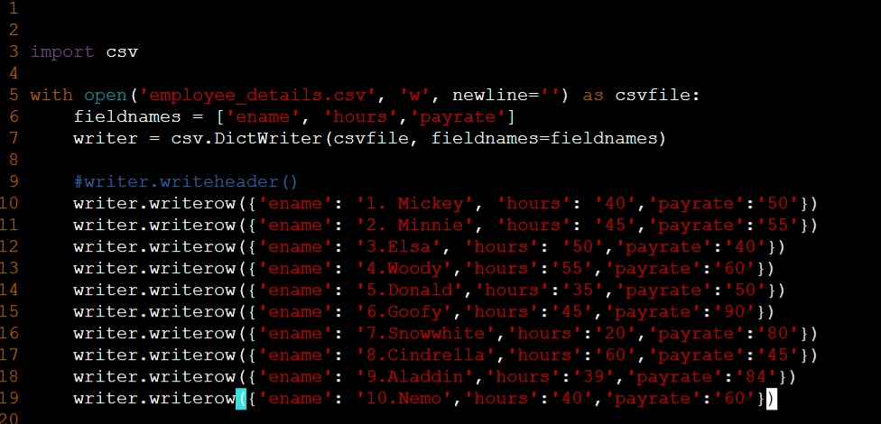

1. **Employee_details.csv file created from the above program**

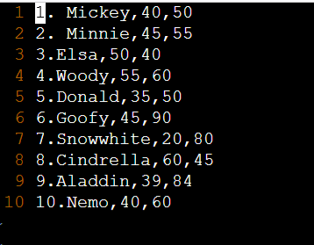

**Payroll Calculator Code:**

**This code reads all the data from employee_details.csv file and calculates the Grosspay, Netpay and displays the data for all the employees.**

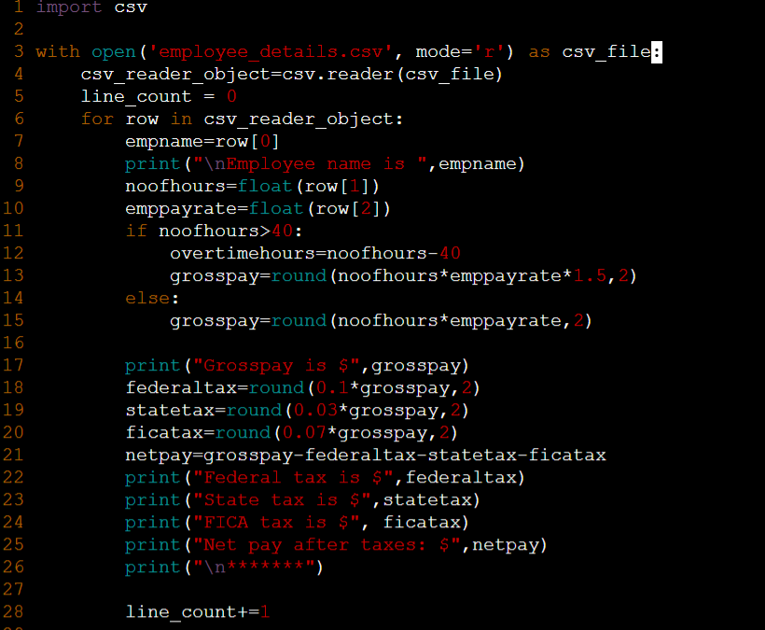

**Output results in the command line,**

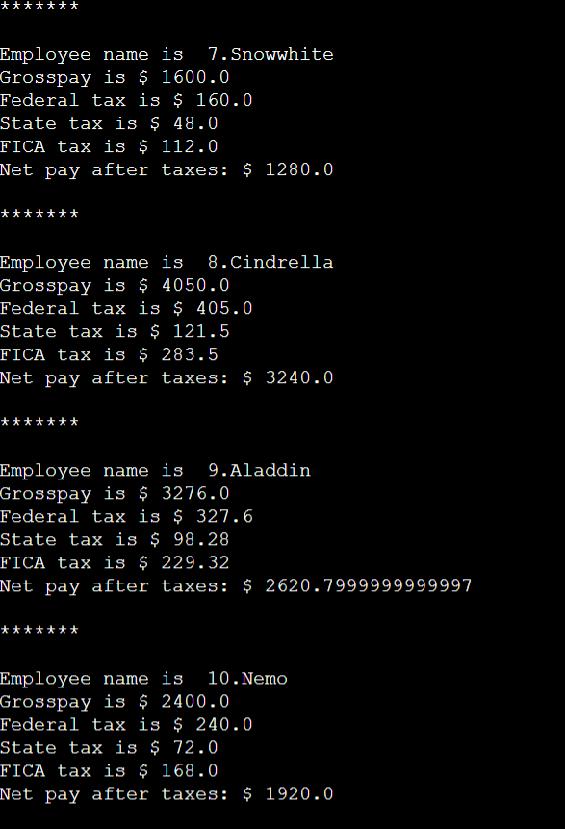

*screenshot above is only for the last 4 employees.