🛍️
VRINDA STORE
Annual Sales Report
Fiscal Year 2022
Data-Driven Analysis | Excel Dashboard Project

1. Executive Summary
Vrinda Store achieved significant sales milestones in 2022. This report presents a comprehensive analysis of order performance, customer demographics, channel contributions, and regional sales — all derived from a dataset of over 31,000 transactions across 12 months.

31,047 | 64% | 92% | 35% | ₹2.99M
Total Orders | Women Buyers | Delivery Rate | Amazon Share | Top State (MH)

2. Dataset Summary

2.1 Overview
The dataset contains 31,047 rows and 20 columns covering all orders placed through Vrinda Store during January–December 2022. The data is complete with no missing values and required minimal cleaning before analysis.

2.2 Key Data Fields
- Order ID & Customer ID — Unique identifiers for orders and customers
- Gender & Age Group — Customer demographic classification
- Date & Month — Order timeline for trend analysis
- Order Status — Delivered, Cancelled, Returned, Refunded
- Channel — Sales platform: Amazon, Flipkart, Myntra, Meesho, Ajio, Nalli, Others
- Category & Size — Product classification details
- Amount — Revenue generated per order
- Shipping Details — City, State, Postal Code, Country
- B2B Indicator — Business-to-business flag

3. Monthly Sales & Orders Trend
Monthly performance data reveals strong seasonality, with peak activity in the early months of the year and a gradual decline through the second half.
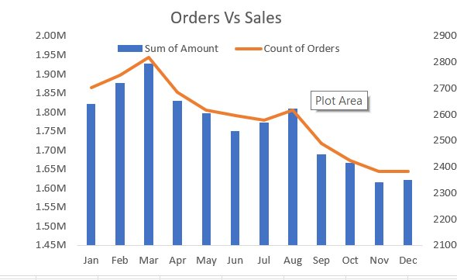
Figure 1: Orders vs Sales Amount by Month (Jan–Dec 2022)

Key Observations
- March was the peak month — highest sales amount (~₹1.93M) and highest order count (~2,820 orders)
- February showed the second-strongest performance, indicating a strong Q1
- Sales and order counts declined steadily from April onwards through December
- November and December recorded the lowest revenue (~₹1.61–1.63M), suggesting limited year-end promotions
- The order count and sales amount trend closely together, confirming consistent average order values throughout the year

💡 | Opportunity: Launching festive-season campaigns in October–December could significantly reverse the end-of-year decline.

4. Gender-Based Sales Analysis
Gender analysis reveals a decisive skew toward female customers in both order count and revenue share.
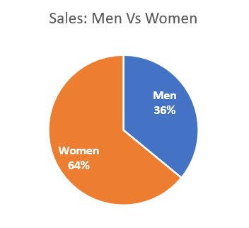
Figure 2: Sales Distribution — Men vs Women

4.1 Revenue Split
- Women contributed 64% of total sales, nearly double the contribution of men (36%)
- This pattern is consistent across all sales channels and product categories

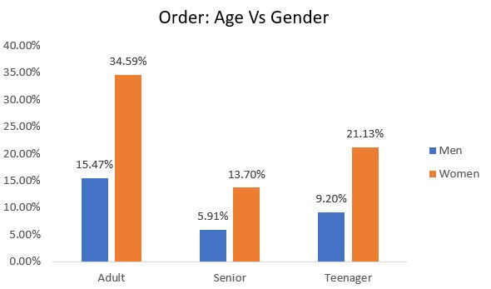
Figure 3: Orders by Age Group & Gender

4.2 Age Group Breakdown
- Adult women are the single largest customer segment at 34.59% of all orders
- Teenage women account for 21.13%, making them the second-largest group
- Senior women (13.70%) outperform senior men (5.91%) by over 2x
- Across all age groups, women consistently place more orders than men

💡 | Recommendation: Direct 70% of marketing budget toward adult and teenage women segments. Consider women-centric loyalty programmes, referral incentives, and curated product bundles.

5. Order Status Analysis
Order fulfilment health is a critical indicator of operational efficiency and customer satisfaction.
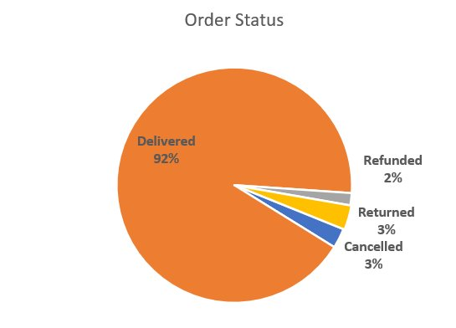
Figure 4: Order Status Distribution

Key Metrics
- Delivered: 92% — An excellent fulfilment rate indicating strong logistics performance
- Returned: 3% — Moderate; signals potential product quality or sizing issues
- Cancelled: 3% — Moderate; may reflect stock availability or customer indecision
- Refunded: 2% — Low refund rate reflects good post-delivery satisfaction

💡 | Recommendation: Investigate reasons for returns in high-return categories. Reducing return + cancel rates by even 1% each could meaningfully improve net revenue.

6. Sales Channel Performance
Vrinda Store sells across multiple e-commerce platforms. Channel diversification provides resilience, but concentration in top platforms drives volume.
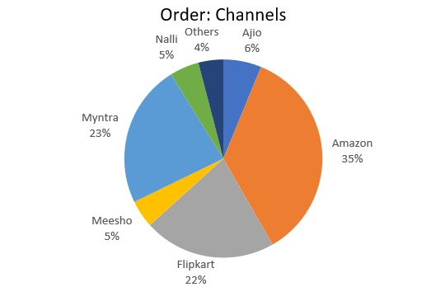
Figure 5: Order Distribution Across Channels

Channel Breakdown
- Amazon: 35% — Market leader; highest volume channel for Vrinda Store
- Myntra: 23% — Strong second; fashion-forward audience aligns with Vrinda's product mix
- Flipkart: 22% — Solid third; broad reach across Tier 2 & 3 cities
- Ajio: 6% — Growing premium channel; worth increased investment
- Nalli: 5% — Niche traditional wear segment
- Meesho: 5% — Social commerce platform; value-segment customers
- Others: 4% — Aggregated smaller platforms

💡 | Recommendation: Double down on Amazon and Myntra advertising spend. Explore Ajio's premium positioning to attract higher average order value customers. Evaluate Meesho for volume growth in value segments.

7. Regional Sales Performance
Geographic analysis identifies high-revenue markets and guides resource allocation for regional campaigns.
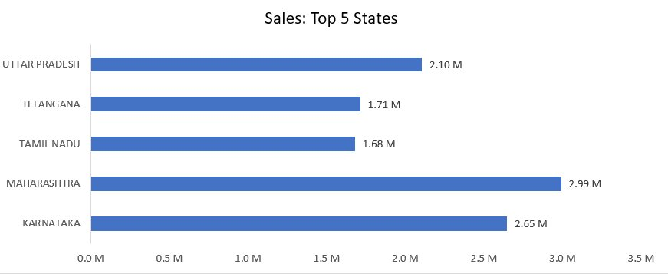
Figure 6: Top 5 States by Sales Revenue

Top 5 States
Rank | State | Sales | % of Top-5 Total
1 | Maharashtra | ₹2.99M | 24.8%
2 | Karnataka | ₹2.65M | 22.0%
3 | Uttar Pradesh | ₹2.10M | 17.4%
4 | Telangana | ₹1.71M | 14.2%
5 | Tamil Nadu | ₹1.68M | 13.9%

💡 | Recommendation: Prioritise Maharashtra and Karnataka for premium campaigns. Invest in Uttar Pradesh for volume growth given its large population base. Telangana and Tamil Nadu show strong southern market potential.

8. Business Recommendations

8.1 Customer Targeting
- Target adult and teenage women (55%+ of all orders) with personalised email campaigns and social media ads
- Design gender-specific loyalty programmes to retain the dominant female customer base
- Launch referral schemes incentivising women customers to bring in peer customers

8.2 Channel Strategy
- Increase Amazon advertising spend — ROI is proven at 35% order share
- Invest in Myntra's fashion ecosystem for brand visibility and premium positioning
- Explore Ajio for higher average order value customers in the premium segment
- Test Meesho campaigns for volume growth in price-sensitive Tier 2–3 markets

8.3 Regional Focus
- Concentrate outdoor and digital campaigns in Maharashtra, Karnataka, and Uttar Pradesh
- Expand logistics and warehouse partnerships in top-5 states for faster delivery
- Explore untapped metro markets in the south (Hyderabad, Chennai) through Telangana/Tamil Nadu data

8.4 Seasonal & Operational
- Launch festive-season campaigns (Diwali, Christmas) in October–December to reverse the H2 decline
- Introduce early-year new-arrivals campaigns to sustain the strong Jan–Mar momentum
- Investigate return and cancellation root causes; target reducing combined rate from 6% to under 4%
- Explore size recommendation tools or fit guides to reduce returns from sizing issues

9. Conclusion
The 2022 annual analysis reveals that Vrinda Store has a strong operational foundation — a 92% delivery rate, broad multi-channel presence, and a loyal female customer base. However, there is meaningful growth potential in three areas:
- Seasonal revenue optimisation — H2 months significantly underperform H1
- Channel investment calibration — Amazon and Myntra are outperforming and merit more budget
- Demographic deepening — Women, especially adults and teenagers, represent the highest-ROI segment

By acting on the recommendations in this report, Vrinda Store can target 15–20% revenue growth in 2023 while improving customer satisfaction metrics through reduced return and cancellation rates.

Vrinda Store Annual Report 2022 | Prepared using Microsoft Excel & Data Analysis

