Title: Proposal to Add “kSEAL_AdditionalSrc” Property to SealSources.txt
Source: suzuki toshiya ( mpsuzuki@hiroshima-u.ac.jp )
Date: 2026-09-27
Action: Discussion by CJK Experts
References:
WG2 N4834 https://unicode.org/wg2/docs/n4843Response%20to%20WG2N4834_TCAandCHINA.pdf
WG2 N4844 https://unicode.org/wg2/docs/n4844_CommentsonencodingShuowenSmallSea_SelenalandEiso.pdf
WG2 N4973 https://unicode.org/wg2/docs/n4973_comments%20on%20encoding%20Shuowen%20Small%20Seal.pdf
WG2 N5089 https://unicode.org/wg2/docs/n5089_Shuowen%20Seal%20Informal%20Meeting%20Report.pdf
WG2 N5230 https://unicode.org/wg2/docs/n5230-TCA%20Feedback%20to%20N5209.pdf
WG2 N5211 https://unicode.org/wg2/docs/n5211-14-columnchart-20171206.pdf

Abstract
There are some glyph names that are supposed to exist in source references but do not appear in the code chart and SealSources.txt, because the duplicated encodings of the same shape glyphs are avoided, as discussed in WG2 N4834, N4844, N4973, N5089, and N5209. However, there is no information which glyphs are omitted, or which codepoints can render them in the presentations of the source data. This submission proposes adding new property to SealSources.txt to give such information.

Omitted Seal Glyphs in Unicode 18.0.0
Some users may try to produce digital texts, or the Seal glyph list of Shuowen Jiezi (SWJZ) by Seal characters coded in Unicode 18.0.0, they would find some glyph names are omitted in the code chart and SealSources.txt. Below is the list of omitted glyph names, the order of the source references follows the order in the code chart (THX, CCZ, QJZ and DYC):
- 17 omitted glyph names for THX:
TH-‍00881, TH-‍00899, TH-‍01029, TH-‍01790, TH-‍01791, TH-‍02063, TH-‍02078, TH-‍02259, TH-‍03407, TH-‍04191, TH-‍04307, TH-‍05054, TH-‍05346, TH-‍06060, TH-‍07327, TH-‍08352, TH-‍09707
- 18 omitted glyph names for CCZ:
C-‍‍00914, C-‍‍00932, C-‍‍01062, C-‍‍01855, C-‍‍01856, C-‍‍02141, C-‍‍02157, C-‍‍02340, C-‍‍03518, C-‍‍04311, C-‍‍04439, C-‍‍05222, C-‍‍05517, C-‍‍06138, C-‍‍06277, C-‍‍07601, C-‍‍08670, C-‍‍10070
- 21 omitted glyph names for QJZ:
K-‍‍00729, K-‍‍00887, K-‍‍00906, K-‍‍01035, K-‍‍02068, K-‍‍02083, K-‍‍02266, K-‍‍03416, K-‍‍03818, K-‍‍04276, K-‍‍04314, K-‍‍05061, K-‍‍05355, K-‍‍06094, K-‍‍07013, K-‍‍07050, K-‍‍07254, K-‍‍07341, K-‍‍08365, K-‍‍09722, K-‍‍10163
- 23 omitted glyph names for DYC:
D-‍‍00636, D-‍‍00637, D-‍‍00876, D-‍‍00894, D-‍‍01023, D-‍‍02046, D-‍‍02061, D-‍‍02244, D-‍‍03397, D-‍‍03795, D-‍‍04175, D-‍‍04292, D-‍‍05039, D-‍‍05181, D-‍‍05334, D-‍‍06050, D-‍‍06991, D-‍‍07315, D-‍‍07635, D-‍‍08341, D-‍‍08865, D-‍‍09705, D-‍‍10147
A demo tool to list the omitted glyph names from SealSources.txt is available at:
https://mpsuzuki.github.io/kSEAL_DUP/

Issues Related to the Omitted Glyphs
Although these omissions were discussed and agreed by the Small Seal experts, the discussion record is not summarized in any part of the standard. The users may wonder about the gap of the glyph name sequences, and how to render the omitted glyphs. Even if they know about the duplicated entries, it would not be so easy to spot which codepoint should be used to render the omitted glyph.

Proposal for New Property
To clarify the omitted glyphs and their substitutions, there might be some options on how to add such information into SealSources.txt. Table 1 describes the proposed kSEAL_AdditionalSrc property in UAX#60 format. The complete list of the proposed properties is shown on page 4, and the detailed rationales for each codepoint are described in the Appendix.

Table 1: Definition of the proposed kSEAL_AdditionalSrc
Property | kSEAL_AdditionalSrc
Status | Provisional
Category | Other data
Introduced | TBD
Delimiter | Space
Syntax | ([CDK]|TH)-‍\d{5}
Default | N/A
Description | One or more kSEAL_THXSrc, kSEAL_CCZSrc, kSEAL_QJZSrc, or kSEAL_DYCSrc property values that correspond to source references that were omitted due to duplicate glyphs in a source. The order of the source references follows the order in the code charts.

There might be other options to add the information on the glyphs omitted from the code chart.
- From the viewpoint of the users, changing kSEAL_THXSrc, kSEAL_CCZSrc, etc. to multi-value properties (like the kSEAL_Rad property) would be the most straightforward solution. The first value would appear in the code chart, but the rest values do not.
- Also, there might be another idea to change the syntax of these properties to the concatenated syntax, like kTGT_MergedSrc of the Tangut script. For example, using the value “TH-00888-06060” to mean “TH-00880 and TH-06060”. The first deduced value would appear in the code chart, but the rest do not. This idea would be still user-friendly too, while the extended property is still single value property.
However, considering that the existing source properties are normative and might be important to maintain the consistency between the code chart and UCD data, changing the existing property design might have some impact with the code chart production workflow. As the first proposal, this document proposes adding new provisional property to minimize the impact.
Also, the expected number of the UCS codepoints with this property would be less than 50, thus it can be a considerable option to have this attribute for each source, like, kSEAL_THXAdditionalSrc, kSEAL_CCZAdditionalSrc, etc.

Acknowledgement
This proposal contains the outcomes of the research supported by JSPS KAKENHI Grant Number JP16K004600A, JP19K12716, and JP22K12719. I would like to thank Jiang Kushim (for his suggestion of the multi-value property), Eiso Chan (for his suggestion of the concatenated syntax), and Ken Lunde for valuable discussion in drafting. This proposal would not have been possible without their support.

# kSEAL_AdditionalSrc
#
# UAX #60 Additions:
#
# Property: kSEAL_AdditionalSrc
# Status: Provisional
# Category: Other data
# Introduced: TBD
# Delimiter: Space
# Syntax: ([CDK]|TH)-\d{5}
# Default: N/A
# Description: One or more kSEAL_THXSrc, kSEAL_CCZSrc, kSEAL_QJZSrc, or kSEAL_DYCSrc property values that correspond to source references that were omitted due to duplicate glyphs in a source. The order of the source references follows the order in the code charts.
#
# 30 New SealSources.txt Records:
#
U+3D1B6 kSEAL_AdditionalSrc K-00729
U+3D228 kSEAL_AdditionalSrc K-07013 D-06991
U+3D3AB kSEAL_AdditionalSrc TH-06060 C-06277 K-06094 D-06050
U+3D3DD kSEAL_AdditionalSrc TH-02078 C-02157 K-02083 D-02061
U+3D406 kSEAL_AdditionalSrc TH-03407 C-03518 K-03416 D-03397
U+3D421 kSEAL_AdditionalSrc TH-08352 C-08670 K-08365 D-08341
U+3D43C kSEAL_AdditionalSrc D-07635
U+3D626 kSEAL_AdditionalSrc C-06138
U+3D685 kSEAL_AdditionalSrc D-05181
U+3D72D kSEAL_AdditionalSrc TH-01791 C-01856
U+3D72E kSEAL_AdditionalSrc TH-01790 C-01855
U+3DB65 kSEAL_AdditionalSrc TH-04307 C-04439 K-04314 D-04292
U+3DC96 kSEAL_AdditionalSrc TH-02259 C-02340 K-02266 D-02244
U+3DE12 kSEAL_AdditionalSrc TH-07327 C-07601 K-07341 D-07315
U+3DE72 kSEAL_AdditionalSrc D-00636
U+3DE73 kSEAL_AdditionalSrc D-00637
U+3E003 kSEAL_AdditionalSrc TH-04191 C-04311 D-04175
U+3E0B3 kSEAL_AdditionalSrc K-10163 D-10147
U+3E923 kSEAL_AdditionalSrc TH-01029 C-01062 K-01035 D-01023
U+3ED9C kSEAL_AdditionalSrc K-07050
U+3EE4E kSEAL_AdditionalSrc TH-00899 C-00932 K-00906 D-00894
U+3EE9D kSEAL_AdditionalSrc K-07254
U+3EFE3 kSEAL_AdditionalSrc TH-00881 C-00914 K-00887 D-00876
U+3F2C6 kSEAL_AdditionalSrc K-04276
U+3F322 kSEAL_AdditionalSrc TH-02063 C-02141 K-02068 D-02046
U+3F38D kSEAL_AdditionalSrc K-03818 D-03795
U+3F4EA kSEAL_AdditionalSrc D-08865
U+3F792 kSEAL_AdditionalSrc TH-09707 C-10070 K-09722 D-09705
U+3FADF kSEAL_AdditionalSrc TH-05346 C-05517 K-05355 D-05334
U+3FB61 kSEAL_AdditionalSrc TH-05054 C-05222 K-05061 D-05039
# EOF

Background of Each Property
In this appendix, the relationship of the omitted glyphs and standardized characters are described. There are 3 categories why there is a gap in the glyph name sequences:
- Row omissions for universal duplicates: all major editions (DaXu Ben, XiaoXu Ben, and Duan Zhu Ben) contain the occurrences, and all instances are duplicated, thus whole row is omitted.
- Row omissions for edition-specific duplicates: some but not all editions (DaXu Ben only, XiaoXu Ben + Duan Zhu Ben only, etc) contain the occurrences, but all instances are duplicated whenever they are found, thus whole row is omitted.
- Cell omissions for edition-specific duplicates: some editions have distinguishable instances, but others have duplicated instances. Only the duplicated instances are omitted, thus the blank cells are left in the row.
The sections below describe each category.

A.1 Terminology: Branch and Edition
A.2 Relevant Columns of WG2 N5211
A.3 Row Omissions for Universal Duplicates
A.4 Row Omissions for Edition-Specific Duplicates
A.5 Cell Omissions for Edition-Specific Duplicates

  - Terminology: Branch and Edition
To describe similarities and differences among the extant texts, this document uses two terms: branch and edition. Figure 1 shows the outline of the relationship.
A printed version issued by a specific publisher is referred to as an “edition”. In most cases, a published SWJZ text is presented as a reproduction of an authoritative source rather than a compilation from multiple sources.
If the principal source is identified as the text restored by Xu Xuan, the edition is regarded as an instance of the “DaXu Ben” (大徐本) branch. If the principal source is identified as the text restored and annotated by Xu Kai, the edition is regarded as an instance of the “XiaoXu Ben” (小徐本) branch. The text restored and annotated by Duan Yucai is referred to as the “DuanZhu Ben” (段注本).
These broad categories are sometimes referred to as “DaXu versions” and “XiaoXu versions”. For greater precision, however, this document uses the terms “DaXu branch” (大徐系統) and “XiaoXu” branch (小徐系統).
The Jiguge edition, published by the Jiguge Library between the late Ming and early Qing periods, underwent significant revision between its earlier printing (“毛4” column in Figure 5) and later printing (“毛5” column in Figure 5). When a distinction is required, these are referred to as the Jiguge early print and the Jiguge later print. Otherwise, both are collectively referred to as the “Jiguge edition”. The Jiguge edition is regarded as an instance of the “DaXu branch” in broad sense, but it is based on “Shuowen Jiezi Wuyun Yunpu” (説文解字五音韻譜), and introduced some entries from the XiaoXu branch. Therefore, it is not an instance of the “DaXu” branch in strict sense.
Figure 1: “Branch” and “Edition” in this document, and their relationship
    - How Omissions Appear in the Code Chart
The appearances of the omissions can be classified into 3 categories as below:
- Row omissions of universal duplicates
Figure 2 shows the case that the occurrence (the second “U”) is found in all editions (L, M, N), and all instance is duplicated and the whole row is omitted. There would be a glyph name gap between the previous (“X”) and next rows (“Y”), for all editions.
Figure 2: Row omissions of universal entries
- Row omissions of edition-dependent duplicates
Figure 3 shows the case where the occurrence (the second “U”) is found in some but not all editions, but the instance is duplicated whenever it occurs. The whole row is omitted, and there would be a glyph name gap for some but not all editions (M and N have gaps, but L has no gap).
Figure 3: Row omissions of edition-dependent entries
- Cell omissions of edition-dependent duplicates
Figure 4 shows the case where the occurrence (the first “V” or second “U”) is found in some or all editions, some but not all instances (the second “U”) are duplicated. Because of non-duplicated instances (the first “V”), the whole row cannot be omitted, but the cell for the duplicated instance (the second “U”) is omitted and leaves a blank at its position. There would be a glyph name gap between the previous and next cell.
Figure 4: Cell omission of edition-dependent entries
  - Relevant Columns of WG2 N5211
To describe the duplicated or unified glyphs, some cropped images of WG2 N5211 are given. For reviewers’ convenience, the structure of the chart is briefly described below.
Figure 5: Structure in WG2 N5211 and relevant columns
The digits under the glyph images are the sequential number of each source (thus, the number in the cell for N4688 differs from TH- glyph name, because TH- glyph names use three different numbering systems; TH-\d{5}, TH-X\d{3}, TH-Y\d{3}.) And the DYC glyph images are taken from kanji-database project (https://kanji-database.sourceforge.net/dict/swjz/) including some missing glyphs and unneeded glyphs (glyphs taken from the description text, not heading glyphs), so the number in the DYC cell is not same with the D-\d{5} glyph names in Unicode 18.0.0. Anyway, the numbers under the CCZ and QJZ glyphs are consistent with the C-\d{5} and K-\d{5} glyph names.
  - Row Omissions for Universal Duplicates
The items in this section are the items that two quite similar shaped glyphs are placed in all editions of Shuowen Jiezi (THX, CCZ, QJZ and DYC).
    - U+3D3AB: “吹”
As shown in Figure 6, all editions (THX, CCZ, QJZ and DYC) have two occurrences of “吹”, under the “口” and “欠” radicals.
Figure 6: Occurrences of Seal “吹” in SWJZ (WG2 N5211)
In both occurrences, the descriptions are exactly the same; “嘘也。从口从欠。昌垂切。”. Unicode 18.0.0 allocates only one codepoint for these instances, at U+3D3AB, which is the earlier instance under the “口” radical, as shown in Figure 7.
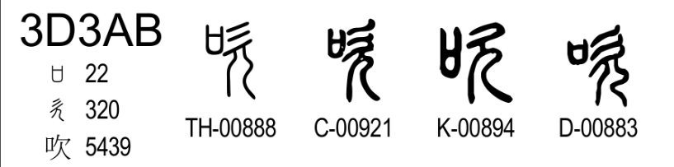
Figure 7: Standardized “吹” in the Unicode 18.0.0
The omitted glyph names can be identified by the gaps in the glyph name sequences in Figure 8.
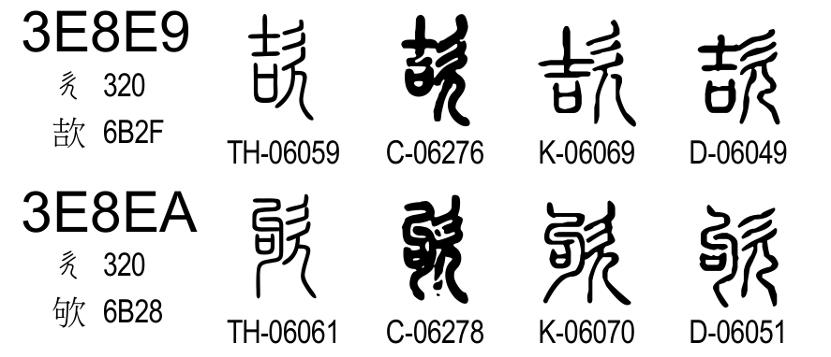
Figure 8: Glyph name gap in the range from U+3E8E9 to U+3E8EA
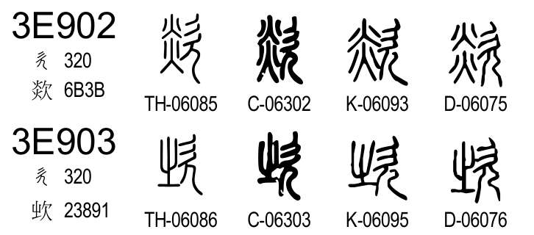
Figure 9: Glyph name gap in the range from U+3E902 to U+3E903
The omitted glyph names under the “欠” radical are identified as TH-‍06060, C-‍06277, D-‍06050 (as shown in Figure 8), and K-‍06094 (as shown in Figure 9). Thus, the proposed property can be designed as:
U+3D3AB kSEAL_AdditionalSrc TH-‍06060 C-‍06277 K-‍06094 D-‍06050

    - U+3D3DD: “𠮢”
As shown in Figure 10, all editions (THX, CCZ, QJZ and DYC) have two occurrences of “𠮢”, under the “口” and “又” radicals.
Figure 10: Occurrences of Seal “右” in SWJZ (WG2 N5211)
In both occurrences, the descriptions are semantically equivalent; “助也。从口从又。徐鍇曰、言不足以左復手助之于。于救切。” and “手口相助也。从口从又。臣鉉等曰、今俗別作佑。于救切。”. Unicode 18.0.0 allocates only one codepoint for these instances, at U+3D3DD, which is the earlier occurrence under the “口” radical.
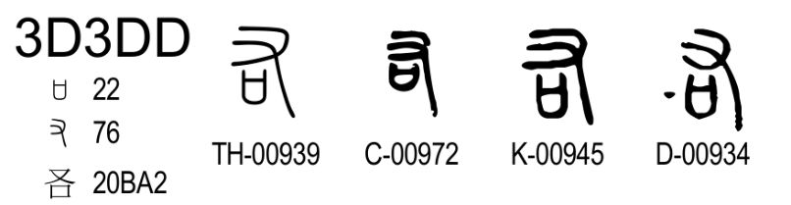
Figure 11: Standardized Seal “右” in the Unicode 18.0.0
The omitted glyph names can be identified by the gaps in the glyph name sequences in Figure 12.
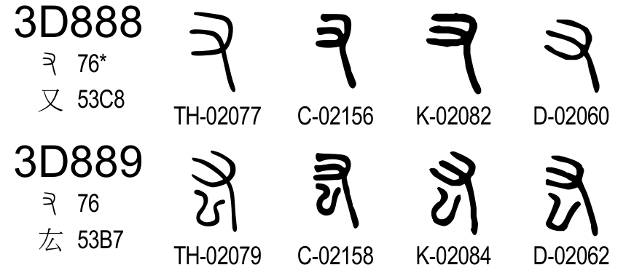
Figure 12: Glyph name gap in the range from U+3D888 to U+3D889
The omitted glyph names under the “又” radical are identified as TH-‍02078, C-‍02157, K-‍02083, and D-‍02061. Thus, the proposed property can be designed as:
U+3D3DD kSEAL_AdditionalSrc TH-‍02078 C-‍02157 K-‍02083 D-‍02061

    - U+3D406: “𠮱”
As shown in Figure 13, all editions (THX, CCZ, QJZ and DYC) contain two occurrences of “𠮢”, under the “口” and “亏” radicals.
Figure 13: Occurrences of Seal “𠮱” in SWJZ (WG2 N5211)
In both occurrences, the descriptions are semantically equivalent; the earlier entry reads “驚也。从口于聲。況于切。”, and the later entry reads “驚語也。从口从亏。亏亦聲。臣鉉等按、口部巳有此重出。于救切。”.
Unicode 18.0.0 allocates only one codepoint for these instances, at U+3D406, which is the occurrence under the “口” radical.
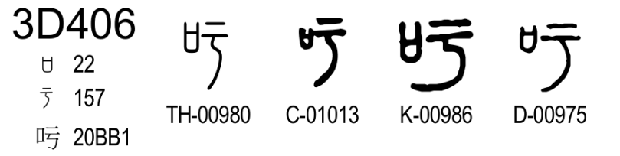
Figure 14: Standardized Seal “𠮱” in the Unicode 18.0.0
The omitted glyph names can be identified by the gaps in the glyph name sequences in Figure 15.
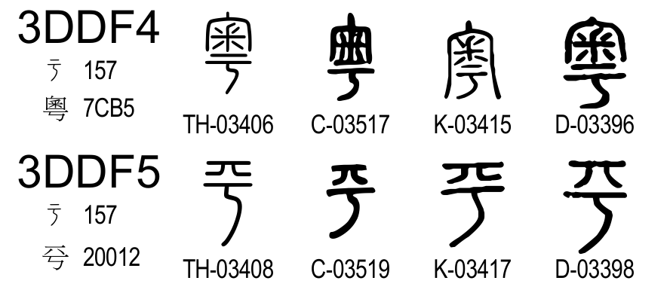
Figure 15: Glyph name gap in the range from U+3DDF4 to U+3DDF5
The omitted glyph names under the “亏” radical are identified as TH-‍03407, C-‍03518, K-‍03416, and D-‍03397. Thus, the proposed property can be designed as:
U+3D406 kSEAL_AdditionalSrc TH-‍03407 C-‍03518 K-‍03416 D-‍03397

    - U+3D421: “否”
As shown in Figure 16, all editions (THX, CCZ, QJZ and DYC) have two occurrences of “否”, under the “口” and “不” radicals.
Figure 16: Occurrences of Seal “否” in SWJZ (WG2 N5211)
In both occurrences, the descriptions are semantically equivalent; the earlier entry reads “否：不也。从口从不。”, and the later entry reads “否：不也。从口从不，不亦聲。”. Unicode 18.0.0 allocates only one codepoint for these instances, at U+3D421, which is the occurrence under the “口” radical.
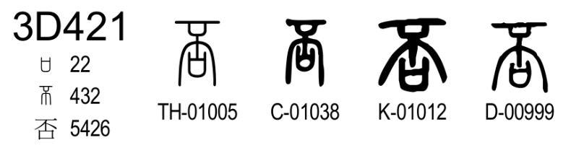
Figure 17: Standardized Seal “否” in the Unicode 18.0.0
The omitted glyph names can be identified by the gaps in the glyph name sequences in Figure 18.
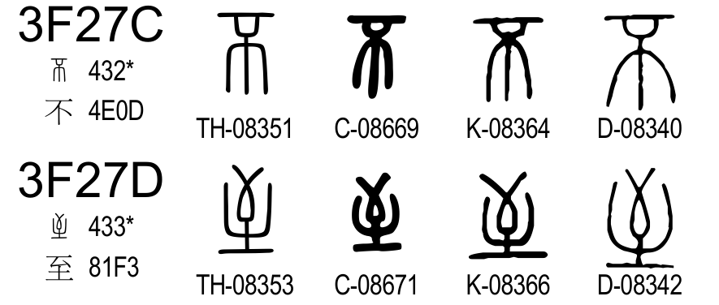
Figure 18: Glyph name gap in the range from U+3F27C to U+3F27D
The omitted glyph names under the “不” radical are identified as TH-‍08352, C-‍08670, K-‍08365, and D-‍08341. Thus, the proposed property can be designed as:
U+3D421 kSEAL_AdditionalSrc TH-‍08352 C-‍08670 K-‍08365 D-‍08341

    - U+3DB65: “𢾍”
As shown in Figure 19, all editions (THX, CCZ, QJZ and DYC) have two occurrences of “𢾍”, under the “放” and “出” radicals.
Figure 19: Occurrences of Seal “𢾍” in SWJZ (WG2 N5211)
In both occurrences, the descriptions are semantically equivalent; the earlier entry reads “敖：出游也。从出从放。”, and the later entry reads “敖：游也。从出从放。”.
Unicode 18.0.0 allocates only one codepoint for these instances, at U+3DB65, which is the occurrence under the “放” radical.
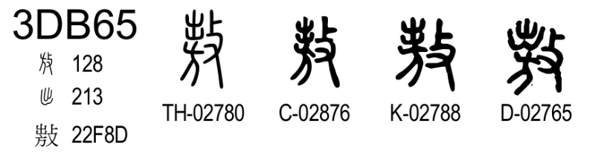
Figure 20: Standardized Seal “𢾍” in the Unicode 18.0.0
The omitted glyph names can be identified by the gaps in the glyph name sequences in Figure 21.
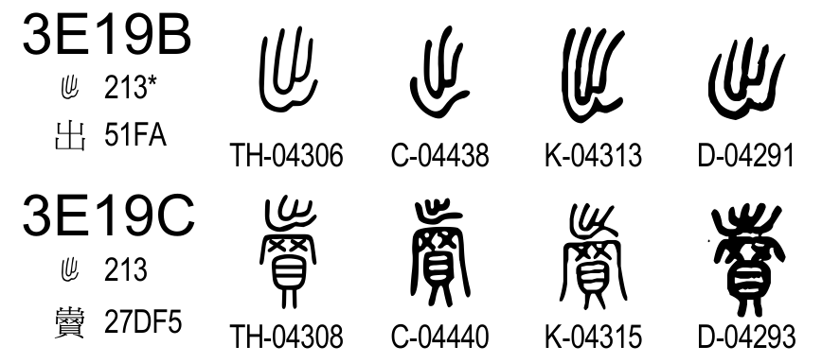
Figure 21: Glyph name gap in the range from U+3E19B to U+3E19C
The omitted glyph names under the “出” radical are identified as TH-‍04307, C-‍04439, K-‍04314, and D-‍04292. Thus, the proposed property can be designed as:
U+3DB65 kSEAL_AdditionalSrc TH-‍04307 C-‍04439 K-‍04314 D-‍04292

    - U+3DC96: “剫”
As shown in Figure 22, all editions (THX, CCZ, QJZ and DYC) have two occurrences of “剫”, under the “刀” and “攴” radicals.
Figure 22: Occurrences of Seal “剫” in SWJZ (WG2 N5211)
In the earlier occurrence, “剫” is not a headword entry but an alternative form of “𢾅”. The headword entry for “𢾅” reads “𢾅：閉也。从攴度聲。讀若杜。徒古切。”, its accompanying entry for “剫” reads “剫：𢾅或从刀。”. In the later occurrence, “剫” is a headword entry, the entry reads “剫：判也。从刀度聲。徒洛切。”.
Although their semantics are not exactly same, their shapes are impossible to distinguish from each other. Thus, the later instance of the headword entry is coded at U+3DC96, and the earlier occurrence is unified with the later instance.
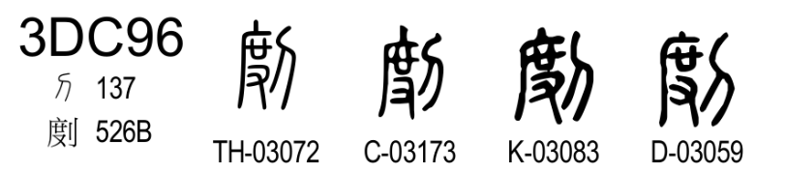
Figure 23: Standardized Seal “剫” in the Unicode 18.0.0
The omitted glyph names can be identified by the gaps in the glyph name sequences in Figure 24.
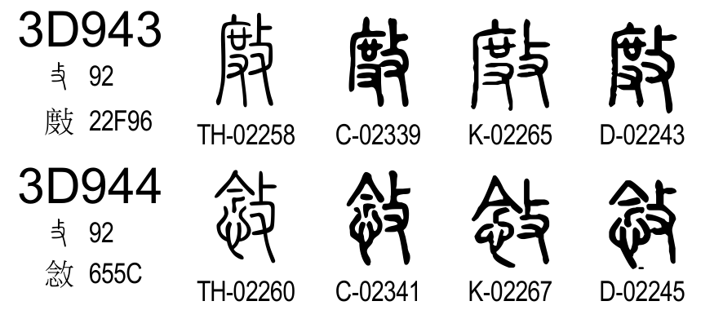
Figure 24: Glyph name gap in the range from U+3D943 to U+3D944
The omitted glyph names are identified as TH-‍02259, C-‍02340, K-‍02266, and D-‍02244. Thus, the proposed property can be designed as:
U+3DC96 kSEAL_AdditionalSrc TH-‍02259 C-‍02340 K-‍02266 D-‍02244

    - U+3DE12: “愷”
As shown in Figure 25, all editions (THX, CCZ, QJZ and DYC) have two occurrences of “愷”, under the “豈” and “心” radicals.
Figure 25: Occurrences of Seal “愷” in SWJZ (WG2 N5211)
In both occurrences, the descriptions are similar; the early entry reads “愷：康也。从心、豈，豈亦聲。苦亥切。”, and the later entry reads “愷：樂也。从心豈聲。臣鉉等曰、豈部巳有。此重出。苦亥切。”. Unicode 18.0.0 allocates only one codepoint for these instances, at U+3DE12, which is the occurrence under the “豈” radical.
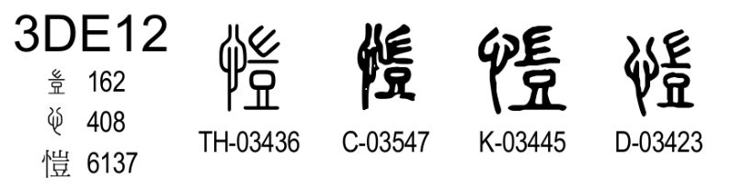
Figure 26: Standardized Seal “愷” in the Unicode 18.0.0
The omitted glyph names can be identified by the gaps in the glyph name sequences in Figure 27.
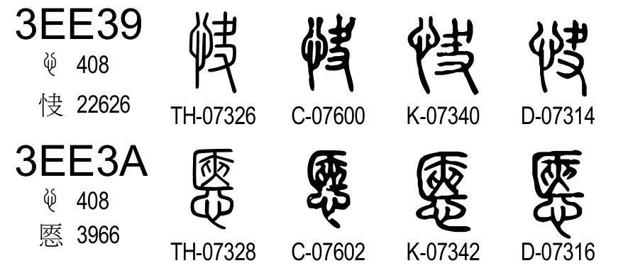
Figure 27: Glyph name gap in the range from U+3EE39 to U+3EE3A
The omitted glyph names under the “心” radical are identified as TH-07327, C-07601, K-07341, and D-07315. Thus, the proposed property can be designed as:
U+3DE12 kSEAL_AdditionalSrc TH-‍07327 C-‍07601 K-‍07341 D-‍07315

    - U+3E923: “𣢜”
As shown in Figure 28, all editions (THX, CCZ, QJZ and DYC) have two occurrences of “𣢜”, under the “欠” and “口” radicals.
Figure 28: Occurrences of Seal “𣢜” in SWJZ (WG2 N5211)
In the earlier occurrence, it is not a headword entry but an alternate form of “呦”. The headword entry “呦” reads “呦：鹿鳴聲也。从口幼聲。”, its accompanying entry for “𣢜” reads “𣢜：呦或从欠。”. In the later occurrence, it is a headword entry. The entry reads “𣢜：愁皃。从欠幼聲。”.
Unicode 18.0.0 allocates only one codepoint for these instances, at U+3E923, which is the later occurrence under the “欠” radical.
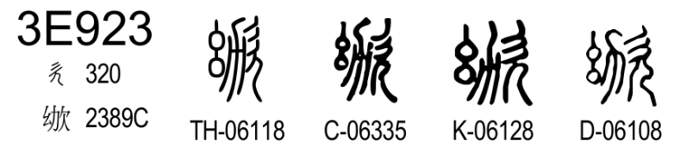
Figure 29: Standardized Seal “𣢜” in the Unicode 18.0.0
The omitted glyph names can be identified by the gaps in the glyph name sequences in Figure 30.
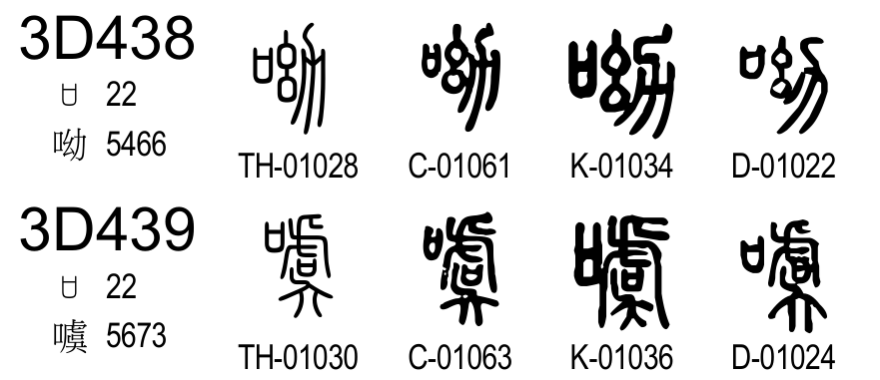
Figure 30: Glyph name gap in the range from U+3D438 to U+3D439
The omitted glyph names under the “口” radical are identified as TH-01029, C-01062, K-01035, and D-01023. Thus, the proposed property can be designed as:
U+3E923 kSEAL_AdditionalSrc TH-‍01029 C-‍01062 K-‍01035 D-‍01023

    - U+3EE4E: “悊”
As shown in Figure 31, all editions (THX, CCZ, QJZ and DYC) have two occurrences of “悊”, under the “口” and “心” radicals.
Figure 31: Occurrences of Seal “悊” in SWJZ (WG2 N5211)
In the earlier occurrence, it is not a headword entry but an alternate form of “哲”. The entry for “哲” reads “哲：知也。从口折聲。”, its accompanying entry for “悊” reads “悊：哲或从心。”. In the later occurrence, “悊” is a headword entry. The entry reads “悊：敬也。从心折聲。”.
Unicode 18.0.0 allocates only one codepoint for these instances, at U+3EE4E, which is the later occurrence under the “心” radical.
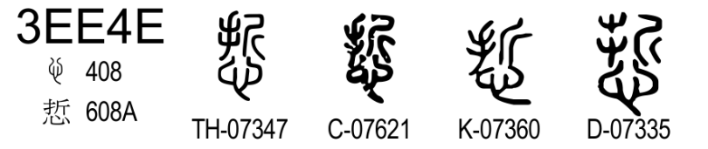
Figure 32: Standardized Seal “悊” in the Unicode 18.0.0
The omitted glyph names can be identified by the gaps in the glyph name sequences in Figure 33.
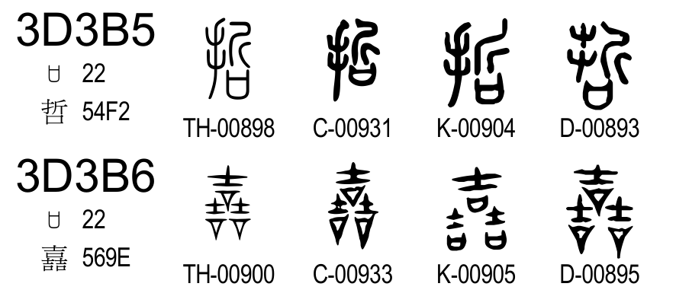
Figure 33: Glyph name gap in the range from U+3D3B5 to U+3D3B6
The omitted glyph names under the “口” radical are TH-‍00899 C-‍00932 K-‍00906 D-‍00894.
Thus, the proposed property can be designed as:
U+3EE4E kSEAL_AdditionalSrc TH-‍00899 C-‍00932 K-‍00906 D-‍00894

    - U+3EFE3: “𰝇”
As shown in Figure 34, all editions (THX, CCZ, QJZ and DYC) have two occurrences of “𰝇”, under the “口” radical and “水” radical.
Figure 34: Occurrences of Seal “𰝇” in SWJZ (WG2 N5211)
In earlier occurrence, “涶” is not a headword entry but an alternative form of “唾”. The headword entry for “唾” reads “唾：口液也。从口𡍮聲。湯臥切。”, its accompanying entry for “涶” reads “涶：唾或从水。”. In the later occurrence, “涶” is a headword entry. The entry reads “涶：河津也。在西河西。从水𡍮聲。土禾切。”.
Unicode 18.0.0 allocates only one codepoint for these instances, at U+3EFE3, which is the later occurrence under the “水” radical.
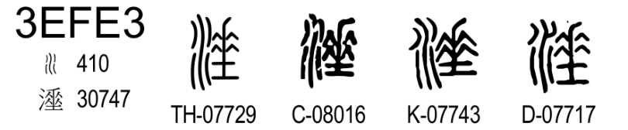
Figure 35: Standardized Seal “𰝇” in the Unicode 18.0.0
The omitted glyph names can be identified by the gaps in the glyph name sequences in Figure 36.
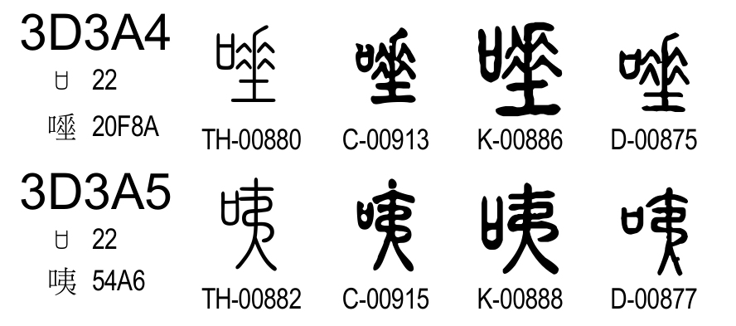
Figure 36: Glyph name gap in the range from U+3D3A4 to U+3D3A5
The omitted glyph names under the “口” radical are identified as TH-00881, C-00914, K-00887, and D-00876. Thus, the proposed property can be designed as:
U+3EFE3 kSEAL_AdditionalSrc TH-‍00881 C-‍00914 K-‍00887 D-‍00876

    - U+3F322: “𢭤”
As shown in Figure 37, all editions (THX, CCZ, QJZ and DYC) have two occurrences of “𢭤”, under the “丮” and “手” radicals.
Figure 37: Occurrences of Seal “𢭤” in SWJZ (WG2 N5211)
In earlier occurrence, “㧬” is not a headword entry but an alternative form of “𢀜”. The headword entry for “𢀜” reads “𢀜：袌也。从丮工聲。居悚切。”, its accompanying entry for “㧬” reads “㧬：𢀜或加手。”. In the later occurrence, “㧬” is a headword entry. The entry reads “㧬：𢹬也。从手𢀜聲。居竦切。臣鉉等案、丮部有「㧬」與「𢀜」同。此重出。”. Xu Xuan supposed they were same character.
Unicode 18.0.0 allocates only one codepoint for these instances, at U+3E322, which is the later occurrence under the “手” radical.
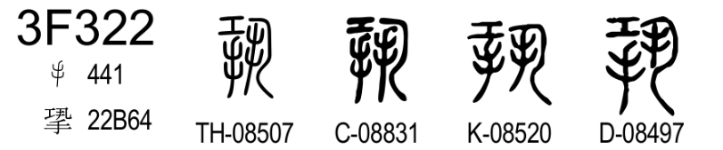
Figure 38: Standardized Seal “𢭤” in the Unicode 18.0.0
The omitted glyph names can be identified by the gaps in the glyph name sequences in Figure 39.
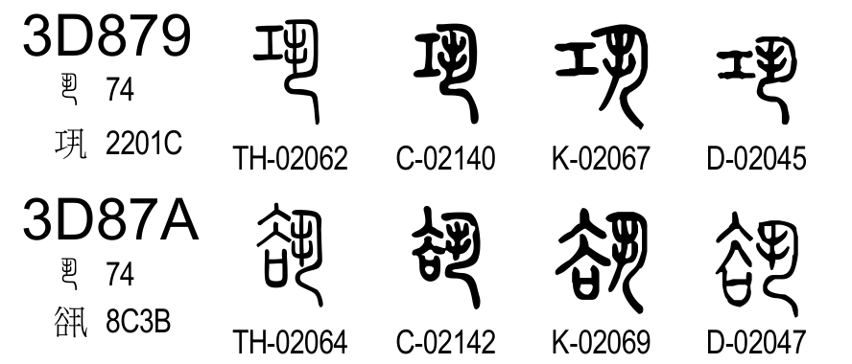
Figure 39: Glyph name gap in the range from U+3D879 to U+3D87A
The omitted glyph names under the “丮” radical are identified as TH-00881, C-00914, K-00887, and D-00876. Thus, the proposed property can be designed as:
U+3F322 kSEAL_AdditionalSrc TH-‍02063 C-‍02141 K-‍02068 D-‍02046

    - U+3F792: “蝥”
As shown in Figure 40, all editions (THX, CCZ, QJZ and DYC) have two occurrences of “蝥”, under the “虫” and “蟲” radicals.
Figure 40: Occurrences of Seal “蝥” in SWJZ (WG2 N5211)
The earlier occurrence is the headword entry, it reads “蝥：螌蝥也。从虫敄聲。臣鉉等曰、今俗作「蟊」、非是「蟊」、即「蠿蟊」、蜘蛛之別名也。莫交切。”. The later occurrence is not a headword entry but an alternative form of “𧔨”. The “𧔨” entry reads “𧔨：蟲食艸根者。从蟲，象其形。吏抵冒取民財則生。徐鍇曰、唯此一字、象蟲形不、从矛。書者多誤。莫浮切。”. And the “蝥” entry reads “蝥：𧔨或从敄。臣鉉等按、虫部巳有。莫交切。作螌蝥蟲。此重出。”. Xu Xuan supposed they were same character.
Unicode 18.0.0 allocates only one codepoint for these instances, at U+3F792, which is the occurrence under the “虫” radical.
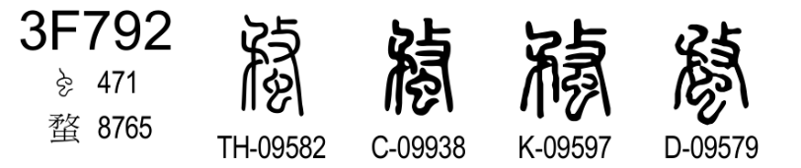
Figure 41: Standardized Seal “蝥” in the Unicode 18.0.0
The omitted glyph names can be identified by the gaps in the glyph name sequences in Figure 42.
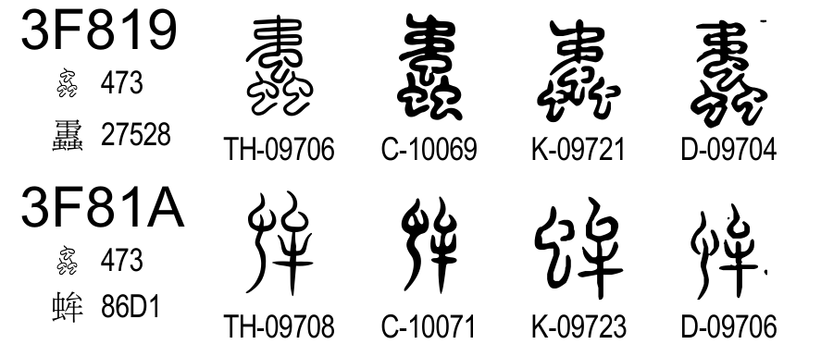
Figure 42: Glyph name gap in the range from U+3F819 to U+3F81A
The omitted glyph names under the “蟲” radical are identified as TH-‍09707, C-‍10070, K-‍09722, and D-‍09705. Thus, the proposed property can be designed as:
U+3F792 kSEAL_AdditionalSrc TH-‍09707 C-‍10070 K-‍09722 D-‍09705

    - U+3FADF: “輟”
As shown in Figure 43, all editions (THX, CCZ, QJZ and DYC) have two occurrences of “輟”, under the “网” and “車” radicals.
Figure 43: Occurrences of Seal “輟” in SWJZ (WG2 N5211)
The earlier occurrence is not a headword entry but an alternative form of “罬”. The headword entry for “罬” reads “罬：捕鳥覆車也。从网叕聲。陟劣切。”, its accompanying entry for “輟” reads “輟：罬或从車。”. The later occurrence is the headword entry, “輟：車小缺復合者。从車叕聲。臣鉉等按、网部「輟」與「罬」同。此重出。陟劣切。”.
Unicode 18.0.0 allocates only one codepoint for these instances, at U+3FADF, which is the occurrence under the “車” radical.
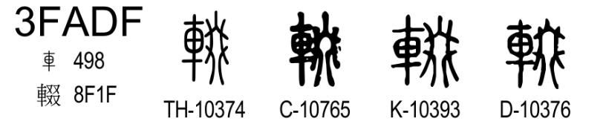
Figure 44: Standardized Seal “輟” in the Unicode 18.0.0
The omitted glyph names can be identified by the gaps in the glyph name sequences in Figure 45.
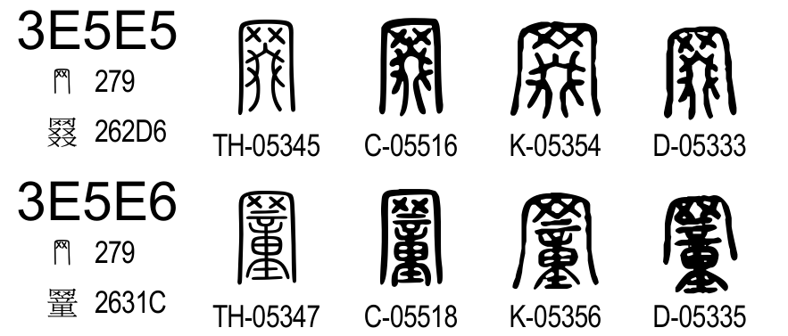
Figure 45: Glyph name gap in the range from U+3E5E5 to U+3E5E6
The omitted glyph names under the “网” radical are identified as TH-‍05346, C-‍05517, K-‍05355, and D-‍05334. Thus, the proposed property can be designed as:
U+3FADF kSEAL_AdditionalSrc TH-‍05346 C-‍05517 K-‍05355 D-‍05334

    - U+3FB61: “院”
As shown in Figure 46, all editions (THX, CCZ, QJZ and DYC) have two occurrences of “院”, under the “宀” and “𨸏” radicals.
Figure 46: Occurrences of Seal “院” in SWJZ (WG2 N5211)
The earlier occurrence is not a headword entry but an alternative form of “寏”. The headword entry for “寏” reads “寏：周垣也。从宀奐聲。胡官切。”, its accompanying entry for “院” reads “院：寏或从𨸏。又爰眷切。”. The later occurrence is the headword entry, it reads “院：堅也。从𨸏完聲。臣鉉等按、宀部巳有。此重出。王眷切。”.
Unicode 18.0.0 allocates only one codepoint for these instances, at U+3FB61, which is the later occurrence under the “𨸏” radical.
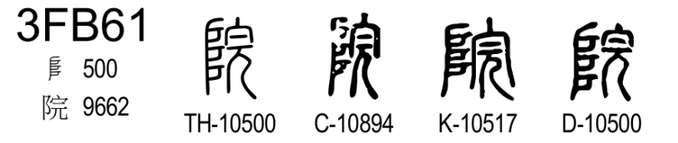
Figure 47: Standardized Seal “院” in the Unicode 18.0.0
The omitted glyph names can be identified by the gaps in the glyph name sequences in Figure 48.
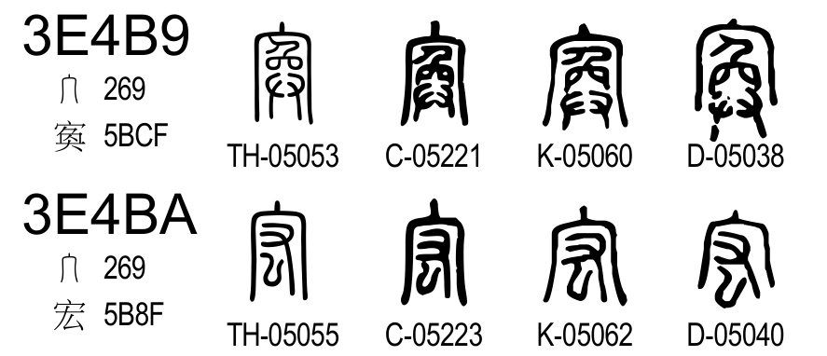
Figure 48: Glyph name gap in the range from U+3E4B9 to U+3E4BA
The omitted glyph names under the “宀” radical are identified as TH-‍05054, C-‍05222, K-‍05061, and D-‍05039. Thus, the proposed property can be designed as:
U+3FB61 kSEAL_AdditionalSrc TH-‍05054 C-‍05222 K-‍05061 D-‍05039

  - Row Omissions for Edition-Specific Duplicates
    - U+3D1B6: “苖”
As shown in Figure 49, the XiaoXu branches have two “苖” occurrences. Both occurrences are found under the “艸” radical, and their descriptions are almost identical;
“苖：蓨也。从艸由聲。臣鍇曰、苖音廸。《爾雅・釋艸》有之注云未詳。徒歴切。又他六切。”, “苖：蓨也。从艸由聲。臣鍇曰、下從由。即《爾雅》注云未詳也。田溺反。臣次立曰、前巳有此重出。”. In the earlier occurrence, the suffix for the fanqie notation is “切”, which differs from the XiaoXu convention “反”, therefore it could be changed from the original description by Xu Kai, and influenced by the DaXu branch. Also, the later occurrence has the note by 張次立.
Figure 49: Occurrences of Seal “苖” in SWJZ (WG2 N5211)
Unicode 18.0.0 allocates only one codepoint for these instances, at U+3D1B6, which corresponds to the earlier occurrence.
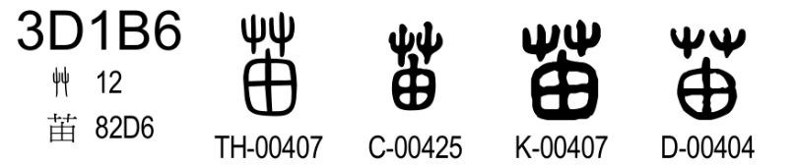
Figure 50: Standardized Seal “苖” in the Unicode 18.0.0
The omitted glyph names can be identified by the gaps in the glyph name sequences in Figure 51.
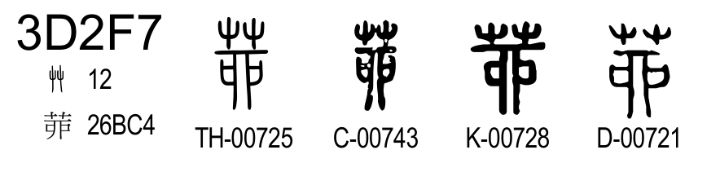
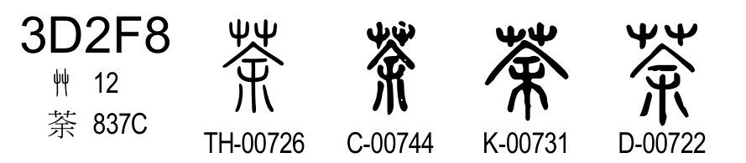
Figure 51: Glyph name gap in the range from U+3D2F7 to U+3D2F8
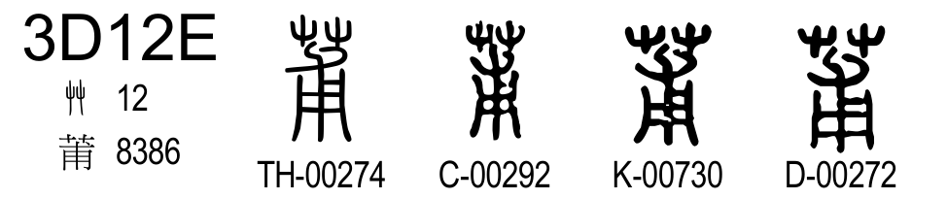
Figure 52: Mapping of K-00730 at U+3D12E
It looks like that two glyph names are omitted between U+3D2F7 and U+3D2F8; K-00729 and K-00730. But K-00730 is used at U+3D12E (as shown in Figure 52), so the omitted glyph is K-00729 only in this gap. Thus, the proposed property can be designed as:
U+3D1B6 kSEAL_AdditionalSrc K-00729

    - U+3D72D: “誤”
As shown in Figure 53, the Sung prints of the DaXu branch and their reproductions (a copy owned by Lu Xinyuan (陸心源舊藏本), a copy owned by Haiyuange library (海源閣舊藏本), and its reproductions like THX, PJG, and CCZ) have duplicated occurrences of “誤”, both under the “言” radical. In both occurrences, the descriptions are exactly same; “謬也。从言吳聲。”.
Figure 53: Occurrences of Seal “誤” in SWJZ (WG2 N5211)
It should be noted that the duplication of “誤” and “詿” is not same ordered. Their earlier occurrence orders “誤” then “詿”, but the later occurrence orders “詿” then “誤”, as shown in Figure 54.
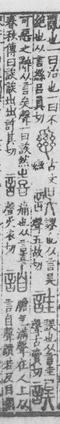
earlier occurrence | later occurrence
Figure 54: Duplicated occurrences of “誤” and “詿” in the Sung print copy owned by the Haiyuange Library (海源閣)
Unicode 18.0.0 allocates only one codepoint for these instances, at U+3D72D, which is the earlier occurrence.
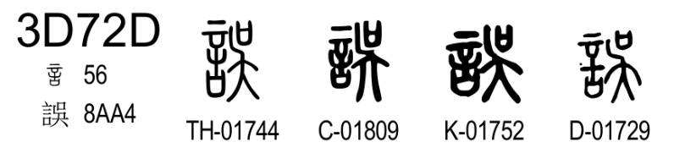
Figure 55: Standardized Seal “誤” in the Unicode 18.0.0
The omitted glyph names can be identified by the gaps in the glyph name sequences in Figure 56.
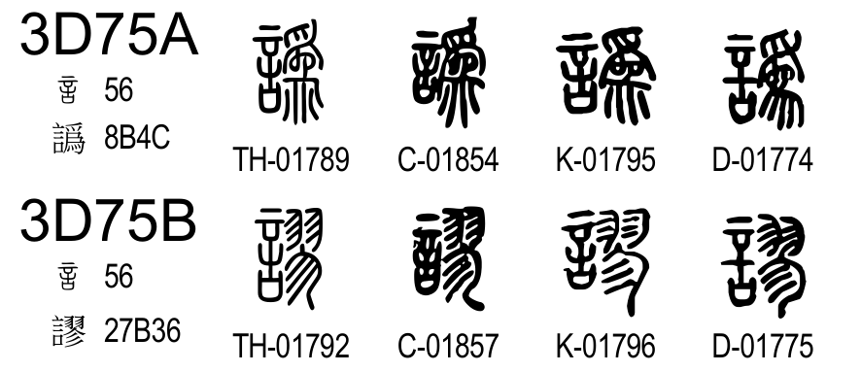
Figure 56: Glyph name gap in the range from U+3D75A to U+3D75B
From the glyph names at U+3D75A and U+3D75B, the omitted glyph names are identified to be TH-01791, and C-01856. Thus, the proposed property can be designed as:
U+3D72D kSEAL_AdditionalSrc TH-‍01791 C-‍01856

    - U+3D72E: “詿”
As shown in Figure 57, the DaXu editions based on the real Sung prints (THX, CCZ, PJG, 岩崎本, 海源閣本) have two occurrences of “詿”, both under the “言” radical. In both occurrences, the descriptions are similar; “誤也。从言圭聲。古賣切。” or “誤也。从言隹省聲。古賣切。”.
Figure 57: Occurrences of Seal “詿” in SWJZ (WG2 N5211)
Unicode 18.0.0 allocates only one codepoint for these instances, at U+3D72D, which is the earlier occurrence.
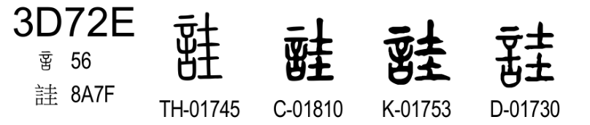
Figure 58: Standardized Seal “詿” in the Unicode 18.0.0
The omitted glyph names can be identified by the gaps in the glyph name sequences in Figure 59.

Figure 59: Glyph name gap in the range from U+3D75A to U+3D75B
The omitted glyph names are identified as TH-01790, C-01855. It should be noted that the duplication of “誤” and “詿” is not same ordered. Their earlier occurrence is “誤” then “詿”, but the later occurrence is “詿” then “誤”, as shown in Figure 54. Thus, the proposed property can be designed as:
U+3D72E kSEAL_AdditionalSrc TH-‍01790 C-‍01855

    - U+3E003: “柅”
As shown in Figure 60, the editions in the DaXu branch and DYC edition contain two “柅” occurrences. The earlier occurrence is a headword entry under the “木” radical. It reads “柅：木也。實如棃。从木尼聲。”. The editions in the XiaoXu branch do not contain this occurrence. The later occurrence is not a headword entry but an alternate form of “杘” under the “木” radical. The headword entry for “杘” reads “杘：籆柄也。从木尸聲。”. And accompanying entry for “柅” reads “柅：杘或从木。尼聲。臣鉉等曰、柅、女氏切、木若棃。此重出。”. The editions in the XiaoXu branch contain this occurrence.
Figure 60: Occurrences of Seal “柅” in SWJZ (WG2 N5211)
As shown in Figure 61, Unicode 18.0.0 allocates only one codepoint for these instances, at U+3E003 whose position corresponds to the earlier but non-universal occurrence. It is because this entry is a headword entry. At this codepoint, there is a QJZ source, but this glyph is moved from the later occurrence (see the glyph sequence number of QJZ in Figure 61).
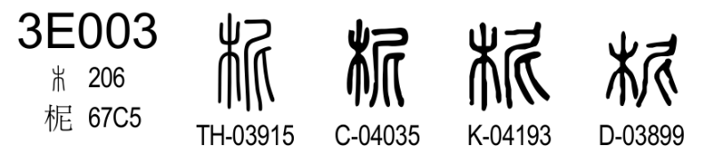
Figure 61: Standardized Seal “柅” in the Unicode 18.0.0
The omitted glyph names can be identified by the gaps in the glyph name sequences in Figure 62.
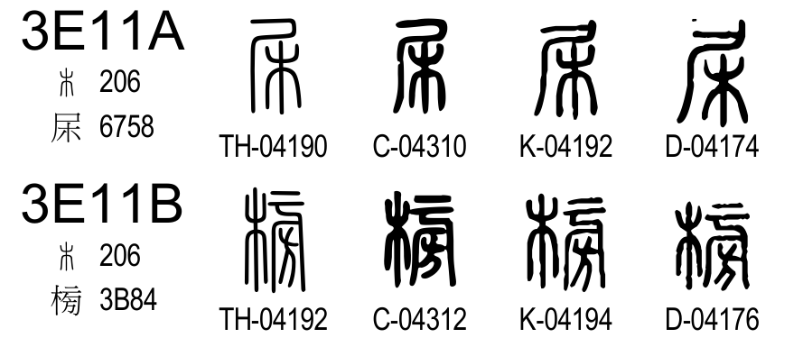
Figure 62: Glyph name gap in the range from U+3E11A to U+3E11B
There are gaps in glyph names; TH-04191, C-04311, K-04193, and D-04175 from U+3E11A to U+3E11B. As shown in Figure 61, K-04193 is moved to U+3E003, therefore, the omitted glyphs are identified as TH-04191, C-04311, and D-04175. Thus, the proposed property for U+3E003 can be designed as:
U+3E003 kSEAL_AdditionalSrc TH-‍04191 C-‍04311 D-‍04175

    - U+3ED9C: “炙”
As shown in Figure 63, the editions in the XiaoXu branch contain two occurrences of “炙”, although the editions of the DaXu branch and the DYC edition contain one occurrence. The earlier occurrence is specific to the XiaoXu editions, which is a headword entry of “炙” under the “火” radical. The later occurrence is an universal headword entry of “炙” as the section head of the “炙” radical.
Figure 63: Occurrences of Seal “炙” in SWJZ (WG2 N5211)
The earlier entry in the XiaoXu editions reads “炙：炙肉也。從肉在火上。臣鍇曰、會意、之射反。又按、炙字別有。部注云、炮肉也、從月在火上、凡炙之屬皆從炙。之石反。此疑誤收。”. The later universal entry reads “炮肉也。從肉在火上。凡炙之屬皆從炙。眞石反。”. Xu Kai suspected the earlier occurrence was mistakenly introduced.
As shown in Figure 64, Unicode 18.0.0 allocates only one codepoint, U+3ED9C, which is the later occurrence under the “炙” radical.
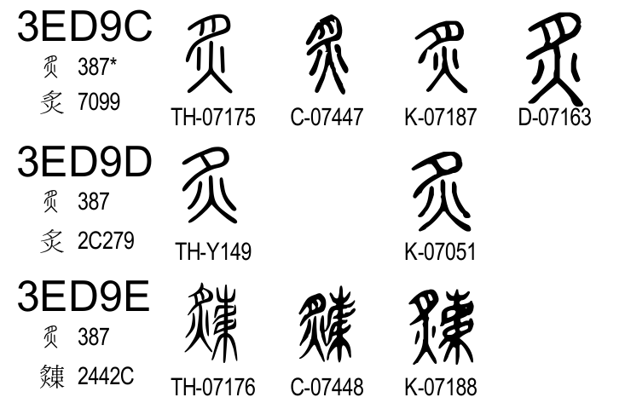
Figure 64: Standardized Seal “炙” in the Unicode 18.0.0
The omitted glyph names can be identified by the gaps in the glyph name sequences in Figure 65.

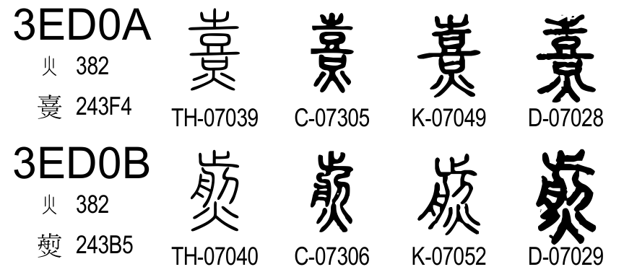
Figure 65: Glyph name gap in the range from U+3ED0A to U+3ED0B
As shown in Figure 65, the glyph names K-07050 and K-07051 are absent in the range from U+3ED0A and U+3ED0B. The K-07051 is identified as U+3ED9D; therefore K-07050 is identified as omitted. Thus, the proposed property for U+3ED9C can be designed as:
U+3ED9C kSEAL_AdditionalSrc K-‍07050

    - U+3EE9D: “𢘼”
As shown in Figure 66, the editions in the XiaoXu branch contain two occurrences of “𢘼” (𢘁) under the “壺” radical, although the editions in the DaXu branch and the DYC edition contain one occurrence. In the XiaoXu editions, both occurrences are headword entries and their descriptions are almost same; the earlier entry reads “𢘼：疾利口也。《書》曰「相時𢘁民。」 臣鍇曰、今皆作憸册所言衆也。會意。先廉反。臣次立曰、疑此誤收巳見心部。”, the later entry reads “𢘼：疾利口也。從心册聲。《詩》曰「相時𢘼民。」 臣鍇曰、今皆憸册所言衆也。會意。先廉反。”. The description for the earlier occurrence does not rationalize the glyph structure, and there is no explanation why this instance is placed under the “壺” radical.
Figure 66: Occurrences of Seal “𢘼” in SWJZ (WG2 N5211)
Therefore, the later instance was coded, and the earlier instance is unified with. As shown in Figure 67, Unicode 18.0.0 allocates only one codepoint, U+3EE9D, which is the later instance under the “心” radical.
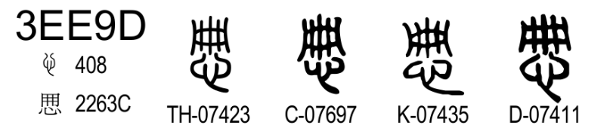
Figure 67: Standardized Seal “𢘼” in the Unicode 18.0.0
The omitted glyph names can be identified by the gaps in the glyph name sequences in Figure 68.
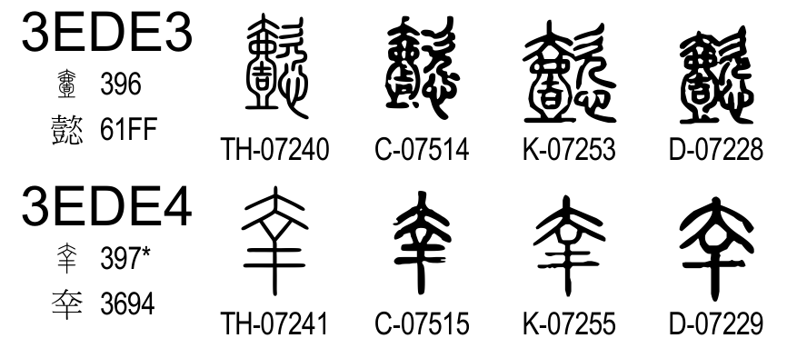
Figure 68: Glyph name gap in the range from U+3EDE3 to U+3EDE4
The omitted glyph name is identified as K-07254. Therefore, the proposed property for U+3EE9D can be designed as:
U+3EE9D kSEAL_AdditionalSrc K-‍07254

    - U+3F2C6: “閑”
As shown in Figure 69, some editions in the XiaoXu branch contain two occurrences of “閑”, under the “木” and “門” radicals. The earlier occurrence is a headword entry specific to the XiaoXu branch, it reads “閑：止也。從木門。臣鍇曰、閑猶闌也。《易》曰、「閑有家。」陶潛有《閑情賦》謂「自閑止其情欲也。」候艱反。”. The later occurrence is an universal headword entry, it reads “閑：闌也。從門中有木。臣鍇按、《易》曰「閑邪存其誠」。陶潛有《閑情賦》謂「闌止其情欲也。」會意。候艱反。”. They are almost identical.
Figure 69: Occurrences of Seal “閑” in SWJZ (WG2 N5211)
Unicode 18.0.0 allocates one codepoint for these instances, U+3F2C6, which is the later occurrence under the “門” radical.
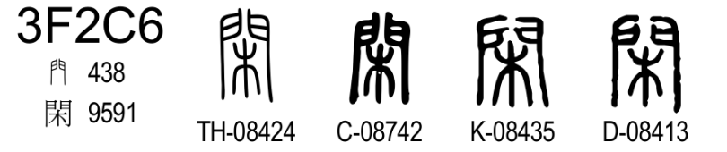
Figure 70: Standardized Seal “閑” in the Unicode 18.0.0
The omitted glyph names can be identified by the gaps in the glyph name sequences in Figure 71.
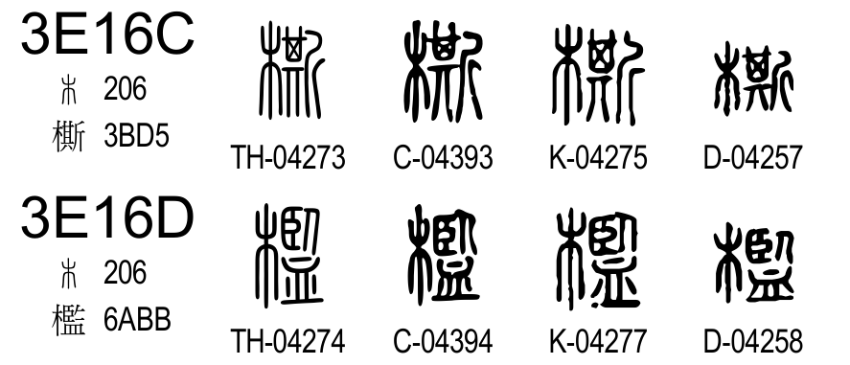
Figure 71: Glyph name gap in the range from U+3E16C to U+3E16D
The omitted glyph is identified as K-04276. Therefore, the proposed property for U+3F2C6 can be designed as:
U+3F2C6 kSEAL_AdditionalSrc K-‍04276

  - Cell Omissions for Edition-Specific Duplicates
    - U+3D228: “䕼”
As shown in Figure 72, there are two occurrences looking like “䕼” in SWJZ, the earlier occurrence is a headword entry under the “艸” radical. It reads “䕼：艸也。从艸難聲。如延切。”. The later occurrence is an alternative form of “然” under the “火” radical. The headword entry for “然” reads “然：燒也。从火肰聲。臣鉉等曰、今俗別作「燃」、蓋後人増加。如延切。”, its accompanying entry for “䕼” reads “䕼：或人从𩁘。臣鉉等案、艸部有䕼、注云「艸也。」此重出。”.
Figure 72: Occurrences of Seal “䕼” in SWJZ (WG2 N5211)
Unicode 18.0.0 allocates two codepoints for these instances. As shown in Figure 73, the earlier occurrence is coded at U+3D228.
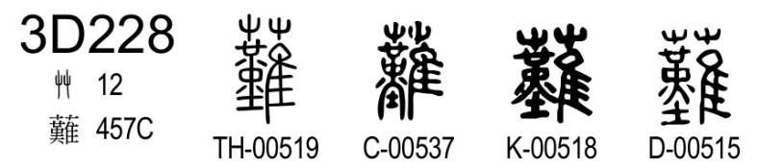
Figure 73: Standardized Seal “䕼” under the “艸” radical in the Unicode 18.0.0
Comparing the earlier and later occurrences in Figure 72, some editions in the DaXu branch have small glyphic difference, but the editions in the XiaoXu branch and the DYC edition do not have. As shown in Figure 74, the QJZ and DYC glyphs, K-07013 and D-06991, are identified as omitted.
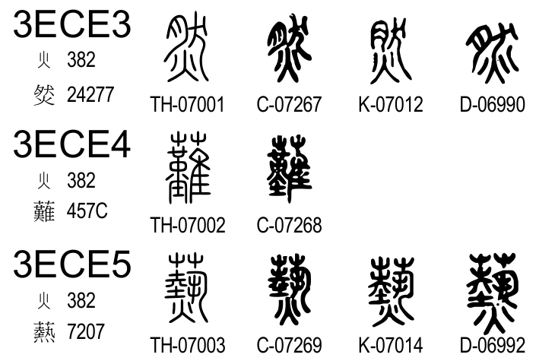
Figure 74: Glyph name gap in the range from U+3ECE3 to U+3ECE5
Therefore, the proposed property for U+3D228 can be designed as:
U+3D228 kSEAL_AdditionalSrc K-‍07013 D-‍06991
    - U+3D43C: “㕣”
As shown in Figure 75, DYC has two “㕣” occurrences, under the “口” and “水” radicals.
Figure 75: Occurrences of Seal “㕣” in SWJZ (WG2 N5211)
The earlier occurrence is an universal headword entry, it reads “㕣：山閒陷泥地。从口，从水敗皃。讀若沇州之沇。九州之渥地也，故以沇名焉。”. The later occurrence is not a headword entry but a Guwen form of the entry for “沇”. Other editions uses “沿”; the editions in the DaXu branch read “沿：古文沇。臣鉉等曰、口部巳有此重出。”, the editions in the XiaoXu branch read “沿：古文沇如此。臣次立按、説文徐鉉注云口部巳有此重出。又本部下文沿字注云、縁水而下。與川反。”. But Duan had “corrected” it by “㕣”. Duan’s description reads “㕣：古文沇如此。各本篆作沿。誤。今正。臣鉉等曰。口部已有。此重出。按口部小篆有㕣。然則鉉時不從水旁也。口部㕣下曰。山閒淊泥地。從口。從水敗皃。葢㕣字在古文則爲沇水、沇州。在小篆則訓山閒淊泥地。如孌字在籒文則訓順。在小篆則訓慕。皆同形而古今異義也。古文作㕣。小篆作沇。𣜩變作兖。此同義而古今異形也。”.
Unicode 18.0.0 allocates only one codepoint for these instances, at U+3D43C, which corresponds to the earlier universal occurrence under the “口” radical.
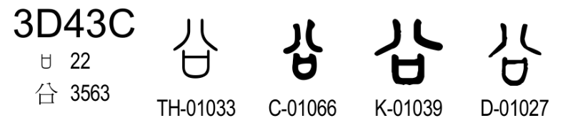
Figure 76: Standardized Seal “㕣” in the Unicode 18.0.0
The omitted glyph name can be identified by the gaps in the glyph name sequences in Figure 77.
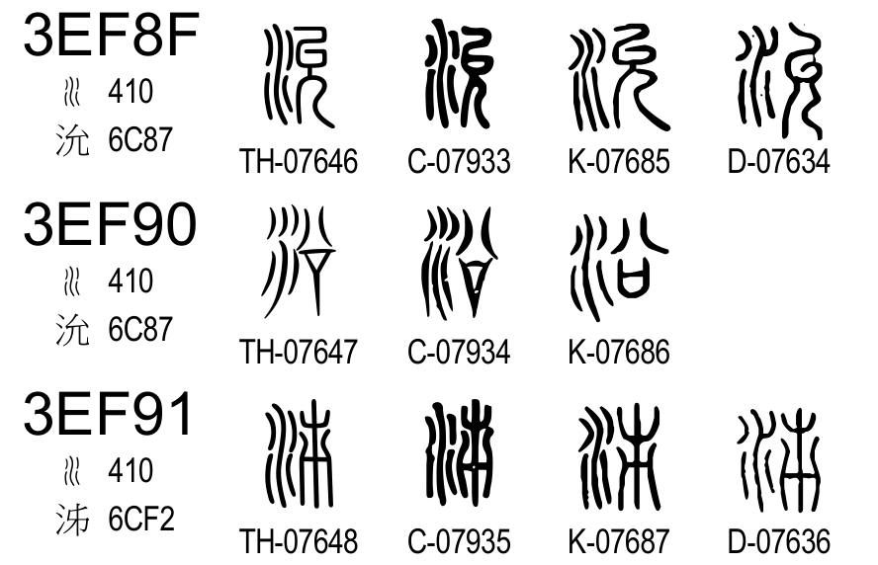
Figure 77: Glyph name gap in the range from U+3EF8F to U+3EF91
The omitted glyph name is identified as D-07635. Thus, the proposed property can be designed as:
U+3D43C kSEAL_AdditionalSrc D-‍07635

    - U+3D626: “踞”
As shown in Figure 78, most editions in the DaXu branch contain two occurrences of “踞”. The earlier occurrence under the “足” radical is a headword entry, it reads “踞：蹲也。足居聲。居御切。”. The later occurrence under the “尸” radical is a deviant form (俗字) of “居”. The headword entry for “居” reads “居：蹲也。从尸古者。居从古。臣鉉等曰、「居从古者」言法古也。九魚切。”, its accompanying entry for “踞” reads “踞：俗居从足”. It should be noted that the editions in the XiaoXu branch and the DYC edition show different glyph “𧿃” at the corresponding position.
Figure 78: Occurrences of Seal “踞” in SWJZ (WG2 N5211)
As shown in Figure 79, Unicode 18.0.0 allocates only one codepoint for these instances, at U+3D626, which is the earlier occurrence under the “足” radical.
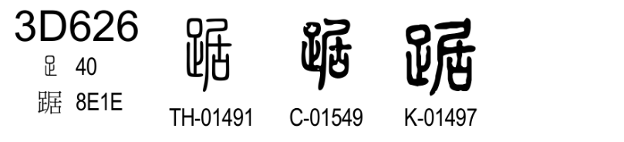
Figure 79: Standardized Seal “踞” in the Unicode 18.0.0
For the position of the later occurrence, the glyph for the QJZ and DYC editions are coded at U+3E85A as shown in Figure 80.
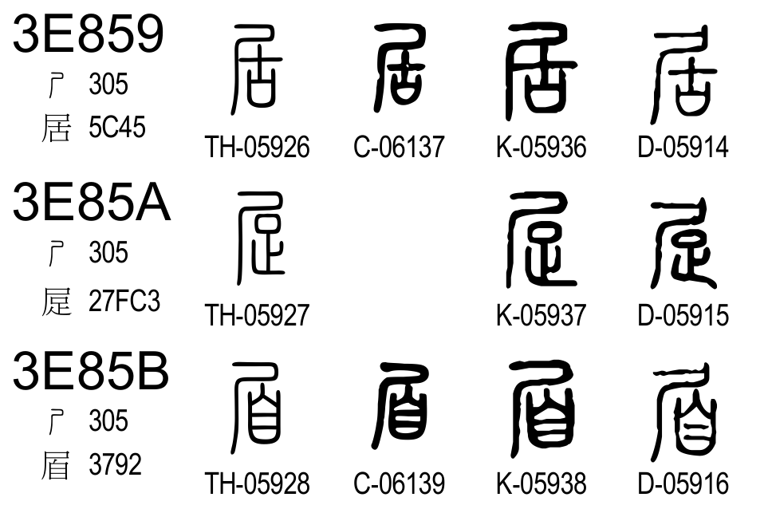
Figure 80: Glyph name gap in the range from U+3E859 to U+3E85B
It is found that the C-06138 is omitted, while the THX column shows a glyph TH-05927. The TH-05927 is a modified glyph to avoid the duplicated glyph issue, with a substitution by the DYC glyph (for the original THX glyph, refer Figure 78). On the other hand, the CCZ column is intended to avoid the modification, therefore the glyph C-06138 is unified with the glyphs at U+3D626, and no glyph suitable for the CCZ column at this codepoint. Therefore, C-06138 does not appear in the code chart or SealSources.txt. Thus, the proposed property for U+3D626 can be designed as:
U+3D626 kSEAL_AdditionalSrc C-‍06138

    - U+3D685: “廿”
As shown in Figure 81, the DYC edition contains two occurrences “廿”.
Figure 81: Occurrences of Seal “廿” in SWJZ (WG2 N5211)
The earlier occurrence is an universal headword entry, it reads “廿：二十并也。古文省。”. The later occurrence is specific to the DYC edition. It is not a headword entry but a Guwen form of “疾”. The headword entry for “疾” reads “疾：病也。从𤕫。矢聲。”, its accompanying entry for “廿” reads “廿：廿：古文。各本篆體作「𤶅」。是仍與小篆無異。今正。攷𥩓篆下曰。「廿」、古文疾。童篆下曰。「廿」、古文以爲疾。此「廿」爲古文疾之明證。而集韵、類篇皆曰。「廿」、古文疾。𥏴、籒文疾。此丁度所見不誤之明證也。其曰籒文作「𥏴」又作「𤶅」者、乃當其時巳有誤本同今本。而因倂入之、又譌古爲籒也。”. Duan wrote the glyphs in the editions of the DaXu and XiaoXu branches have no differences from the headword glyph shape, and recovered by the descriptions in other entries like “𥩓”, “童”, and the texts in the Jiyun and Leipian.
Unicode 18.0.0 allocates only one codepoint for the universal instance, at U+3E685 as shown in Figure 82, which is under the “十” radical.
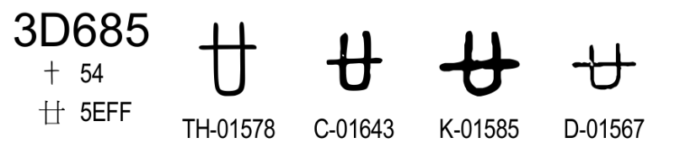
Figure 82: Standardized Seal “廿” in the Unicode 18.0.0
The omitted glyph name can be identified by the gaps in the glyph name sequences in Figure 83.
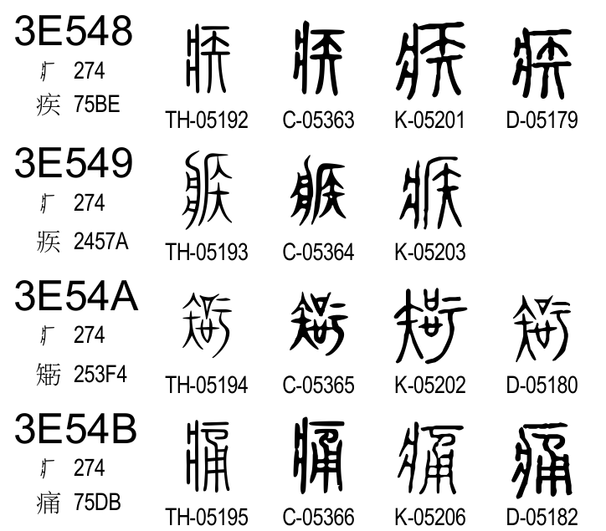
Figure 83: Glyph name gap in the range from U+3E548 to U+3E54B
The omitted glyph name is identified as D-05181. Thus, the proposed property for U+3D685 can be designed as:
U+3D685 kSEAL_AdditionalSrc D-‍05181

    - U+3DE72: “𧗎”
As shown in Figure 84, the most editions of the DaXu and XiaoXu branches contain two similar pairs of glyphs; “𦼬”/“𧗎”, and “𧂚”/“𧗘”. Their differences are the contrast of “血” and “皿”. The earlier occurrences under the “艸” radical are alternate forms of “菹”. The headword entry for “菹” reads “菹：酢菜也。从艸沮聲。側魚切。”, its accompanying entry for “𦼬” reads “𦼬：或从皿。”, and another accompanying entry for “𧂚” reads “𧂚：或从缶。”. The later occurrences under the “血” radical are the headword entry of “𧗎”, and its alternate form “𧂚”. The headword entry for “𧗎” reads “𧗎：醢也。从血菹聲。側余切。”, its accompanying entry for “𧂚” reads “𧗎：或从缶。”. The DYC edition changed “皿” components to “血” components.
Figure 84: Occurrences of Seal “𧗎” in SWJZ (WG2 N5211)
Unicode 18.0.0 allocates four codepoints for all instances; “𦼬”, “𧂚”, “𧗎”, and “𧗘”, as shown in Figues Figure 85 and Figure 86.
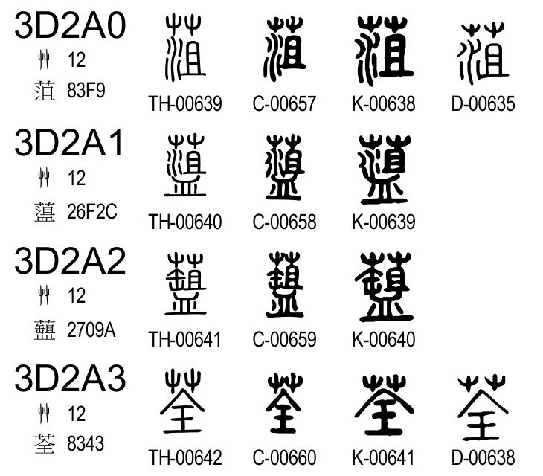
Figure 85: Glyph name gap in the range from U+3D2A0 to U+3D2A3
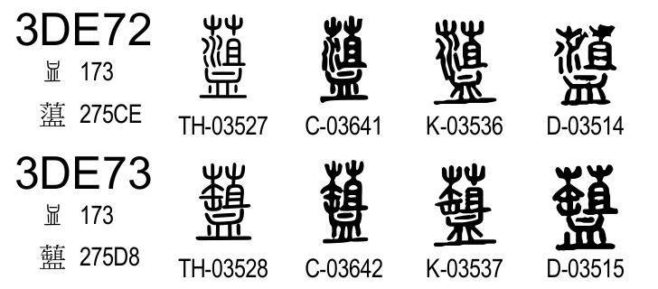
Figure 86: Standardized Seal “𧗎” and “𧗘” in the Unicode 18.0.0
Because the DYC edition changed the glyphs for the earlier occurrences, and the resulted glyphs are same with those for the later occurrences, the codepoints for the earlier occurrences have no DYC glyphs. The omitted glyph names are identified as D-00636 for the modified “𦼬”, D-00637 for modified “𧂚”.
In summary, the proposed property for U+3DE72 can be designed as:
U+3DE72 kSEAL_AdditionalSrc D-‍00636

    - U+3DE73: “𧗘”
As shown in Figure 87, the DYC edition changed the glyph for “𧂚” to “𧗘”.
Figure 87: Occurrences of Seal “𧗘” in SWJZ (WG2 N5211)
By this change, the DYC glyph with untouched shape for the earlier occurrence is unified with that at the later occurrence. Thus, the omitted glyph D-00637 (see the row U+3D2A2 in Figure 85) is identified as unified with D-03515 in Figure 88.
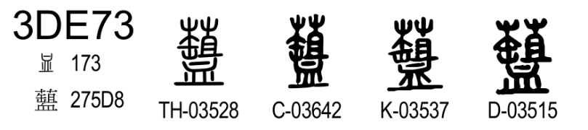
Figure 88: Standardized Seal “𧗘” in the Unicode 18.0.0
Thus, the proposed property can be designed as:
U+3DE73 kSEAL_AdditionalSrc D-‍00637

    - U+3E0B3: “槾”
As shown in Figure 89, all editions of SWJZ contain two similar occurrences looking like “槾”. The earlier occurrence is a headword entry under the “木” radical, it reads “槾：杇也。从木曼聲。母官切。”. The later occurrence is not a headword entry but an alternative form of “鏝” under the “金” radical. The headword entry for “鏝” reads as “鏝：𨮯杇也。从金曼聲。母官切。”, its accompanying entry for “槾” reads “槾：或从木。臣鉉等案、木部巳有。此重出。”.
Figure 89: Occurrences of Seal “槾” in SWJZ (WG2 N5211)
Unicode 18.0.0 allocates two codepoints to these instances. The earlier is U+3E0B3 under the “木” radical, corresponding to the universal headword entry as shown in Figure 90.
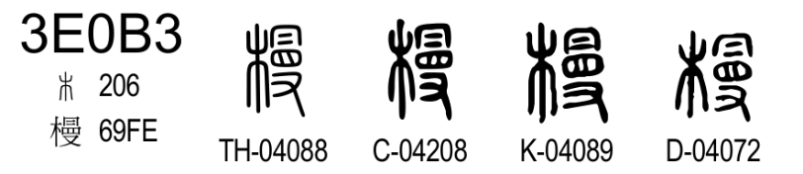
Figure 90: Standardized Seal “槾” in the Unicode 18.0.0
For the later occurrence, the glyphs for the editions in the DaXu branch are coded, but the QJZ and DYC glyphs are unified with these in the earlier occurrence. The omitted glyph names can be identified by the gaps in the glyph name sequences in Figure 91.
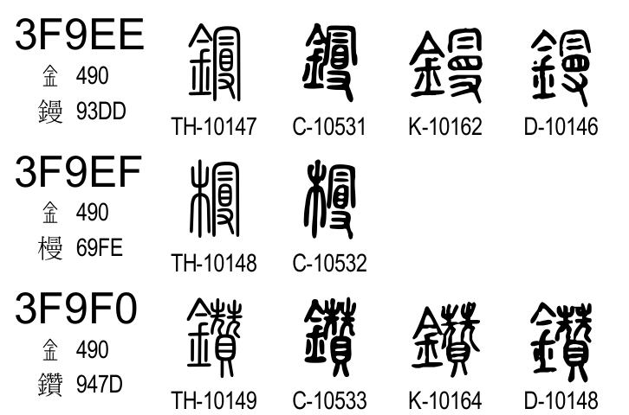
Figure 91: Glyph name gap in the range from U+3F9EE to U+3F9F0
The omitted glyph names are identified as K-10163, and D-10147. Thus, the proposed property of U+3E0B3 can be designed as:
U+3E0B3 kSEAL_AdditionalSrc K-‍10163 D-‍10147

    - U+3F38D: “𢱀”
As shown in Figure 92, two editions (QJZ and DYC) have two occurrences of “𢱀”, under the “韋” and “手” radicals. The DaXu occurrences show different glyph shapes, like “揫” and “𢱀”, but QJZ and DYC show same glyph shape, their shapes are same with the later occurrences in the DaXu branch under the “手” radical.
Figure 92: Occurrences of Seal “𢱀” in SWJZ (WG2 N5211)
The earlier occurrence under the “韋” radical is not a headword entry but an alternative form of “𩏷”. The headword entry for “𩏷” reads “𩏷：收束也。从韋𥼚聲。讀若酋。臣鉉等曰、𥼚側角切。聲不相近未詳。即由切。”, and its accompanying entry for “揫” reads “揫：𩏶或从秋手。”. The later occurrence under the “手” radical is a headword entry, the entry for “𢱀” reads “𢱀：束也。从手秋聲。《詩》曰：「百祿是揫。」即由切。”.
DaXu did not mention the relationship of two occurrences, but DYC mentioned as “束者、縳也。鄉飲酒義曰。西方者秋。秋之爲言愁也。愁讀爲揫。按韋部𩏶、收束也。或从要作𩏶。或从秋手作揫。揫卽𢱀。然則此篆實爲重出也。”. And changed the earlier occurrence to look like a duplicated entry of “𢱀”.
Unicode 18.0.0 allocates two codepoints for the universal glyph “𢱀” at U+3F38D (Figure 93) and the DaXu-specific glyph “揫” at U+3DF98 (Figure 94). The codepoint for the DaXu-specific glyph leaves the QJZ and DYC columns as blank.
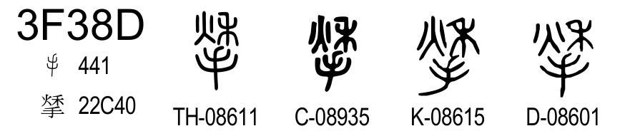
Figure 93: Standardized Seal “𢱀” in the Unicode 18.0.0
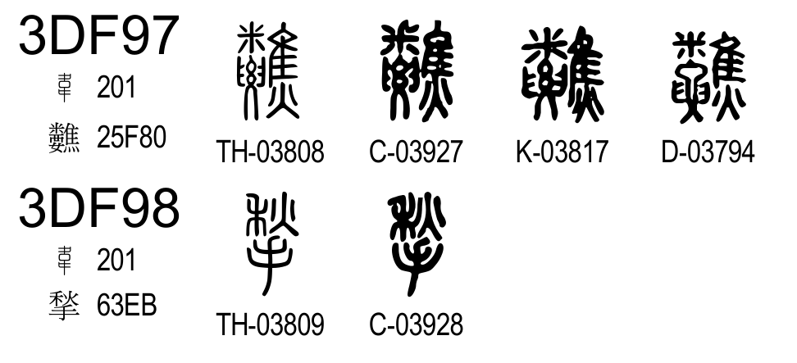
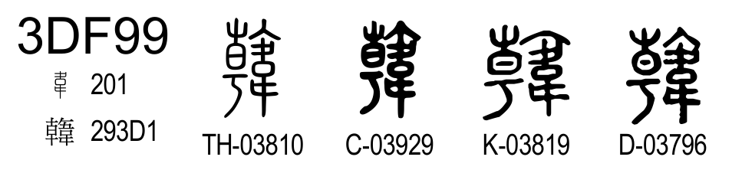
Figure 94: Blanked QJZ and D columns at U+3FF98 for “揫”
The omitted glyph names can be identified as K-03818 and D-03795 from the glyph names at previous and next codepoints. The glyphs K-03818 and D-03795 under the “韋” radical should be displayed by K-08615 or D-8601 at U+3F38D under the “手” radical. Thus, the proposed property can be designed as:
U+3F38D kSEAL_AdditionalSrc K-‍03818 D-‍03795

    - U+3F4EA: “孌”
As shown in Figure 95, most editions of SWJZ contain two occurrences “孌” under the “女” radical. The earlier occurrence is a Zhouwen form of “𡡗”. The headword entry for “𡡗” reads “𡡗：順也。从女𤔔聲。《詩》曰：「婉兮𡡗兮。」”, its accompanying entry for “孌” reads “孌：籀文𡡗。”. The later occurrence is the headword entry, it reads “孌：慕也。从女䜌聲。”. Their glyph shapes have small structural differences in the DaXu editions. The QJZ edition has similar differences, but the glyphs are transposed. The DYC edition does not have this difference.
Figure 95: Occurrences of Seal “孌” in SWJZ (WG2 N5211)
As shown in Figures Figure 96 and Figure 97, Unicode 18.0.0 allocates two codepoints for these instances. The earlier instance is coded at U+3F4A8, and the later instance is coded at U+3F4EA.
The omitted glyph name can be identified by the gaps in the glyph name sequences in Figure 96.
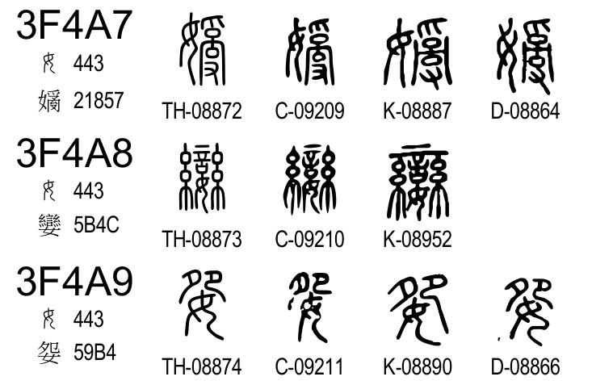
Figure 96: Glyph name gap in the range from U+3F4A7 to U+3F4A9
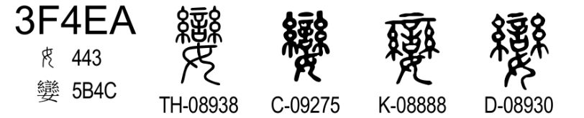
Figure 97: Standardized Seal “孌” in the Unicode 18.0.0
As shown in Figure 96, the omitted glyph name for DYC is identified as D-08865. Therefore, the proposed property for U+3F4EA can be designed as:
U+3F4EA kSEAL_AdditionalSrc D-‍08865

In some editions derived from the late print by the Jiguge library in the Qing dynasty has it, while it is regarded as an edition in the DaXu branch. It is because it tried to merge the XiaoXu editions.
In 《説文解字繫傳》中國古代語言學基本典籍叢書 (中華書局, 2024,ISBN 978-7-101-16594-4) p.782, it is suggested that the later occurrence in the XiaoXu editions was by the later hands, to match with the DaXu editions.
For more precise location of the evidence, the entry for “𥪽”, which is a Zhouwen form of “童” should be referred.
In the Jiguge edition, two occurrences are unified because its ancestor 五音韻譜 had already unified them.
The SGT edition (述古堂本) and WQS edition (汪啓淑本) in the XiaoXu branch do not have this glyph difference.

