Campus Life Newsletter — Fall Edition
Campus Life Newsletter: Fall Festival Draws Record Turnout
By the Office of Student Engagement Staff Writers

Upcoming Events
This fall, campus life came alive. The fall festival attracted over 200 students to the quad this year. Organizers called it the biggest turnout in five years.
The festival will be held on October 22 at the main quad, rain or shine.
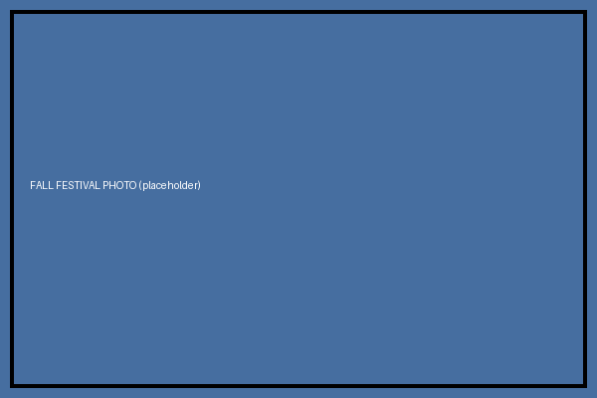
Photo: Fall Festival 2026
Staff Spotlight
Meet the student leaders who made this fall’s events possible.
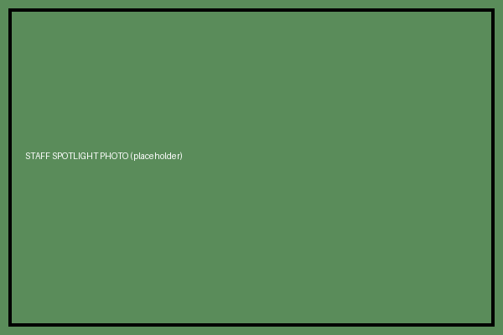
Photo: Fall 2026 Staff Team
Editor’s note: this paragraph was pasted in from an email draft and still needs cleanup before publication.
According to the Office of Student Engagement’s post-event survey, satisfaction scores rose sharply compared to last year.

Get Involved
Dozens of student clubs recruited new members at the fall activities fair.
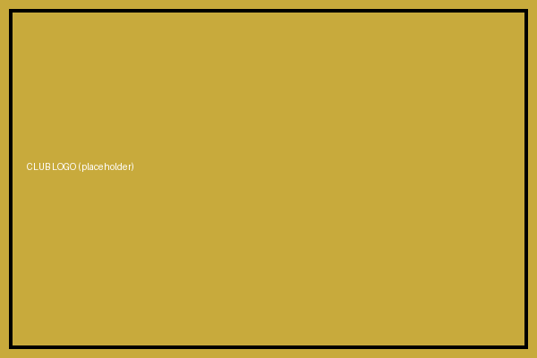
Club Fair sign-up table logo

For more information, visit the Office of Student Engagement in the Student Union.

Survey conducted September 2026; n=214 respondents.

